A1 – Thread/Process Benchmarker
Ben Soer
A00843110

Table of Contents
Table of Contents 2
Finite State Machines 3
Processess 3
Threads 4
Data Flow Diagrams 5
Processess 5
Threads 6
Pseudocode 7
Threads 7
tmain.cpp (Main Thread) 7
main() 7
bootstrapper(WorkerThread) 7
WorkerThread.cpp (Worker Thread) 7
start() 7
checkForMoreWork() 7
stop() 8
isIdle() 8
Processess 8
pmain.cpp (Main Process) 8
main() 8
WorkerProcess.cpp (Worker Process) 8
parseValueForWork() 8
start() 8
stop() 8
setIdleState(state) 9
checkForMoreWork() 9

Finite State Machines
Diagram Notes:
- “Program Initialization” as labeled in the state diagrams is defined as all steps carried out in the pseudocode (listed below) up to step 6 in tmain.cpp (main method for threads) and up to step 7 in pmain.cpp (main method for processes)

Processess
See ProcessStateMachine.jpg for seperate image
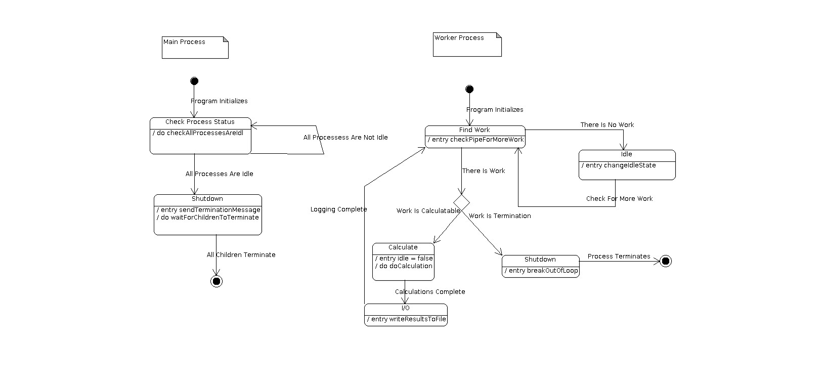

Threads
See ThreadStateMachine.jpg for seperate image
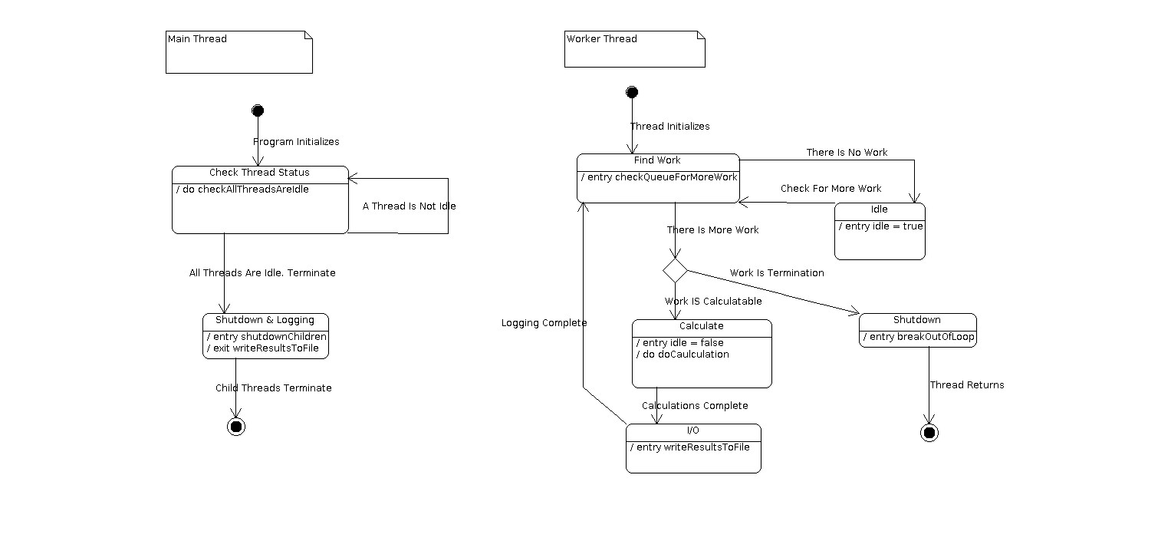

Data Flow Diagrams

Processess
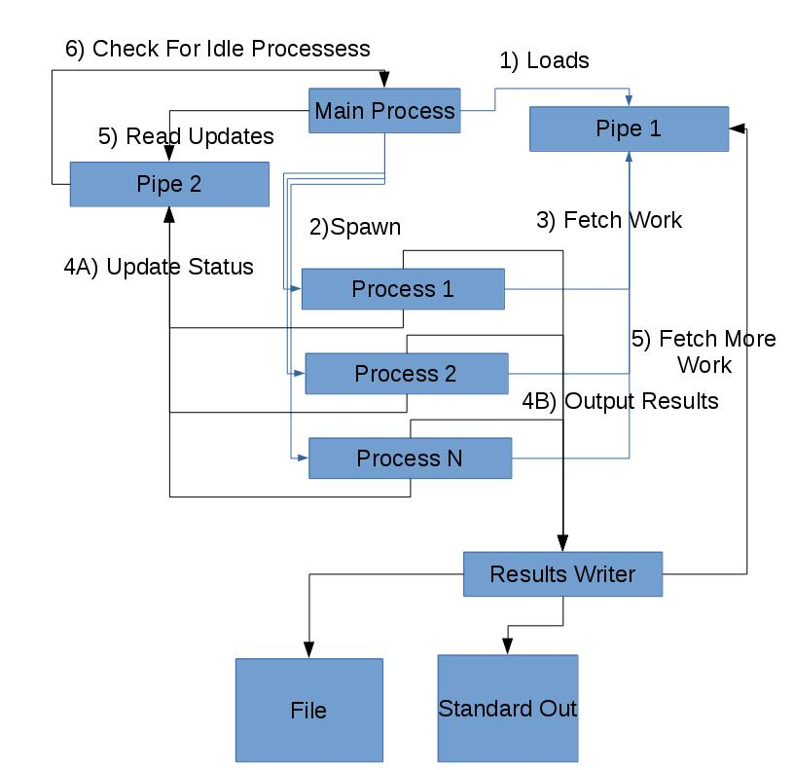

Threads
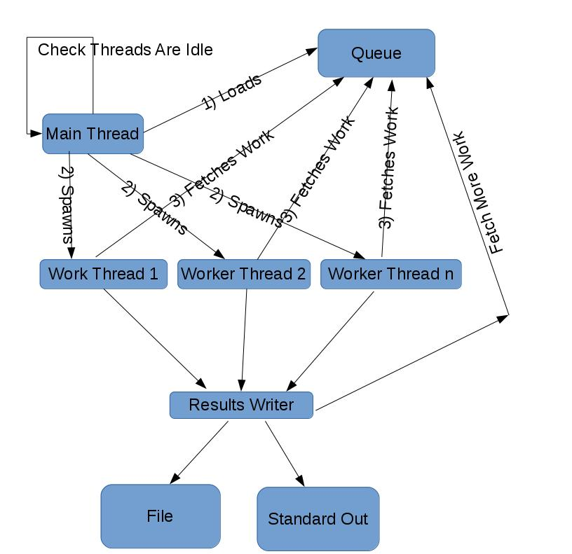

Pseudocode

Threads

tmain.cpp (Main Thread)

main()
- Read In Arguments
- Create TaskManager object wrapping a Queue to be used as a shared resource for the worker threads. This will contain all tasks needed by the worker threads
- Get Time
- Create 5 POSIX Worker Threads
- Generate all work for worker threads and load into shared resource queue
- Start POSIX Worker Thrreads
- Check for Idle Threads
- Join all worker threads to main thread
- Write additional logging information to file
- Cleanup

bootstrapper(WorkerThread)
- Instantiate Worker Thread
- Call Start on Worker Threaded

WorkerThread.cpp (Worker Thread)

start()
- checkForMoreWork()
- Execute Caclualtion of new Task

checkForMoreWork()
- Check for new work in TaskManager
- While there is no new valid task, set Thread to idle, and then check again
- Set current task to the fetched task

stop()
- Set continueRunning to false

isIdle()
- Return value of idle attribute

Processess

pmain.cpp (Main Process)

main()
- Read in Arguments
- Setup Pipes for IPC
- Load Pipe with Initial Tasks
- Get Time
- Create 5 Child Worker Processes
- While All Worker Processes Are Not Idle, Check All Worker Process Are Idle
- Wait For Child Processes To Terminate
- Cleanup

WorkerProcess.cpp (Worker Process)

parseValueForWork()
- Parse substring of N value and D value, seperated by a '.'
- cast to long and assign to object attributes

start()
- checkForMoreWork()
- if can continue working, parseValueForWork()
- make calculation
- log values and send notification messages to parent or more tasks to work pipe
- else break

stop()
- Set continueWorking to false to stop allow start loop from continueing

setIdleState(state)
- If state is different from current state, update state and then send message through pipe to parent
- else state is the same, do nothing

checkForMoreWork()
- Check pipe for more work
- If there is more work, setIdleState(false) and set work as currentWork
- else setIdleState(true) and release CPU

