A2 – Scalable Servers
Ben Soer
A00843110

Table of Contents
Finite State Machines 4
Traditional 4
Select 4
Epoll 6
Data Flow Diagrams 7
Pseudocode 9
Traditional 9
Main.cpp (Program Main Entry) 9
Main() 9
shutdownServer(int signo) 9
readInPipeMessage(int * pipeToParent) 9
createChildProcesses(int socketDescreiptor, int * pipeToParent, vector<pid_t> * children, unsigned int howMany) 10
ConnectionProcess.cpp (Wrapper of Child Process) 10
Start() 10
readInMessage(int socketDescriptor) 10
Select 10
Main.cpp (Program Main Entry) 10
Main() 10
shutdownServer(int signo) 11
readInPipeMessage(int * pipeToParent) 11
getActiveConnectionsCount() 11
createChildProcesses(int socketDescreiptor, int * pipeToParent, vector<pid_t> * children, unsigned int howMany) 11
ConnectionProcess.cpp (Wrapper of Child Process) 12
start() 12
readInMessage(int socketDescriptor) 12
Epoll 13
Main.cpp (Program Main Entry) 13
Main() 13
shutdownServer(int signo) 13
readInPipeMessage(int * pipeToParent) 13
getActiveConnectionsCount() 13
createChildProcesses(int socketDescreiptor, int * pipeToParent, vector<pid_t> * children, unsigned int howMany) 13
ConnectionProcess.cpp (Wrapper of Child Process) 14
start() 14
readInMessage(int socketDescriptor) 15
Client 15
Main.cpp 15
Main() 15
shutdownClient(int signo) 15
connectToServer(string host, int port, int socketDescriptor) 15

Finite State Machines

Traditional
See imgs/statechart/TraditionalServerStateMachine.jpg for seperate image

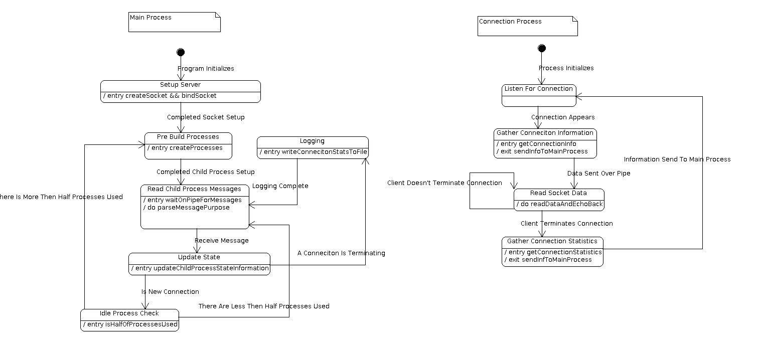
Select
See imgs/staechart/SelectServerStateMachine.jpg for seperate image
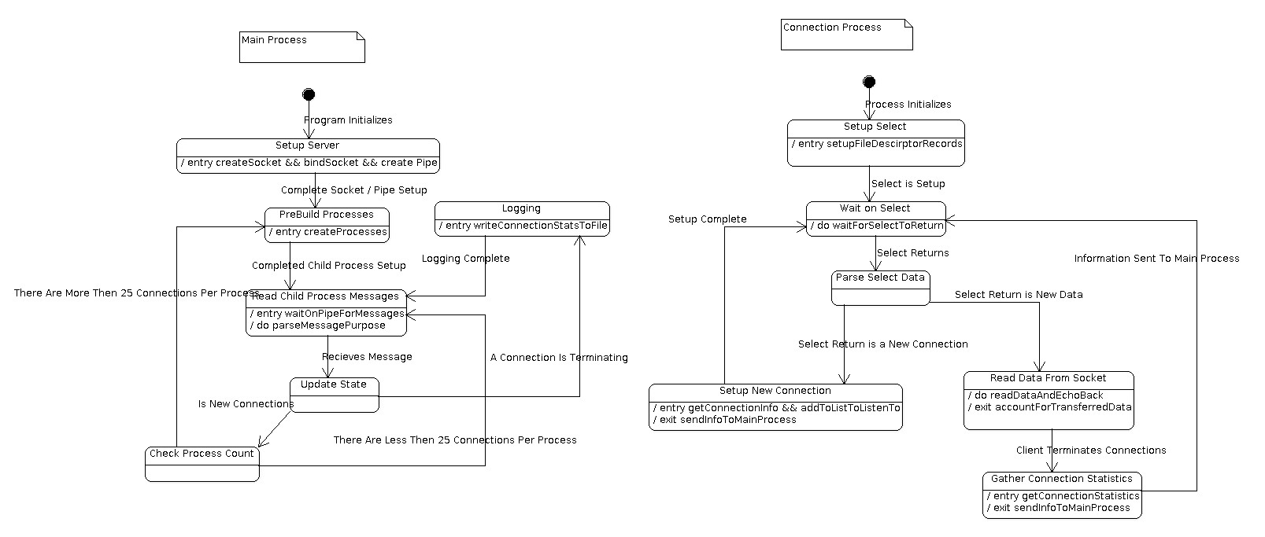

Epoll
See imgs/staechart/EpollServerStateMachine.jpg for seperate image

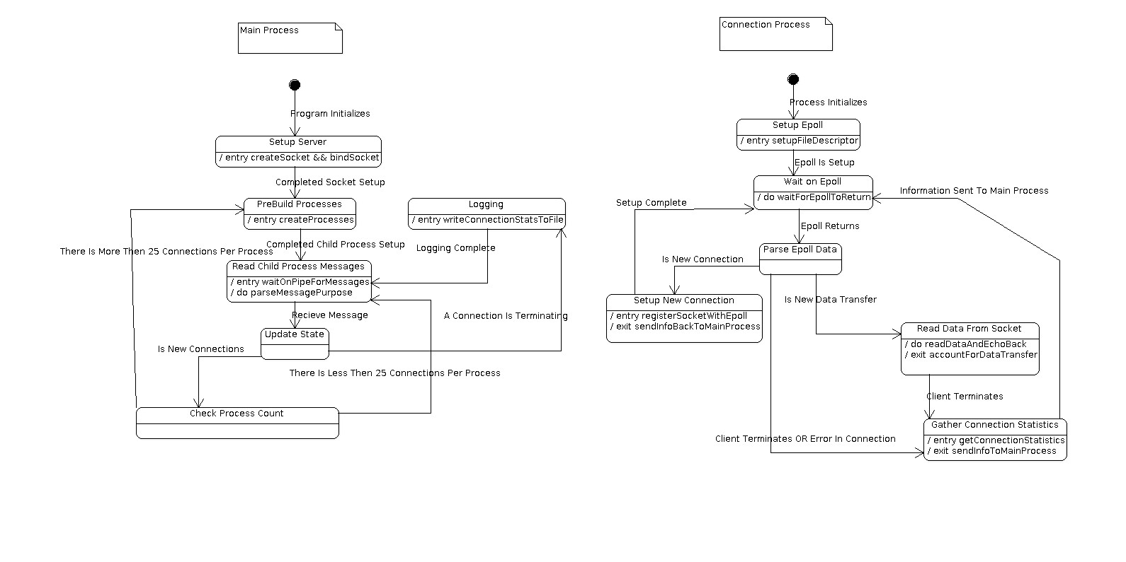
Data Flow Diagrams
Due to the similar nature of all the the server's designs. The data flow diagram is identical for all of the different servers. They all try to solve the same problem, the same way, except for the tool which they use for listening to and interacting the the sockets. Below is a general data flow of how the servers all function and pass data around

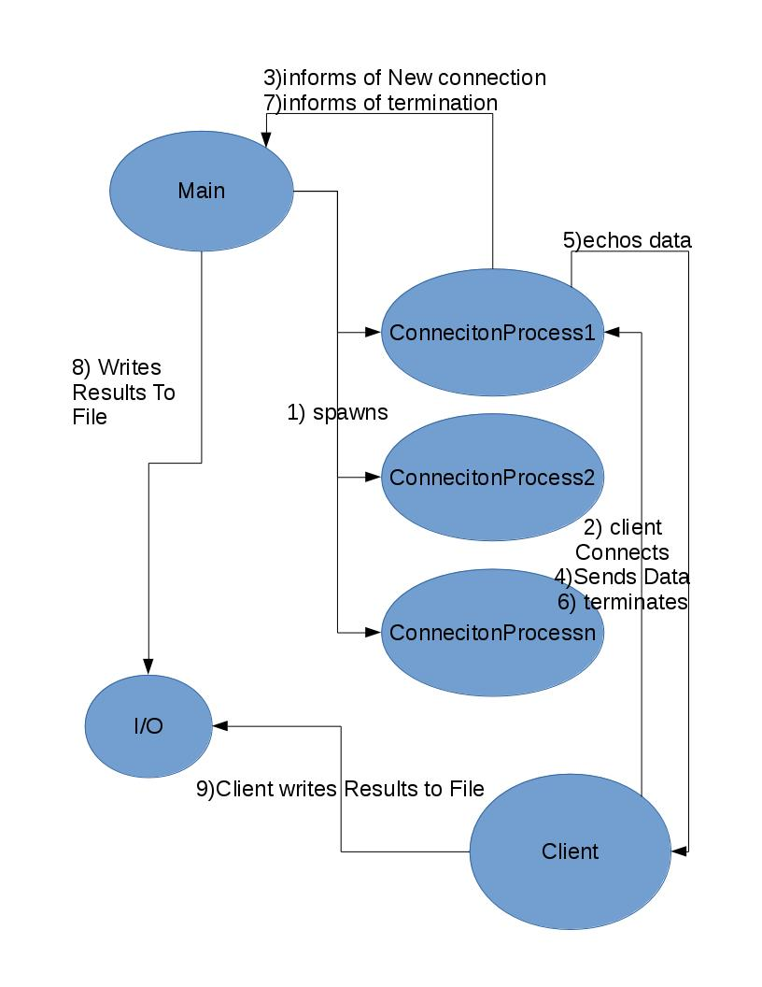

Pseudocode

Traditional

Main.cpp (Program Main Entry)

Main()
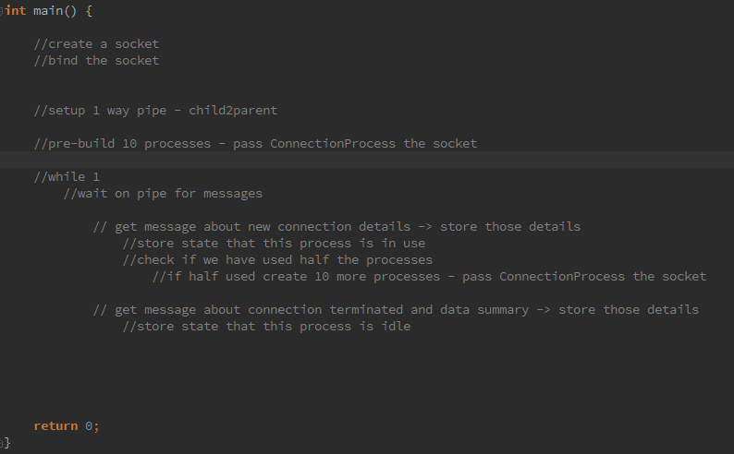

shutdownServer(int signo)
- Check if caller is child process, if child return immediately
- If parent get all children and SIGTERM them and then self terminate

readInPipeMessage(int * pipeToParent)
- While character is not '}' character. Read next character
- Once find '}' (means end of message). Assemble message and return

createChildProcesses(int socketDescreiptor, int * pipeToParent, vector<pid_t> * children, unsigned int howMany)
- Generate as many child processes as specified by 'howMany' parameter. Pass the pipe to the child process.
- In the fork, if child, create a ConnectionProcess object, passing the socketDescriptor and pipeToParent
- In the fork, if child, call start() method of ConnectionProcess
- In the fork, if parent, add the child process id to the child process records

ConnectionProcess.cpp (Wrapper of Child Process)

Start()
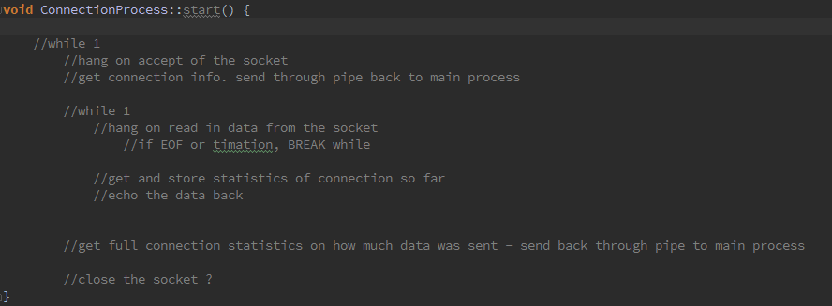

readInMessage(int socketDescriptor)
- Read from passed in socketDescriptor
- If 0 bytes read return nullptr →this tells caller the client dropped connection
- while '}' is not read in, read in next byte
- Once found '}' (means end of transfer). Append together message and return

Select

Main.cpp (Program Main Entry)

Main()
- Setup Socket
- Setup Pipe For Communicating with Children
- PreCreate Child Processes
- While Not Terminated → Wait On Pipe For Messages
  - If New Connection
    - Create A Record About The Connection
    - Check Ratio of How Many Connections There Are To Processes Running. Add More Processes if there are more then 25 connections per process
  - If Termination
    - Find Record. Update Record With Complete Information on Transfer
    - Write Data To File

shutdownServer(int signo)
- Check if caller is child process, if child return immediately
- If parent get all children and SIGTERM them and then self terminate

readInPipeMessage(int * pipeToParent)
- While character is not '}' character. Read next character
- Once find '}' (means end of message). Assemble message and return

getActiveConnectionsCount()
- Cycle through all connection records. If they are still active (we have no received a termination message from it yet), add them to count.
- Return the count

createChildProcesses(int socketDescreiptor, int * pipeToParent, vector<pid_t> * children, unsigned int howMany)
- Generate as many child processes as specified by 'howMany' parameter. Pass the pipe to the child process.
- In the fork, if child, create a ConnectionProcess object, passing the socketDescriptor and pipeToParent
- In the fork, if child, call start() method of ConnectionProcess
- In the fork, if parent, add the child process id to the child process records

ConnectionProcess.cpp (Wrapper of Child Process)

start()
- Setup need structures and arrays for select
- infinite while loop
  - Wait for select to return
  - Check if the socketDescriptor is set, thus meaning we have a new connection request
    - Accept the Connection
    - Create a record and send a message back to Main of new connection
    - Add socketSessionDescriptor to select structures
  - Check all descriptors for new data
    - if new data, read in data
      - updated records about new data message and bytes sent
      - echo the message back
    - if client terminates or read shows client terminated
      - send message to Main with all information about terminated connection
      - remove connection from select structures

readInMessage(int socketDescriptor)
- Read from passed in socketDescriptor
- If 0 bytes read return nullptr →this tells caller the client dropped connection
- while '}' is not read in, read in next byte
- Once found '}' (means end of transfer). Append together message and return

Epoll

Main.cpp (Program Main Entry)

Main()
- Setup Socket
- Setup Pipe For Communicating with Children
- PreCreate Child Processes
- While Not Terminated → Wait On Pipe For Messages
  - If New Connection
    - Create A Record About The Connection
    - Check Ratio of How Many Connections There Are To Processes Running. Add More Processes if there are more then 25 connections per process
  - If Termination
    - Find Record. Update Record With Complete Information on Transfer
    - Write Data To File

shutdownServer(int signo)
- Check if caller is child process, if child return immediately
- If parent get all children and SIGTERM them and then self terminate

readInPipeMessage(int * pipeToParent)
- While character is not '}' character. Read next character
- Once find '}' (means end of message). Assemble message and return

getActiveConnectionsCount()
- Cycle through all connection records. If they are still active (we have no received a termination message from it yet), add them to count.
- Return the count

createChildProcesses(int socketDescreiptor, int * pipeToParent, vector<pid_t> * children, unsigned int howMany)
- Generate as many child processes as specified by 'howMany' parameter. Pass the pipe to the child process.
- In the fork, if child, create a ConnectionProcess object, passing the socketDescriptor and pipeToParent
- In the fork, if child, call start() method of ConnectionProcess
- In the fork, if parent, add the child process id to the child process records

ConnectionProcess.cpp (Wrapper of Child Process)

start()
- Setup epoll. Create epoll file descriptor. Register socketDescriptor with epoll
- infinite while loop
- Wait for epoll to return
- For loop Through All File Descriptors. For Each File Descriptor:
  - Check For Errors. If Errors:
    - Close The Connection
    - Collect all known accounting information about conneciton and send termination message back to main
    - continue on next increment of for loop
  - Check For EPOLLIN. This should never occur. If It Does. Exit(1) process and explode as much as possible
  - Check If This is A New Connection. If A New Connection:
    - Accept the Connection.
    - Create a record about the client
    - Send A Message Back to Main about the new client
    - Register the client with Epoll
  - Otherwise Check For New Data. Call readInMessage passing the file descriptor
  - If readInMessage returns nullptr:
    - Client has terminated. Collect information. Send Termination Message to Main
    - Close connection → deregister connection from epoll
  - If readInMessage returns message:
    - Echo back the content
    - updated records about new data message and bytes sent
    - delete the returned message

readInMessage(int socketDescriptor)
- Read from passed in socketDescriptor
- If 0 bytes read return nullptr →this tells caller the client dropped connection
- while '}' is not read in, read in next byte
- Once found '}' (means end of transfer). Append together message and return

Client

Main.cpp

Main()
- Read in Arguments
- Setup Socket
- Establish Connection With Server. Call connectToServer(string host, int port, int socketDescriptor)
- Setup Epoll To Listen For Replies From Server
- Infinite While
  - Send Message. Take Timestamp. Add message number of bytes to running total of data sent from client
  - Wait For Reply From Epoll
    - Check For Errors. If Errors Terminate Client
    - If Not Errors Read In Data
    - Take Timestamp. Create record of transaction start and finish time and add to connection struct containing requests

shutdownClient(int signo)
- Stop main's infinite while from running
- Cycle through list of all transactions and get their times.
  - Write sendtime, recievetime and deltatime to file
- Write totalDataSent to file
- Calculate average RTT of all requests. Write To File

connectToServer(string host, int port, int socketDescriptor)
- Resolve hostname
- create socketaddr_in
- connect to the server. On failure exit client sending error to terminal. On success return

