Test Documentation
Ben Soer

A00843110
COMP 8006
BTECH Set 6D

Table of Contents
Test Chart 3
Results 5
DNS_T1 5
DNS_T2 5
DNS_T3 6
DNS_T4 7
SSH_T1A 7
SSH_T1B 7
SSH_T2 7
SSH_T3 8
SSH_T4 8
HTTP_T3 9
HTTP_T4 9
HTTP_T5 9
HTTP_T6 10
HTTP_T7 10
HTTP_T8 10
HTTP_T9 11
HTTP_T10 11

Test Chart
Below is a breakdown chart of all the tests executed and the appropriate tests. Note that the Rule/Test # correspond directly to the iptables rule in the fwall.sh file and the hping3 test in the hping-tests.sh file. Each rule is commented with these numbers in the source files if you would like to see how each rule corresponds.
Rule/Test # | Test Description | Tool Used | Expected Result | Pass / Fail
DNS_T1 | Accept UDP DNS Lookup Requests | Hping3 + Accounting Tables | Packet Accepted | PASS – See Test Results Section For Details
DNS_T2 | Accept UDP DNS Lookup Responses | hping3 | Packet Accepted | PASS – See Test Results Section For Details
DNS_T3 | Accept TCP DNS Lookup Responses | hping3 | Packet Accepted | PASS – See Test Results Section For Details
DNS_T4 | Accept TCP DNS Lookup Responses | Hping3 + Accounting Tables | Packet Accepts | PASS – See Test Results Section For Details
SSH_T1A | Drop SSH Responses that are SYN | Hping3 + Accounting Tables | Packet Dropped | PASS – See Test Results Section For Details
SSH_T1B | Accept SSH Responses that are not SYN | hping3 | Packet Accepts | PASS – See Test Results Section For Details
SSH_T2 | Accept SSH Connection Request | hping3 | Packet Accepts | PASS – See Test Results Section For Details
SSH_T3 | Accept SSH Outbound Connection Request | Hping3 + Accounting Tables | Packet Accepts | PASS – See Test Results Section For Details
SSH_T4 | Accept SSH Outbound Connection Responses that are not SYN | Accounting Tables | Packet Accepts | PASS – See Test Results Section For Details
HTTP_T1 | DROP HTTP Connections from ports 0:1024 to port 80 | hping3 | Packet Dropped | PASS – See Test Results Section For Details
HTTP_T2 | DROP HTTP Connections from 0:1024 to port 80 | hping3 | Packet Dropped | PASS – See Test Results Section For Details
HTTP_T3 | Accept HTTP Inbound Responses from port 80 that are not SYN | Hping3 + Accounting Tables | Packet Accepted | PASS – See Test Results Section For Details
HTTP_T4 | Accept HTTP Inbound Responses from port 443 that are not SYN | Hping3 + Accounting Tables | Packet Accepted | PASS – See Test Results Section For Details
HTTP_T5 | Accept HTTP Inbound Connections to port 80 | Hping3 | Packet Accepted | PASS – See Test Results Section For Details
HTTP_T6 | Accept HTTP Inbound Connections to port 443 | Hping3 | Packet Accepted | PASS – See Test Results Section For Details
HTTP_T7 | Accept HTTP Outbound Connections to port 80 | Hping3 | Packet Accepted | PASS – See Test Results Section For Details
HTTP_T8 | Accept HTTP Outbound Connections to port 443 | Hping3 | Packet Accepted | PASS – See Test Results Section For Details
HTTP_T9 | Accept HTTP Outbound Responses from port 80 that are not SYN | Hping3 + Accounting Tables | Packet Accepted | PASS – See Test Results Section For Details
HTTP_T10 | Accept HTTP Outbound Responses from port 80 that are not SYN | Hping3 + Accounting Tables | Packet Accepted | PASS – See Test Results Section For Details

Results
Below is the various screenshots of the test being run. The original images can be found in the /tests folder

DNS_T1
Accounting Table Before
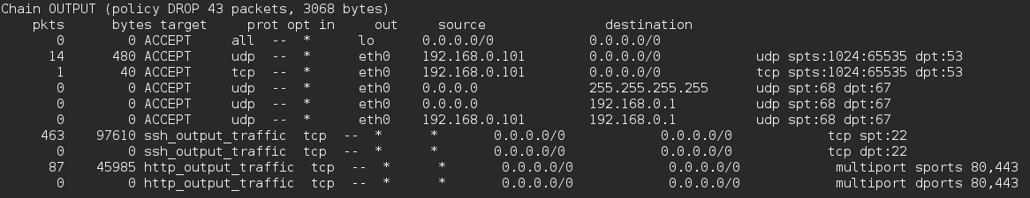
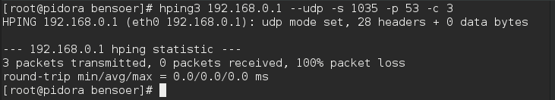
hping3
Accounting Table After
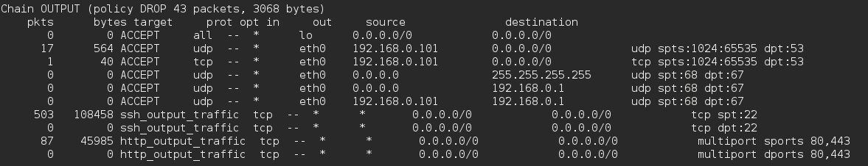

DNS_T2
Although 3 packets were sent, only 1 was accepted
Accounting Table Before
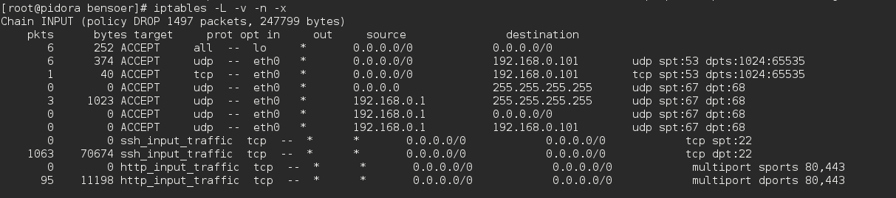
hping3
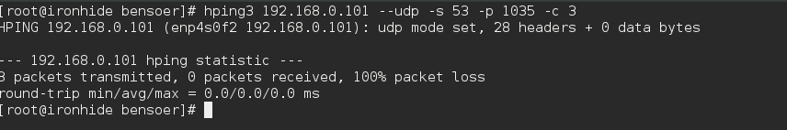
Accounting Table After
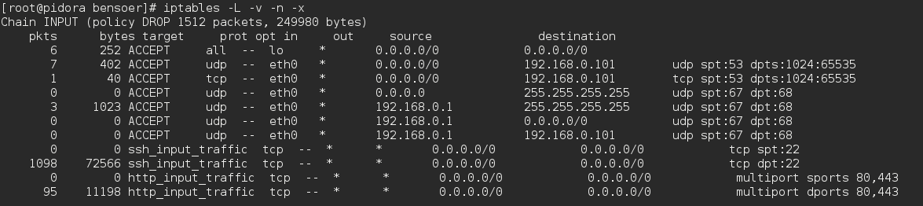

DNS_T3
hping3
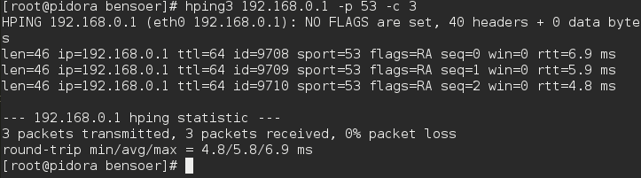

DNS_T4
Although 3 packets were sent, only 1 was accepted
hping3
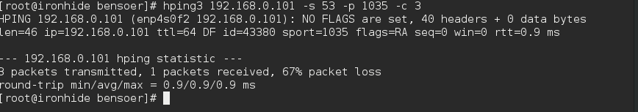

SSH_T1A
hping3
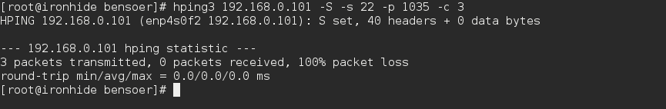

SSH_T1B
Although 3 packets were sent only 1 was accepted, returning a reset request
hping3
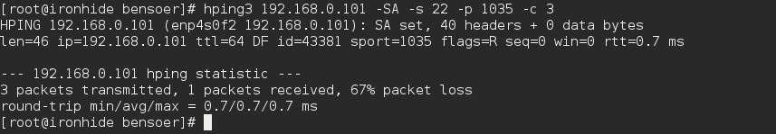

SSH_T2
hping3
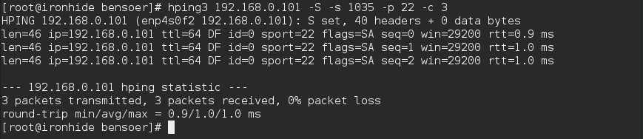

SSH_T3
The return messages are coming as RA because there is no SSH daemon running at the destination host
hping3
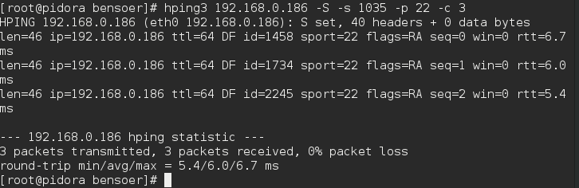

SSH_T4
Note that the two accounting reads don't accuratly match in how much they have incremented. That is because for this experiement SSH was being used to connect to the device that this test was being executed on.
Accounting Table Before
Accounting Table After

HTTP_T3
Although 3 packets were sent. Only one was received
hping3
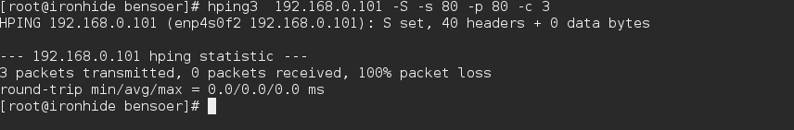

HTTP_T4
Although 3 packets were sent. Only one was received
hping3
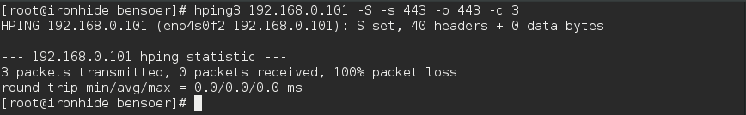

HTTP_T5
hping3
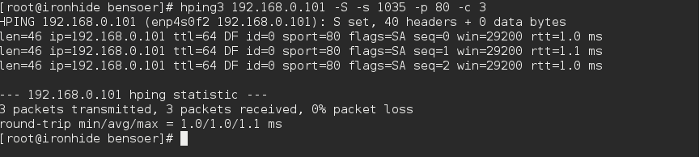

HTTP_T6
hping3
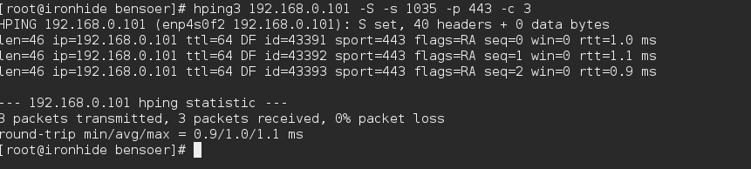

HTTP_T7
hping3
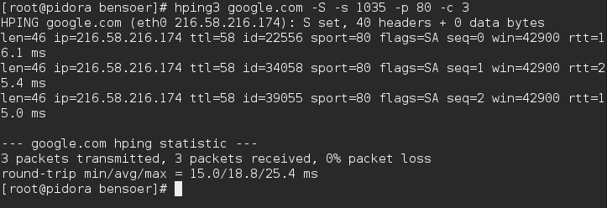

HTTP_T8
hping3
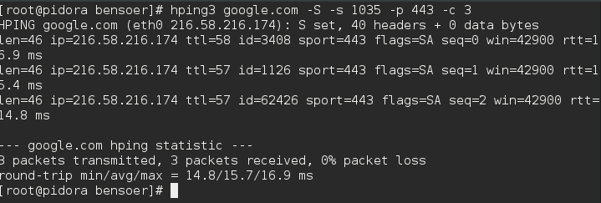

HTTP_T9
Accounting Table Before
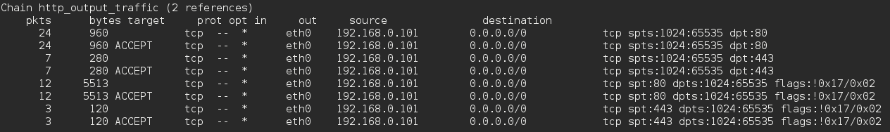
hping3
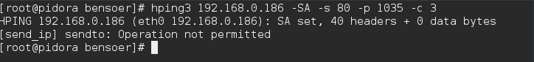
Accounting Table After
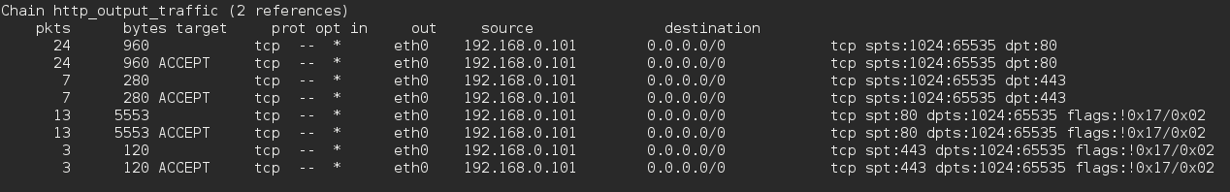

HTTP_T10
Accounting Table Before
hping3
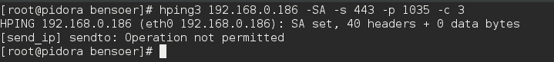
Accounting Table After
