Test Documentation
Ben Soer

A00843110
COMP 8006
BTECH Set 6D

Table of Contents
Test Chart 3
Inbound Tests 3
Outbound Tests 5
Results 6
Inbound Tests 6
TOS_T1 6
TOS_T2 6
TOS_T3 6
TOS_T4 6
TOS_T5 6
TOS_T6 6
TOS_T7 6
TOS_T8 6
NAE_T1 6
NAE_T2 7
IE_T1 7
IE_T2 8
OI_T1 8
OI_T2 9
SYNFIN_T1 9
TELNET_T1 10
TELNET_T2 10
TELNET_T3 10
EXPDR_T1 11
EXPDR_T2 11
TCP_T3 12
TCP_T4 12
UDP_T3 13
UDP_T4 13
ICMP_T1 13
Outbound Tests 14

Test Chart

Inbound Tests
Below is a breakdown chart of all the tests executed and the appropriate tests. Note that the Rule/Test # correspond directly to the iptables rule in the fwall.sh file and the hping3 test in the hping-tests.sh file. Each rule is commented with these numbers in the source files if you would like to see how each rule corresponds.
Rule/Test # | Test Description | Tool Used | Expected Result | Pass / Fail
TOS_T1 | SSH Traffic Should have Miminimse Delay TOS (4) | Wireshark | Packet Has TOS 4
TOS_T2 | SSH Traffic Should have Miminimse Delay TOS (4) | Wireshark | Packet Has TOS 4 | PASS – See Attached
TOS_T3 | SSH Traffic Should have Miminimse Delay TOS (4) | Wireshark | Packet Has TOS 4
TOS_T4 | SSH Traffic Should have Miminimse Delay TOS (4) | Wireshark | Packet Has TOS 4 | PASS – See Attached
TOS_T5 |  | Wireshark
TOS_T6 |  | Wireshark
TOS_T7 |  | Wireshark
TOS_T8 |  | Wireshark
NAE_T1 | New or Established TCP Connections Should Get Through | Hping3 | SYN Call Should Get Through | PASS – See Attached
NAE_T2 | New or Established UDP Connections Should Get Through | Hping3 + Accounting Table | UDP Call Should Get Through | PASS – See Attached
IE_T1 | Established TCP Connections Should Get Through | Google Chrome + Accounting Table | TCP Established Calls Should Get Through | PASS – See Attached
IE_T2 | Established UDP Connections Should Get Through | Hping3 + Accounting Table | UDP Should Fail Due To No Established Connection | PASS – See Attached
OI_T1 | Drop Incoming Packets with Source Matching Internal Host IP | Hping3 + Accounting Tables | Packet Is Dropped | PASS - Packet Dropped But Not Where Expected
OI_T2 | Drop Incoming Packets with Source Matching Firewall Interal IP | Hping3 + Accounting Tables | Packet Is Dropped | PASS - Packet Dropped But Not Where Expected
SYNFIN_T1 | Drop Incoming Packets with with SYN and FIN flags set | Hping3 | Packet Is Dropped | PASS – See Attached
TELNET_T1 | Drop Telnet Connections | Hping3 | Packet Is Dropped | PASS – See Attached
TELNET_T2 | Drop Telnet Connections | Hping3 | Packet Is Dropped | PASS – See Attached
TELNET_T3 | Drop Telnet Connections | Hping3 | Packet Is Dropped | PASS – See Attached
EXPDR_T1 | Drop Explicit TCP Ports | Hping3 | Packet Is Dropped | PASS – See Attached
EXPDR_T2 | Drop Explicit UDP Ports | Hping3 + Accounting Tables | Packet Is Dropped | PASS – See Attached
TCP_T3 | Allow NEW and Established Connections on Valid TCP Ports Through | Hping3 | Packets Get Through | PASS – See Attached
TCP_T4 | Allow only ESTABLISHED Connections on valid Response ports Through | Hping3 | Packets Won't Get Through due to Hping3 unable to hold a session | PASS – See Attached
UDP_T3 | Allow NEW and ESTABLISHED Connections on Valid UDP Ports Through | Hping 3 + Accounting Table | Packet Gets Through | PASS – See Attached
UDP_T4 | Allow only ESTABLISHED Connections on valid Response ports Through | Hping3 + Accounting Table | Packet Will Go Through Since UDP Has No State and Hping3 does not hold a sessions | PASS – See Attached
ICMP_T1 | ICMP Of The Appropriate Type Will Be Let Through | Hping3 | Valid ICMP Type Will Go Through | PASS – See Attached

Outbound Tests
Rule/Test # | Test Description | Tool Used | Expected Result | Pass / Fail

Results
Below is the various screenshots of the test being run. The original images can be found in the /tests folder

Inbound Tests

TOS_T1

TOS_T2
Wireshark
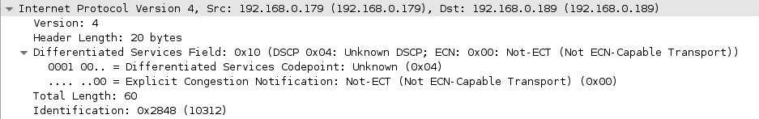

TOS_T3

TOS_T4
Wireshark
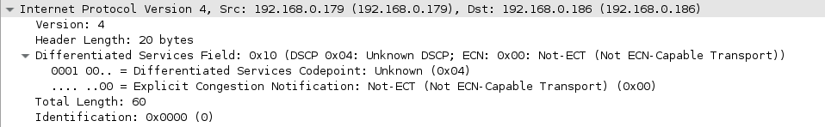

TOS_T5

TOS_T6

TOS_T7

TOS_T8

NAE_T1
Hping3
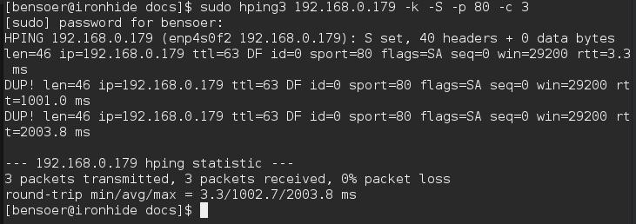

NAE_T2
Accounting Table Before
Hping3
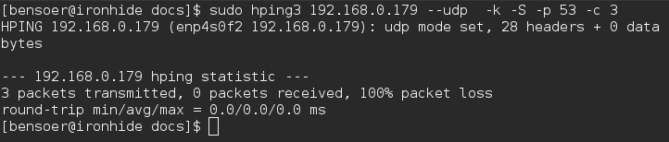
Accounting Table After

IE_T1
Test was executed by loading a page hosted on the internal host in Google Chrome. After the initial SYN by the browser, the SYN ACK and ACK packets fall under the is_established chain
Accounting Table Before
Accounting Table After

IE_T2
From this test we can see that UDP traffic being stateless does not easily fall under being established. We can see from before and after that is_established packets do not change. Instead we can see them being redirect to the is_new_and_established chain from the udp_traffic chain
Accounting Table Before
Accounting Table After
Where Traffic Actualy Went
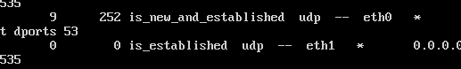

OI_T1
Results were successful in that the packets were blocked. But they were blocked by being dropped in the INPUT chain of the gateway. Rules put in the FORWARD chain are never used. The rules added in the INPUT chain are soley for accounting of this test.
Accounting Table Before
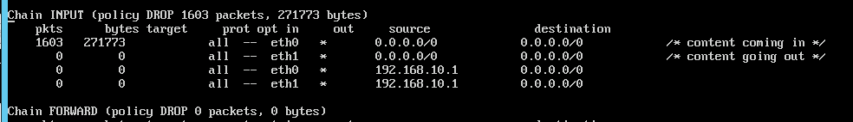
Hping3
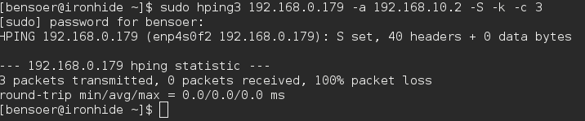
Accounting Table After
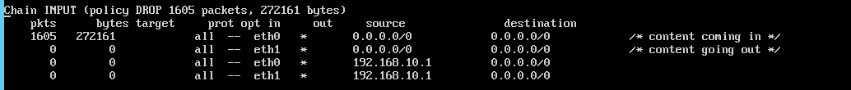

OI_T2
Results were successful in that the packets were blocked. But they were blocked by being dropped in the INPUT chain of the gateway. Rules put in the FORWARD chain are never used. The rules added in the INPUT chain are soley for accounting of this test.
Accounting Table Before
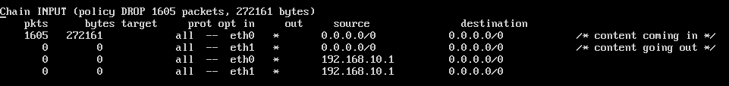
Hping3
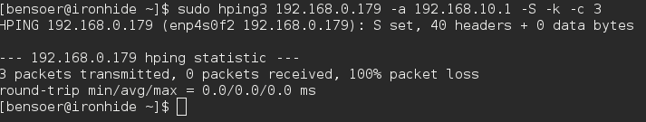
Accounting Table After
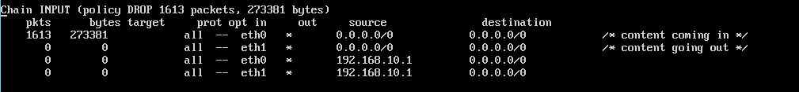

SYNFIN_T1
Hping3
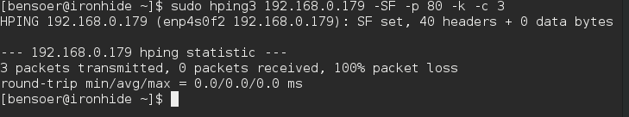

TELNET_T1
Hping3
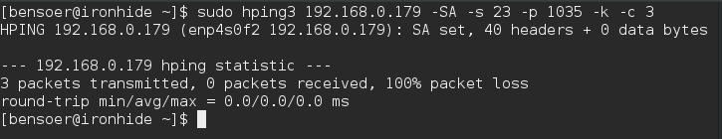

TELNET_T2
Hping3
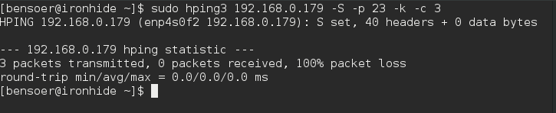

TELNET_T3
Hping3
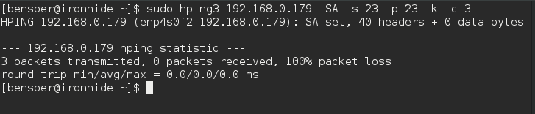

EXPDR_T1
Hping3
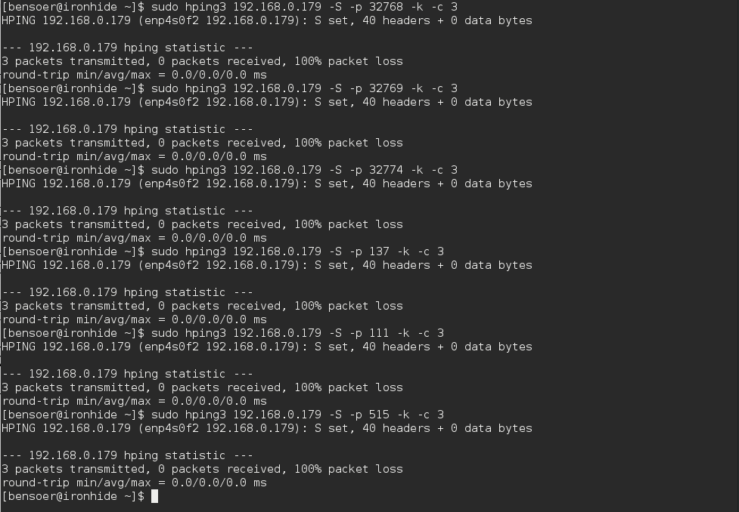

EXPDR_T2
Accounting Table Before
Hping3
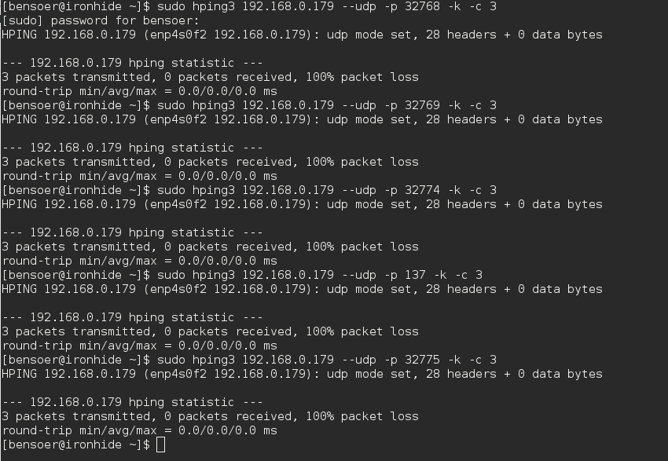
Accounting Table After

TCP_T3
Hping3
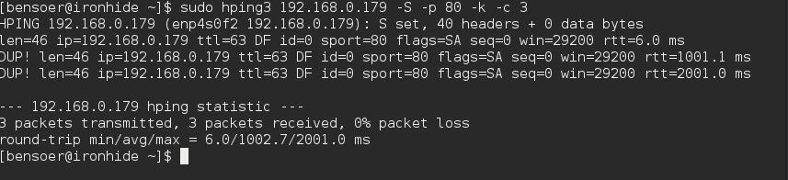

TCP_T4
Hping3
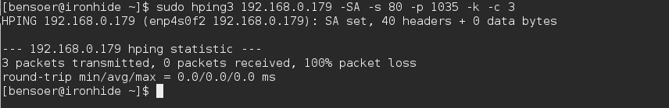

UDP_T3
Accounting Table Before
Hping3
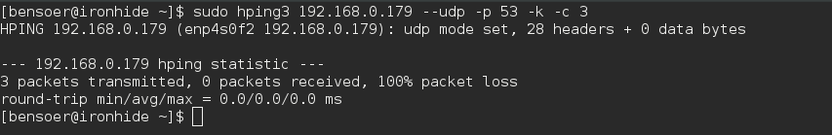
Accounting Table After

UDP_T4
Accounting Table Before
Hping3
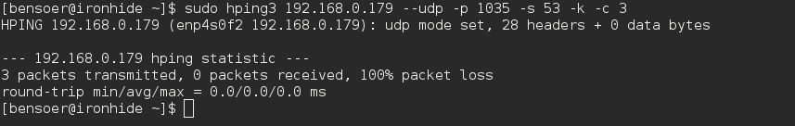
Accounting Table After

ICMP_T1
Below shows a valid ICMP and an invalid ICMP being sent through. These can be set in the firewall script. For this test ICMP type 8 (echo) are allowed through, but ICMP type 0 (echo response) is not allowed through. This being because echo response is what comes back, not what goes through
Hping3
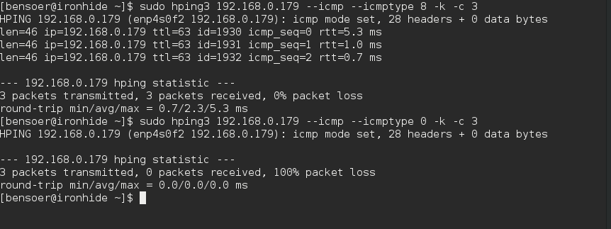

Outbound Tests

