Gateway Firewall
Ben Soer
Sean Hodgkins

COMP 8006
BTECH Set 6D

Table of Contents
Network Diagram 3
Flow Diagrams 3
Forward Chain 3

Network Diagram
Below is a high level diagram of what this assignment is accomplishing. The firewall is installed on a gateway router which redirects all traffic to the workstation behind in. From the internet side, the firewall is hidden and users are unaware that the IP they are connecting to, is not the IP of the actual workstation their resources are on. The workstation aswell is unaware of the changes being made in its traffic to disguise it to the internet.
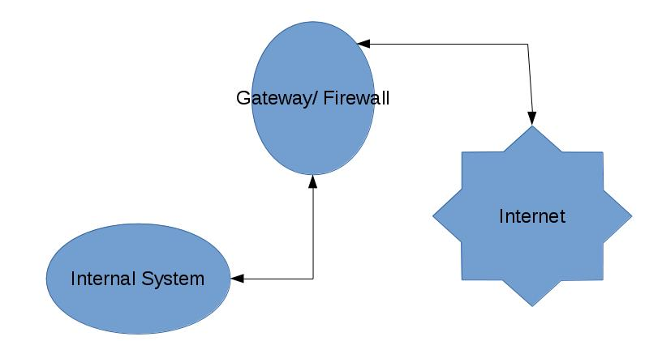

Flow Diagrams
The following diagrams show how packets flow through the firewalls FORWARD chain. Because no data is directed to or form the actual firewall machine, all content on the INPUT and OUTPUT chains is blocked. Data only traverses through the FORWARD chain while being transferred from the interface connected to the internet and the interface connected to the internal system. During the traversal, the NAT table is used to translate the destination and source addresses of packets from the external IP to the internal IP. Due to the simplicity and minimal rules added to the NAT table, the traversal of that table is not described in the documentation

Forward Chain
From the FORWARD chain a number of explicit checks are made initialy as to whether the packets should be immediately dropped. This includes checking for packets with SYN and FIN flags enabled, telnet packets and a number of specific ports that are blocked from use. From here the traffic is split up based on whether it is udp, tcp or icmp. Each is sent to its own user chain to check for specifics in direction, valid ports and other criteria. From this point, depending on what criteria the packet meets, the packet will then be forwarded to the is_new_and_established or the is_established user chains which check the packets state information as to whether the pack can be a NEW or ESTABLISHED or can only be ESTABLISHED. Upon matching criteria, the packet is then sent out the appropriate interface.

(See Next Page For Image)
