A3 – IPS Testing Documentation
Ben Soer
A00843110

Table of Contents
Unit Tests 3
Summary 3
Results 5
ArgParcer Unit Tests 5
RecordManager Unit Tests 5
Record Unit Tests 6
ServiceChecker Unit Tests 6
Settings Unit Tests 6
General Tests 6
Summary 6

Unit Tests
All unit tests can be examined closer by looking at the appropriate unit test class located in the tests folder. For example to find unit tests for the ArgParcer class, look in the ArgParcerTest.php file. Each test will be labeled with a comment matching the test numbers listed below.
Results will be listed below with screenshots of the results form execution by PHPUnit

Summary
Test # | Class | Test Procedure | Parameters | Expected Outcome | Actual Outcome
AP_UT1 | ArgParcer | Can format arguments | Array("programname", "-a", "value1", "-b", "value2"); | Associative array is returned not empty and has keys “-a” and “-b” | Associative array is returned not empty and has keys “-a” and “-b”
AP_UT2 | ArgParcer | Can format an empty array of arguments | Array() | Returned value should be an empty array | Returned value is an empty array
AP_UT3 | ArgParcer | Can create an instance | N/A | An instance of ArgParcer is returned | An instance of ArgParcer is returned
AP_UT4 | ArgParcer | Can get a key from the instance from the given formatted array | Array("programname", "-a", "value1", "-b", "value2"); | Getting a value with key “-a” will return “value1” and a key of “-b” will return “value2” | Getting a value with key “-a” returns “value1” and a key of “-b” returns “value2”
RM_UT1 | RecordManager | Can create an instance | N/A | Instance will create an instance of “RecordManager” | Instantiation creates an instance of “RecordManager”
RM_UT2 | RecordManager | Can add a record | Generic record | Record Manager will not be empty and the record manager's array will have our record in it | Record Manager is not be empty and the record manager's array has our record in it
RM_UT3 | RecordManager | Can delete a record | Generic record | Deleting a record will have the RecordManagers array empty | Deleting a record has the RecordManagers array empty
RM_UT4 | RecordManager | Can update a record | Generic record | Updating a record will update a record in the record manager with our changes | Updating a record will update a record in the record manager with our changes
RM_UT5 | RecordManager | Can get record if exists | Fetching a generic record that does exist | Returned value will be an instance of “Record” | Returned value is an instance of “Record”
RM_UT6 | RecordManager | Can get record if exists | Fetching a generic record that does not exist | Returned value will be null | Returned value is null
RM_UT7 | RecordManager | Record with attempts under threshold or with identicle timespread can be detected | Determine if a record is offending with identical dates for offence times | Return value will be true as this is an offence | Return value is true
RM_UT8 | RecordManager | Record with attempts not under threshold will not be detected as a regular offence | Determine if a record is offending with 2 identical and 1 far future offence time | Return value will be false as this is not an offence | Return value is false
R_UT1 | Record | Instantiate record | N/A | Will create instance of “Record” | Created an instance of “Record”
R_UT2 | Record | Check Default Attributes | N/A | Default Attributes will be as expected when hardcoded in Record.php file | Default Attributes are as expected
R_UT3 | Record | Check Changing Default Attributes |  | Changes will work | Changes work
SC_UT1 | ServiceChecker |  |  | Can identify valid SSH record | Can identify valid SSH record
SC_UT2 | ServiceChecker |  |  | Can identify invalid SSH record | Can identify invalid SSH record
S_UT1 | Settings | Check default attributes | N/A | Default attributes are equal to those hardcoded in the Settings.php file | Default attributes are equal to those hardcoded in the Settings.php file
S_UT2 | Settings | Check instantiate creates instance of “Settings” | N/A | Creates an instance of “Settings” | Creates an instance of “Settings”
S_UT3 | Settings | Check changing settings works | N/A | Altered settings are still their values when changed | Altered settings are still their values when changed

Results

ArgParcer Unit Tests

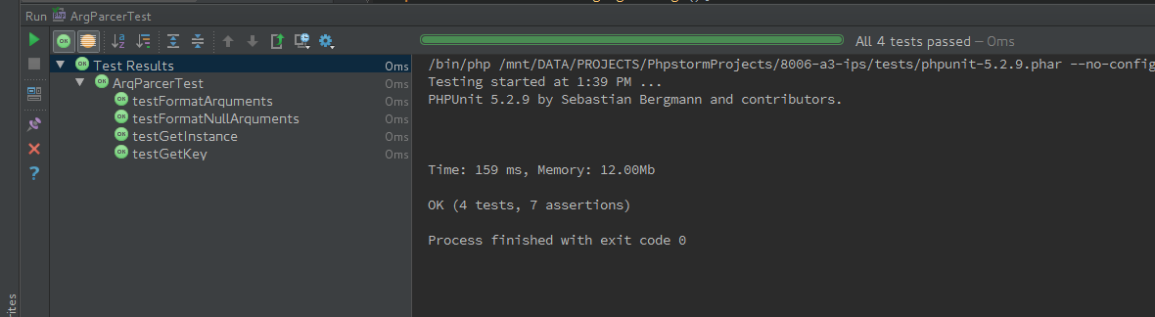
RecordManager Unit Tests
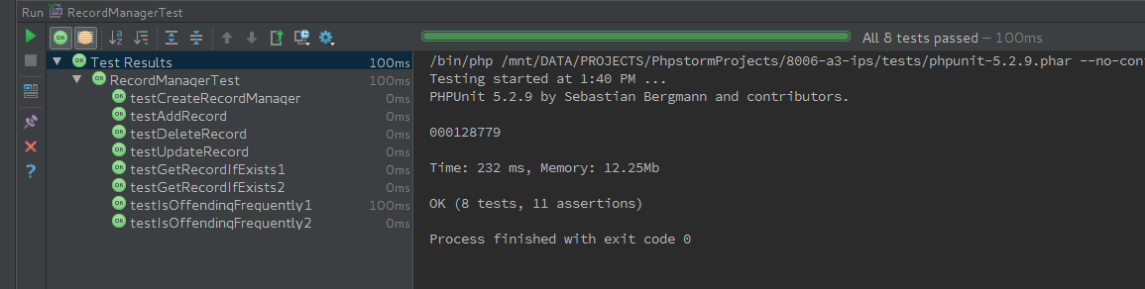

Record Unit Tests

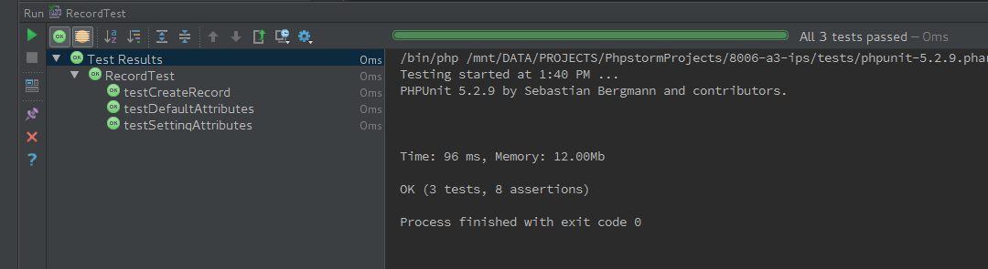
ServiceChecker Unit Tests

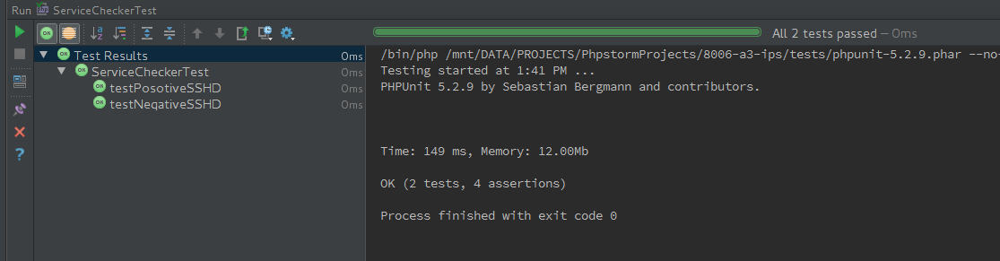
Settings Unit Tests
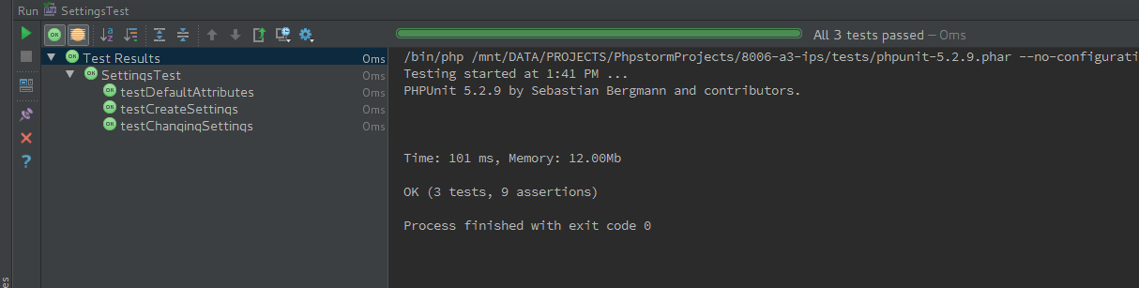

General Tests

Summary
Test # | Class | Test Procedure | Parameters | Expected Outcome | Actual Outcome
SSH_T1 |  | Fail SSH login 3 times | Block has no release time. Read from /var/log/secure | Ips blocks after reading it out of logs | Ips blocks after reading it out of logs
SSH_T2 |  | Fail SSH Login 3 times, wait 3 minutes. Run again | Read from /var/log/secure | Ips blocks after reading it out of logs and then unblocks after 3 minutes | Ips blocks after reading it out of logs and then unblocks after 3 minutes
SSH_T3 |  | 3 times, wait 3minutes. Run again | /var/log/messages | Ips blocks after reading it out of logs | Ips blocks after reading it out of logs
SSH_T4 |  | 3 times, wait 3minutes. Run again | /var/log/messages | Ips blocks after reading it out of logs and then unblocks after 3 minutes | Ips blocks after reading it out of logs and then unblocks after 3 minutes
G_T1 |  | Fail a login | Block has no release time. Read from /var/log/messages | Block should never be released | Block is never released
TELNET_T1 |  | Fail Telnet Login 3 times | Block has no release time. Read from /var/log/messages | Block should never be released | Block is never released
TELNET_T2 |  | Fail Telnet Login 3 times, wait 3 minutes |  | Ips blocks after reading it out of logs and then unblocks after 3 minutes | Ips blocks after reading it out of logs and then unblocks after 3 minutes
G_T2 |  | Change Settings | -tl 3 -al 3 -ld /var/log/messages | Ips time limit is set to 3 min, attempt limit is set to 3 and log dir is set to the messages file | Ips time limit is set to 3 min, attempt limit is set to 3 and log dir is set to the messages file

Results

SSH_T1
Blocking Found
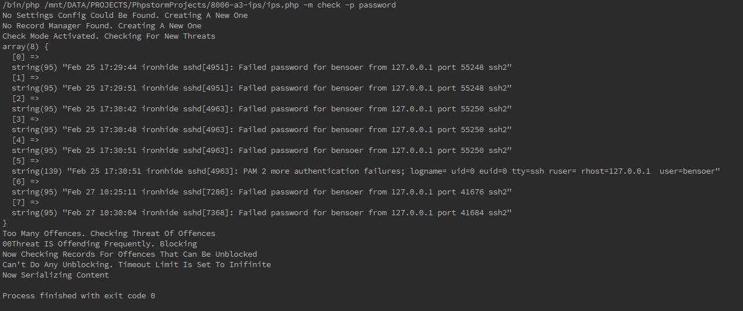

SSH_T2
Blocking Found

Blocking Released
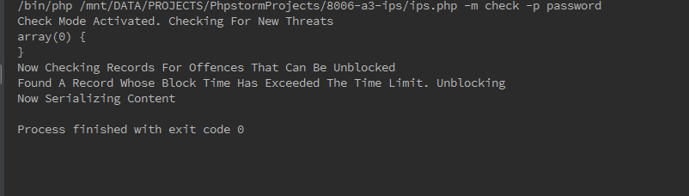

SSH_T3
Blocking Found
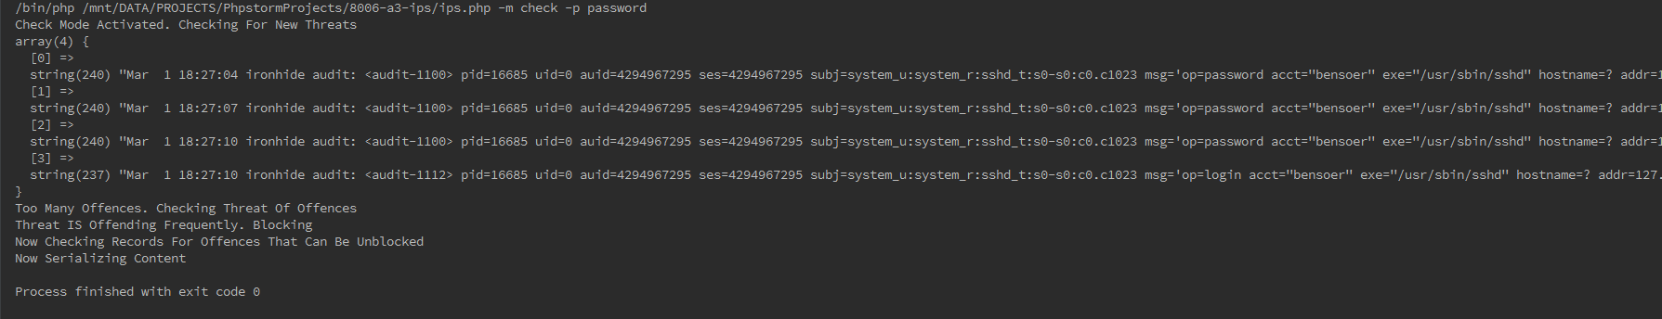

SSH_T4
Blocking Found
Blocking Released
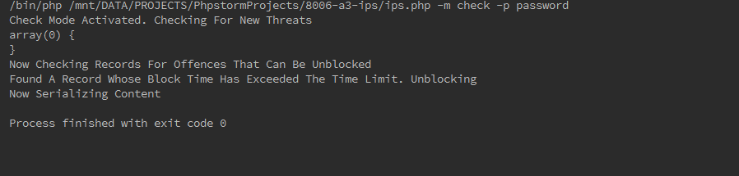

G_T1
Block with No Release Time
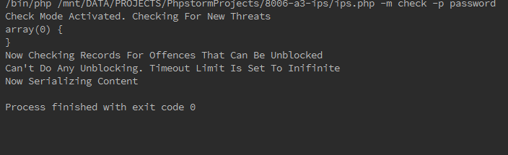

TELNET_T1
Block Found
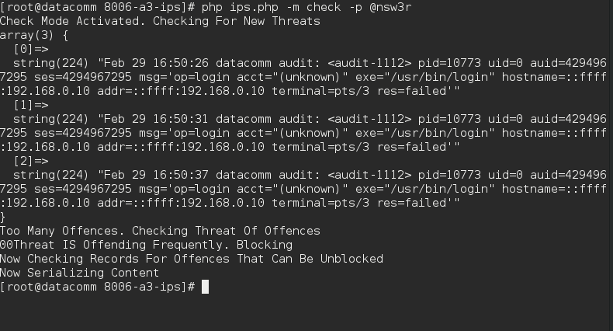

TELNET_T2
Block Found
Blocking Released
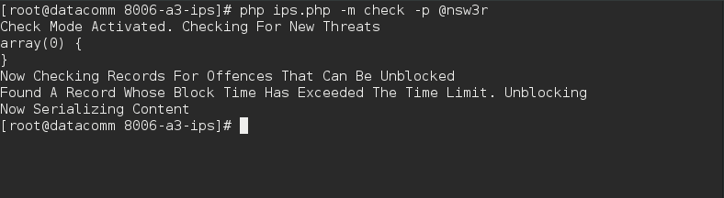

G_T2
Settings Changed
