A3 – IPS
Ben Soer
A00843110

Table of Contents
Class Diagram 3
Finite State Machines 4
Data Flow Diagram 5
Pseudocode 6
Ips.php (Program Main Entry) 6
main(argc, argv) 6
LogManager.php 6
findNewLoginAttempts(timeStamp = null) 6
isGreaterThenDate(thresholdDate, dateInQuestion) 6
getTimeStampOfLastEntry() 7
getAllEntries() 7
createRecordOfEntry(entry) 7
NetfilterManager.php 7
generateBlockingRule(ip, protocol) 7
generateUnBlockingRule(ip, protocol) 7
block(ip,protocol) 7
unblock(ip, protocol) 7
ServiceChecker.php 7
telnet(logEntry) 7
sshd(logEntry) 8
ArgParcer.php 8
formatArguments(Array argv) 8
getInstance(Array formattedArguments) 8
getValue(key) 8
Record.php 8
createDateFromEntry(entry) 8
RecordManager.php 8
addRecord(Record record) 8
getRecordIfExists(ip, service) 8
updateRecord(ip, service, Record record) 8
deleteRecord(Record toBeDeletedRecord) 9
getAllRecords() 9
getTotalMinutesFromDif(DateInterval diff) 9
isOffendingFrequently(Record record, offenceThreshold = 3) 9
SSHRecord.php (extends Record) 9
createFromMessageLog(logEntry) 9
createFromSecureLog(logEntry) 9
TelnetRecord.php (extends Record) 10
createFromMessageLog(logEntry) 10
createFromSecureLog(logEntry) 10

Class Diagram
Original image can be found under /docs/imgs/IPSClassDiagram.png
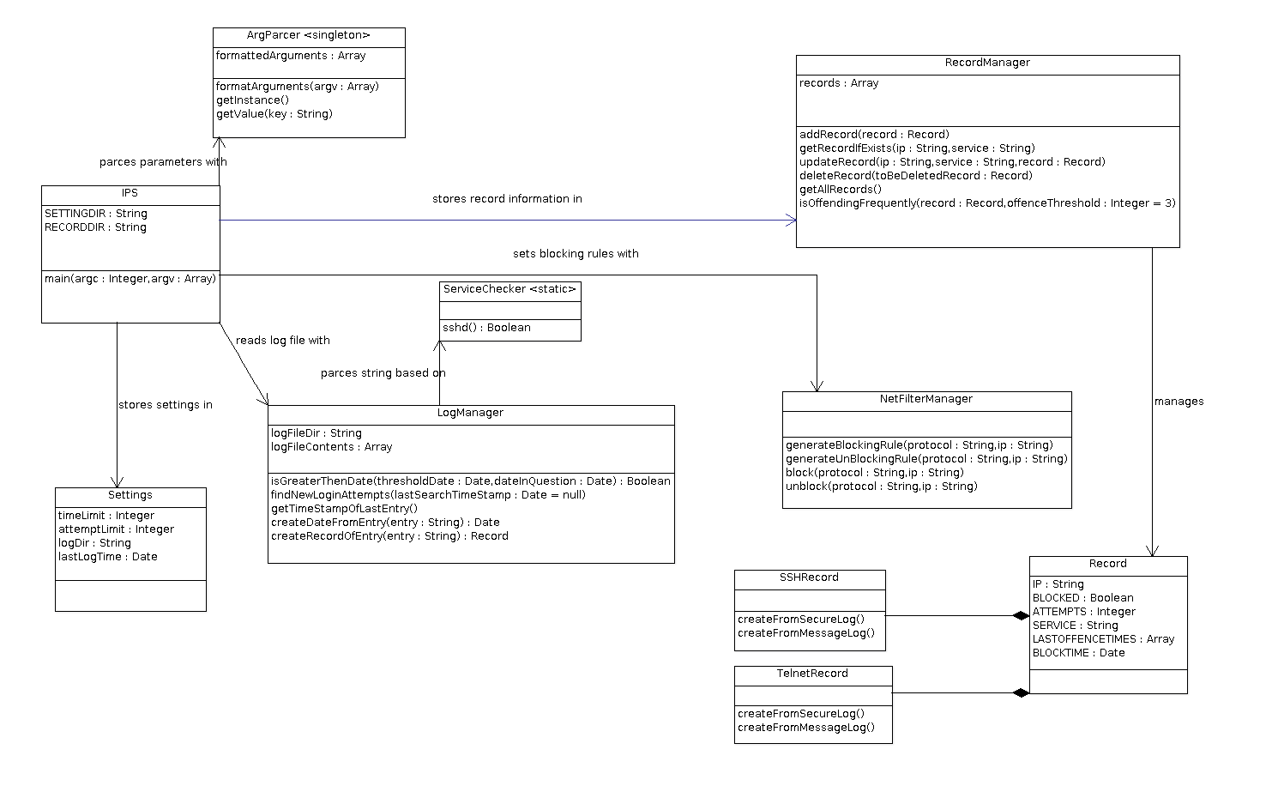

Finite State Machines
Original Image can be found under /docs/imgs/IPSStateChartDiagram.png
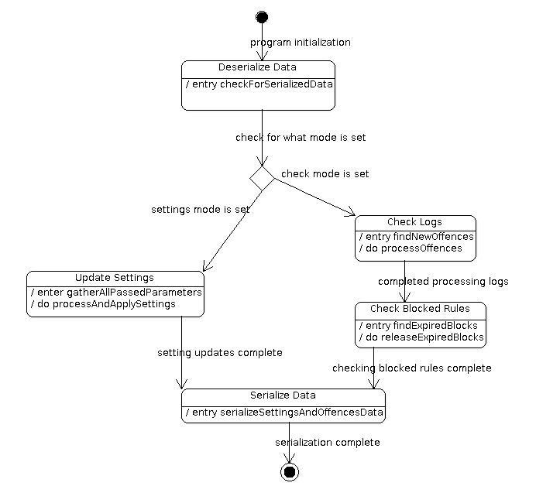

Data Flow Diagram
Original Image can be found in /docs/imgs/DataFlowDiagram.jpg
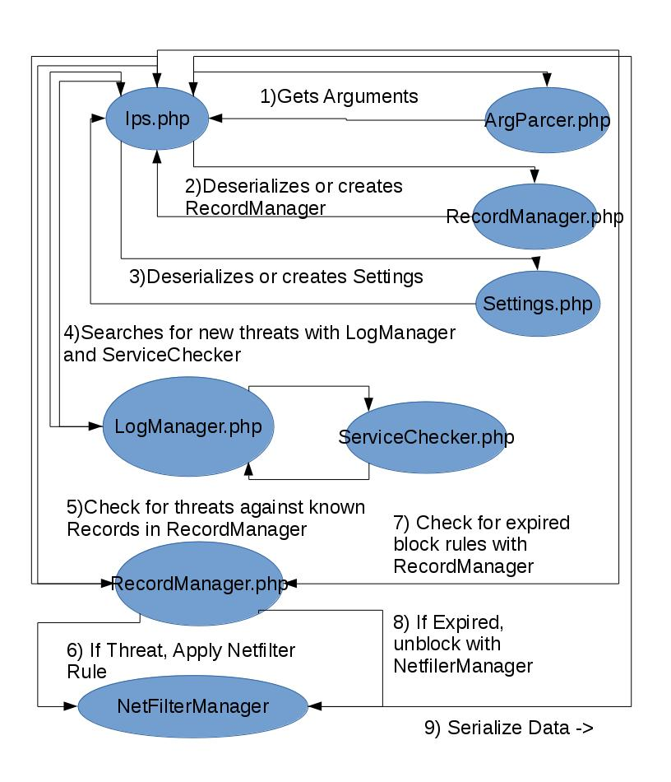

Pseudocode

Ips.php (Program Main Entry)

main(argc, argv)
- Get Command Line Arguments
- Deserialize Settings and RecordManager. If Not Existend Create New Ones
- Get mode from Command Line Arguments
- If check mode
  - Get list of threats from logs
  - Check logs against records if they are new or exist already
    - If exist increment how many offences the record has made & check if should be blocked
      - If should be blocked, block with netfiler
    - If not exists add the record with this being its first offence
  - Check Records for any blocked records
    - If blocked, check if time has expired
    - If time has expired unblock and delete the record

LogManager.php

findNewLoginAttempts(timeStamp = null)
- If timeStamp is null
  - Search logs from the beginning
  - If valid LoginAttempt, add to list of new login attempts
- If timeStamp is not null
  - Search logs only from after timeStamp point
  - If valid LoginAttempt, add to list of new login attempts
- return loginAttempts

isGreaterThenDate(thresholdDate, dateInQuestion)
- Format dateInQuestion into a date object
- Compare if dateInQuestion is greater (newer) then the thresholdDate
- return result

getTimeStampOfLastEntry()
- Search log for last entry
- Parce out and return timestamp as a date object

getAllEntries()
- Return All log entries parsed from the log file

createRecordOfEntry(entry)
- Determine type of log entry / what service the entry belongs to
- Generate a Record object of that service type

NetfilterManager.php

generateBlockingRule(ip, protocol)
- Create iptables command as a string to block the passed ip and protocol

generateUnBlockingRule(ip, protocol)
- Create iptables command as a string to unblock the passed ip and protocol

block(ip,protocol)
- Generate blocking iptables command for given ip and protocol
- Execute the command

unblock(ip, protocol)
- Generate unblocking iptables command for given ip and protocol
- Execute the command

ServiceChecker.php

telnet(logEntry)
- Parse logEntry to determine if it is a telnet failure log entry. Return true or false

sshd(logEntry)
- Parse logEntry to determine if it is an sshd failure log entry. Return true or false

ArgParcer.php

formatArguments(Array argv)
- Reformat the single argv array containing initialization parameters into an associative array where the key is the flag and the value is the value to the flag
- Return the associative array

getInstance(Array formattedArguments)
- Create singleton instance of ArgParcer. Do not set formattedArguments if an instance already exists. Return the instance

getValue(key)
- Get the value belonging to the key in the formattedArguments associative array
- If the value or key does not exist, return null

Record.php

createDateFromEntry(entry)
- Parse out date stamp in log entry
- convert to a date object and return

RecordManager.php

addRecord(Record record)
- Add the passed in record to the array storing all records

getRecordIfExists(ip, service)
- Search through all records for record matching ip and service
- If does not exist, return null

updateRecord(ip, service, Record record)
- Search through all records for record matching ip and service
- If match is found, replace entry in the array with passed in record object

deleteRecord(Record toBeDeletedRecord)
- Search through all records for record matching ip and service in the toBeDeletedRecord Record.
- If record is found, delete it

getAllRecords()
- Return all records stored in the array of the RecordManager

getTotalMinutesFromDif(DateInterval diff)
- Calculate total minutes from diff object. Diff object stores count of years, months, days, hours seperatly and not cumulatively on their own, thus to get a total amount of minutes a quick calculation of minutes in the years, months, days, hours are also needed
- Return totalMinutes

isOffendingFrequently(Record record, offenceThreshold = 3)
- Get all of the interval times between each offense that has occurred for this record
- Determine if any of the intervals are greater then the offenceThreshold. If there is one, then there is a large enough gap between offenses that this is not likely an attack.
- Determine if the interval times are identical and thus meaning a bot could be calling but just extremely slowly.
- Return true if step 1 or 2 are true, otherwise false

SSHRecord.php (extends Record)

createFromMessageLog(logEntry)
- Parce out data from log entry assuming it has come from the /var/log/message file and set the record information for it

createFromSecureLog(logEntry)
- Parce out data from log entry assuming it has come from the /var/log/secure file and set the record information for it

TelnetRecord.php (extends Record)

createFromMessageLog(logEntry)
- Parce out data from log entry assuming it has come from the /var/log/message file and set the record information for it

createFromSecureLog(logEntry)
- Parce out data from log entry assuming it has come from the /var/log/secure file and set the record information for it

