A1 – Covert Sockets
Ben Soer
A00843110

Table of Contents
Finite State Machines 3
Covert Socket Application 3
Class Diagram 4
Covert Socket Application 4
Pseudocode 4
main.cpp 4
main() 4
usage(char *programname) 5
host_convert(const char *hostname) 5
IEndpoint.cpp 5
in_chksum(unsigned short *ptr, int nbytes) 5
EndpointFactory.cpp 5
getEndpoint(int isServer) 5
ServerEndpoint.cpp 5
setConfiguration(Configuration configuration) 5
execute() 6
ClientEndpoint.cpp 6
setConfiguration(Configuration configuration) 6
execute() 6

Finite State Machines

Covert Socket Application
See images/CovertSocketStateMachine.jpg for original image
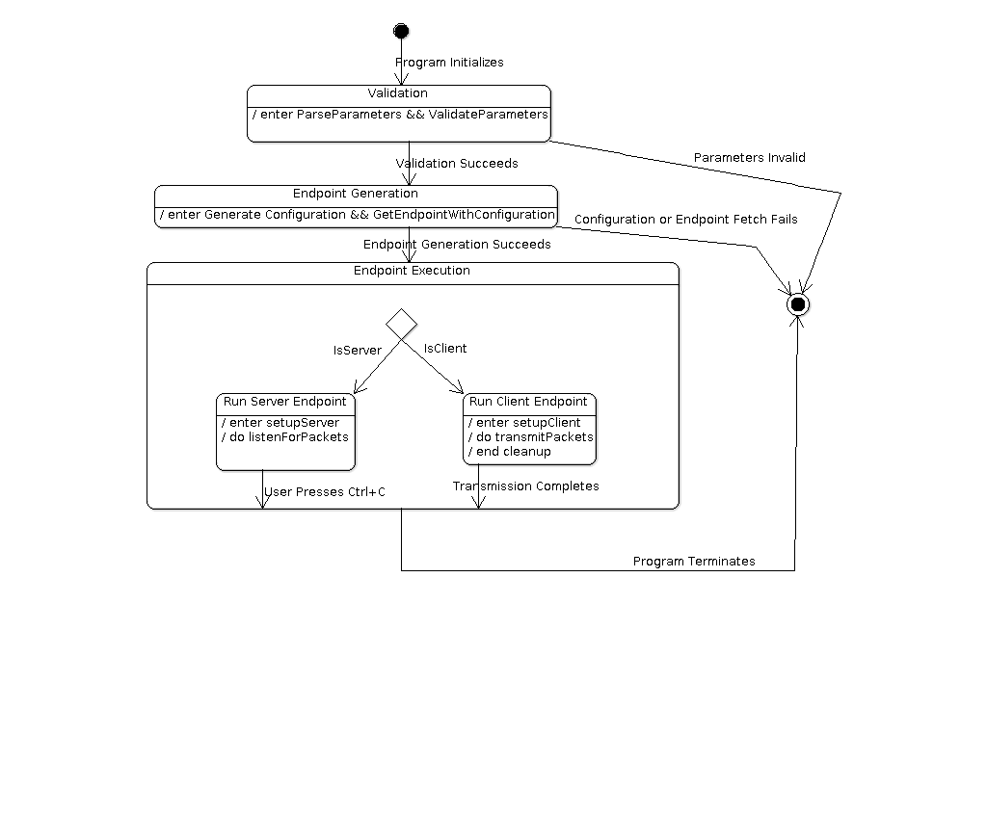

Class Diagram

Covert Socket Application
See imgs/CoverSocketClassDiagram.jpg for original image
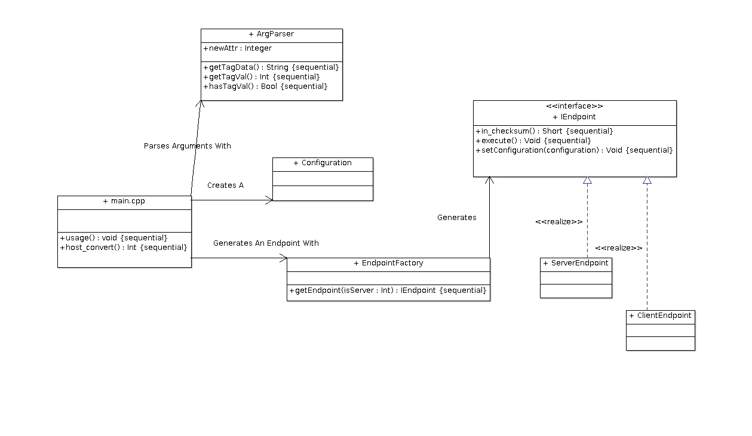

Pseudocode

main.cpp

main()
- Check Running as Admin/Root. Check Parameters passed. Call usage() if no parameters passed
- Create ArgParcer – start parsing arguments
- Run validation on arguments
- Create Configuration struct and store arguments into it
- Create EndpointFactory – get an Endpoint
  - If Error Getting Endpoint Abort
- Execute endpoint
- Cleanup and Terminate

usage(char *programname)
- Print program usage along with examples

host_convert(const char *hostname)
- Make DNS request to resolve hostname if name instead of IP is given
  - If Error Resolving. Abort. Else Return result adress

IEndpoint.cpp

in_chksum(unsigned short *ptr, int nbytes)
- Create a checksum based on ptr data and return its value

EndpointFactory.cpp

getEndpoint(int isServer)
- If Server == 0. This is a Client.
  - Validate configuration object for client setup
  - Determine and print mode being used
  - Create ClientEndpoint
  - Return ClientEndpoint object
- Else. This Is A Server
  - Validate configuration object for server setup
  - Determine decoding mode being used
  - Create ServerEndpoint
  - Return ServerEndpoint object

ServerEndpoint.cpp

setConfiguration(Configuration configuration)
- Set the configuration object to be used during execution of the server

execute()
- Initialize packet structures and variables
- Configure file writing for received and parsed packets
- Infinite While Loop:
  - receive packet
  - parse out appropriate header based on configuration object settings
  - print to screen
  - write to file

ClientEndpoint.cpp

setConfiguration(Configuration configuration)
- Set configuration object to be used during execution of client

execute()
- Initialize packet structures and variables
- Configure file reading for packets to be sent. If error opening file abort
- While there are characters to read in the file:
  - Build packet based on configuration object
  - Send packet
  - Print character that was sent

