A2 – Steganography
Ben Soer
A00843110

Table of Contents
Class Diagrams 3
Finite State Machines 3
Pseudocode 4
stego.py (Program Main Entry) 4
main() 4
printHelp() 4
dcimage.py 4
getImageNameLength() 4
canHoldImage() 4
getPixelAccess() 4
getPilImage() 4
getPilWidth() 4
getPilHeight() 4
getImageName() 5
createNewImage(height, width, savedir) 5
dcutils.py 5
isLargeEnoughImg(carrierImg, dataImg) 5
calculateMaxStorageCapactiy(carrierImg) 5
calculateMaxWidthAndHeight(maxDataBytes) 5
dcstego.py 5
getHeaderInformation() 5
addHeaderInformation(totalDataBytes, totalWidthPixels, totalHeightPixels, fileName) 6
encryptPixel(pixel) 6
decryptPixel(pixel) 6
addDataPixelImage(dcDataImage) 6
parseDataImage() 7
getCarrierImage() 7

Class Diagrams
Original image can be found under imgs/SteganographyClassDiagram.jpg
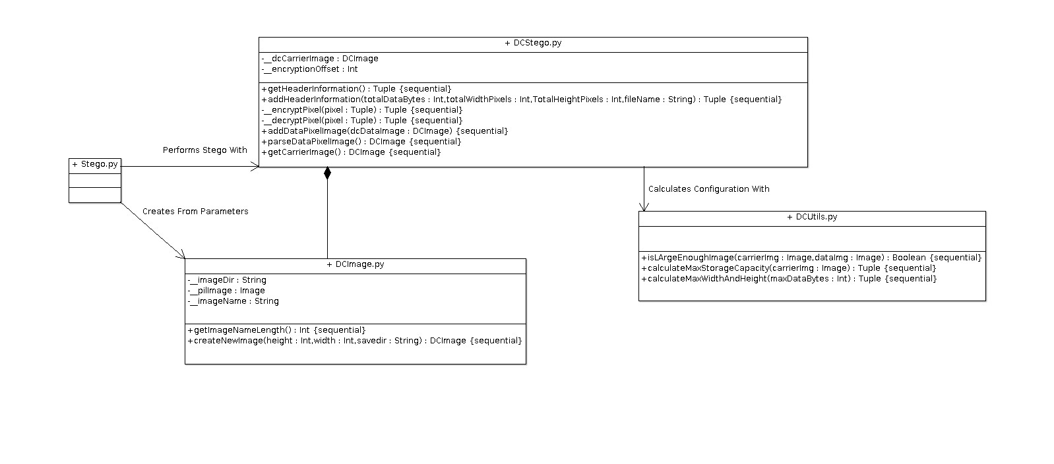

Finite State Machines
Original image can be found under imgs/SteganographyStateMachine.jpg
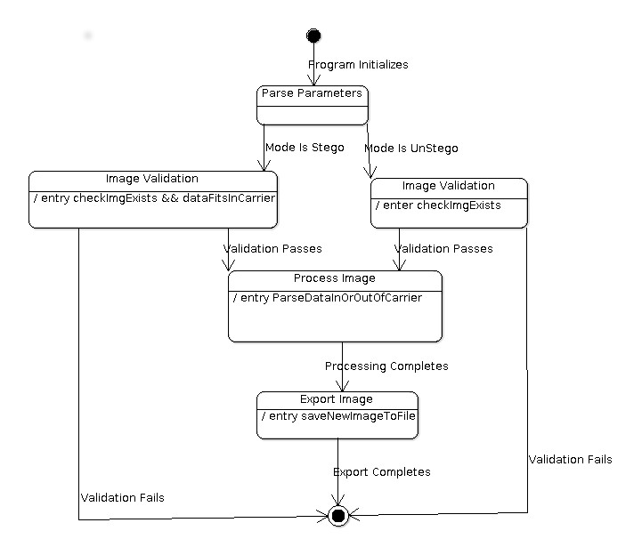

Pseudocode

stego.py (Program Main Entry)

main()
- Parse Command Line Arguments. If none or –HELP call printHelp()
- Determine Mode. If Stego
  - Configure Logging For Stego Procedure
  - Fetch Image. Test If Data Fits Inside Carrier. If not, Terminate
  - Process Image
  - Save Processed image to the file system
  - Cleanup imaging library resources

printHelp()
- Print Help Information

dcimage.py

getImageNameLength()
- Fetch Length of Image

canHoldImage()
- Call DCUtils.isLargeEnough and return results

getPixelAccess()
- Get PixelAccess object from Image object

getPilImage()
- Return the pil image stored as class attribute

getPilWidth()
- Get width of image stored as class attribute

getPilHeight()
- Get height of image stored as class attribute

getImageName()
- Return the file name of the image as stored as the class attribute.

createNewImage(height, width, savedir)
- Create a plain new image using passed height and width
- Save in savedir location
- Close resources
- Create a DCImage object passing savedir to the constructor
- Return the DCImage

dcutils.py

isLargeEnoughImg(carrierImg, dataImg)
- Call DCUtils.calculateMaxStorageCapacity passing the carrierImg
- determine if the maxBytes is larger then the dataImg size in bytes
- Return true or false

calculateMaxStorageCapactiy(carrierImg)
- Calculate max storage capacity of the carrier image in bytes and how many bits it will take to represent that number. Round up as a precaution to give extra space

calculateMaxWidthAndHeight(maxDataBytes)
- Calculate max possible pixels that the image could be based on the maxDataBytes and how many bits it would take to represent that number. Round up as a precaution to give extra space

dcstego.py

getHeaderInformation()
- Determine max storage capacity of the carrier image
- calculate space needed for max storage, width, height and name headers
- parse out max bytes
- parse out height
- parse out width
- parse out file name
- Return index of first data pixel along with all parsed information in a tuple

addHeaderInformation(totalDataBytes, totalWidthPixels, totalHeightPixels, fileName)
- Calculate max storage capacity of carrier image and bits needed to represent that value
- encode max byte size of data image into calculated max space
- calculate max width and number of bits needed to represent that value
- encode width of data image into calculated max width space
- calculate max height and number of bits needed to represent that value
- encode height of data image into calculated max height space
- encode static 30 characters into the image
- Return indexes of where first data bit will go

encryptPixel(pixel)
- Parse out red, blue green values from pixel
- Apply ceasar cipher using offset amount. Correct pixels values if they go out of range
- Put red,blue,green values back into pixel
- return pixel

decryptPixel(pixel)
- Parse out red, blue green values from pixel
- Apply ceasar cipher using offset amount. Correct pixels values if they go out of range
- Put red,blue,green values back into pixel
- return pixel

addDataPixelImage(dcDataImage)
- Calculate width and height of dcDataImage
- Get PixelAccess object of data image
- call addHeaderInformation() passing calculated header data
- loop through data image pixels
  - fetch data pixel
  - parse into red, green, blue
  - loop over red green and blue planes
    - grab 3 carrier pixels. Loop over each red, green, blue plane in carrier pixels
      - grad lsb from data image. Right shifting 0-7 times to get each bit
      - alter carriers lsb to match currently fetched lsb from data image
    - put altered palnes back into appropriate carrier pixels
    - put altered carrier pixels into appropriate carrier pixel position
    - increment by 3 so that next loop will get the next 3 carrier pixels in the carrier image

parseDataImage()
- Calculate width and height of dcDataImage
- Get PixelAccess object of data image
- call getHeaderInformation() returning the data start posiitons, totalDataBytes, width, height and filename
- loop through data pixels height and width
  - parse data pixel
  - create list of all planes in r,g,b order. Loop over all planes
    - get 3 carrier pixel
    - parse out RGB planes of each carrier pixel
    - place each plane in reverse order (pixel3 – pixel1, GRB order) into a list
    - loop through the pixelList
      - left bit shift data int from 0-7 through loop
      - grab lsb from each plane in the list and place into data int.
    - replace plane being used in loop from step 2 with newly generated one in loop
    - increment by 3 to get next 3 carrier image pixels
  - Create new data pixel using updated planes from loop in step 2
  - Insert data pixel into data image being built
- Return data image

getCarrierImage()
- Return the carrier image stored as a class attribute

