A3 – Design Document
Ben Soer
A00843110
Sean Hodgkinson
A00887719

Table of Contents
Class Diagrams 3
Backdoor 3
Client 3
Statechart Diagrams 3
Backdoor 3
Client 4
Pseudocode 4
Common Classes 4
Logger.cpp 4
debug(string message) 4
println(string message) 4
print(string message) 5
error(string message) 5
setDebug(bool state) 5
ArgParcer.h 5
GetTagData(string preTag, char *argArray[], int length) 5
TagExists(string preTag, char *argArray[], int length) 5
GetTagVal(string preTag, char *argArray[], int length) 5
Backdoor 5
Main.cpp 5
main(argc, argv) 5
printUsage() 6
executeCommand(string command) 6
getInterface() 6
shutdownServer(int signo) 6
NetworkMonitor.cpp 7
setCaesarOffset(int offset) 7
getInstance() 7
setListeningPort(string port) 7
packetCallback(u_char * ptrnuill, const struct pcap_pkthdr *pkt_info, const u_char *packet) 7
killListening() 7
listenForTraffic(pcap_if_t * listeningInterface) 7
CovertSocket.cpp 7
setCaesarOffset(int offset) 7
getInstance() 8
setDestinationAddress(string destinationAddress) 8
setSourceAddress(string sourceAddress) 8
constructor() 8
send(string data) 8
csum(unsigned short *ptr, int nbytes) 8
ChangetoDNSNameFormat(char* dns, char*host) 8

Class Diagrams
Note for the below labeling “Backdoor” refers to the component that is installed on the victim machine. The “Client” is then the component installed on the attackers machine which will communicate with the “Backdoor”

Backdoor
Original Image can be found in docs/imgs/BackdoorClassDiagram.png
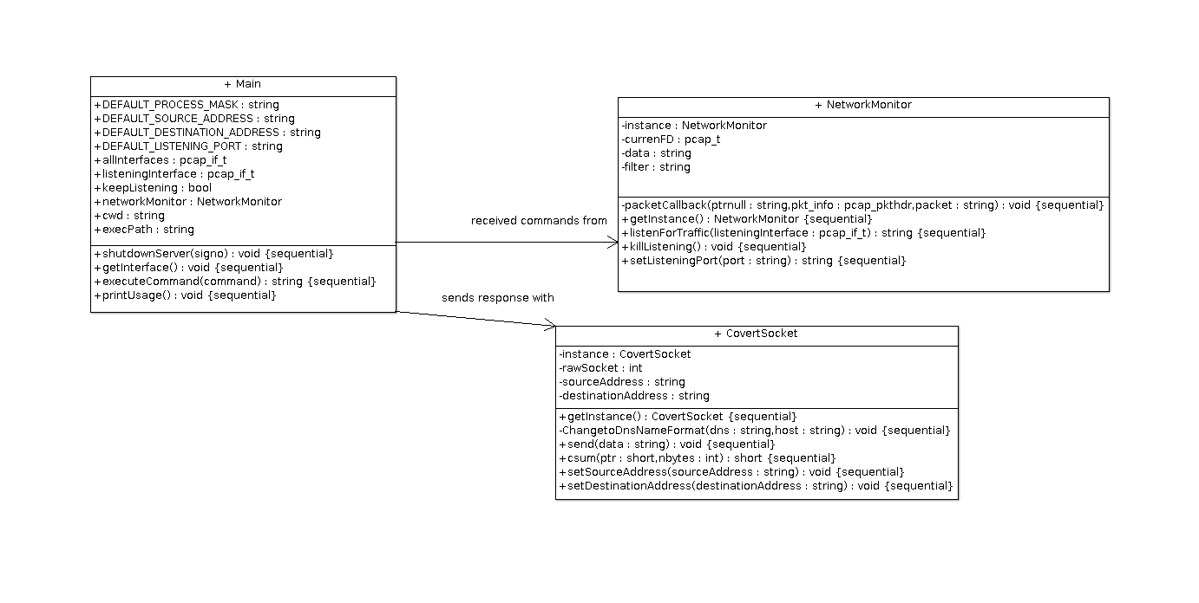

Client

Statechart Diagrams
Note for the below labeling “Backdoor” refers to the component that is installed on the victim machine. The “Client” is then the component installed on the attackers machine which will communicate with the “Backdoor”

Backdoor
Original Image can be found in docs/imgs/BackdoorStatechartDiagram.png
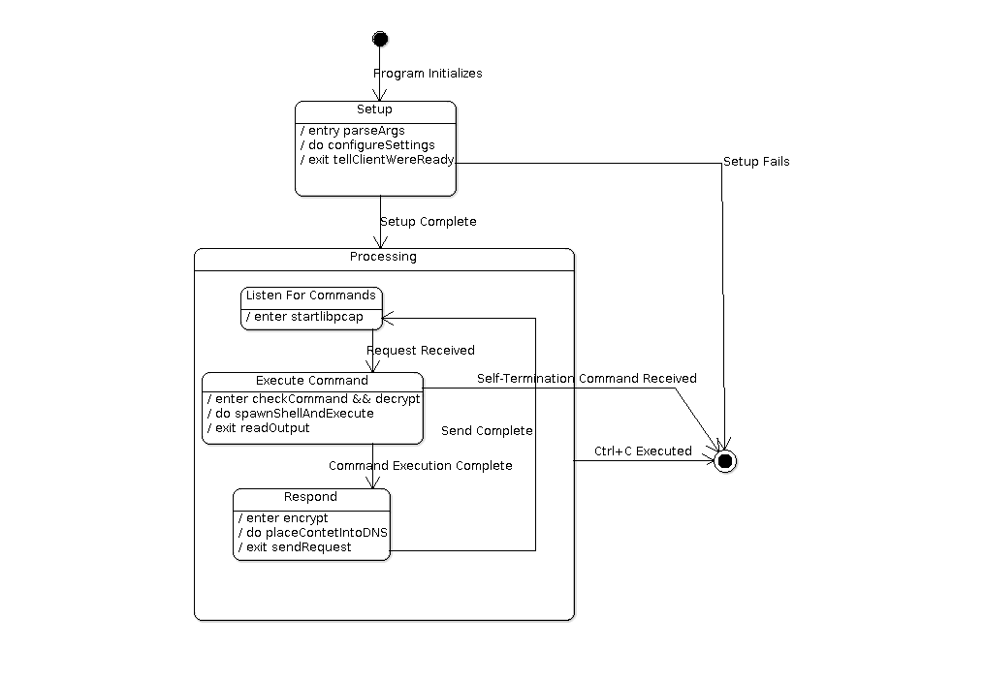

Client

Pseudocode

Common Classes
Common classes are classes that are available in the source code of both the Backdoor and Client. Their use though may or may not necessarily be explicitly used throughout both programs but are available as part of the design.

Logger.cpp

debug(string message)
- IF isDebug is true. Call Logger::println(message) passing message

println(string message)
- Print message to stdout. Include a return character at the end

print(string message)
- Print message to stdout

error(string message)
- Print message to stderr. Include a return character at the end

setDebug(bool state)
- Set isDebug to the value of state

ArgParcer.h

GetTagData(string preTag, char *argArray[], int length)
- Sort through argArray for preTag. IF found, get value in next index ELSE return “-1”
- Return the value in the next index

TagExists(string preTag, char *argArray[], int length)
- Sort through argArray for preTag. IF found, return true, ELSE return false

GetTagVal(string preTag, char *argArray[], int length)
- Sort through argArray for preTag. IF found, get value in next index ELSE return -1
- Cast the value in the next index to int and return that value

Backdoor

Main.cpp

main(argc, argv)
- Parse Parameters. Abort If Any Errors
- Configure Parameters and decide whether to use defaults or not
- Find binaries working directory for setting up self termination
- Mask the program
- Register for Ctrl+C events. shutdownServer(int segno) will handle events
- getInterfaces()
- Configure CovertSocket and NetworkMontior components based on parameters
- Send packet to client informing backdoor is ready
- While Loop. IF keepListening :
  - NetworkMonitor→listenForTraffic(listeningInterface)
  - Check response is not -1. IF -1 terminate
  - IF keepListening executeCommand() ELSE break
  - IF keepListening CovertSocket→send(response) ELSE break
- Free all resources used in loop
- return 0

printUsage()
- Print usage information

executeCommand(string command)
- Initiate variables and strucutres and prepare command for executiong
- Check if command is ‘killurself’ or contains ‘cd’
  - IF command is ‘killurself’:
    - Delete binary
    - call shutdownServer()
    - return empty string
  - IF command contains ‘cd’:
    - Parse out cd parameters and make call to chdir() instead
    - Change command to ‘pwd’
- Execute command in subshell
- Read out response
- return response

getInterface()
- Initialize strucutres
- Get all network interfaces. Set global ‘allInterfaces’ to this value
- Loop through interfaces and find one named ‘all’. Set global ‘interface’ to this value
- return true IF ‘all’ interface found ELSE false

shutdownServer(int signo)
- Set keepListening to false
- call NetworkMonitor->killListening()

NetworkMonitor.cpp

setCaesarOffset(int offset)
- Set the caesarOffset variable to the passed in offset

getInstance()
- IF instance already exists, return it ELSE create new instance of NetworkMonitor
- return NetworkMonitor instance

setListeningPort(string port)
- Append port string value to libpcap filter “udp dst port” + port

packetCallback(u_char * ptrnuill, const struct pcap_pkthdr *pkt_info, const u_char *packet)
- Parse structures from packet
- Parse payload out of packet and set data to it
- IF caesarOffset != -1 (meaning no encryption) then decrypt this payload using the offset
- call NetworkMonitor→killListening() to make listenForTraffic() return

killListening()
- IF a raw socket has been created to be listened on then call pcap_breakloop to stop libpcap from continueing to listened

listenForTraffic(pcap_if_t * listeningInterface)
- Fetch network information using pcap_lookupnet
- Open raw socket on network using pcap_open_live. Set network to promisc mode
- Compile and set pcap filter. IF errors return “-1”
- call pcap_loop() setting NetworkMonitor→packetCallback() as the handler. This call will then hang until pcap_breakloop() is called

CovertSocket.cpp

setCaesarOffset(int offset)
- Set the caesarOffset variable to the passed in offset

getInstance()
- IF instance does not exist create a new instance of CovertSocket. ELSE return the instance
- return the new instance of CovertSocket

setDestinationAddress(string destinationAddress)
- Set destinationAddress attribute to destinationAddress

setSourceAddress(string sourceAddress)
- Set sourceAddress attribute to sourceAddress

constructor()
- Create raw socket and set instance rawSocket to it
- set REUSEADDR on socket
- set IP_HDRINCL on socket

send(string data)
- Create structures for bulding DNS packet
- Create destination address sockaddr_in
- Set IP headers
- Set UDP headers
- Set Pseudoheader
- Generate checksum with pseudoheader and set UDP checksum
- Set DNS headers
- Append data to packet. IF caesarOffset != -1 (meaning no encryption) then Encrypt the payload
- Send raw packet out rawSocket

csum(unsigned short *ptr, int nbytes)
- Generate checksum

ChangetoDNSNameFormat(char* dns, char*host)
- Reformat string into DNS format

