A4 – Design Document
Ben Soer
A00843110

Table of Contents
Class Diagrams 3
ARP Poison 3
DNS Spoof 3
Statechart Diagrams 4
ARP Poison 4
DNS Spoof 5
Pseudocode 5
ARP Poison 5
arppoison.py 5
Main() 5
parseArg(args, key) 6
howTo() 6
DNS Spoof 6
Logger.cpp 6
debug(string message) 6
println(string message) 6
print(string message) 6
error(string message) 6
setDebug(bool state) 6
ArgParcer.h 7
GetTagData(string preTag, char *argArray[], int length) 7
GetTagVal(string preTrag, char *argArray[], int length) 7
TagExists(string preTrag, char*argArray[], int length) 7
Main.cpp 7
shutdownServer(int signo) 7
getInterface() 7
printUsage() 7
main(int argc, char * argv[]) 7
NetworkMonitor.cpp 8
NetworkMonitor() 8
getInstance() 8
setFilter(string filter) 8
packetCallback(u_char *ptrnull, const struct pcakpkt_hdr *pkt_info, const u_char *packet) 8
killListening() 8
listenForTraffic(pcap_it_t * listeningInterface) 8
csum(unsigned short *ptr, int nbytes) 9

Class Diagrams

ARP Poison
Original image can be found under imgs/ARPPoisonClassDiagram.png

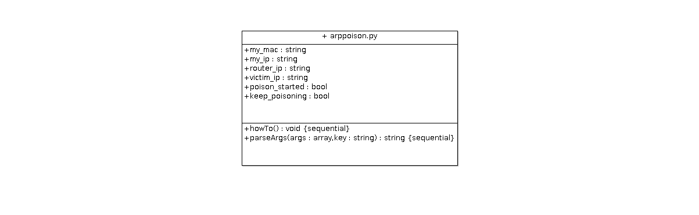
DNS Spoof
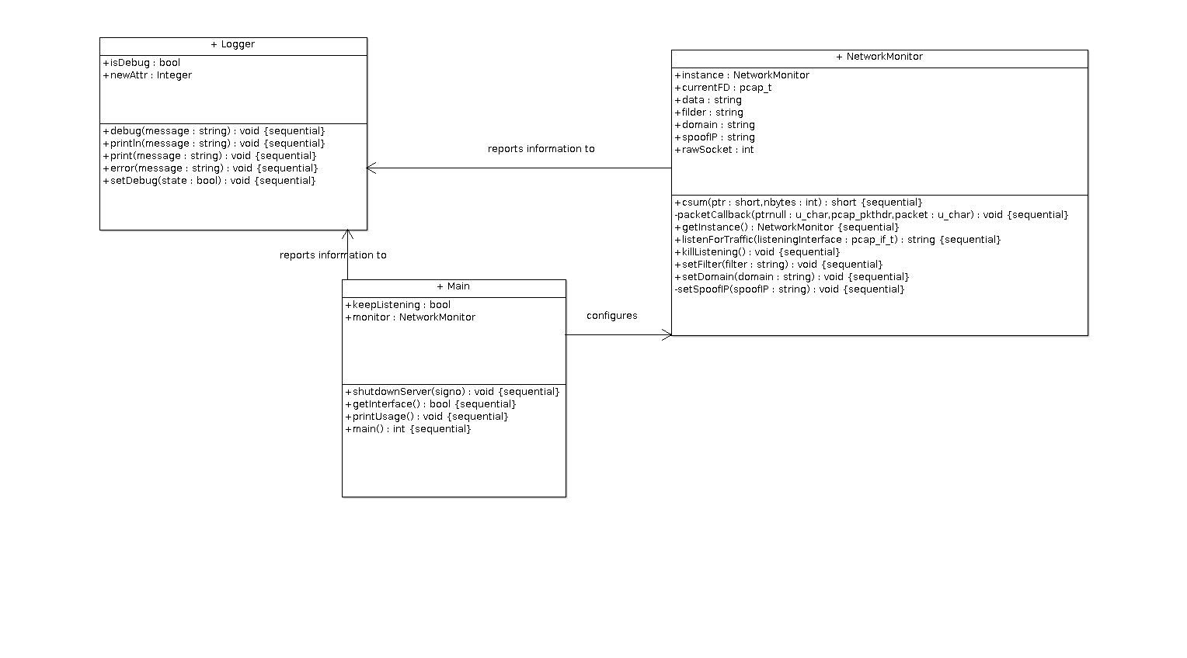
Original image can be found under imgs/DNSSpoofClassDiagram.png

Statechart Diagrams

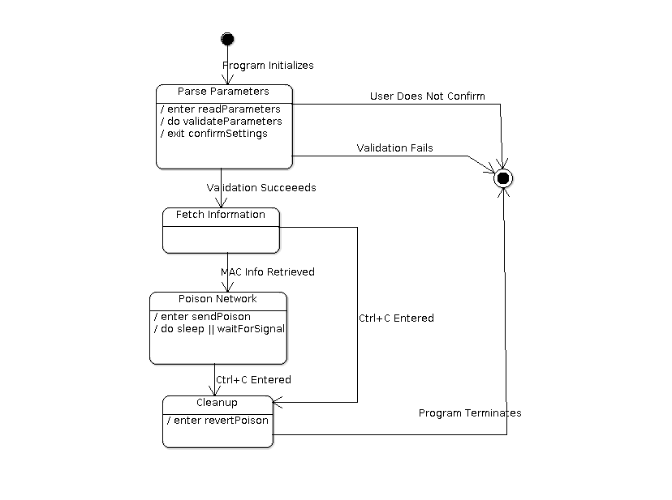
ARP Poison
Original image can be found under imgs/ARPPoisonStateChartDiagram.png

DNS Spoof
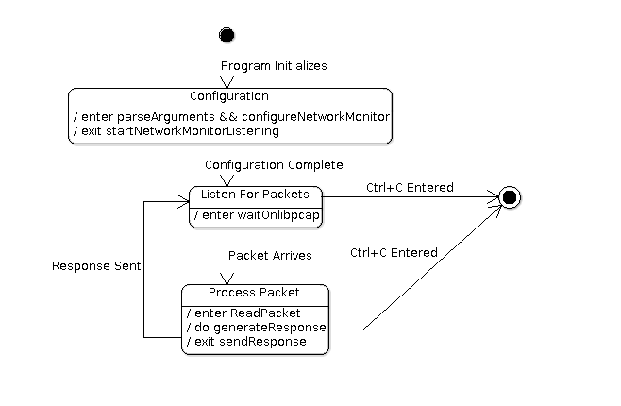
Original image can be found under imgs/DNSSpoofStateChartDiagram.png

Pseudocode

ARP Poison

arppoison.py

Main()
- Parse arguments using parseArg()
- Validate arguments. Call howTo() in failure
- Confirm settings. Wait for user confirm
- Get Router and Victim MAC information using ARP requests
- While: keep_poisoning
  - sleep for a second
  - send arp poison to the victim
  - send arp poison to the router
- sleep for another second to let things calm down
- check if poison had started. IF it started
  - send correction ARP to victim
  - send correction ARP to router
  - sleep for a second
  - send correction ARP again to victim
  - send correction ARP again to router

parseArg(args, key)
- Search through args. FOREACH
  - IF item equals to key. RETURN it. ELSE continue
- RETURN empty string

howTo()
- Print how to use the application instructions

DNS Spoof

Logger.cpp

debug(string message)
- IF isDebug print the passed in message

println(string message)
- Print the passed in message to stdout appending a return after

print(string message)
- Print the passed in message to stdout\

error(string message)
- Print the passed in message to stderr appending a return after

setDebug(bool state)
- Set isDebug to the passed in state value

ArgParcer.h

GetTagData(string preTag, char *argArray[], int length)
- Parse tag from argArray. IF found return the string value. ELSE return “-1”

GetTagVal(string preTrag, char *argArray[], int length)
- Parse preTrag from argArray. IF found cast to int and return value. ELSE return -1

TagExists(string preTrag, char*argArray[], int length)
- Parse preTag from argArray. IF found return TRUE, ELSE return FALSE

Main.cpp

shutdownServer(int signo)
- Set keepListening to False to stop re-execution of NetworkMonitor
- call killListening() on NetworkMonitor to terminate libpcap

getInterface()
- Get system network interfaces using libpcap
- FOR loop through all interfaces, search for “any” interface.
- IF “any” interface found set listeningInterface. RETURN true. ELSE RETURN false

printUsage()
- Print usage information on how to use the DNS Spoof Application

main(int argc, char * argv[])
- Parse parameters using ArgParcer.
- Validate input, IF parameters missing call printUsage() and RETURN 1
- Register sigaction to call shutdownServer() on Ctrl+C
- call getInterface() IF false print error and RETURN 1
- Create and configure instance of NetworkMonitor with settings
- WHILE keepListening
  - call listenForTraffic() on the NetworkMonitor passing the listeningInterface
  - check keepListening. IF false break loop
- Free all resources
- RETURN 0

NetworkMonitor.cpp

NetworkMonitor()
- Create Raw Socket
- Configure REUSADDR and IP_HDRINCL on raw socket

getInstance()
- IF NetworkMonitor::instance is nullptr. Create a new instance of the NetworkMonitor. ELSE return the existing instance. This is to enforce a singleton

setFilter(string filter)
- Set filter value used for libpcap to determine what to return when listening

packetCallback(u_char *ptrnull, const struct pcakpkt_hdr *pkt_info, const u_char *packet)
- Parse packet. Update information as soon as possible for DNS response
- Parse DNS Request information. Configure header for repsonse
- Parse out all Queries.
- Generate Answers
- Appen Answers to Packet
- Recalculate IP Checksum and Length
- Recalculate UDP Checksum and Length
- Send Response out of Raw Socket

killListening()
- IF pcap is currently listening on a file descriptor. Call pcap_breakloop on it

listenForTraffic(pcap_it_t * listeningInterface)
- Lookup network information for passed in listeningInterface
- Open interface with pcap_open_live
- Setup pcap filter and compile and assign
- Call pcap_loop using packetCallback() to parse incoming packets

csum(unsigned short *ptr, int nbytes)
- Generate checksum based on passed in ptr data and the number of bytes passed in via nbytes

