# Milestone 1: Project Proposal

## Topic

The main topic of our HTML project will be a photography website. It will host the photography of the amateur photographer Keri Jens – going by the alias Jane Doe on the site. The main purpose of the site will be to provide users easy access to her work with the ability to provide feedback as well as make requests. The target demographic of the site will be adults with an existing interest in photography.

The main success factors for the site will be making it user-friendly and eye catching while still keeping the focus on the photography itself. In order to achieve this, we have set up a list of short term goals for the site to have:

* Ability to host photos
* Ability to comment and spark discussion
* Ability to request photos
* Ability to subscribe to alerts
* Ability to register as a member
* Integration with Facebook and other social sites
* Site map
* Ability to search archives
* Navigation bar

In order to achieve all of this, a fair bit of functionality will need to be coded into the site. The bulk of the site content will be photography, so there will be plenty of graphics required, as well as alt text describing them. Text to speech will increase accessibility to those with visual problems. JavaScript will be required as well as Ajax to ease functionality of any search functions and subscription forms.

There are already sites in place which have similar functionality. For instance, [Tumblr](http://www.tumblr.com) is a website which pans to a much wider audience. It is a blogging platform open to everyone in order to share what they love. It is extremely easy to use and very appealing to the user. However, it isn’t specialised directly for photography, so where we would want the functionality of Tumblr, we will be designing our site to be primarily photography-oriented.

In addition to Tumblr, there is the site [Lensblr](http://lensblr.com) which is targeted specifically towards photography. It is another site open to everyone to share their photographic work. Its site has a straightforward layout with its main focus on the photography. However, while users are free to submit their photos for consideration, the site administrators choose which pictures to host, so there is no guarantee a photographer will have their work displayed. While we would want to emulate their site’s focus on photography, our site will be designed to promote the work solely of Keri Jens.

## Functional Requirements

One of the functional requirements our site must have is the ability to submit a form. Our site will have a couple of sections in which a form will need to be filled out. In order to sign up as a member, users will have to complete a form with a user name, password and the possibility of an email address in order to subscribe to photo alerts. In order to request a photo, users will need to fill out a different form. Not only will members be able to suggest locations and subjects to photograph, but they will also have the option to select the type of lens they would prefer to be used from a drop down list. Subscribing to alerts will require an additional form to be completed, though much simpler. They will be able to select which photo tags they want to receive an alert for, and whether they would prefer to receive alerts through email or via their account with the site.

Another requirement is to have some form of list on the site. There will be two key functions that will show up in a list format: the site map and navigation bar. The navigation bar will only show the key pages of the site whereas the site map will not only show the key pages, but any sub-pages that may be contained within them as well. Another possibility for a list would come under the search function. As mentioned previously, users would be able to filter photos based on tags. The tags themselves would be displayed in a list or table and users would have the option to select all photos with a certain tag, or photos that specifically don’t have that tag.

## Work Plan

In order to actualize this project on more than just paper, a strict work plan must be adhered to if we are to have the site up in time. First, we have agreed upon a goal for the project which is 84+%. All four members of this project wish to enroll in a co-op program, so this target is based on the cut-off for the co-op program, based on last year’s entry.

An hour per weekday has been set aside in which the members will meet in order to discuss what they are currently working on and what they have managed to complete for the site already. In addition the project on a whole will be discussed and any required changes implemented.

As part of the project, a series of milestones must be completed every other week. The physical deadlines for these projects will not be used as the actual deadline for when a milestone must be completed. Instead, we will treat the milestones as to be completed the Wednesday before they are normally due. This way any necessary changes can still be implemented in time.

# Milestone 2: Site Map and Page Design

## Project Site Map



Figure 1 – Site map

This site map shows how we will structure the main navigation for our site. There will be a navigation bar on almost every page that will lead to the pages for Project 365, a gallery, an about page and a members page. Project 365 is gallery where a new photo will be added every day. It is a popular series to be involved in by modern photographers. It is kept separate from the gallery to advertise involvement for our photographer and create easier access for people interested specifically in the series. Clicking on a thumbnail for a photo on the home page, Project 365 page and gallery will load a new page on top of the current page similar to how Facebook loads an image when clicked on. The member’s page will have a way to navigate between their account settings, photo subscriptions and a form to request a photo.

## Page Layouts

The layout for our web site will be…



Figure 2 - Home page

For the home page we will feature random images from a pool of the latest photographs taken, so the widths, heights and alignments of the images will vary. We feel like this will keep the homepage dynamic and make it more interesting for a user on subsequent visits. This page will have a liquid layout with additional photos from the pool being added to fill in the space created when the user expands the size of the window. The opposite will occur if the user decides to shrink the window size. With this function and the alternating alignments of photos there is only a one column layout for the content area of the page. The head section of the page uses a two column layout with the logo in the left column and the title, main navigation, search bar, and login in the right column.



Figure 3 - Project 365 page

The Project 365 page will have a photograph taken for each day. Each photo will have a date and name below it with some tags associated with it. The menu on the side will allow the user to choose photographs from a specific date using a PHP calendar. This page will have a fixed-width layout and it will use a two column layout. The left column will contain a calendar, and the right column will contain the 365 image, tags, photo name and date. The head, like the home page, will be a two column layout.



Figure 4 - Gallery page

The gallery page will have an area for the user to filter photos by tags. We will limit the number of thumbnails per page so the user will not have to scroll as much. There will be arrow buttons for navigating between the different pages of photos. By using Ajax we will try to only swap the image thumbnails without loading a new page. This page will have a liquid layout with the same features to the photos as the home page. The head, like the home page, will be a two column layout.



Figure 5 - Image page

Clicking on a thumbnail on the home, Project 365 and gallery pages will load a page for that photo. The first thing we want to show is the photo itself, then the name of the photo, any tags associated with it and some information from the photographer about the photo. We will also have buttons for liking the photo on external sites like Facebook, and buttons to navigate to the next and previous photos. There will also be an area to submit comments and any previous comments below that. This page will have a fixed-width and single column layout. The head, like the home page, will be a two column layout.



Figure 6 - About page

Our about page will have a menu to select between information about the photographer and equipment that is used. Using Ajax we will replace the content in the information box and will not load a separate page. This page will be a fixed-width page with a two column layout. The head, like the home page, will be a two column layout.



Figure 7 - Members page

The members page will be structured similarly to the about page. There will be a menu on the side to navigate between account settings, managing subscriptions and a page to request photos. The area for the content of these pages may vary slightly in size. This page will be fixed width and have a two columned layout. The left column contains the menu. The right column contains the settings content pane. The head, like the home page, will be a two column layout.



Sign up & Registration Page

The sign up page and registration pages are not on their own pages. Instead they will be pop-up boxes when the Sign in or Registration links are pressed located in the header of the website page. The pop-up will appear in the middle of whatever page the viewer is currently viewing at the time the links are pressed. This will be done with Javascript and a form will be used to submit the information given.

## Sample layout

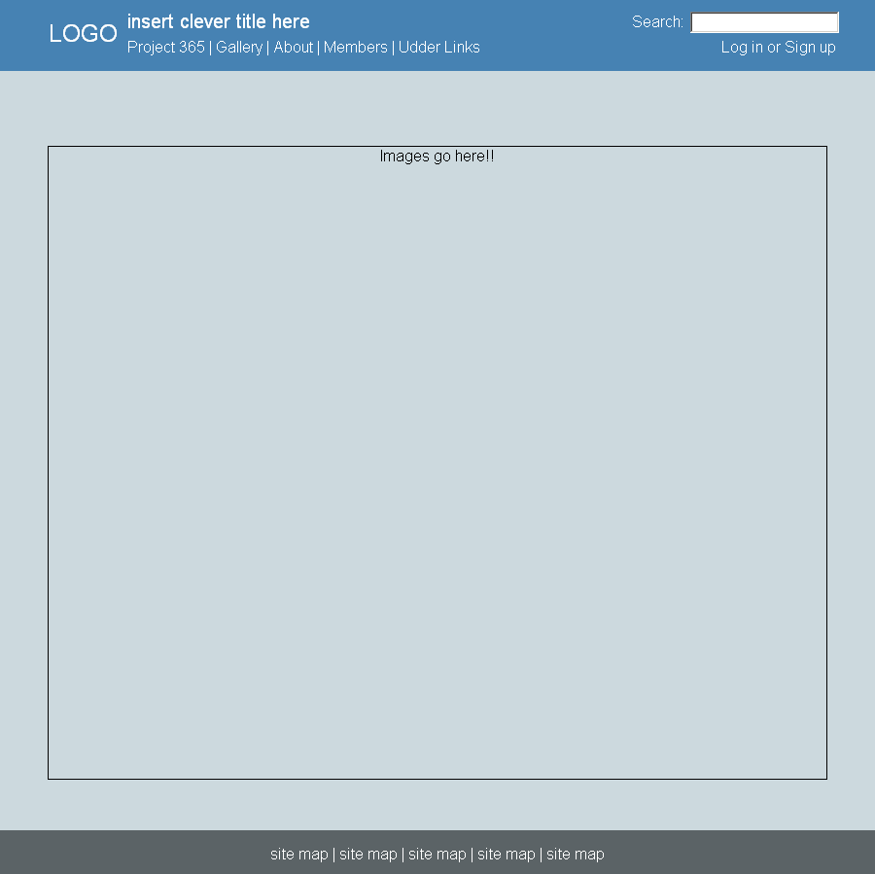

Figure 8 - Sample home page

This is the sample page we have composed for our home page with the proposed colour scheme.

## Print Layout



Figure 9 - Print layout for image page

We anticipate that some users of the site will want to print some of the photographs so we will have a separate print layout for the image page. The comments section will be stripped out along with any extra buttons. The text and any background colours will be set to black and white for ease of printing. This page will be fixed width and a single column layout.

## Form Page

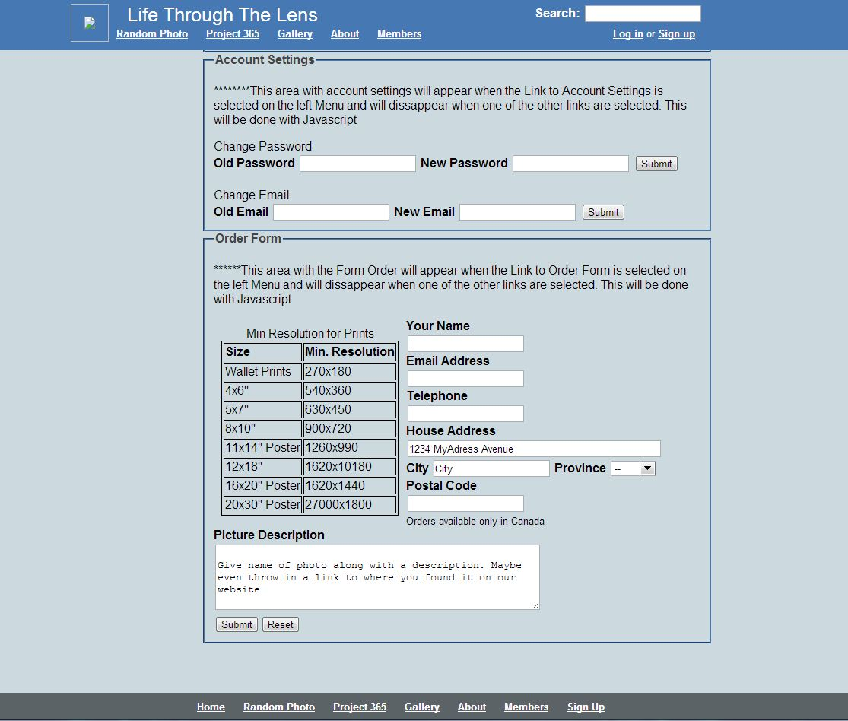

**Note:** This photo of the form is the members page scrolled down to where the forms are located on the page.The required table is used to show the minimum resolution a photo can be for it to be printed in the desired size.

## Front Page

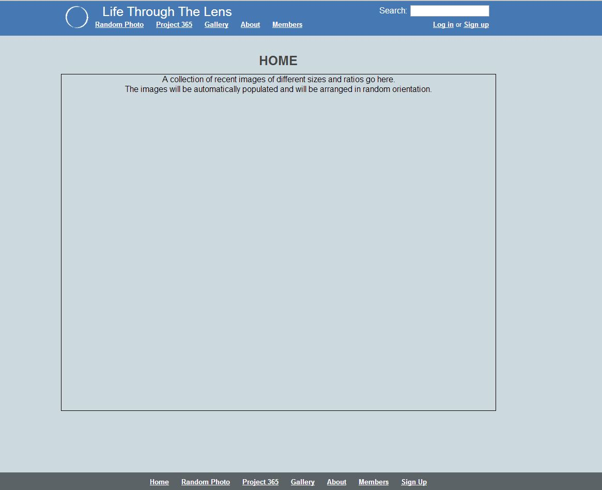

## URL to current site setup:

http://students.bcitdev.com/A00761759/COMP1536/A7/index.html

## Items Completed for Milestone 3

* Basic layouts of all pages
* Missing Wire Frame for Registration page added
* Functioning pseudo-code and links for main navigation
* Forms and tables built and functional. Action attribute goes to form demo website
* Description of all colors fonts and styles described below. Documentation of text color was missing from Milestone 2.

## Work Done Ahead of Milestone 3:

* All work done has been to meet the requirements of Milestone 3.

## Changes from Original Design:

* “Random Photo” link added to the main navigation. The purpose is so that viewers who just want to “jump in” to the website can have instant access to a random photo and what people are saying about it. It will also help us easily test the single photo page through menu navigation.
* There will be a PHP calendar on the Project 365 page, for navigating to specific images on each day.

## Website Issues During Design:

* Color choice as color is important in designing a photography website. We each had some color preferences of our own
* Unfinished work can be difficult to user test – users expect full functionality and can find it hard to imagine what might be.

## Usability Testing of Milestone 3:

Comments:

* The colour scheme looks too much like Facebook
* The layout is simple and functional
* Doesn’t like that single images navigate away from the gallery page (this will be implemented in a later stage of development)
* The gallery page needs a next page button if there are more than 9 images.
* The members page should have an indication of what fields are required before submission.
* The members page should have a form to upload a user image (for comments).

## Styling:

### Fonts and Colors:

The colors applied across all of our pages will be blue (#4679B3) for the header with white text, a light gray (#CCD9DE) with black text for the body section, grey (#444444) text headers for each section, and a dark stone grey (#5B6366) with white text for the footer. We want to keep these colors subtle so as to maximize the contrast to the photo so that it will catch the viewers’ attention easily.

The fonts applied across all of our pages will be Arial and Sans-Serif fonts for all sections of the page.

### Common Elements:

The styling for a number of sections will use mostly default settings. Paragraphs and areas containing text will use default styling. Links in the header will be bold and underlined. In the body , the section headers will be bold 25px. For headings within text documents and forms, they will be bold and default size. Lists are styled horizontally in the head section and the footer, and vertically for the left side menu on the About and Members page. The lists will all be bold font and underlined.

### Pseudo-classes:

The pseudo-classes on the main navigation links will originally be white and underlined but will turn  black when hovered over or put in focus by the keyboard. Visited pages will also be white in order to keep the look of the navigation consistent.

### Forms and Tables:

The form will be styled within divisions and use the fonts defined in the fonts section. They will be set inside a blue fieldset with a bold legend. The form will be presented in a formal manner with a very straightforward and intuitive layout.  The table uses default colours for each row for visual appeal. It will have a simple 1px border and table header tags for the headings of each column.