bamazonCustomer

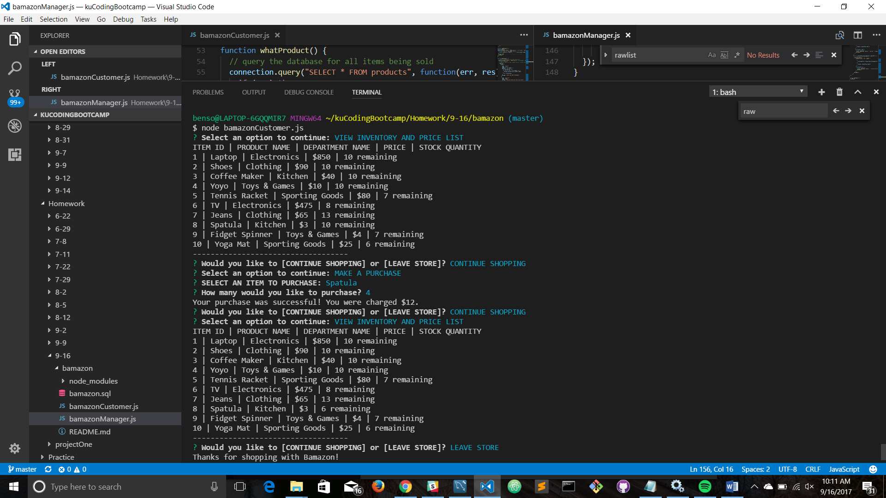

bamazonManager

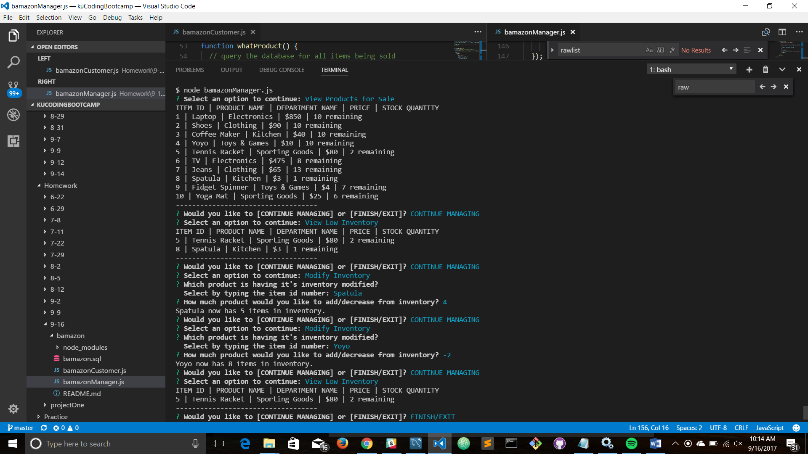

The only thing from bamazonManager I haven’t completed yet is the “add new product” feature.