vim /etc/nginx/nginx.conf

cd /usr/local/storage/php-5.6.30/ext
cd /etc/nginx

vim /usr/local/php/lib/php.ini

cd /var/www/accountBook/

/usr/local/php/bin/php -v

/usr/local/php/bin/php-cgi -b 127.0.0.1:9000 -c /usr/local/php/lib/php.ini

cd /usr/local/php/lib/php/extensions/

cp /usr/local/storage/php-5.6.30/php.ini-development /usr/local/php/lib/php.ini

php-fpm -c php.ini -y php-fpm. conf
区别就是
Php-fpm管理多个php fastcgi进程
你现在只有一个php fastcgi进程

ps -aux | grep php

netstat -tunlp

Php安装
Linuxphp环境需要按照pdo_mysql和openssl扩展
Makedir php
./configure --prefix=/usr/local/php
Make
Make install

#./configure --prefix=/usr/local/php --enable-fpm --with-mcrypt \
--enable-mbstring --disable-pdo --with-curl --disable-debug --disable-rpath \
--enable-inline-optimization --with-bz2 --with-zlib --enable-sockets \
--enable-sysvsem --enable-sysvshm --enable-pcntl --enable-mbregex \
--with-mhash --enable-zip --with-pcre-regex --with-mysql --with-mysqli \
--with-gd --with-jpeg-dir

Yum install -y php-fpm
cd /usr/local/php
cp etc/php-fpm.conf.default etc/php-fpm.conf
vim etc/php-fpm.conf

启动php-fpm和nginx

/usr/local/php/sbin/php-fpm

开启openssl
可以一开始安装的时候就加上--with-openssl
find / -name phpize
cd /usr/local/storage/php-5.6.30/ext/openssl (源代码路径)
/usr/local/php/bin/phpize
./configure --with-php-config=/usr/local/php/bin/php-config --with-openssl （安装路径）
make
make install
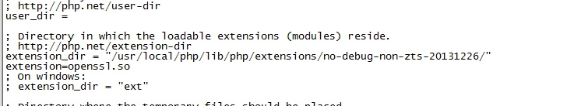

mv config0.m4 config.m4

开启pdo_mysql扩展
#下载pdo_mysql源码

wget http://pecl.php.net/get/PDO_MYSQL-1.0.2.tgz

tar -zxv -f PDO_MYSQL-1.0.2

cd PDO_MYSQL-1.0.2

/usr/local/bin/phpize #必须安装有 m4 autoconf

./configure --with-php-config=/usr/local/php/bin/php-config --with-pdo-mysql=/usr/local/mysql

make && make install

加入php.ini的extension中
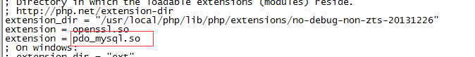

Make的时候可能报错
/tmp/PDO_MYSQL-1.0.2/php_pdo_mysql_int.h:25:19: fatal error: mysql.h:
在编译时需要MySQL的头的文件，默认搜索找不到头文件的位置，需要建立个软连接：
ln -s /usr/local/mysql/include/* /usr/local/include/

然后再make就可以了

如果还有如下错误
1、libmysqlclient.so.18: cannot open shared object file: No such file or directory in Unknown on line 0

解决方法：

ln -s /usr/local/mysql/lib/libmysqlclient.so.18 /usr/lib64/
重启nginx

2、checking for gawk... gawk
checking for MySQL support for PDO... yes, shared
checking for mysql_config... not found
configure: error: Cannot find MySQL header files under

解决方法：
yum install mysql-devel
然后重新
./configure --with-php-config=/usr/local/php-5.2.14/bin/php-config
make
make install

Mysql相关

http://www.cnblogs.com/fnlingnzb-learner/p/5830622.html

ln -s /var/lib/mysql/mysql.sock /tmp/mysql.sock

修改密码：
mysql> SET PASSWORD FOR 'root'@'localhost' = PASSWORD('newpass');

如果忘记加参数，可单独安装php-fpm
Yum install php-fpm
whereis php-fpm

php-fpm: /usr/sbin/php-fpm /etc/php-fpm.d /etc/php-fpm.conf /usr/share/man/man8/php-fpm.8.gz

ln -s /usr/sbin/php-fpm /usr/local/php/sbin/php-fpm
cp /etc/php-fpm.conf /usr/local/php/etc/php-fpm.conf

#启动php-fpm
/usr/local/php/sbin/php-fpm
/usr/local/php/sbin/php-fpm -c /usr/local/php/lib/php.ini -y /usr/local/php/etc/php-fpm.conf

#关闭php-fpm
kill -INT `cat /usr/local/php/var/run/php-fpm.pid`

#重启php-fpm
kill -USR2 `cat /usr/local/php/var/run/php-fpm.pid`

