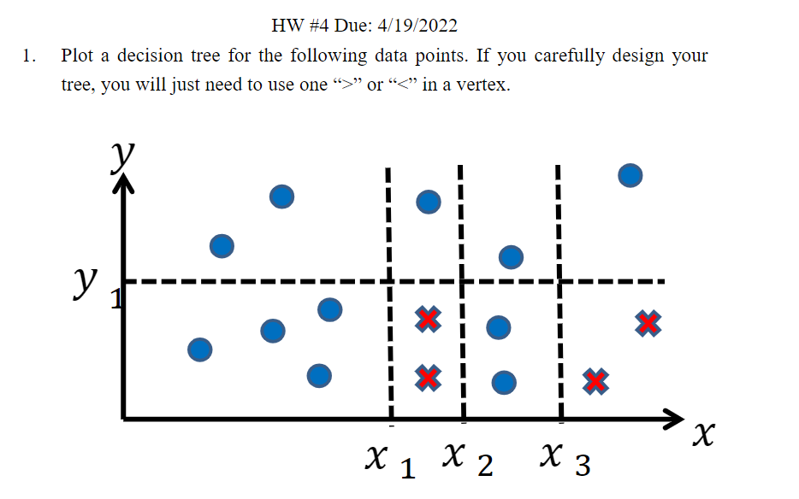

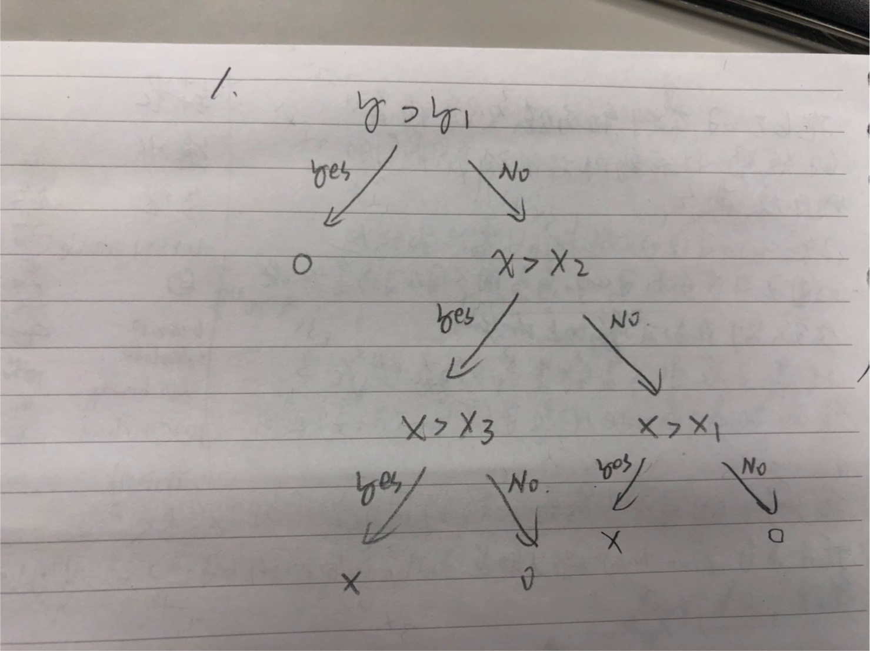



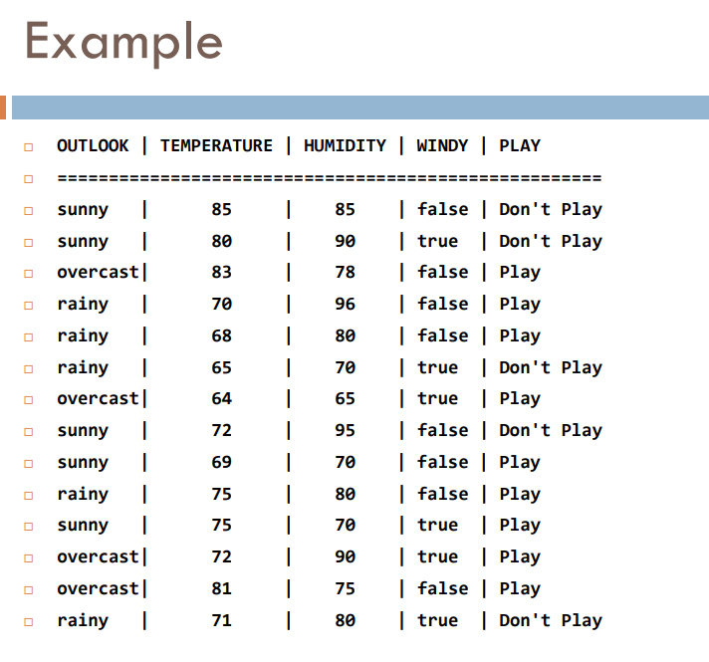

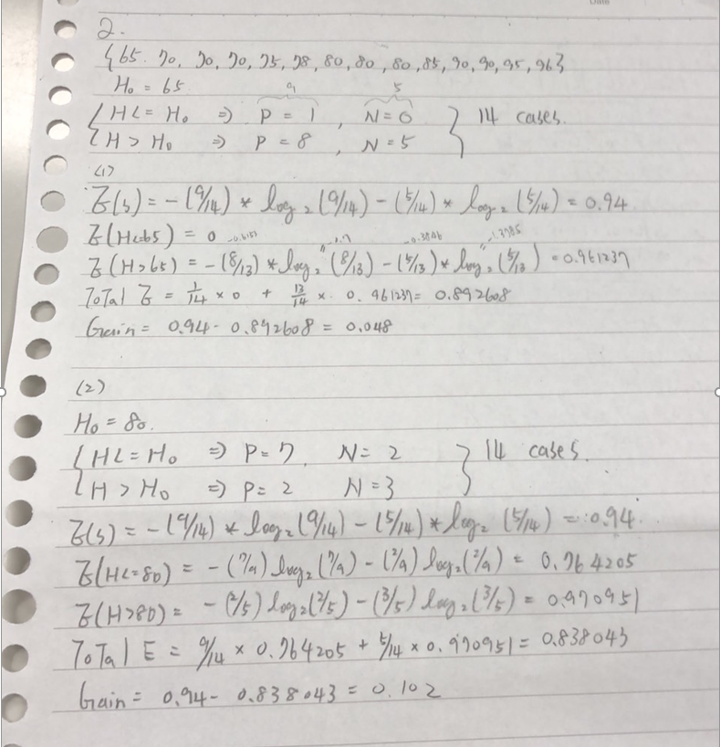

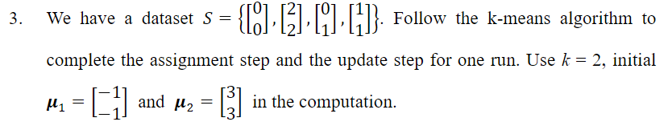

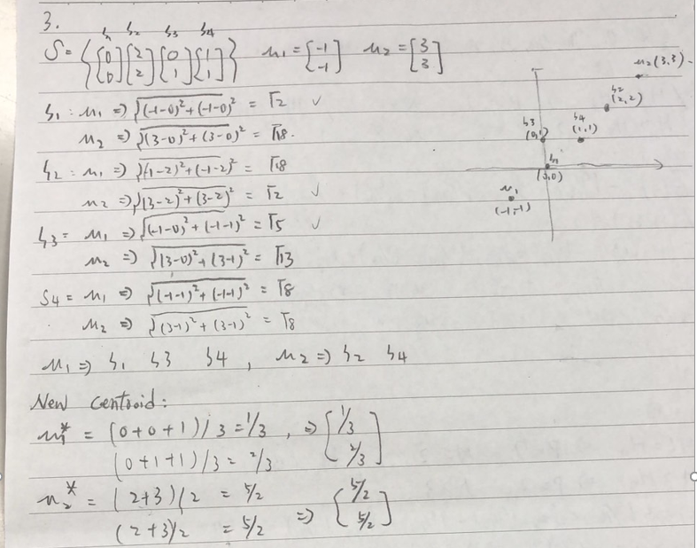

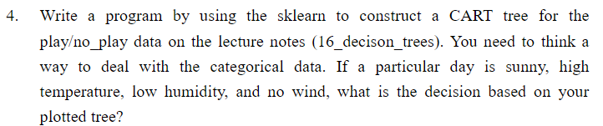

import pandas as pd

df=pd.read_csv("./dataset.csv")

print (df)

y=df['PLAY']

df=pd.get_dummies(df)

df=df.drop("PLAY_ Don't Play",axis=1)

df=df.drop("PLAY_ Play",axis=1)

print(df,None)

print(y)

from sklearn.tree import DecisionTreeClassifier,plot_tree

model=DecisionTreeClassifier()

model.fit(df,y)

import matplotlib.pyplot as plt

from matplotlib import figure

plt.figure(figsize=(10,8),dpi=150)

plot_tree(model,feature_names=df.columns,filled=True)

plt.show()

# https://data36.com/coding-a-decision-tree-in-python-classification-tree-gini-impurity/

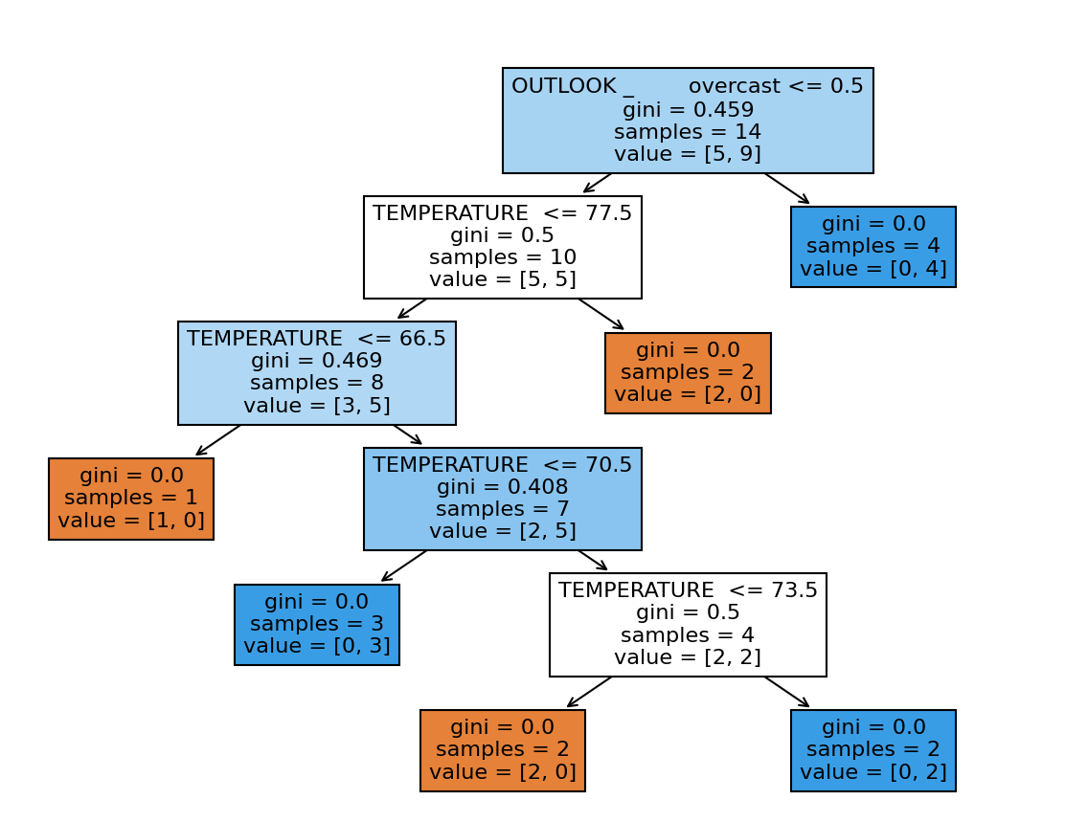

Sunny, high temperature, low humidity, no wind -> play

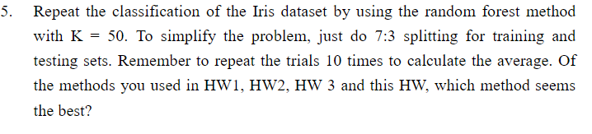

Knn(0.97) is better , random forest=0.955555

from sklearn import datasets

from sklearn.model_selection import train_test_split

from sklearn.metrics import accuracy_score

iris = datasets.load_iris()

#print(iris.feature_names)

#print(iris.target_names)

data_x=iris.data

data_y=iris.target

x_train,x_test,y_train,y_test=train_test_split(data_x,data_y,test_size=0.3)

from sklearn.preprocessing import StandardScaler

sc = StandardScaler()

x_train = sc.fit_transform(x_train)

x_test = sc.transform(x_test)

from sklearn.ensemble import RandomForestClassifier

classifier = RandomForestClassifier(n_estimators=50)

classifier.fit(x_train, y_train)

#avg accuracy for 10 times

count=0

for i in range(10):

    y_pred = classifier.predict(x_test)

    count+=accuracy_score(y_test, y_pred)

count=count/10

print ("Accuracy : ", count)