STUDENT ORGANIZATION APPLICATION FORM |  |  |  |  |  |  |  |  | NUD-ACS-SDA-F-003  ver 2024
APPLICATION FOR | 🗹 NEW ☐ RENEWAL |  |  |  | Academic Year |  |  | 2025-2026
1. Contact Information
Organization Name: | Computer Society
Contact Person: | Samantha Joy Madrunio
Contact No.:
Email Address: | madruniosm@students.nu-dasma.edu.ph
2. DETAILS OF ORGANIZATION
Date Organized | March 6, 2026
Purpose of Organization | Ex laborum Odit officia pariatur Ex id
Type of Organization | 🗹 Co-Curricular Organization ☐ Extra Curricular Organization / Interest Clubs
College | School of Engineering, Computing and Architecture
3. ENDORSEMENTS (Department Chair/Dean) |  |  |  | 4. Received by:
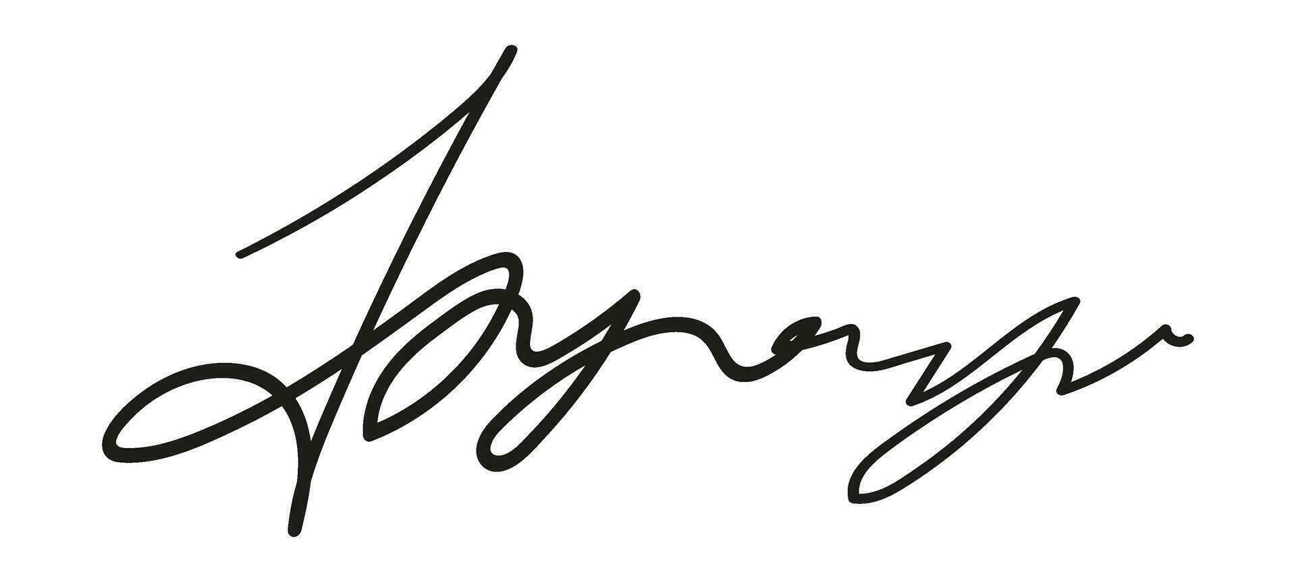 |  |  |  |  |  |  | 
Date: Mar 6, 2026 |  | Date: Mar 6, 2026 |  | Date: Mar 6, 2026 |  |  | Date: Mar 6, 2026
Time: 01:30 PM |  | Time: 01:30 PM |  | Time: 01:30 PM |  |  | Time: 01:30 PM
5. APPROVAL
🗹 APPROVED  ☐ PROBATION |  |  | Student Affairs Office   |  |  | Academic Director  
 |  |  | Date: Mar 6, 2026 |  |  | Date: Mar 6, 2026
6. Additional Remarks from Student Affairs Office / Academic Director
Instructions:
- Prepare two (2) copies: (1) Applicant; and (2) Student Affairs Office.
- Please give about 5 to 15 days for the processing of application.
- Please route this form and submit the signed form within fifteen (15) days from the start of every term for renewal: (a) Your College Dean; and (b) Student Affairs Office.
- Application and renewal or organization should be done within the period of 1st Term of every A.Y. (deadlines will be set by SDAO)
7. REQUIREMENTS ATTACHED:
NEW APPLICATION  🗹 Letter of Intent  ☐ Application Form  🗹 By Laws of the Organization (approved by the officers, adviser/s, program chairs and dean)  🗹 List of Officers/Founders  🗹 Official Logo (send to sdao@nu-dasma.edu.ph)  🗹 Letter from the College Dean endorsing the Faculty Adviser (Co-Curricular organizations)  🗹 List of Members  🗹 Latest Certificate of Grades of Officers  🗹 Biodata/CV of Officers  🗹 Resume/CV of Adviser  🗹 Letter from the College Dean/Department Chair endorsing the Faculty Adviser  🗹 List of Proposed Projects with Proposed Budget for the AY  ☐ Others _________________________________________ |  |  |  | RENEWAL APPLICATION  ☐ Letter of Intent  ☐ Application Form  ☐ By Laws of the Organization (if there is an update done last AY and approved by the officers, adviser/s, program chairs and dean)  ☐ Updated List of Officers/Founders for the AY  ☐ Updated Logo (send to sdao@nu-dasma.edu.ph)  ☐ Letter from the College Dean/Department Chair endorsing the Faculty Adviser  ☐ List of Members  ☐ Latest Certificate of Grades of Officers  ☐ Biodata/CV of New Elected Officers  ☐ List of Proposed Projects with Proposed Budget for the AY  ☐ List of Past Projects  ☐ Financial Statement of the previous AY (signed by officers and adviser)  ☐ List of Past Projects  ☐ Summary of Evaluation of the Past Projects  ☐ Others _________________________________________

