Optimization Theory HW1

|  |  |  |  |  |
| --- | --- | --- | --- | --- |
| method | Stopping Criterion | Best x | Best f(x) | Iteration |
| steepest descent (fig1) |  | [1.0769;1.1598] | 0.005914 | 21 |
| steepest descent  (fig2) |  | [1.0058;1.0117] | 0.000034 | 3367 |
| Newton  (fig1) |  | [1;1] | 0 | 6 |
| Newton  (fig2) |  | [1;1] | 0 | 7 |

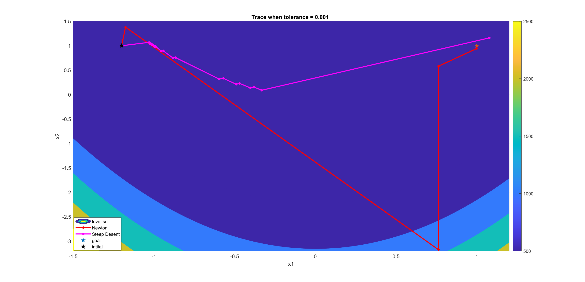

Fig 1

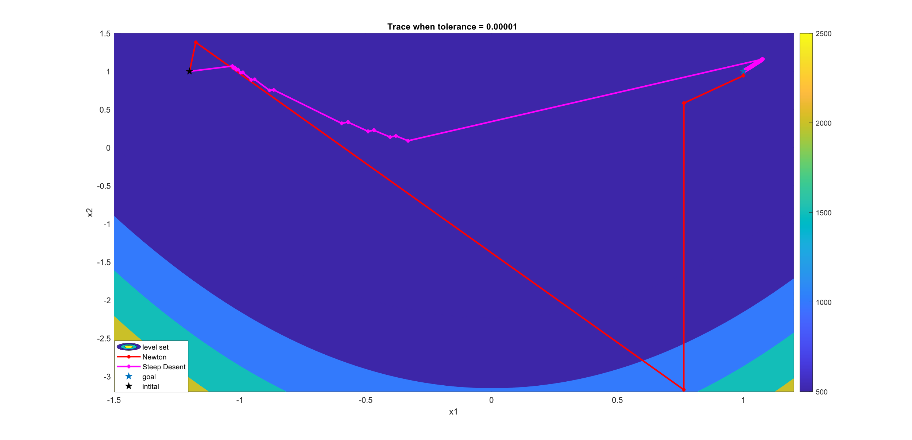

Fig 2

|  |  |  |  |
| --- | --- | --- | --- |
| method | Update direction | convergence speed | cost |
| steepest descent. | Based on the first derivative. | Slow. | Small. first derivative and update rate. |
| Newton. | Based on first-order derivatives and second-order derivatives. | Fast. | Large. first-order derivative and second-order derivative, the higher the dimension, the more obvious it is. |

The steepest descent method updates along the opposite direction of the gradient to find the global minimum, while Newton's method utilizes information from the second derivative of the function to approximate the minimum. As evident from Fig 1 and Fig 2, it is clear that Newton's method exhibits an extremely fast convergence rate. Under the same stopping condition (Fig 1), Newton's method has already converged to the minimum, while the steepest descent method is still in the process of searching for the minimum. When the stopping condition is modified (Fig 2), although the gradient method shows a gradual approach to the optimal solution, there is still a slight practical error. Additionally, as the solution approaches the optimum, the convergence speed becomes slower, and there is an issue of excessively high iteration count. (Further test results are available on the following pages.)

In the experiment, the step size (alpha) in the steepest descent method is determined through the use of fminsearch by setting an initial point. Consequently, different initial points lead to different results, as fminsearch identifies local minima (since finding the global minimum would be computationally expensive). Figures 1 and 2 depict the outcomes when the initial point for fminsearch is set to 5. In Figure 3, the results are shown when the initial point is set to 1. It is observed that the choice of initial point influences the step size, resulting in slower convergence due to a shorter step length.

|  |  |  |  |  |
| --- | --- | --- | --- | --- |
| method | Stopping Criterion | Best x | Best f(x) | Iteration |
| steepest descent  (fig3) |  | [1.0877;1.1834] | 0.00770 | 3674 |

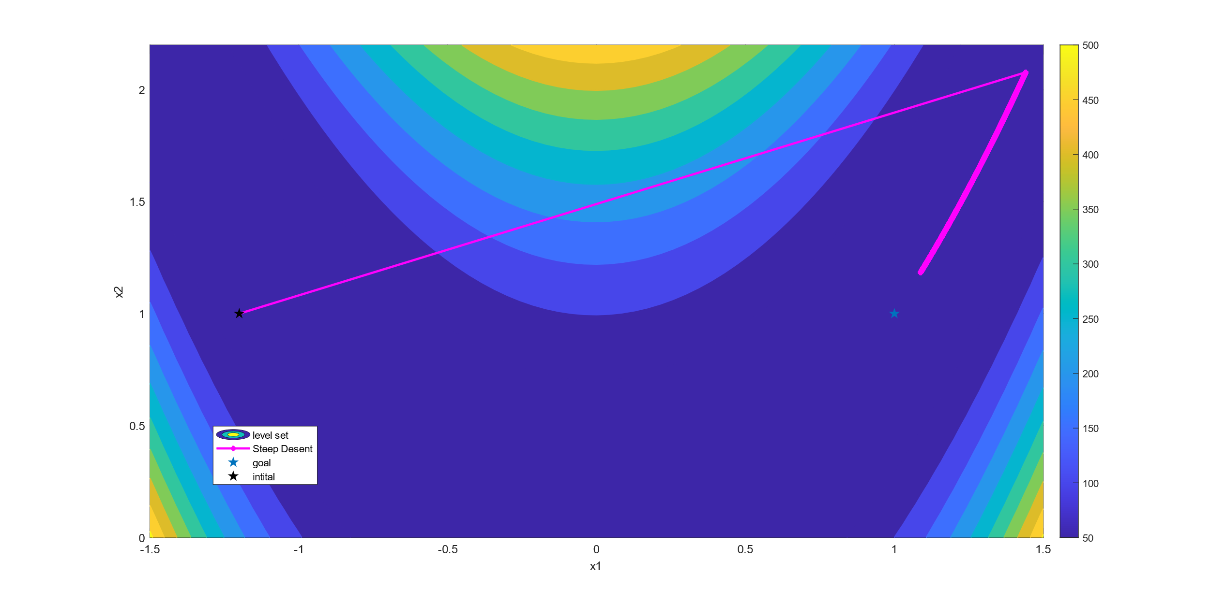

Steep Descent

Stopping Criterion:

1.

Tolerance:0.001

Iteration: 28040

Best x: [0.999999999999998;0.999999999999996]

Best f: 3.99360833268137e-30

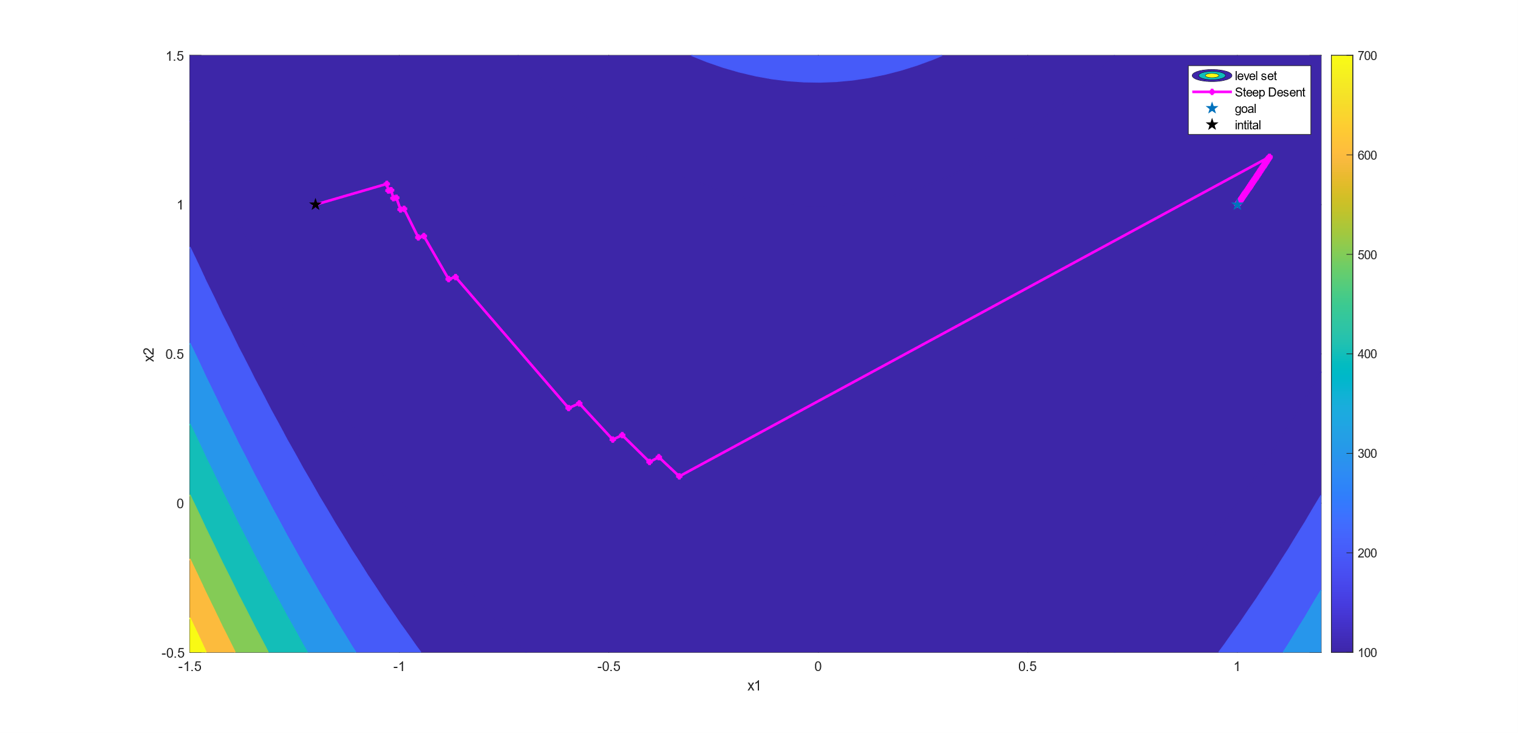

2.

Tolerance:0.005

Iteration: 21

Best x: [1.0769 1.1598]

Best f: 0.00591453910321

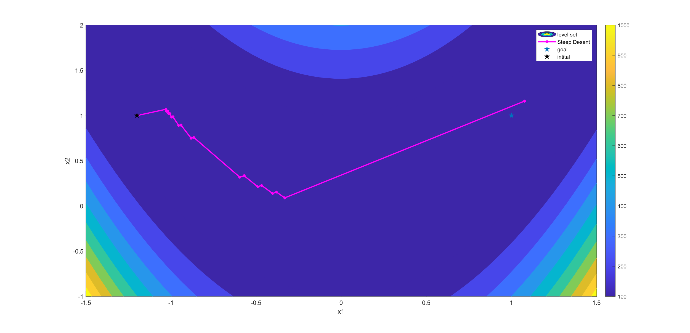

Stopping Criterion:

1.

Tolerance:0.001

Iteration: 21

Best x: [1.0769 1.1598]

Best f: 0.00591453910321

Stopping Criterion: x

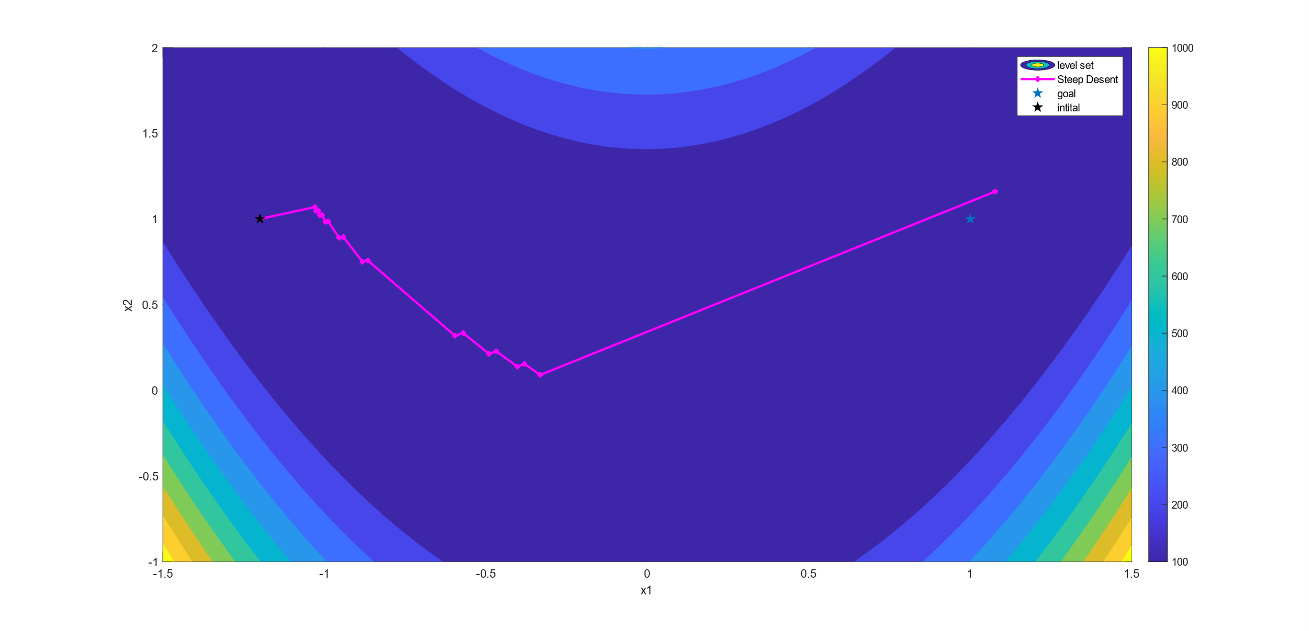

2.

Tolerance:0.00001

Iteration: 3367

Best x: [1.00583625651175;1.01171898300331]

Best f: 3.40772861400416e-05

Stopping Criterion: x

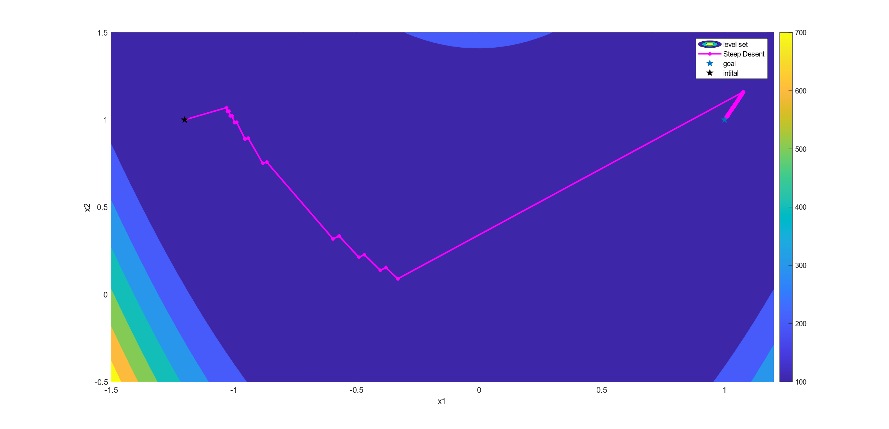

Newton

Stopping Criterion:

1.

Tolerance:0.1

Iteration:6

Best x: [0.999995695653697 ;0.999991391325773]

Best f: 1.85273970966024e-11

Stopping Criterion: x

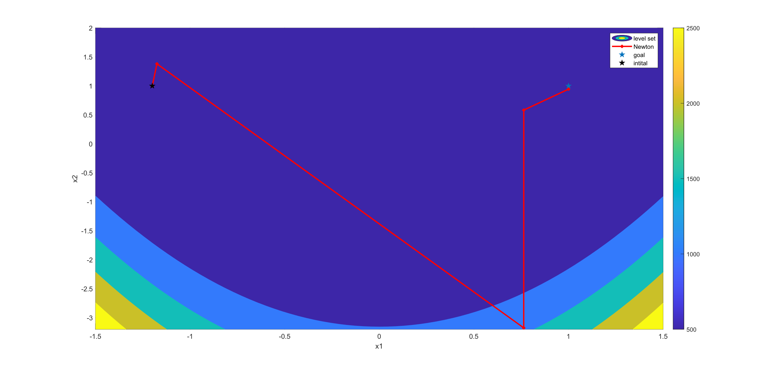

2.

Tolerance:0.01~ 0.00001

Iteration:7

Best x: [0.999999999999998;0.999999999981469]

Best f: 3.43248163352177e-20

Stopping Criterion: x

