Optimization Theory HW2

1. PSO (only_PSO.m)

|  |  |  |  |
| --- | --- | --- | --- |
| param\\Type | cognition-only | social-only | best |
| w | 0.729844 | 0.729844 | 0.729844 |
| C1 | 1.496180 | 0 | 1.496180 |
| C2 | 0 | 1.496180 | 1.496180 |
| Best f(x) | 0.62425 | 0.00102 | 9.56890e-07 |

range = [-2 2]; iterate=500; dimension=2; pop size=4;

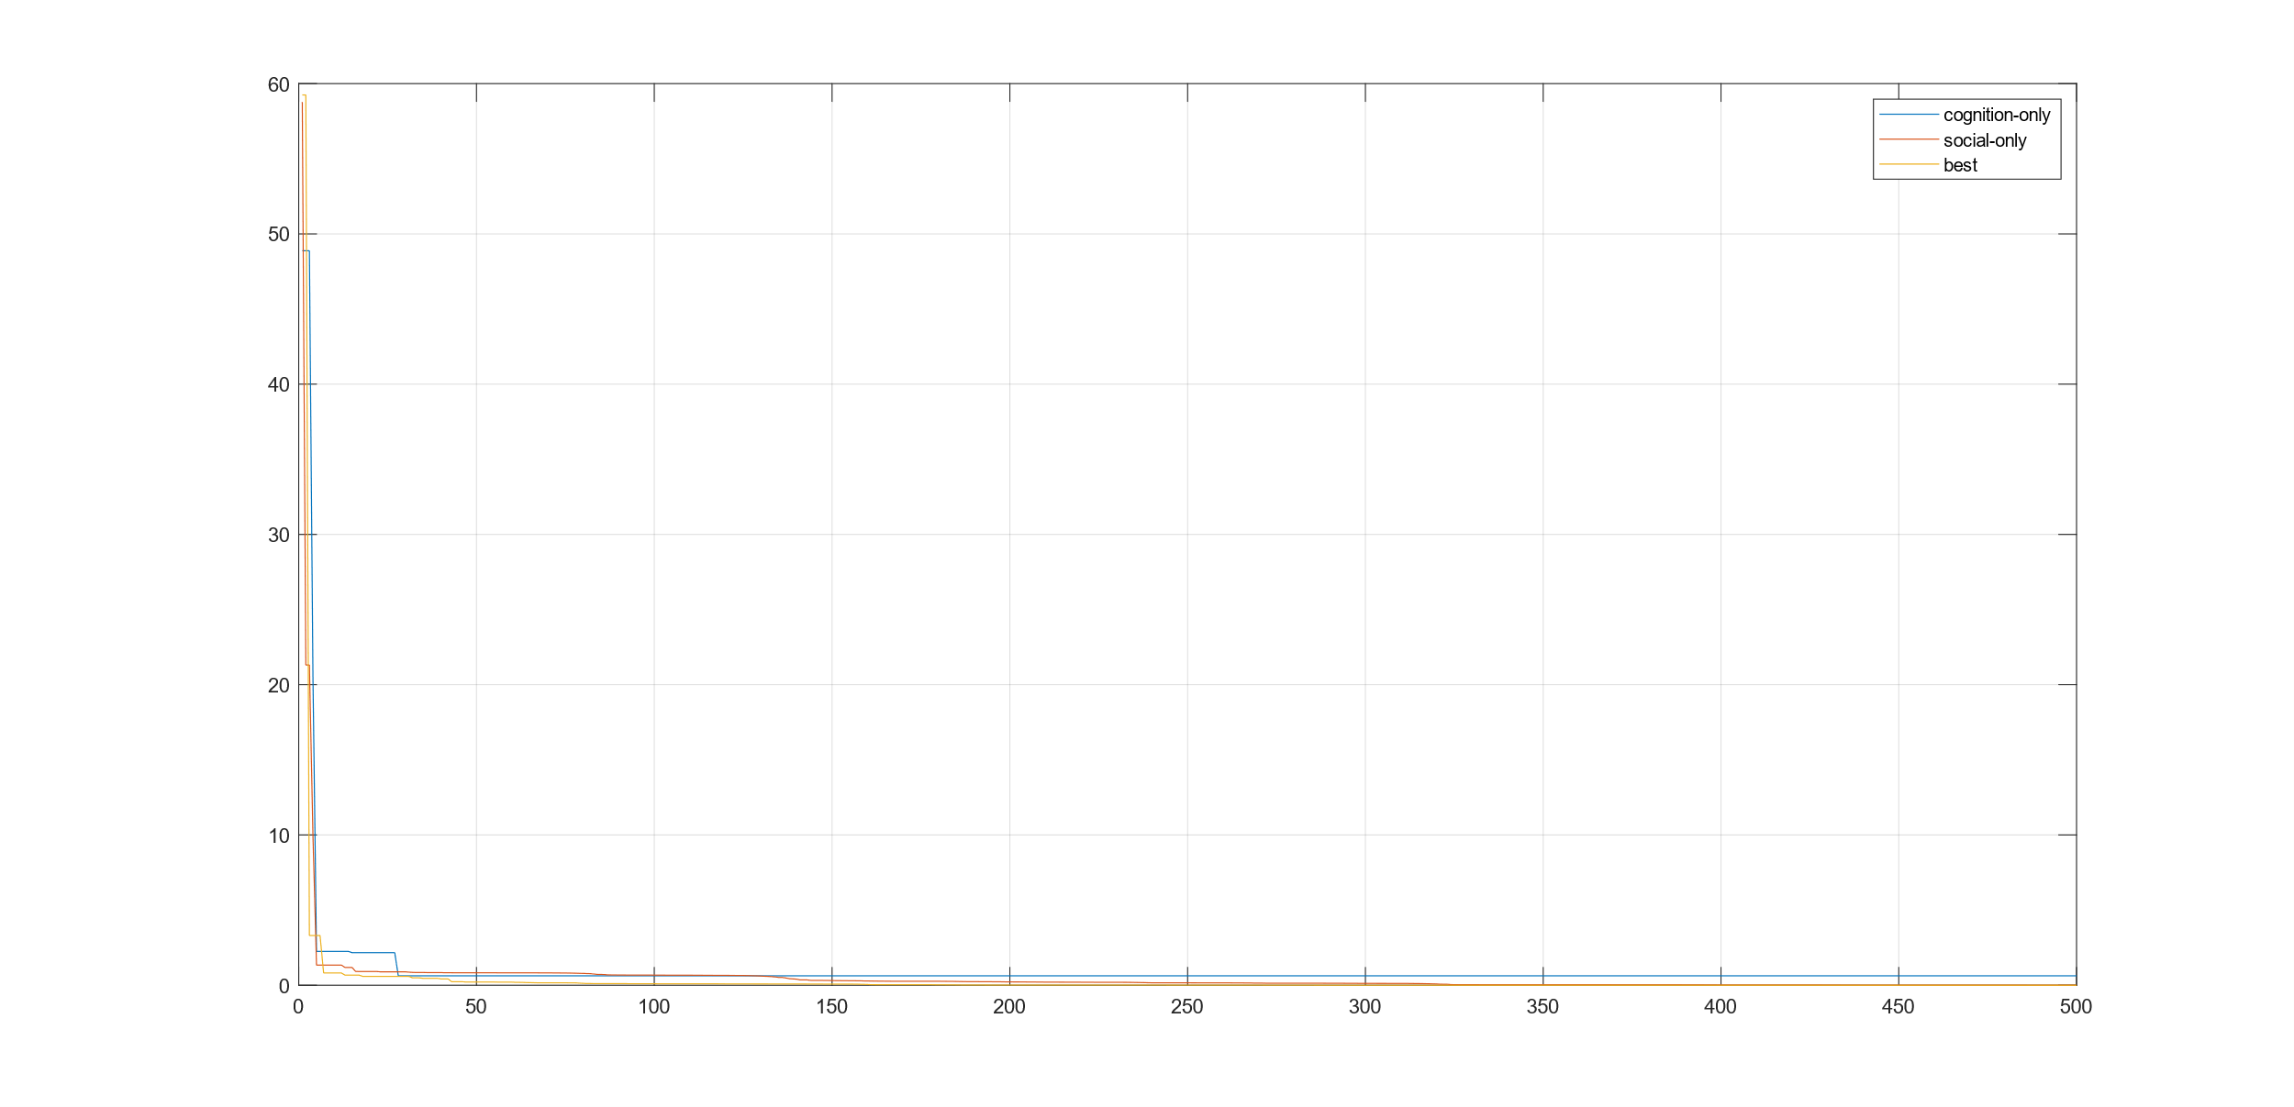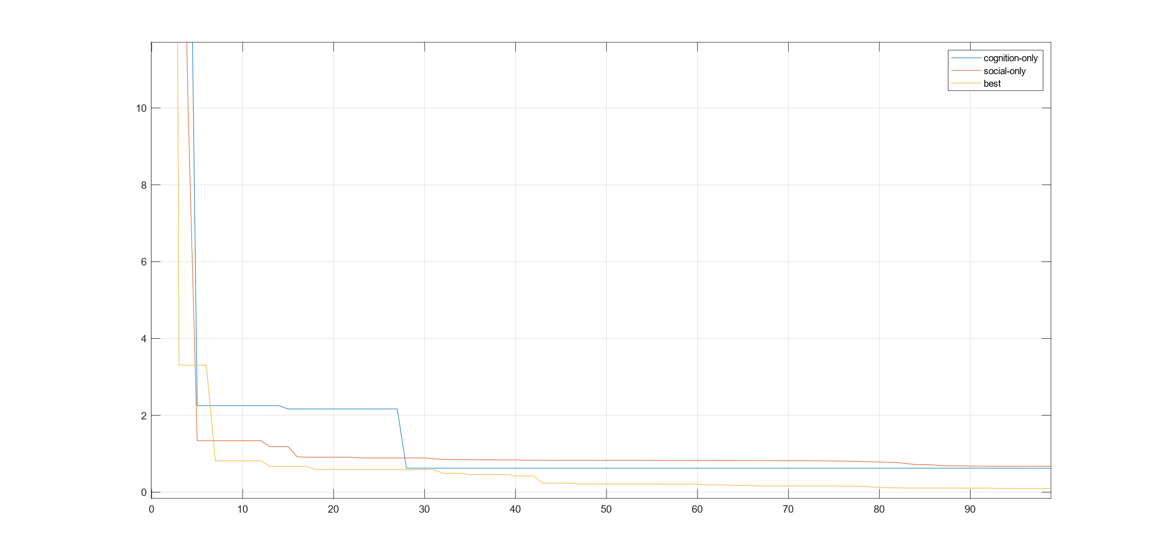

In the “cognition-only”(c2 = 0)，excessively relying on local optima and neglecting the consideration of global optimum, it becomes challenging to discover better solutions.

In the “social-only” (c1= 0)，Excessively relying on the current global optimum and neglecting consideration of local optima, it is prone to getting stuck in local optimal solutions.

In the “best”, Striking a balance between referencing the current local optimum and the global optimum, it results in a fast convergence rate and facilitates the discovery of the optimal solution.

1. CS (only_CS.m)

|  |  |  |  |
| --- | --- | --- | --- |
| param\Type | more global | equilibrium | more local |
| pa | 0.25 | 0.5 | 0.75 |
| Best f(x) | 0.0018523 | 0.108997 | 0.354828 |

range = [-2 2]; iterate=500; pop size=8; dimension=2; beta=1.5

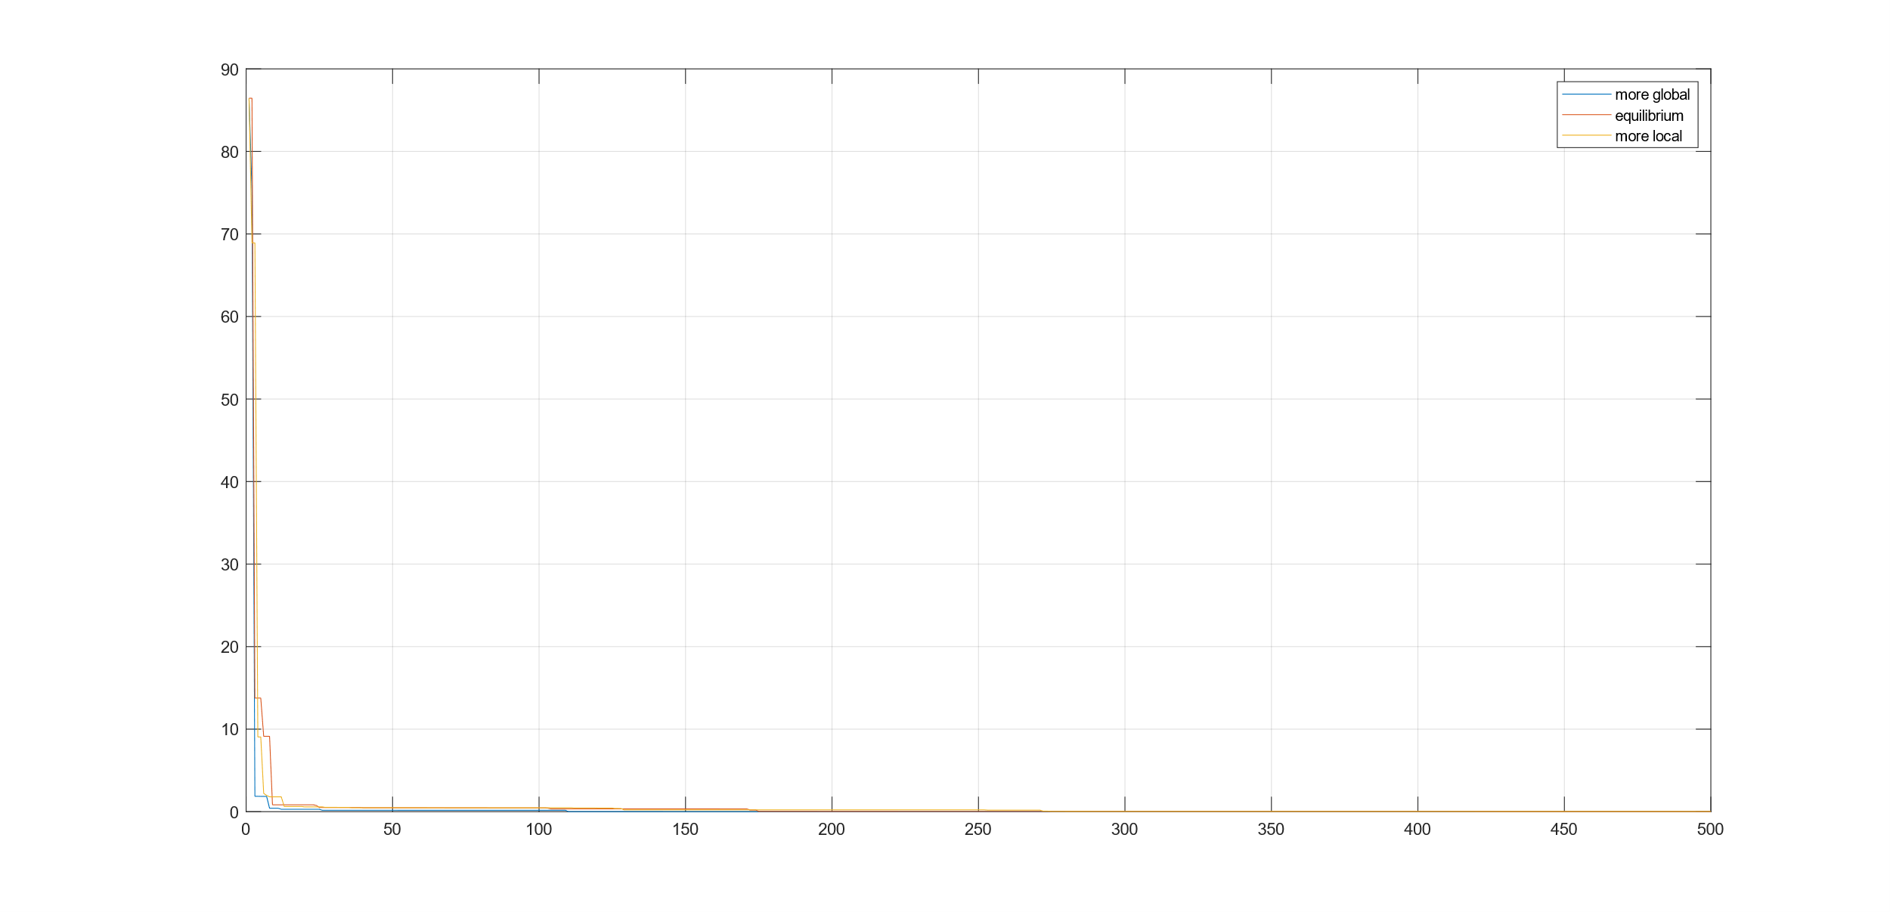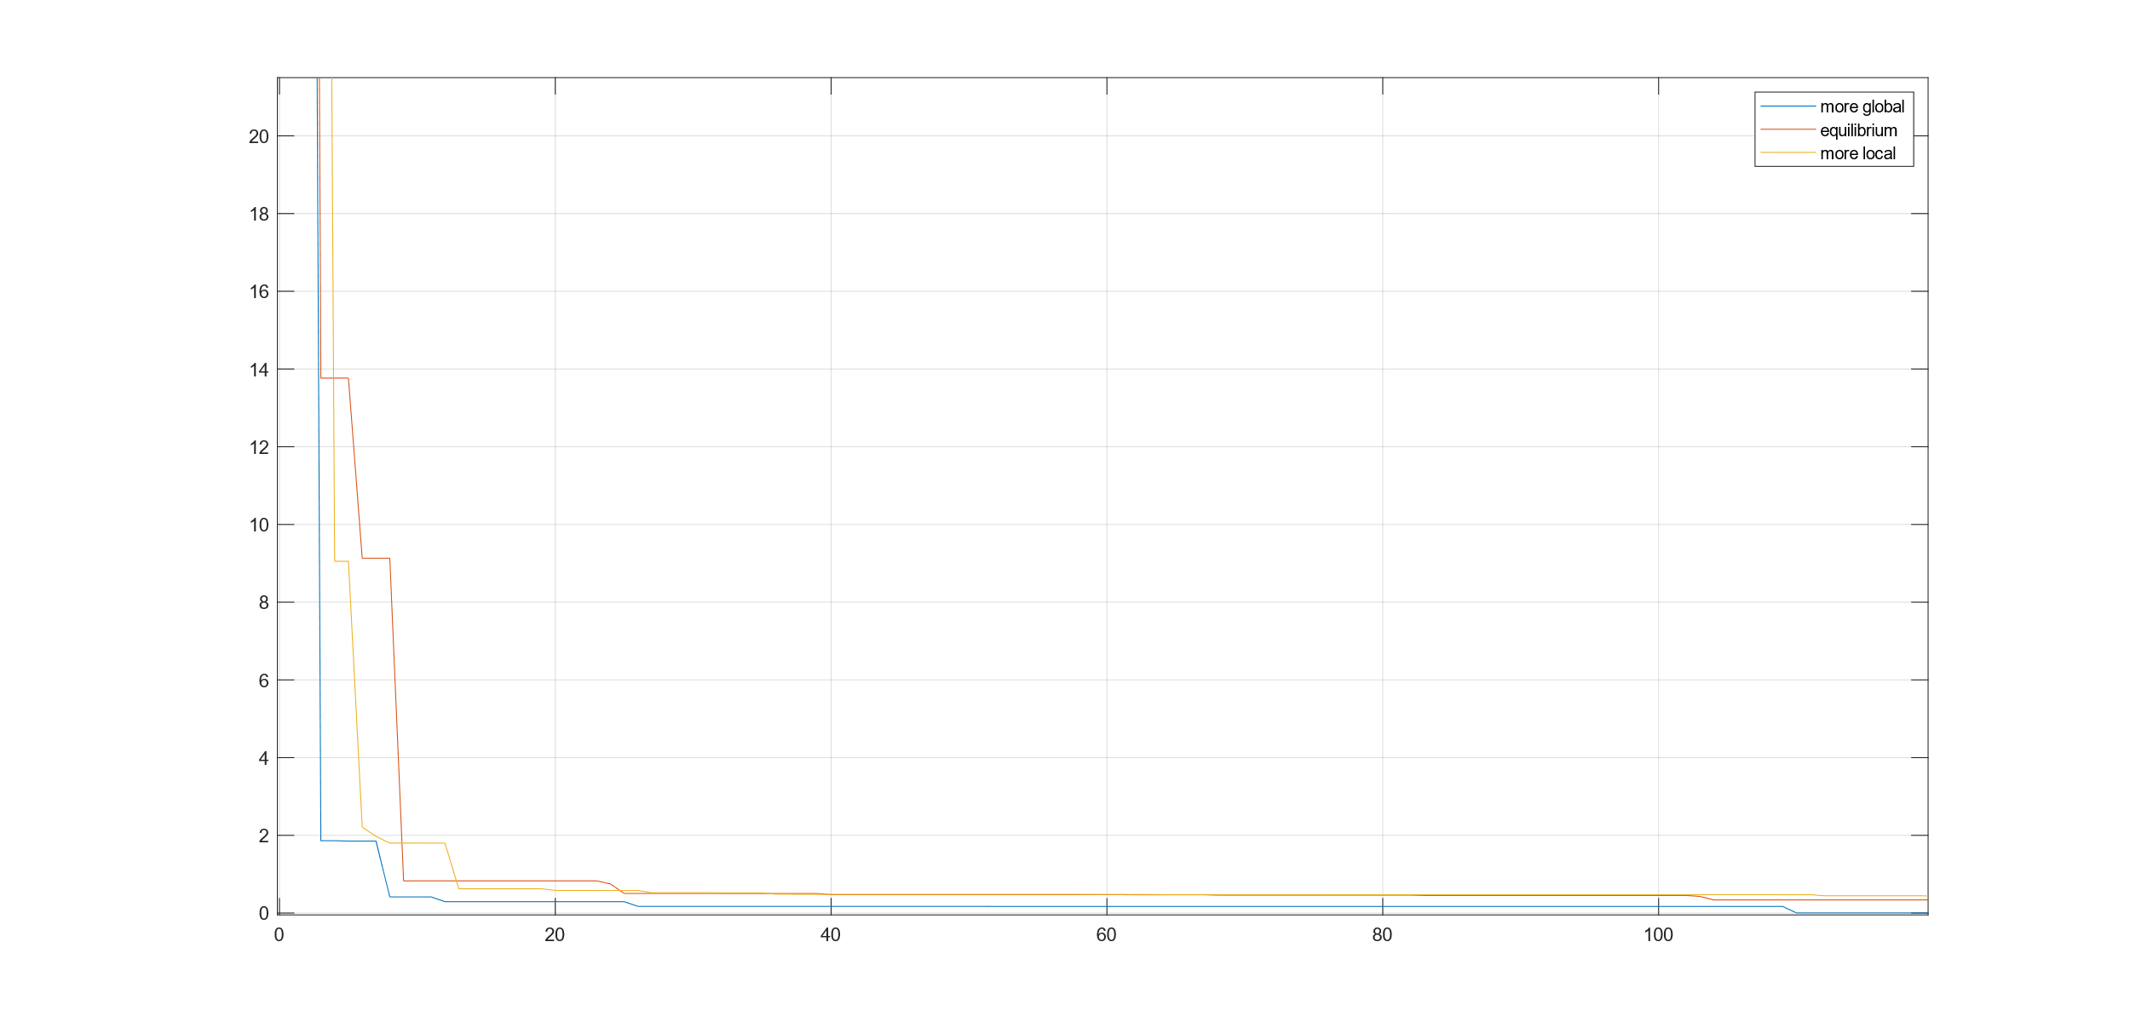

cuckoo search has two search capabilities: local search and global search, controlled by a switching/discovery probability (pa)，in the ” more global” the local search is very intensive, with about 1/4 of the search time (for pa = 0.25), whereas global search takes about 3/4 of the total search time. This allows that the search space can be explored more efficiently on a global scale, and consequently the global optimality can be found with a higher probability.

1. GA (only_GA.m)

|  |  |  |  |
| --- | --- | --- | --- |
| param\\Type | A | B | C |
| Crossover rate | 0.8 | 0.2 | 0.8 |
| Mutation rate | 0.01 | 0.01 | 0.03 |
| Best f(x) | 0.06390 | 0.08597 | 0.05235 |

range = [-2 2]; iterate=500;pop_size=10; dimension=2; bit size=32;

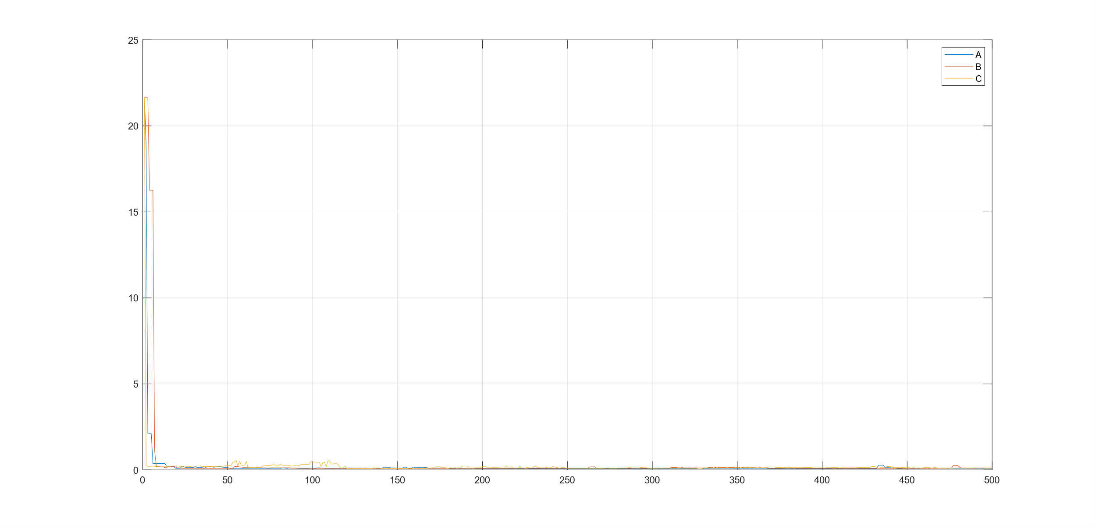

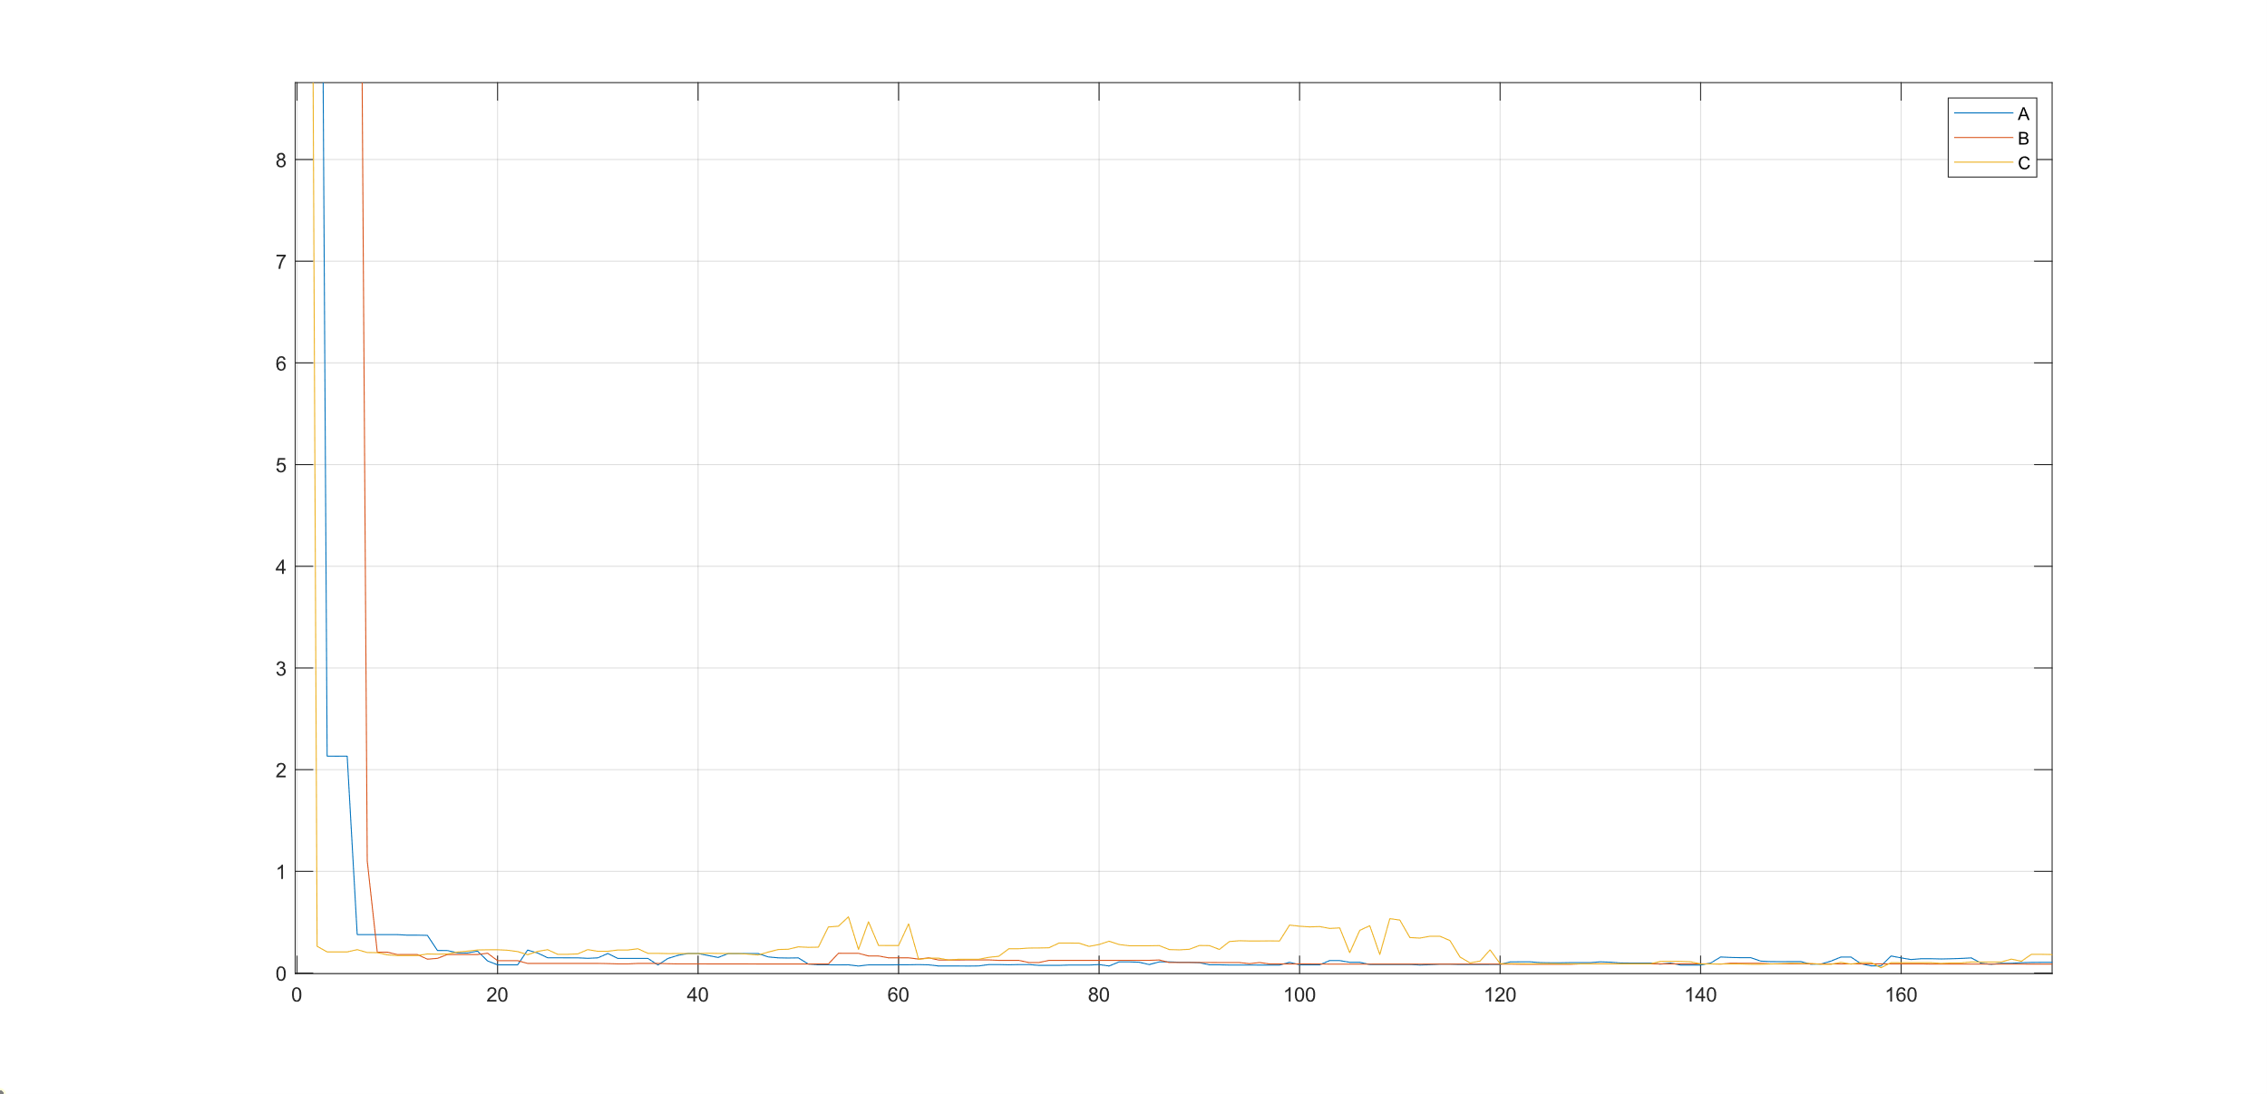

In type “B”, Due to the excessively low Crossover rate, it is challenging to find better solutions.

In type “C”, Increasing the Mutation rate can lead to finding better solutions, but during each iteration, the solutions found may exhibit slight perturbations.

1. Compare PSO、CS、GA (HW2_312512032.m)

|  |  |  |  |
| --- | --- | --- | --- |
| param\\Type | PSO | CS | GA |
| w | 0.729844 | NaN | NaN |
| C1 | 1.496180 | NaN | NaN |
| C2 | 1.496180 | NaN | NaN |
| pa | NaN | 0.25 | NaN |
| Crossover rate | NaN | NaN | 0.8 |
| Mutation rate | NaN | NaN | 0.03 |
| Bit size | NaN | NaN | 32 |
| Best f(x) | 4.89272e-22 | 0.00010862 | 0.0163778 |

range = [-2 2]; iterate=500; dimension=2;

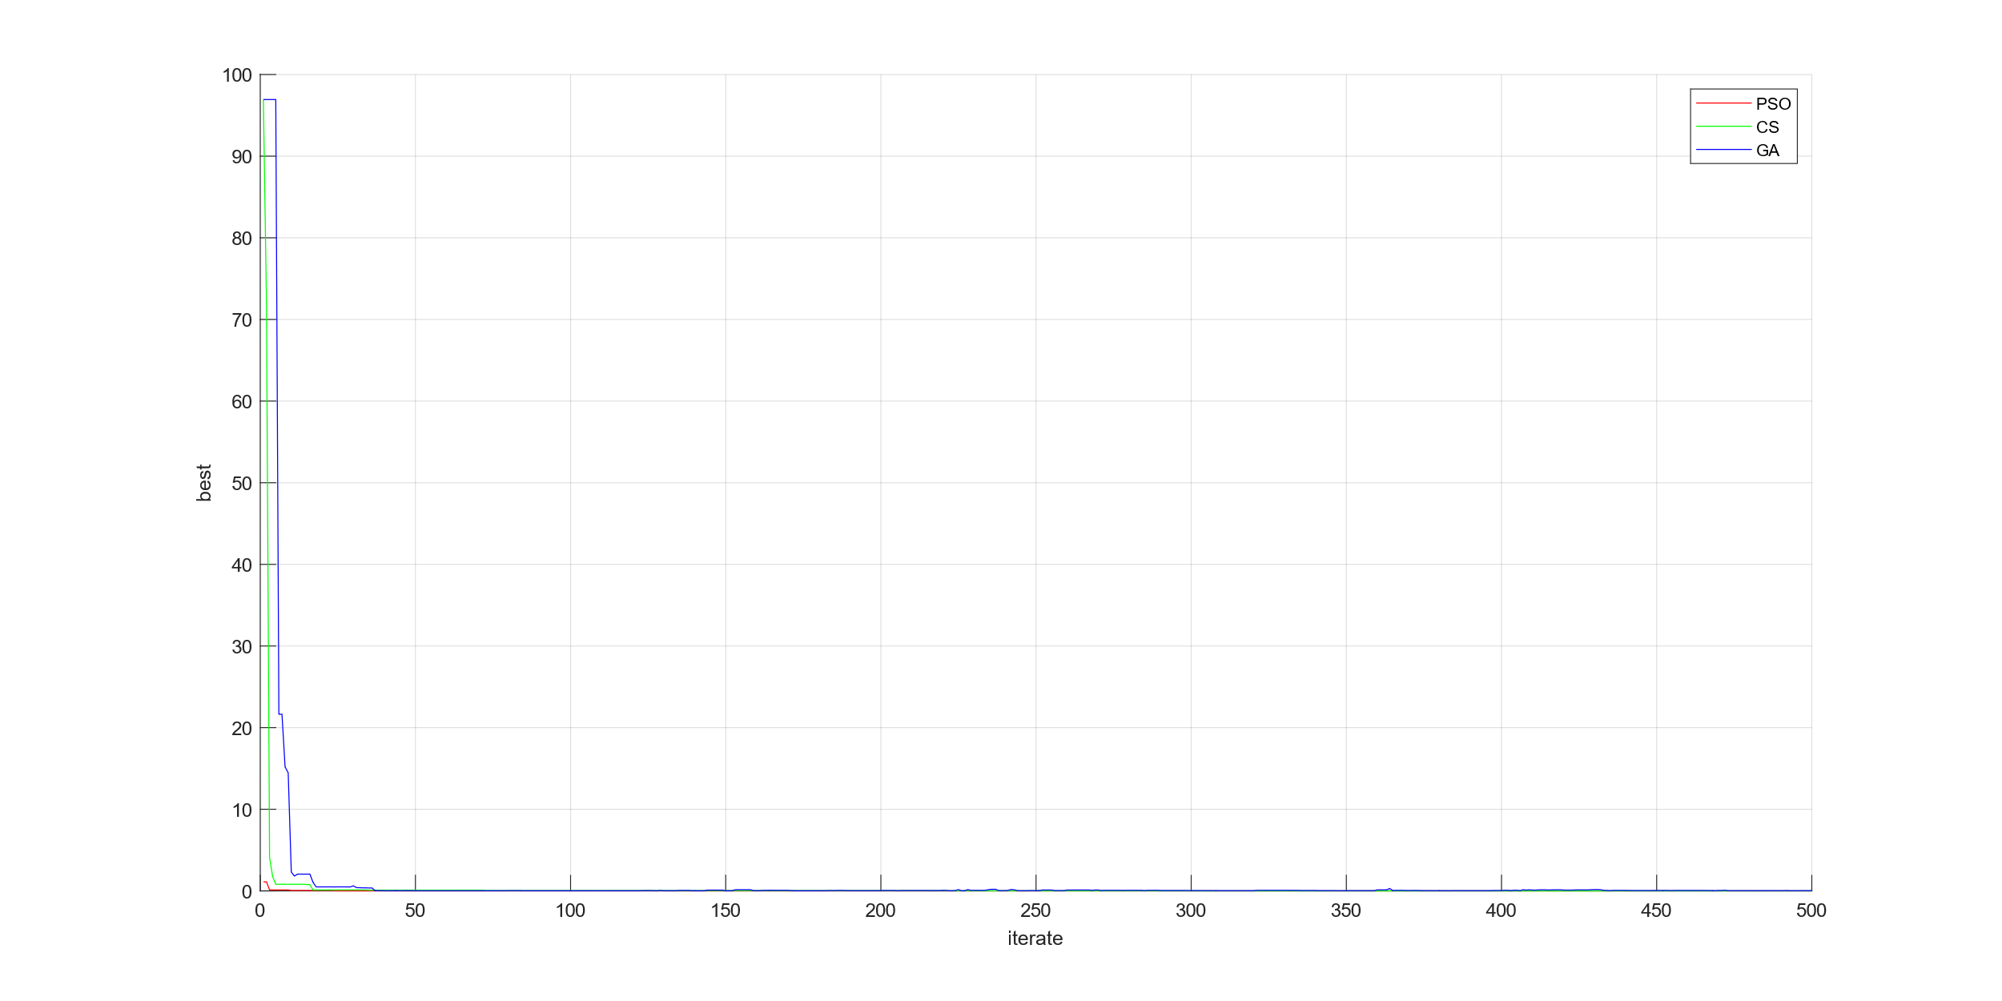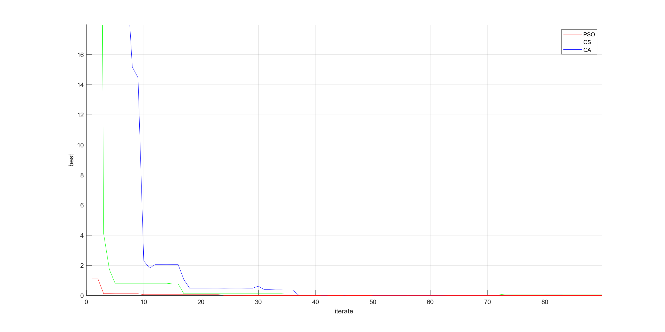

"In this experiment, the implementation difficulty is arranged from low to high as PSO, CS, GA. However, due to the low-dimensional and simple nature of the test functions used, it is challenging to discern whether GA possesses superior capabilities in finding solutions for multivariate test functions or functions with numerous local extrema. Additionally, the number of bits significantly affects computation time and solution accuracy. Therefore, for low-dimensional test functions, using PSO and CS for solution search is a better choice." (The initial values for testing in all three methods are identical.)

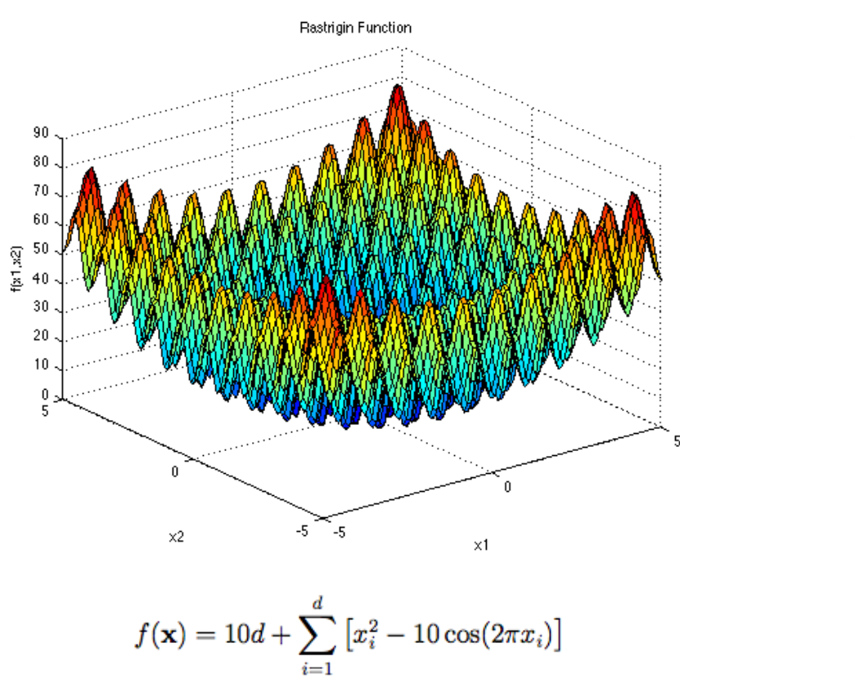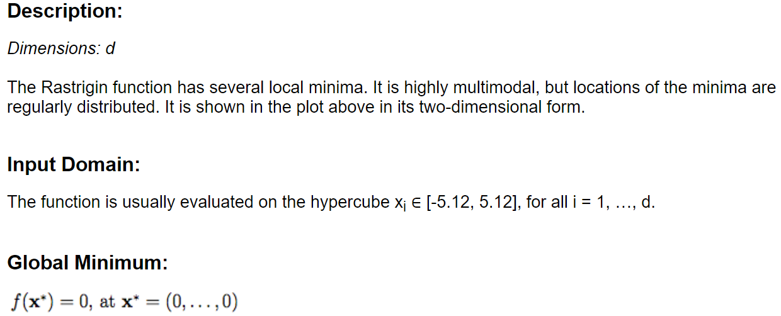

|  |  |  |  |
| --- | --- | --- | --- |
| param\\Type | PSO | CS | GA |
| Best f(x) | 3.9798362 | 0.25541 | 0.11503 |

range = [-2 2]; iterate=500; dimension=5;

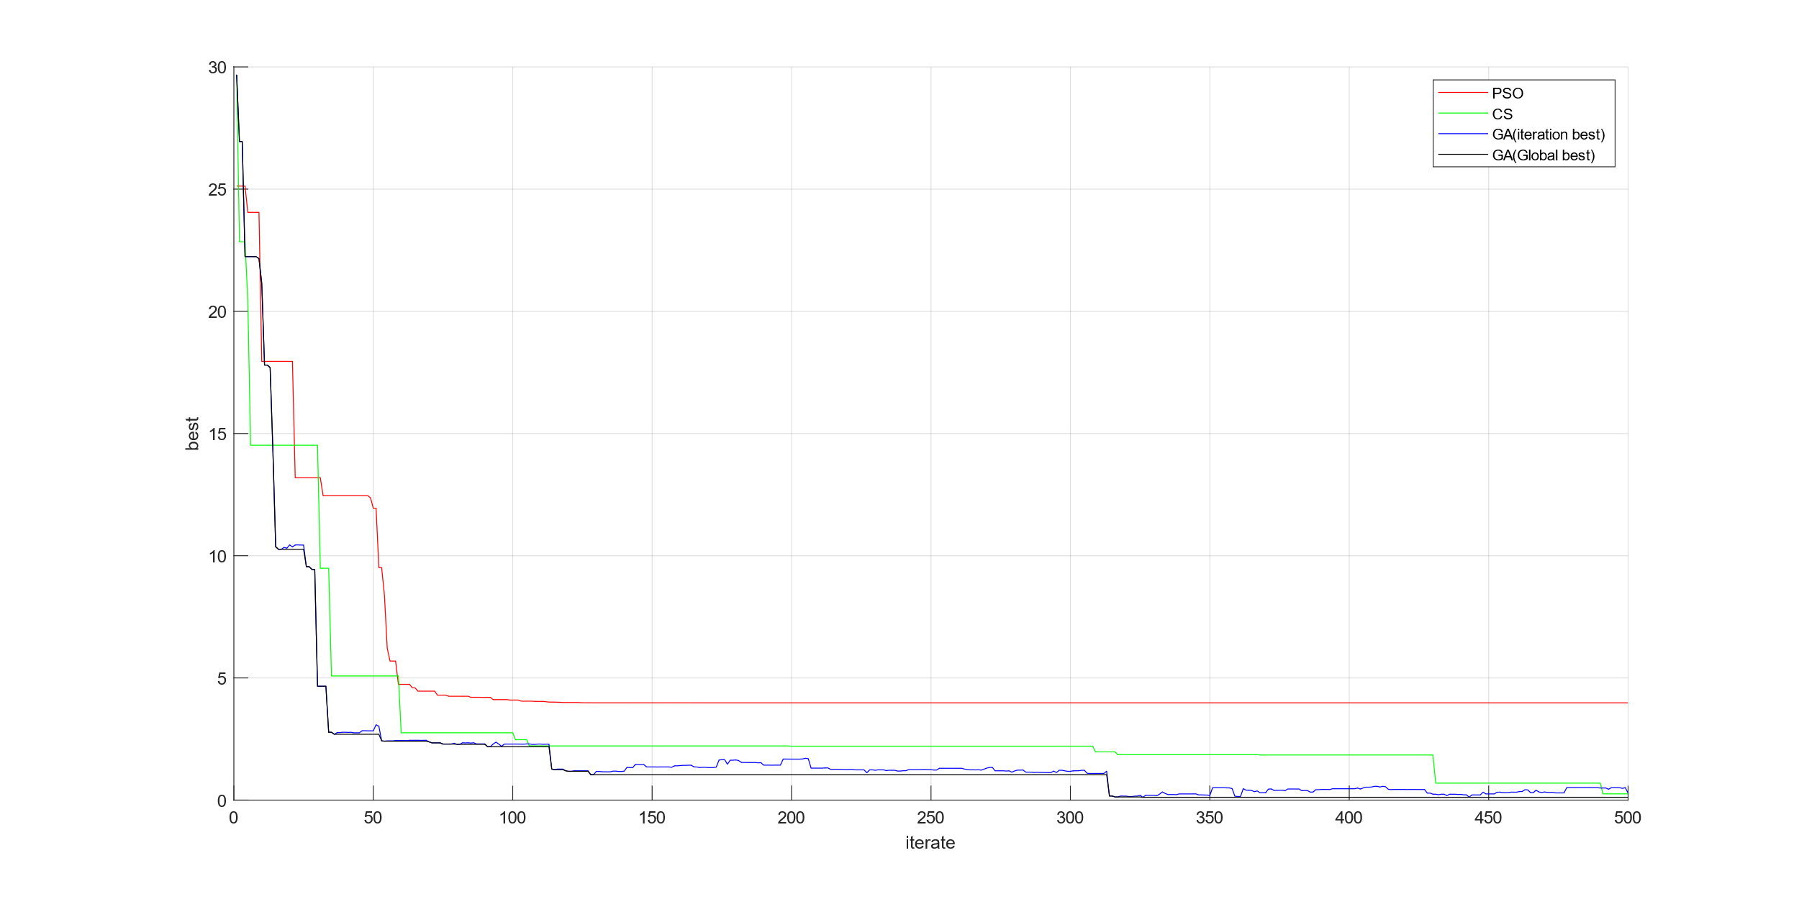  
"In this experiment, the parameters for each algorithm are the same as in the previous experiment, but the dimensionality of the test function is increased, and there is a significant number of local extrema. In this situation, the advantages of GA over other algorithms become evident."