**第10週**

1. DFT (DFS, DTFT) implementation in **Python** by

**(1)** nesting two (for …end) loop (下面function的名稱中， # = 1).

For a better efficient implementation, we would use matrix-vector multiplication.

**(2)** Write a DFT/IDFT pair function using matrix-vector multiplication as we discussed in the class.

下面function的名稱中， # = 2). (hint: generate  matrix first)

(注意: N值不可以固定，寫成一個function，可以隨呼叫而改變)

**function** [Xk] = my_DFT#(xn, N),

**function** [xn] = my_IDFT#(Xk, N)

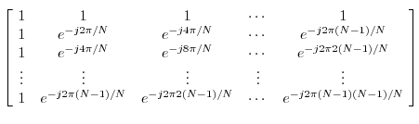

之後再以此自寫的FFT/IFFT重作下面的題目，並與numpy內的FFT function比較及驗證結果是否正確。

**2.**  (use the result from 1. above)

(a) Plot DFT(x[n]) using (after proper zero-padding)

(b) Plot IDFT (x[n]), using .(use the result (a) above) (use for loop)

**3.**  (use the result from 1. above)

(a) Compute DFT(x[n]) using (after proper zero-padding)

(b) Plot x[n], and compare it with IDFT of (a). (plot together)

(c) Downsample (decimate) the DFT of (a) by a factor of 4, and compute the IDFT (100 points), and plot it with for a comparison. Please comment on your observation.

4. (a) Implement a circular shift by “mod”

% circular shift of M samples with respect to size N in sequence x.

function y = cirshift(x,M,N)

(b) Given an N-point sequence  , determine and plot  for  .

**5.** , 

(a)use the DFT’s to compute their circular convolution by 41 points.

(b) use the DFT’s to compute their circular convolution by 50 points.

(c) Implement their linear convolution by proper zero-padding (e.g. 64 points) and verify your answer by **conv** function.

(d) (c) How many points are wrong in (a),(b) compared with (c).