**DSP LAB 15**

1. 以加窗法設計並驗證課本內之例題(P.102、P.104)，算出h[n]並繪出頻譜以確認是否合乎規格要求。
2. P.102， $f_{p}=1.5kHz, ∆f=0.5kHz, R_{p}=0.1dB, A_{s}>50dB,F_{s}=8kHz$，低通濾波器

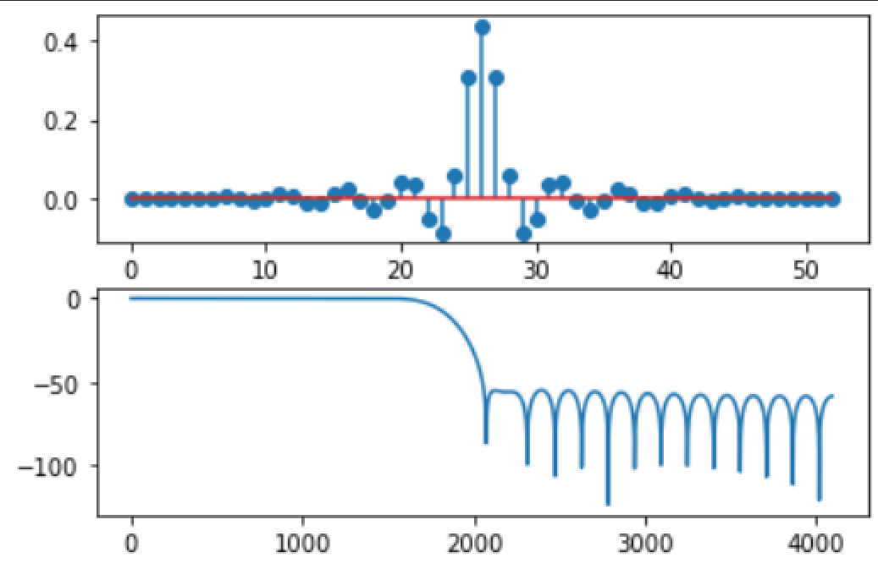

1. P.104， $ω_{1s}=0.1π, A_{s}=60dB ,ω_{1p}=0.25π, R_{P}=1dB$

$ω_{2p}=0.55π, R_{P}=1dB ,ω_{2s}=0.7π, A_{s}=60dB$，帶通濾波器

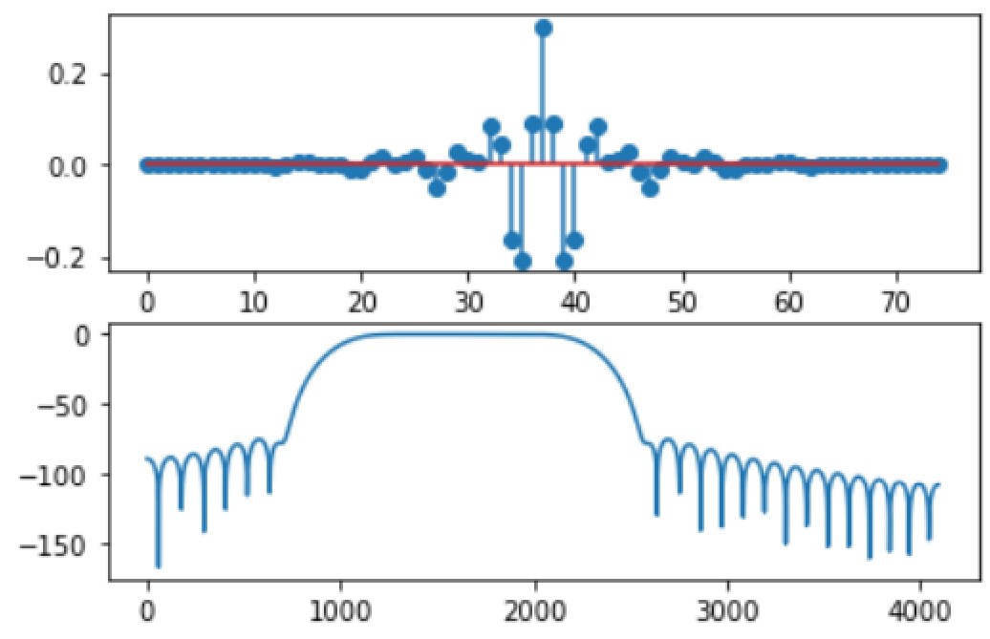

1. 試以加窗法設計下面規格之高通濾波器：

阻帶邊緣頻率： $ω_{s}=0.4π$, 

通帶邊緣頻率： $ω_{p}=0.6π$, 

並繪出所設計得的濾波器之脈衝響應及振幅頻率響應。

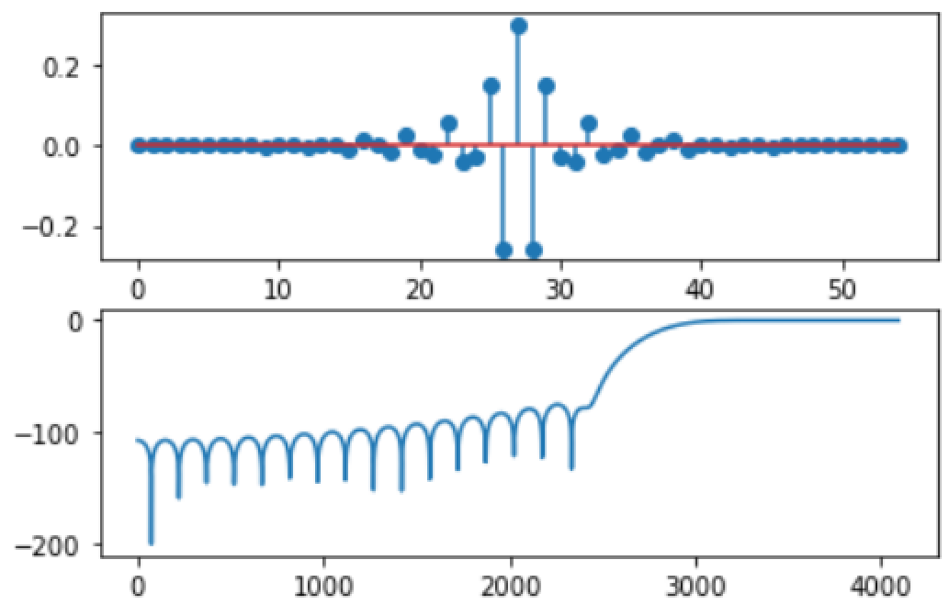

1. (Signal generation) Use python to generate a contaminated signal:
   * noise: Gaussian with zero mean and variances = 1, 2, 4
   * signal : (1) , where $f_{m}=4kHz,Fs=40kHz$ $∆f=0.5kHz$

(2) ,

1. Choose a proper sampling frequency and **show the spectra** of signal and signal+noise (6 cases). Assume noise is added after the signal was sampled.
2. **Design an FIR** low pass or band pass filter (define your own specification and pick your own method) to process the contaminated signals. Show your results in time and frequency domain.

1.

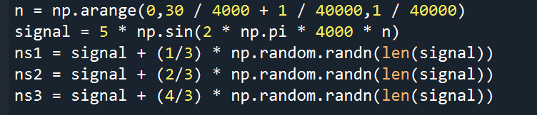

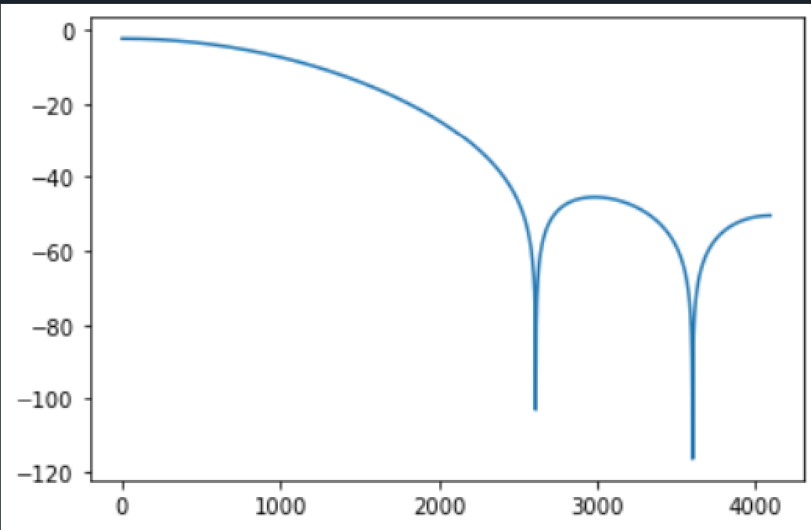

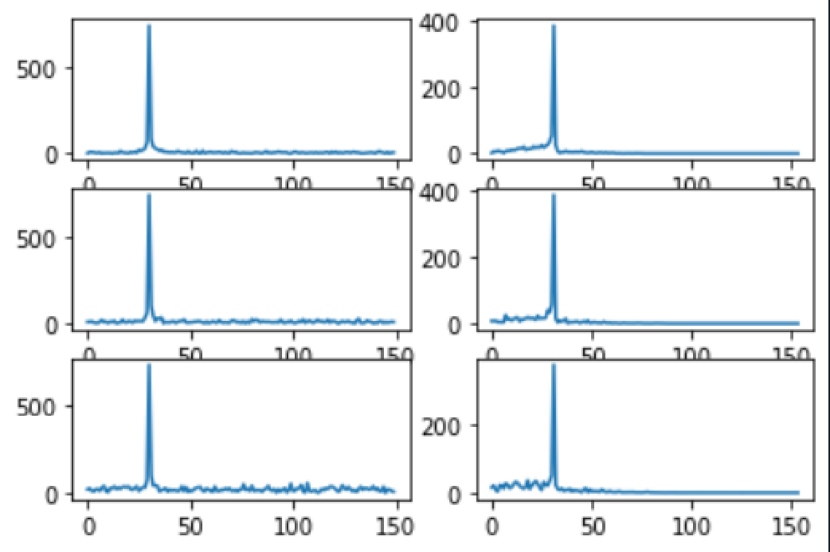

2.

