PROJECT CHARTER AND PROJECT PROPOSAL
Educational Resource Management and Sharing Platform for Universities in Sierra Leone
This proposal is prepared for an IT Project Management assignment. The proposed system is a university-focused educational resource management platform designed to support controlled resource uploads, multimedia access, administrative review and database-backed resource sharing.
Table of Contents
Section | Page
1. Executive Summary | 2
2. Problem Identification | 2
3. Requirement Gathering and User Interviews | 3
4. Requirements Specification | 4
5. Project Charter | 5
6. Product Life Cycle and SDLC Model | 6
7. Risk Management Plan | 6
8. Work Breakdown Structure | 7
9. Gantt Chart, Dependencies and Critical Path | 8
10. Conclusion | 8
References | 9
The table of contents is arranged to fit the 9-page limit while covering all marked areas in the brief: problem identification, requirement gathering, project charter, project plan, WBS, Gantt chart and critical path analysis.

1. Executive Summary
This proposal presents the development of a web-based Educational Resource Management and Sharing Platform for universities in Sierra Leone. The system will allow lecturers to upload learning resources, allow administrators to review and approve submitted materials, and allow students to access approved resources through a centralized repository. The platform will support PDF files, DOCX files, presentations, videos, audio files, research materials and educational links.
The proposed solution responds to common academic resource management challenges such as scattered learning materials, poor version control, limited access to multimedia resources, weak approval procedures and difficulty retrieving study materials. The system will be implemented using HTML, CSS, JavaScript and Bootstrap for the frontend, Python Flask for the backend, SQLite for development storage and MySQL for the production database. Git and GitHub will be used for source control and project tracking.
The project will follow an Agile development approach because the system contains multiple modules that can be designed, developed, tested and improved incrementally. The final product will include user authentication, lecturer uploads, student access, administrative approval, resource categorization, search and filtering, dashboard summaries, audit logging and multimedia resource handling.
2. Problem Identification
2.1 ICT Problem
Universities depend heavily on learning materials, yet many resources are still shared through informal channels such as email, WhatsApp groups, flash drives and individual cloud folders. These methods make it difficult for students to locate updated materials and difficult for lecturers to manage resources consistently. Administrators also lack a clear method for verifying, approving and monitoring the distribution of institutional academic content.
2.2 Justification and Impact
• Students may receive outdated or duplicated learning materials.
• Lecturers spend additional time resending notes, slides, recordings and documents.
• Administrators cannot easily monitor uploaded academic content.
• Large video and audio resources are difficult to distribute through informal channels.
• There is no single repository for organizing university learning resources.
A centralized platform is therefore required to improve access, control, organization and long-term management of academic resources. This aligns with project management principles that emphasize clear scope, stakeholder involvement and structured planning (Schwalbe, 2022).

3. Requirement Gathering and User Interviews
Requirement gathering was carried out through interviews with three stakeholder groups: a lecturer, a student and an administrator. The aim was to identify current problems, expected system functions and operational needs. This supports the requirement engineering principle that system development must begin with a clear understanding of user needs (Sommerville, 2020).
Stakeholder | Question | Response Summary | Need Identified
Lecturer | What difficulties occur when sharing materials? | Resources are shared through email and messaging apps. Students sometimes use outdated files. | Central upload area, categorization, multimedia support.
Student | What problems occur when accessing materials? | Resources are scattered across many channels, especially during revision. | Search, filtering, download, video and audio access.
Administrator | What controls should the system provide? | Uploaded resources should be reviewed before students access them. | Approval workflow, audit logs, dashboard monitoring.
3.1 User Needs Summary
User Group | Main Needs | Priority
Lecturers | Upload documents, videos, audio files, slides and research resources. | High
Students | Search, view, play and download approved resources. | High
Administrators | Approve resources, monitor activity and maintain audit records. | High
3.2 Requirement Findings
The interviews show that the system must be more than a file upload tool. It must support resource organization, multimedia access, role-based access and approval workflows. The requirement findings also confirm that the database design must capture metadata such as title, description, category, resource type, file name, owner and approval status.
• Lecturers require simple upload and resource management.
• Students require fast and organized access to learning materials.
• Administrators require approval, monitoring and reporting features.
• The system must support files, videos, audio resources and links.

4. Requirements Specification
The requirements below translate the stakeholder interviews into measurable system features. They are separated into functional requirements, which define what the system must do, and non-functional requirements, which define how well the system should operate.
ID | Functional Requirement | User Benefit
FR1 | User registration and login | Controls access
FR2 | Role-based access for lecturer, student and admin | Separates responsibilities
FR3 | Lecturer resource upload | Supports content submission
FR4 | PDF, DOCX and PPT upload | Supports common academic files
FR5 | Video and audio upload | Supports multimedia learning
FR6 | Resource categorization | Improves organization
FR7 | Admin approval workflow | Improves governance
FR8 | Search and filtering | Improves retrieval
FR9 | Download and resource viewing | Improves access
FR10 | Dashboard statistics and audit logs | Supports monitoring
4.2 Non-Functional Requirements
ID | Non-Functional Requirement | Reason
NFR1 | Security through authentication | Protects users and resources
NFR2 | Usability and clear navigation | Supports non-technical users
NFR3 | Performance during search and downloads | Improves user experience
NFR4 | Reliability of database storage | Prevents resource loss
NFR5 | Maintainability of source code | Supports future updates
NFR6 | Scalability for more users and resources | Supports university growth
NFR7 | Responsive web interface | Supports different devices
NFR8 | Backup and recovery support | Reduces data loss risk
These requirements create a clear basis for design, development and testing. They also support a project plan where tasks can be grouped into interface design, backend development, database development, testing and deployment.

5. Project Charter
5.1 Project Title
Educational Resource Management and Sharing Platform for Universities in Sierra Leone
5.2 Purpose
The purpose of the project is to develop a centralized university resource management platform that improves access to learning materials and provides a controlled workflow for uploading, approving and distributing academic resources.
5.3 Objectives
• Develop a secure web platform for university learning resources.
• Allow lecturers to upload documents, videos, audio files, presentations and research materials.
• Allow administrators to approve resources before publication.
• Allow students to search, view and download approved resources.
• Provide dashboard information and audit records for monitoring.
5.4 Scope
Included in Scope | Excluded from Scope
Authentication, lecturer uploads, student access, admin approval, search, downloads, dashboard, audit logs, document support, video support, audio support, SQLite and MySQL databases. | Online payments, live video conferencing, social media features, native mobile app development and integration with external university systems.
5.5 Stakeholders and Deliverables
Stakeholder | Role | Main Deliverable
Students | Access approved resources | Student resource library
Lecturers | Upload and manage resources | Upload dashboard
Administrators | Approve and monitor resources | Admin dashboard
ICT Support | Maintain system | Deployment and backup support
5.6 Tools and Technologies
The frontend will use HTML, CSS, JavaScript and Bootstrap. The backend will use Python Flask. SQLite will be used during development because it is lightweight and simple for local testing. MySQL will be included as the production database deliverable because it is suitable for larger multi-user deployment. Git and GitHub will be used for version control and project history.

6. Product Life Cycle and SDLC Model
Life Cycle Phase | Application to the Project
Initiation | Problem identified and project proposal prepared.
Planning | Requirements, schedule, resources and risks defined.
Design | Database, interface and architecture planned.
Development | Frontend, backend and database modules implemented.
Testing | Functional and integration testing conducted.
Deployment and Maintenance | System prepared for use and future improvement.
6.1 Selected SDLC Model: Agile
Agile is selected because the system can be built in increments. Authentication, upload management, admin approval, resource viewing, dashboards and multimedia handling can each be developed, tested and improved separately. Agile also supports stakeholder feedback, which is important for a university system where lecturers, students and administrators have different priorities (Agile Alliance, 2024; Sommerville, 2020).
7. Risk Management Plan
Risk | Impact | Probability | Mitigation
Schedule delay | High | Medium | Weekly milestone checks and early testing.
Changing requirements | Medium | Medium | Confirm priorities with stakeholders before implementation.
Data loss | High | Low | Use SQLite backups during development and MySQL backup planning.
Security weakness | High | Medium | Use authentication, role checks and testing.
Deployment failure | Medium | Low | Prepare deployment checklist and rollback plan.
Low user adoption | Medium | Medium | Provide simple interface and user guidance.
Risk management is necessary because project delays, weak requirements and poor testing can affect delivery. Project management literature emphasizes planning, monitoring and controlled execution as key practices for successful IT projects (Schwalbe, 2022).

8. Work Breakdown Structure
WBS Code | Task | Output
1.0 | Project Initiation | Problem statement and proposal
2.0 | Requirement Analysis | Interview findings and requirements
3.0 | System Design | Interface and database design
4.0 | Database Development | SQLite and MySQL schema
5.0 | Frontend Development | User pages and dashboards
6.0 | Backend Development | Flask routes and business logic
7.0 | Integration | Connected frontend, backend and database
8.0 | Testing | Testing report and corrections
9.0 | Documentation | User guide and final proposal
10.0 | Submission | Final project package
9. Task Dependencies and Critical Path
9.1 Task Dependencies
• Requirement gathering must finish before system design can be finalized.
• System design must guide database and interface design.
• Database development must support backend resource upload and approval functions.
• Frontend and backend must both finish before integration.
• Integration must finish before full testing.
• Testing must finish before documentation and final submission.
9.2 Critical Path Analysis
The critical path is: Requirement Gathering -> System Design -> Database Development -> Backend Development -> Integration -> Testing -> Documentation -> Final Submission. These tasks directly determine the project completion date. If any task on this path is delayed, the final submission will also be delayed unless time is recovered in a later activity.
9.3 Project Success Criteria
• Lecturers can upload documents, videos and audio resources.
• Administrators can review and approve resources.
• Students can access and download approved materials.
• Resource data is stored in SQLite during development and prepared for MySQL production use.
• The project is pushed to GitHub and submitted with documentation.

10. Gantt Chart: Week 2 to Week 11 Schedule
The schedule below follows the assignment timeline. The proposal begins in Week 2, while implementation activities run mainly from Week 4 to Week 11. The chart also shows that design, database, backend, integration and testing activities are time-sensitive because they form part of the critical path.
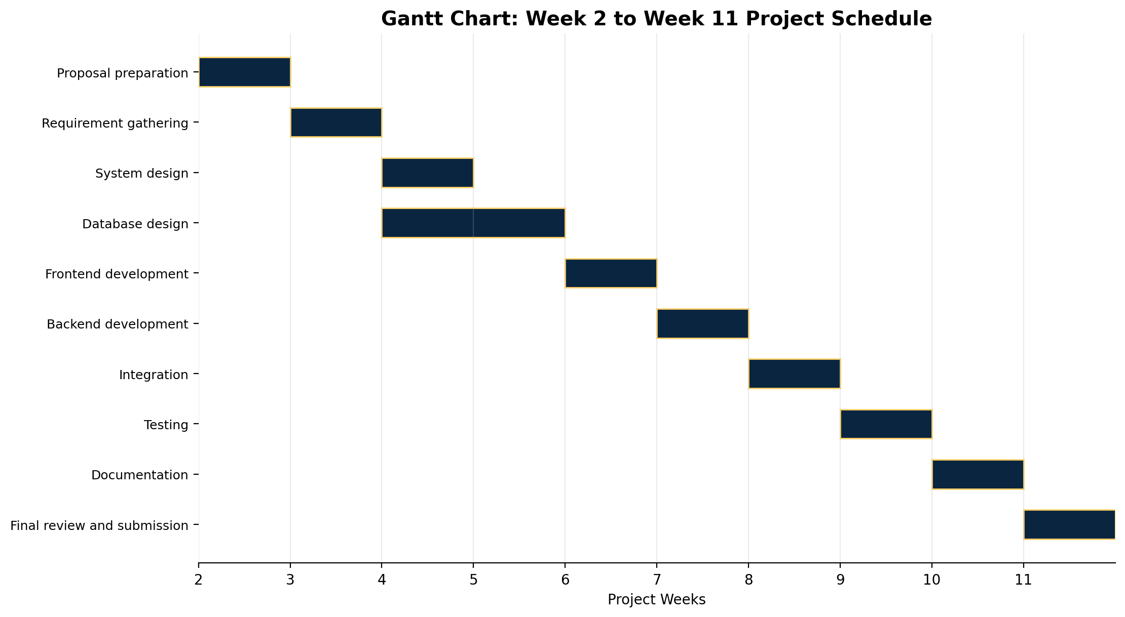
10.1 Gantt Chart Summary
Activity | Start | Finish | Dependency
Proposal | W2 | W2 | None
Requirements | W3 | W3 | Proposal
Design | W4 | W4 | Requirements
Database | W4 | W5 | Design
Frontend | W6 | W6 | Design
Backend | W7 | W7 | Database
Integration | W8 | W8 | Frontend and Backend
Testing | W9 | W9 | Integration
Documentation | W10 | W10 | Testing
Submission | W11 | W11 | Documentation
11. Conclusion
The proposed platform will improve how universities organize and distribute learning resources. It provides a controlled workflow for lecturer uploads, administrator review and student access. The project plan includes requirement gathering, scope definition, deliverables, product life cycle, Agile development, risk management, WBS, a Gantt schedule and critical path analysis, meeting the key planning requirements for the assignment.

References
Agile Alliance (2024) What is Agile? Available at: https://www.agilealliance.org (Accessed: 5 June 2026).
Pressman, R.S. and Maxim, B.R. (2020) Software Engineering: A Practitioner's Approach. 9th ed. New York: McGraw-Hill.
Schwalbe, K. (2022) Information Technology Project Management. 10th ed. Boston: Cengage Learning.
Sommerville, I. (2020) Software Engineering. 10th ed. Harlow: Pearson.
Turban, E., Pollard, C. and Wood, G. (2021) Information Technology for Management: Driving Digital Transformation. 12th ed. Hoboken: Wiley.

