**Testcases:**

|  |
| --- |
|  |
| **Test Case** | **Description** | **Input** | **Expected Output** | **Actual Result** | **Screenshot** |
| 1 | Minimum valid date | SimpleDate(1, 1, 1842) | The date is valid. |  |  |
| 2 | Maximum valid date | SimpleDate(12, 31, 2042) | The date is valid. |  |  |
| 3 | Date with invalid day | SimpleDate(2, 31, 2000) | The date is invalid. | IllegalArgumentException: Invalid Date |  |
| 4 | Date with invalid month | SimpleDate(13, 15, 2000) | The date is invalid. | IllegalArgumentException: Invalid Date |  |
| 5 | Date with invalid year | SimpleDate(5, 15, 2043) | The date is invalid. | IllegalArgumentException: Invalid Date |  |
| 6 | Next date within the same month | SimpleDate(6, 20, 2022) | The next date is SimpleDate(6, 21, 2022). | SimpleDate(6, 21, 2022) |  |
| 7 | Next date at the end of a month | SimpleDate(2, 28, 2020) | The next date is SimpleDate(2, 29, 2020). | SimpleDate(2, 29, 2020) |  |
| 8 | Next date at the end of February in a non-leap year | SimpleDate(2, 28, 2021) | The next date is SimpleDate(3, 1, 2021). | SimpleDate(3, 1, 2021) |  |
| 9 | Next date at the end of December | SimpleDate(12, 31, 2041) | The next date is SimpleDate(1, 1, 2042). | SimpleDate(1, 1, 2042) |  |

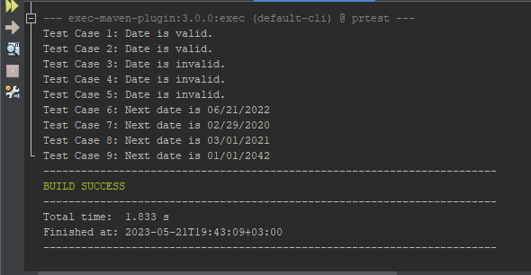

Figure : Combined screenshot of output