URLs for each of your pages.

**URL TABLE**

|  |  |
| --- | --- |
| **Page File** | **URL** |
| Index.html | http://127.0.0.1:5500/index.html |
| About.html | http://127.0.0.1:5500/About.html |
| Services.html | http://127.0.0.1:5500/services.html |
| Gallery.html | http://127.0.0.1:5500/gallery.html |
| Contact.html | http://127.0.0.1:5500/contact.html |
| Template.html | http://127.0.0.1:5500/template.html |

Names of the browsers you used to view the pages.

Chrome, Firefox

Pasted image from your validation screen capture.

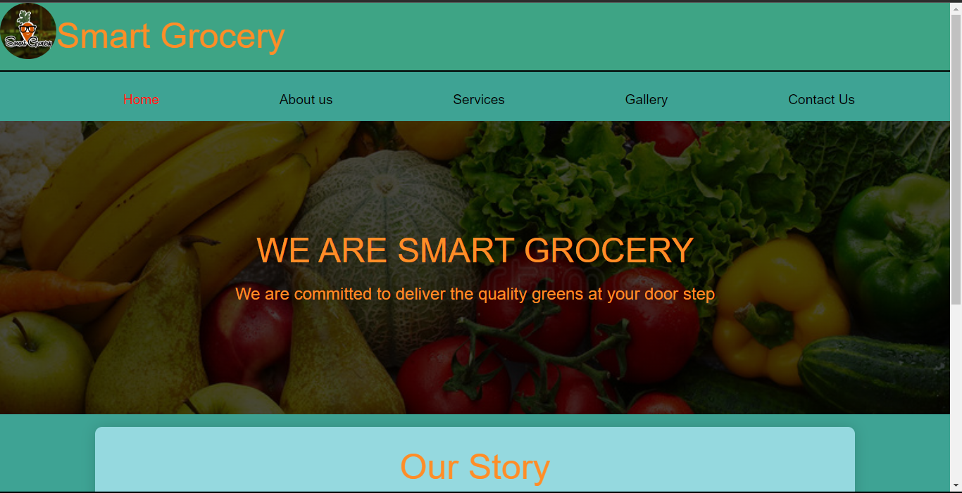

Figure 1 1: smart grocery homepage

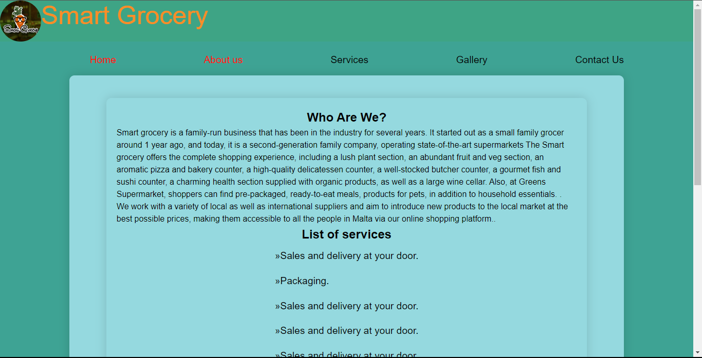

Figure 2: About us page

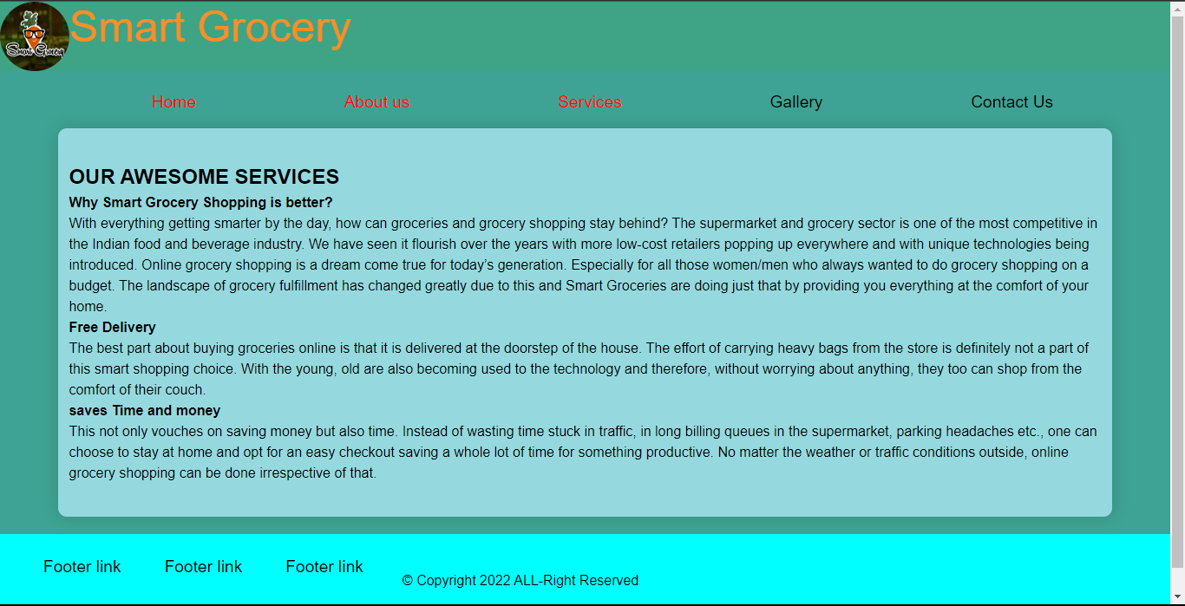

Figure 3: services page

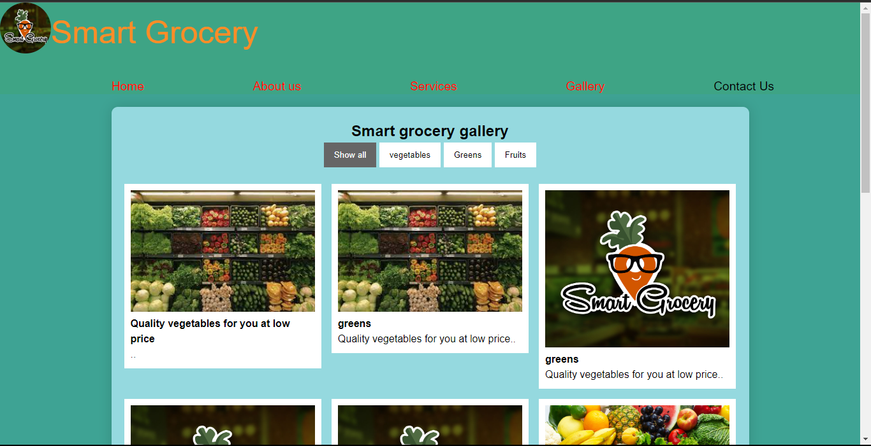

Figure 4: Gallery

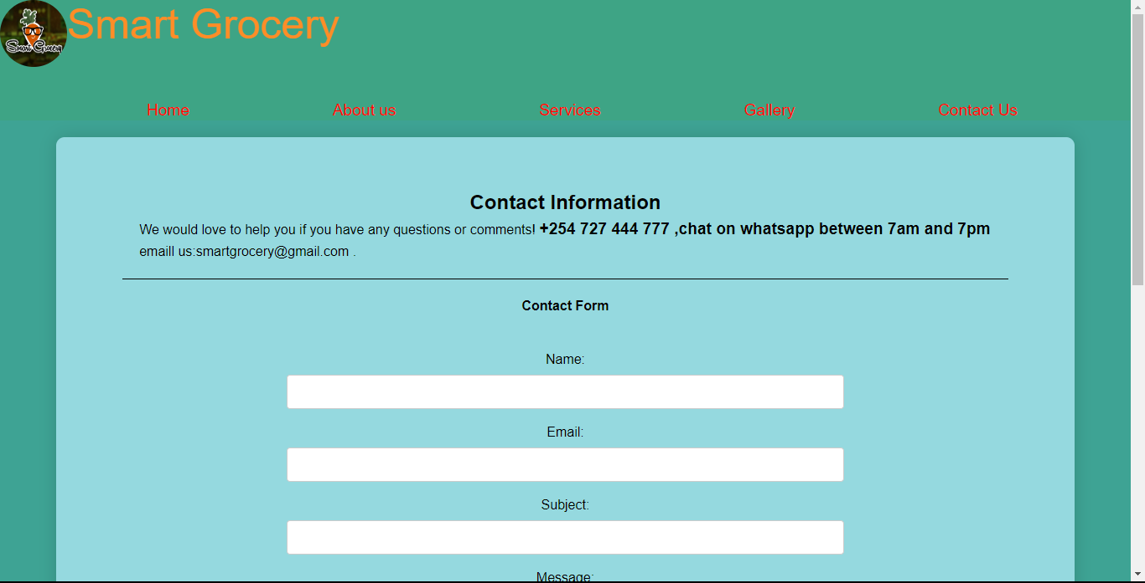

Figure 5: Contact page

Any ancillary files such as graphic or photos you may have decided to include.

