When pandemic outbreaks it shows how we are as community not prepared to tackle this situation.In country with large population centre point of spread is happened when buying essentials(groceries and vegtables) where people not following social distancing which makes the situation worse.
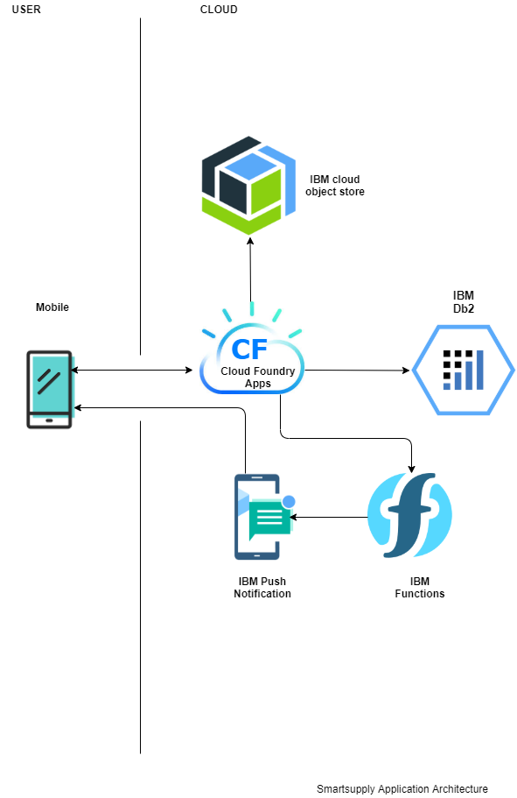

we build an app that connects local vendors who need to sell their items and customers who are in need of essentail items with safety and socail distancing as main goal. we are engaging to build this solution quickly with IBM cloud based service like IBM cos,functions..so.. on.

Road map:
