SUPPORTPILOT
Product Requirements and Scope
What SupportPilot is, who uses it, and what the first production-ready version must do
Document ID | SP-PRD-001
Status | Architecture baseline for implementation
Version | 1.0
Date | 2026-09-07

Purpose
This document defines the agreed SupportPilot product and secure implementation. It is written in simple English so product, engineering, security, and operations teams can use the same design.

Contents
- Product Definition
- Users and Roles
- Product Scope
- Core User Journeys
- Functional Requirements
- Security and Quality Requirements
- Product Rules
- Success Criteria
- Assumptions and Open Decisions
- Glossary

1. Product Definition
SupportPilot is a multi-tenant AI support agent built on Onyx. It helps authorized support staff find customer, order, shipment, and ticket information; summarize support history; and request controlled business actions. The product uses real services, a persistent PostgreSQL database, individual user identities, policy-based authorization, approval workflows, and audit records.
Core rule: The model may propose tool use, but trusted services decide what is allowed and perform every real action.

Product goals
- Reduce the time required to find and explain support information.
- Preserve the permissions of the authenticated user on every request.
- Allow useful automation without giving the model unrestricted database or system access.
- Require independent approval for financial, administrative, destructive, or externally visible actions.
- Create evidence that explains who requested, approved, and executed each sensitive action.

Non-goals for the first release
- Autonomous refunds without approval.
- Free-form SQL generated by the model.
- General shell, file-system, or cloud-administration access.
- Training or fine-tuning a foundation model.
- Replacing the existing customer-support system of record before integrations are proven.

2. Users and Roles
Role | Purpose | Typical permissions
Support Agent | Handles normal customer questions. | Read assigned customer and order data; create notes; propose limited actions.
Support Manager | Supervises support work. | Read team records; approve selected actions within policy limits.
Finance Approver | Reviews financial actions. | Approve or reject refund requests within assigned limits.
Auditor | Reviews evidence. | Read audit records and action history; no business-data changes.
Product Administrator | Manages agents and tool registration. | Control-plane access; no automatic business-data access.
Platform Administrator | Operates infrastructure. | Deployment and emergency administration through separate accounts.

A person can hold more than one role, but sensitive approvals must still satisfy separation-of-duty rules. The requester cannot approve the same high-impact action when policy requires an independent approver.

3. Product Scope

Included business objects
- Organizations and organization memberships.
- Customers and customer contact details.
- Orders and order items.
- Shipments and shipment status.
- Support tickets and ticket messages.
- Internal support notes.
- Refund requests, approval decisions, action jobs, and execution results.
- Audit events and idempotency records.

Initial tool scope
Tool | Type | Behavior
search_customers | Read | Find customers visible to the authenticated user.
get_customer | Read | Return an approved subset of one customer record.
get_order | Read | Return order, item, and shipment status for an authorized order.
get_ticket | Read | Return a ticket and permitted conversation history.
add_internal_note | Write | Add an internal note after authorization and input checks.
propose_refund | Proposal | Create a pending refund request; does not move money.
get_action_status | Read | Return the status of a previously requested action.

4. Core User Journeys

Read an order
- The user signs in through Keycloak and opens the SupportPilot agent in Onyx.
- The user asks for order ORD-2001.
- The model requests the get_order tool with the order number.
- Onyx sends the tool request and the user access token to the SupportPilot API.
- The API validates identity, obtains trusted resource attributes, and asks OPA for a policy decision.
- The API performs a parameterized database query under the restricted API database role.
- PostgreSQL row security limits returned rows to the organization in the trusted request context.
- The API returns a minimal result to Onyx, and the model writes the final answer.
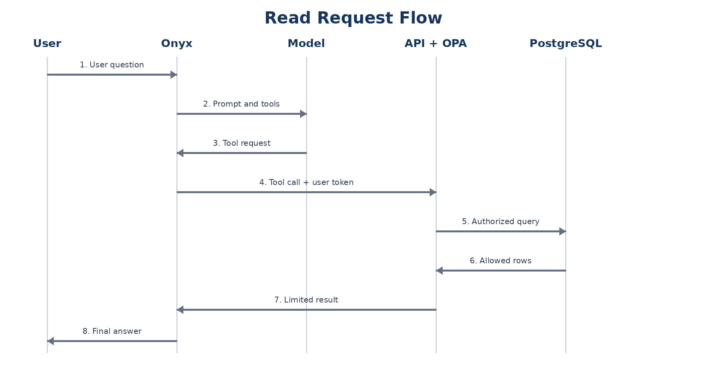

Request a refund
- The user asks for a refund and provides the order, amount, currency, and reason.
- The model requests propose_refund. The model does not call a payment provider.
- The API validates the order, amount, currency, reason, user permission, and tenant ownership.
- The API creates an immutable action request with a hash of the exact approved payload.
- An authorized independent approver reviews and approves or rejects the request.
- The worker claims the approved job and executes it once through an allowlisted business adapter.
- The worker stores the provider reference, outcome, timestamps, and audit records.
- The user checks the action status and receives the confirmed outcome.

5. Functional Requirements
ID | Requirement | Acceptance signal
FR-01 | Every chat user authenticates through the configured identity provider. | Requests without a valid token are rejected.
FR-02 | Onyx forwards the user identity to SupportPilot actions. | The API receives and verifies a user-bound token.
FR-03 | The model can call only explicitly registered tools. | No generic SQL, shell, HTTP, or file tool is available.
FR-04 | Read tools return only authorized records and approved fields. | Cross-organization and excessive-field tests fail safely.
FR-05 | Sensitive writes use proposal, approval, and worker execution. | The API cannot directly execute the protected effect.
FR-06 | Every tool request has a correlation identifier. | Logs can reconstruct one request across services.
FR-07 | Repeated action submissions do not cause repeated effects. | The same idempotency key produces one execution.
FR-08 | Users can inspect the status of their action requests. | Pending, approved, rejected, executing, succeeded, and failed states are visible.

6. Security and Quality Requirements
- Authorization is performed by trusted code for every tool call, including calls generated after reading untrusted content.
- The model never receives database passwords, service secrets, approval credentials, or unrestricted access tokens.
- User identifiers, organization identifiers, roles, and approval status are not trusted when supplied as model arguments.
- The runtime database roles do not own protected tables and do not have superuser or row-security bypass privileges.
- External text is treated as data. It cannot register tools, change policies, grant permissions, or modify system prompts.
- Tool parameters use strict schemas, length limits, type checks, enumerations, and business constraints.
- Agent loops have limits for model calls, tool calls, elapsed time, tokens, and cost.
- Sensitive output is minimized and redacted before it enters model context or logs.
- The system denies access when Keycloak, OPA, or required authorization data is unavailable.

7. Product Rules
Rule | Required behavior
Identity authority | Only the verified access token and server-side records define the current user and organization.
Tenant isolation | Every protected business object belongs to an organization and is checked at API and database layers.
Least privilege | Each service, database role, tool, and user receives only the permissions required for its task.
High-impact actions | The exact payload must be approved independently before execution.
No model authority | Model text, reasoning, confidence, or tool arguments never grant permission.
Evidence | Authorization decisions and sensitive state changes create tamper-evident audit events.

8. Success Criteria
- Alice can read an order in Cedar when her membership permits it.
- Alice cannot read another organization’s order by changing the order identifier.
- A prompt claiming administrator status does not change authorization.
- A malicious instruction stored in a ticket cannot add tools or change policy.
- A refund cannot execute before the required approval exists.
- The requester cannot approve their own refund when independent approval is required.
- Retrying an approved action does not execute the effect twice.
- The audit trail identifies the requester, approver, policy version, payload hash, executor, and outcome.

9. Assumptions and Open Decisions
Item | Current baseline | Decision point
System of record | Local PostgreSQL stores real persistent lab records. | Choose production migration or external-system adapters before production use.
Financial integration | Refund execution uses a controlled adapter. | Select the real payment or order-management provider and its sandbox.
Tenant model | One database with organization identifiers and row security. | Review regulatory or customer requirements for physical separation.
Deployment | Docker Compose for the local build. | Select the production container platform and managed services.
Availability targets | Not yet committed. | Define service-level objectives before production launch.
Data retention | Audit and business retention are configurable. | Approve legal and customer retention periods.

10. Glossary
Term | Meaning
Agent loop | The repeated cycle of model decision, tool request, tool result, and next model decision.
Control plane | Administration of agents, prompts, tools, policies, deployments, and credentials.
Data plane | Normal user requests, model calls, tool calls, database access, and action execution.
OPA | Open Policy Agent, the service that evaluates policy and returns a decision.
RLS | Row-level security in PostgreSQL.
Tool | A narrow operation the model may request through a defined schema.
Worker | A service that executes approved jobs outside the chat request.

