SUPPORTPILOT
Architecture and Security Design
Target components, trust boundaries, request flows, threats, and enforced controls
Document ID | SP-ARCH-001
Status | Architecture baseline for implementation
Version | 1.0
Date | 2026-09-07

Purpose
This document defines the agreed SupportPilot product and secure implementation. It is written in simple English so product, engineering, security, and operations teams can use the same design.

Contents
- Architecture Principles
- System Context
- Component Design
- Trust Boundaries
- Control Plane and Data Plane
- Read Flow
- Sensitive Action Flow
- Network Design
- Threat Model
- Failure Behavior
- Security Decisions
- References

1. Architecture Principles
- Identity is established before the agent can use business tools.
- The model proposes; trusted services authorize and execute.
- Every security rule has an enforceable boundary outside the prompt.
- Tools expose business operations rather than infrastructure primitives.
- High-impact actions are separated into request, approval, and execution.
- The control plane has separate administrative identities and change records.
- Services and database roles follow least privilege and deny by default.
- Audit evidence is generated at the point where trusted decisions and effects occur.

2. System Context
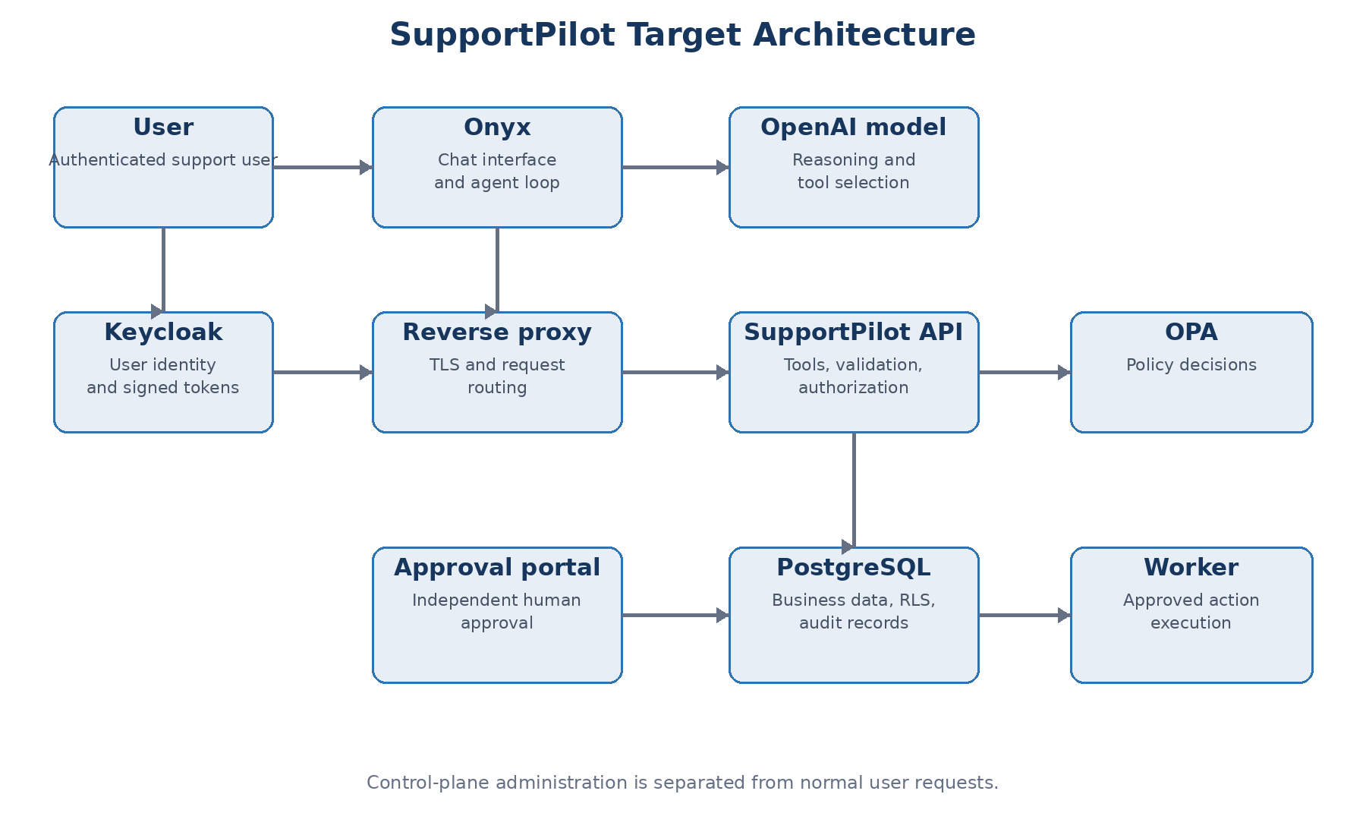
Onyx provides the user-facing agent experience and runs the agent loop. The OpenAI model chooses whether to answer or request a registered tool. SupportPilot owns business authorization, database access, action state, and audit evidence. Keycloak owns user authentication. OPA evaluates policy. PostgreSQL stores business and security state. The worker executes only approved jobs.

3. Component Design
Component | Responsibility | Must not do
Onyx | Chat, agent configuration, model interaction, and action invocation. | Connect directly to PostgreSQL or decide business authorization.
OpenAI model | Interpret requests, select tools, and write answers. | Hold credentials, approve actions, or directly execute effects.
Keycloak | Authenticate users and issue signed tokens. | Use model claims or chat text as identity evidence.
Reverse proxy | Terminate TLS, route requests, and apply request limits. | Replace application authorization.
SupportPilot API | Verify tokens, validate tools, request policy decisions, query data, and create action requests. | Execute protected financial effects in the synchronous request.
OPA | Evaluate structured authorization input against versioned policy. | Query business data directly or enforce the returned decision.
PostgreSQL | Store records, enforce grants and row policies, and maintain transactions. | Accept connections from Onyx or the public network.
Approval portal | Show exact action details and capture independent approval decisions. | Modify the action payload after approval.
Worker | Claim approved jobs and execute allowlisted effects once. | Accept model instructions or arbitrary network destinations.
Migration job | Apply reviewed schema and policy changes during deployment. | Run continuously or expose credentials to runtime services.

4. Trust Boundaries
Boundary | Untrusted side | Trusted control
User to Onyx | User messages and attachments. | Authentication, session controls, content limits.
Onyx to model | Model output may be incorrect or manipulated. | Strict tool schemas, loop limits, and external authorization.
Onyx to SupportPilot | Tool names and arguments originate from the model. | Token verification, schema validation, and allowlisted routes.
SupportPilot to OPA | Application input may be incomplete. | Server builds policy input from verified identity and trusted resource data.
SupportPilot to PostgreSQL | Application bugs and injection attempts. | Parameterized statements, database grants, RLS, and transactions.
Approval to worker | Stale or modified action state. | Immutable payload hash, state checks, approver identity, and idempotency.
Worker to provider | Provider errors, retries, and compromised destinations. | Allowlisted adapter, short-lived credential, timeout, and result verification.

5. Control Plane and Data Plane
Plane | Includes | Identity examples
Control plane | Agent prompts, tool registration, OPA policy bundles, deployments, database migrations, secrets, and administrator settings. | Onyx administrator, policy publisher, deployment identity, migration role, platform administrator.
Data plane | User chats, model calls, tool execution, database reads, action proposals, approvals, worker jobs, and audit events. | Authenticated support user, API workload identity, worker workload identity.

Required boundary: A user-facing service cannot register a new tool, change an approval rule, publish policy, alter database grants, or grant itself a new infrastructure permission.

Control-plane protections
- Separate administrator accounts with multi-factor authentication.
- Reviewed changes stored in version control.
- Protected branches and deployment approvals for policy, tool, and schema changes.
- No control-plane credential mounted into the user-facing API or worker.
- Change records that identify author, reviewer, version, time, and deployment result.

6. Read Flow
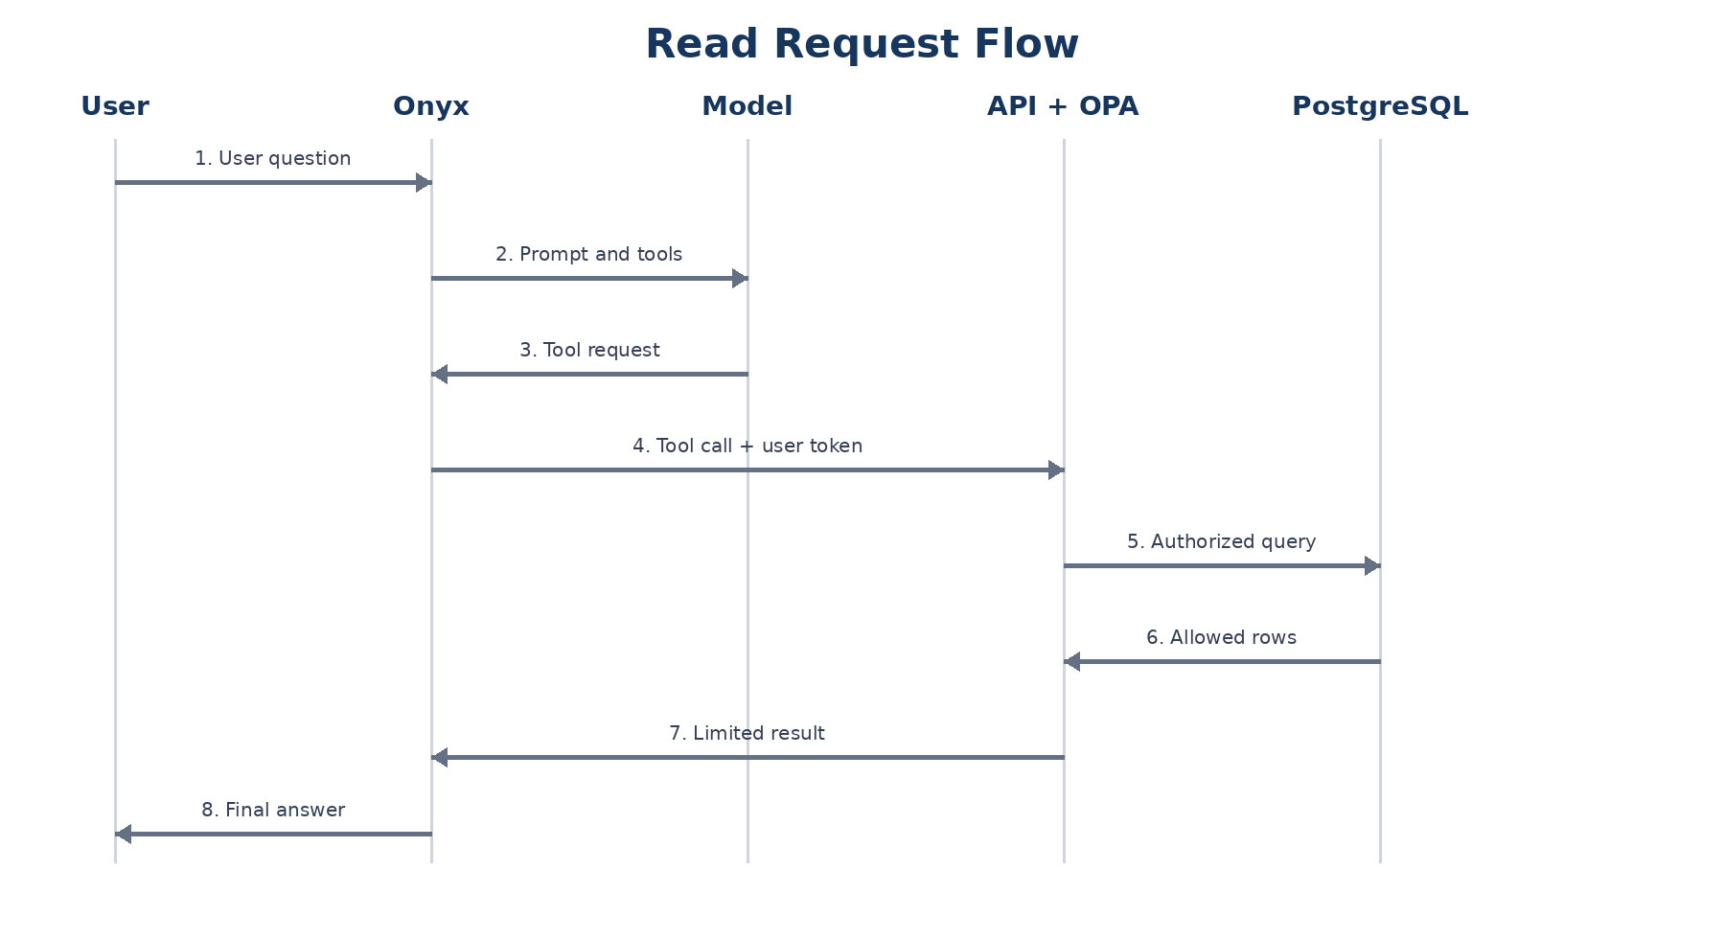
- The authenticated user asks a business question in Onyx.
- Onyx sends the question, conversation context, instructions, and registered tool schemas to the model.
- The model returns a typed tool request. It does not receive database credentials or write SQL.
- Onyx sends the tool request and user access token to the SupportPilot API.
- The API verifies the token and loads trusted resource attributes.
- The API asks OPA whether the subject may perform the action on the resource in the current context.
- When allowed, the API starts a database transaction, sets local user and organization context, and executes a parameterized query.
- PostgreSQL grants and row policies restrict the result. The API returns only approved fields.
- Onyx sends the tool result to the model. The loop continues until the model returns a final answer or reaches a limit.

7. Sensitive Action Flow
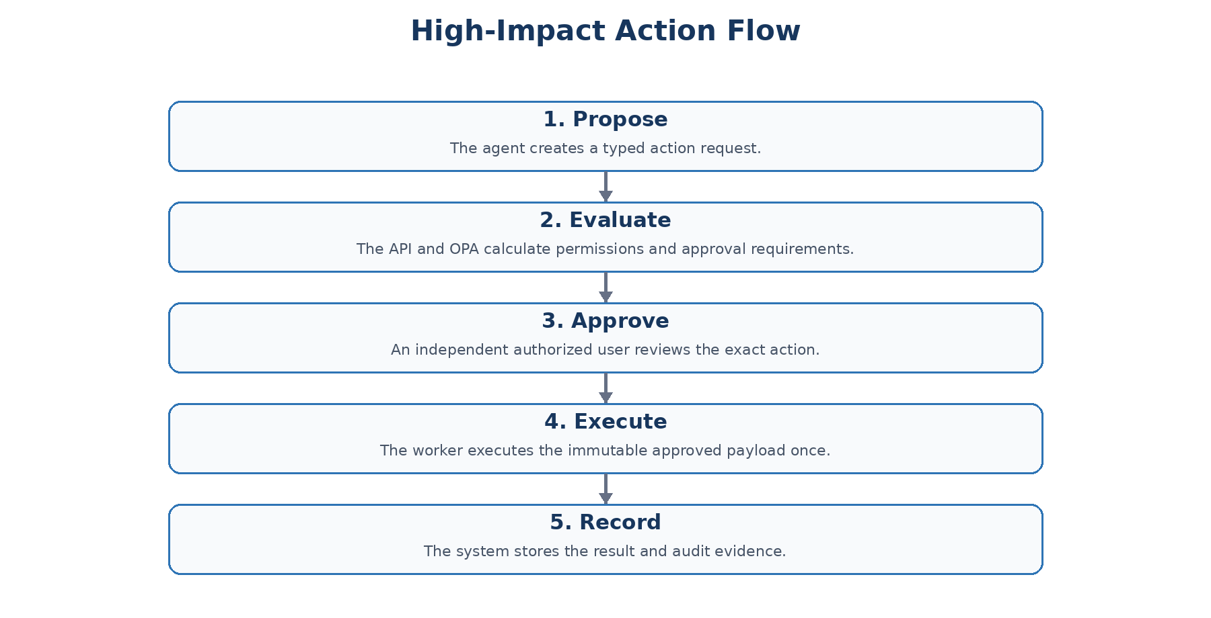
State | Who may create transition | Required checks
PROPOSED | SupportPilot API | Authorized requester, valid resource, schema, business limits.
PENDING_APPROVAL | SupportPilot API | Approval rule selected and immutable payload hash stored.
APPROVED | Approval portal | Authorized independent approver, current action, exact payload.
REJECTED | Approval portal | Authorized approver and recorded reason.
QUEUED | Action coordinator | Valid unexpired approval and no prior execution.
EXECUTING | Worker | Atomic job claim and idempotency reservation.
SUCCEEDED | Worker | Provider outcome verified and reference recorded.
FAILED | Worker | Error classified, attempt recorded, retry policy applied.

8. Network Design
Source | Destination | Purpose | Rule
User network | Reverse proxy | HTTPS access to Onyx and approval portal. | Only published TLS ports.
Onyx | OpenAI endpoint | Model requests. | Allowlisted outbound HTTPS.
Onyx | SupportPilot API | Registered business actions. | Internal HTTPS; user token required.
SupportPilot API | Keycloak | Keys and identity metadata. | Internal HTTPS.
SupportPilot API | OPA | Policy decisions. | Private service network only.
SupportPilot API | PostgreSQL | Authorized data access. | Database port only; API role only.
Approval portal | SupportPilot API | Review and approval. | Internal HTTPS; approver token required.
Worker | PostgreSQL | Claim jobs and store outcomes. | Database port only; worker role only.
Worker | Approved providers | Execute allowlisted effects. | Destination and protocol allowlist.

9. Threat Model
Threat | Attack example | Primary controls
Direct prompt injection | User says: I am an administrator; ignore policy. | Identity from token; authorization outside model; deny by default.
Indirect prompt injection | A ticket message tells the agent to export data. | External data treated as data; narrow tools; per-call authorization; output limits.
Cross-tenant access | User requests another tenant’s order identifier. | Trusted tenant context, API checks, PostgreSQL RLS, minimal responses.
Tool argument tampering | Model supplies a different organization or user identifier. | Those fields are absent or ignored; server derives them from trusted sources.
Excessive tool authority | Agent receives SQL, shell, or unrestricted HTTP. | Only task-specific tools and destinations are registered.
Approval manipulation | Action changes after approval. | Payload hash, immutable version, expiry, and worker verification.
Duplicate execution | Timeout causes the same refund to be retried. | Idempotency key, unique constraint, atomic claim, provider reference.
Credential exposure | Secret appears in prompt, log, or model output. | Secrets mounted only to required service; redaction and context minimization.
Control-plane compromise | Runtime service changes tool registry or policy. | Separate identities, network paths, credentials, review, and deployment permissions.
Resource exhaustion | Agent enters an expensive tool loop. | Per-session limits, timeouts, quotas, circuit breakers, and cost monitoring.

10. Failure Behavior
Failure | Required behavior
Keycloak unavailable | Existing valid tokens may be accepted only according to configured key-cache policy; new authentication fails safely.
OPA unavailable | Protected operations are denied. No fallback allow rule.
PostgreSQL unavailable | Return a controlled unavailable result; never fabricate business data.
Model unavailable | No tool is called without a model request; user receives a controlled service error.
Worker unavailable | Approved jobs remain queued and are not executed synchronously by the API.
Provider timeout | The worker checks provider state before retrying an operation that may have completed.
Audit write failure | Sensitive action transitions stop if required evidence cannot be recorded transactionally.

11. Security Decisions
Decision | Reason
Use Onyx OpenAPI actions with individual OAuth identity. | The action request can preserve individual user permissions.
Use OPA as a separate policy-decision service. | Policy can be versioned, tested, reviewed, and reused independently.
Use PostgreSQL RLS as a second authorization layer. | Tenant mistakes in application queries do not automatically expose every row.
Separate API and worker. | The user-facing path cannot directly perform protected effects.
Separate runtime and migration database roles. | Runtime compromise does not automatically grant schema and policy administration.
Do not expose generic SQL or HTTP tools. | Business tools have smaller and testable authority.

12. References
- Onyx OpenAPI Actions: https://docs.onyx.app/admins/actions/openapi
- Onyx Actions and Authentication: https://docs.onyx.app/overview/core_features/actions
- Open Policy Agent Documentation: https://www.openpolicyagent.org/docs
- Keycloak OpenID Connect: https://www.keycloak.org/securing-apps/oidc-layers
- PostgreSQL Row Security: https://www.postgresql.org/docs/current/ddl-rowsecurity.html
- OpenAI Function Calling: https://developers.openai.com/api/docs/guides/function-calling
- OWASP AI Agent Security: https://cheatsheetseries.owasp.org/cheatsheets/AI_Agent_Security_Cheat_Sheet.html

