Benjamin Tate
04/09/2017
CS 325 – Section 400
Homework #1

- 8n² < 64nlgn
True when n > 2^(1/8)

  - f(n) = O(g(n)), because lim_{n→∞}(n^{0.25})/(n^{0.5}) = 0.
  - f(n) = Ω(g(n)), because lim_{n→∞}(n)/(log²n) = ∞.
  - f(n) = Θ(g(n)), because lim_{n→∞}(log n)/(ln n) = 1/ln(2).
  - f(n) = Θ(g(n)), because the limit as n approaches ∞ is 5,000,000.
  - f(n) = O(g(n)), because the limit as n approaches ∞ is 0.
  - f(n) = O(g(n)), because the limit as n approaches ∞ is 0.
  - f(n) = Θ(g(n)), because the limit as n approaches ∞ is ½.
  - f(n) = Ω(g(n)), because the limit as n approaches ∞ is ∞.
  - f(n) = O(g(n)), because the limit as n approaches ∞ is 0.
  - f(n) = O(g(n)), because the limit as n approaches ∞ is 0.

  - An efficient algorithm for finding the min and max of a list would be to compare the numbers in the list by pairs. Each pair would first be compared to each other, and then the smaller would be compared to the min and the larger to the max.
Psuedocode:
Min = max = L[0]
for (itr = 1; itr < length, itr +=2):
if list[itr] < list[itr+1]:
if list[itr] < min, then min = list[itr]
if list[itr+1] > max, then max = list[itr+1]
else:
if list[itr+1] < min, then min = list[itr+1]
if list[itr] > max, then max = list[itr]
  - This algorithm performs at most 1.5n comparisons, because it makes 3 comparisons per pair of numbers (the first being list[itr] vs. list[itr+1], and the second and third being the comparisons of those to min and max).
  - Initialization: min = max = 9
Loop 1: 3 < 5 → 3 < min(9), and 5 < max(9) → min = 3, max = 9
Loop 2: 10 > 1 → 1 < min(3), and 10 > max(9) → min = 1, max = 10
Loop 3: 7 < 12 → 7 > min(1), and 12 > max(10) → min = 1, max = 12
The total number of executions in this case is 9, which is less than 1.5*7.

  - False: For example, let f₁(n) = x, f₂(n) = x², and g(n) = x³. In this case, lim_{n→∞}f₁(n)/g(n) and lim_{n→∞}f₂(n)/g(n) both equal 0, meaning that f₁(n) = O(g(n)) and f₂(n) = O(g(n)), but lim_{n→∞}f₁(n)/f₂(n) = 0, which means that f₁(n) = O(f₂(n)), not Θ(f₂(n)).
  - True:
There exists constants c₁ and N₁, such that 0<f₁(n)≤c₁g₁(n) for all n≥N₁.
There exists constants c₂ and N₂, such that 0<f₂(n)≤c₂g₂(n) for all n≥N₂.
Let G(n) = max{g₁(n), g₂(n)}, and let c = 2.
f₁(n)≤G(n) for n≥N₁+N2, and f₂(n)≤G(n) for n≥N₁+N₂, so
0<f₁(n)+f₂(n)≤G(n)+G(n), so
0<f₁(n)+f₂(n)≤2G(n), which means 0<f₁(n)+f₂(n)≤cG(n).
Therefore, f₁(n)+f₂(n) = O(g(n)) = O(max{g₁(n), g₂(n)}).

  - See attached file, 'hw1p5.py' for source code.
  - *Five repetitions were run for each value of n.
Average Execution Times* (sec)
n | Merge Sort | Insertion Sort
100 | 0.0004762649536 | 0.0006517887115
500 | 0.003063964844 | 0.01423921585
1000 | 0.006812667847 | 0.06034593582
2000 | 0.01465492249 | 0.2324795723
3000 | 0.02322435379 | 0.5142115593
5000 | 0.04127230644 | 1.473435259
7500 | 0.06482887268 | 3.435245657
10000 | 0.09091959 | 5.861822796

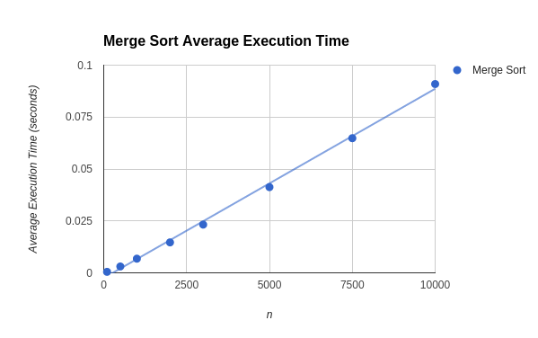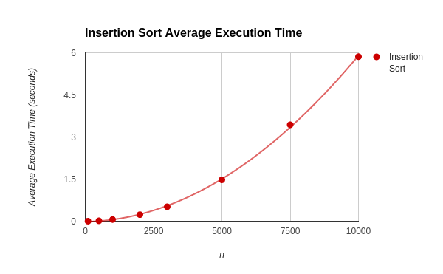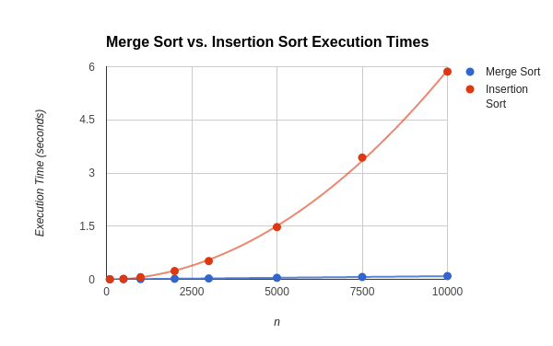
The individual plots are useful for visualizing the rates at which each algorithm's execution time increases with growing values of n, particularly the fact that merge sort increases fairly linearly, but overall, the combined plot is far more useful for looking at just how much faster than insertion sort merge sort becomes at higher values of n.
  - Merge sort displays a strong linear pattern, while insertion sort displays a quadratic growth pattern.
T_{merge} = 9.1127924501471·10⁻⁶x – 0.0024911646568351
T_{insertion} = 5.741472705·10⁻⁸x² + 1.786022393·10⁻⁵x – 1.90567523·10⁻²
  - My data matches up very well with the theoretical runtimes of O(n) for merge sort and O(n²) for insertion sort.

