Evaluation

Completeness of objectives
Below is another copy of the objectives. I have highlighted the incomplete objectives in bold, and provided a detailed explanation as to why it was left incomplete at the end of the project. This allows it to be seen a percentage completeness of the entire project, and is concise and visual for the end-user to review. The explanation of why a particular objective was not completed can be found below the objective in question. I have differentiated these explanations by making them italics and bullet-pointing them for clarity.
- Input and Display
  - Display a Rubik’s Cube, default size 3x3x3. (TEST 1a)
    - The Rubik’s Cube should correspond to a real cube. (TEST 1b)
      - The colours will be the same colours (red, orange, green, blue, yellow and white).
      - The orientation of the colours will also match. (Red opposite orange, green opposite blue, yellow opposite white).
    - The Rubik’s Cube will be able to be rotated using the mouse. (TEST 2)
      - Speed of rotation and any other camera controls will be customisable in the settings page using sliders. (TEST 24)
      - Rotation speed will be split between manual speed and solve speed.
        - Both will be limited to between 0 and 3. (TEST 3b)
        - Must be a float data type. (TEST 3c)
    - The Rubik’s Cube can be zoomed in and out of using the scroll wheel. (TEST 4a)
    - The Rubik’s Cube can be double clicked to recenter the window. (TEST 4b)
    - The left/right arrow keys rotate the entire cube left/right. (TEST 5)
    - The Rubik’s Cube’s sides will be able to be rotated using key controls (the letters ‘F’, ‘B’, ‘L’, ‘R’, ‘U’, ‘D’ for each direction, front, back, left, right, up and down). (TEST 6)
      - All key controls will be able to be changed in the settings page using a key detector. (TEST 7)
      - Nothing will happen if an invalid key is pressed. (TEST 8)
      - Anticlockwise key presses will be entered with the CAP LOCK on. (TEST 9)
    - There should be a button (enter by default) to shuffle the cube into a random position. (TEST 10a)
      - This will also be able to be changed in the settings page, in a similar manner. (TEST 10b)
      - Nothing should be able to be done while the cube is shuffling.
    - There should be a button (space by default) to solve the cube regardless of its current position. (TEST 10c)
      - This will be using algorithmic AI and will be discussed further in the processing objectives.
      - This will also be able to be changed in the settings page. (TEST 10d)
      - Nothing should be able to be done while the cube is solving. (TEST 11)
    - Closing the main window should end the program. (TEST 12)
    - The main window should not be able to be resized. (TEST 13)
  - There should be a button ‘A’ that displays all algorithms for each step of the solving proces. (TEST 14)
    - The algorithm window will not close, simply hide if closed by the user. (TEST 15)
    - Uppercase letters will be clockwise rotations and lowercase letters will be anti-clockwise rotations. (TEST 16)
    - Each algorithm should be able to be interactive – the user can click to carry them out.
      - While the algorithms display as the solve progresses, detecting a user click in one window while carrying out the algorithm in another window proved tricky and too time consuming. Another issue is that the algorithms are already running when they display in the window, so the objective is rendered moot.
  - There should be a menu button ‘M’ by default that displays a menu offering several buttons as options. (TEST 17)
    - There should be a button on the menu to change the mode of the simulation. (TEST 18)
      - Learn mode should take the user through the algorithms step by step using a randomly shuffled cube.
        - The solve button will be enabled.
        - The algorithm display button will be enabled.
        - The solve will happen as the user presses the correct buttons.
          - As will be detailed below and is mentioned briefly in the implementation, I decided to leave the learn mode alone during the development of the program. This is because of the integral infrastructure of the way I coded the cube, and halting it during a solve for the user to catch up was inherently extremely hard, and would require changing much of the already-finished code.
      - Free mode should allow the user to do whatever they want with the Rubik’s Cube. (TEST 19a)
        - The solve button will be enabled.
        - The algorithm display button will be enabled.
        - If an algorithm is clicked via the algorithm display button, the cube should do the algorithm semi-instantly.
          - While the algorithms display as the solve progresses, detecting a user click in one window while carrying out the algorithm in another window proved tricky and too time consuming. Another issue is that the algorithms are already running when they display in the window, so the objective is rendered moot.
      - Test mode should allow the user to test how fast they can solve the cube. (TEST 19b)
        - The solve button will be disabled.
        - The algorithm display button will be disabled.
        - A timer will be displayed that runs until the cube is solved or the mode is exited.
          - This is something that the end-user mentions below in the interview, and should not be too tricky to accomplish. This may be potentially added and provided below as proof of action upon end-user feedback at the conclusion of the project.
      - Custom mode should allow the user to create their own cube. (TEST 19c)
        - There will be a button to load the cube into the simulation.
        - It will be validated everytime the cube is loaded.
        - Each sub block in the builder will cycle through the 6 colours in order to build a cube. (TEST 20a/b)
    - There should be a button on the menu to take the user to the settings page.
      - The settings page should have a button to change any controls.
        - This section of the menu will also act as an indication of which buttons do what, solving the issue raised in interview 2. (TEST 21)
        - The user should be able to select the corresponding control button, and then press a key on the keyboard to replace the current control.
          - If any contrasting controls are selected, the most recent one is kept and others are scrapped. (TEST 22)
          - If any invalid controls are selected, an error will display and they will be reset. (TEST 23)
            - A warning message will display if this occurs: “ONE OR MORE DUPLICATES”
      - The settings page should have a slider to change the camera speed.
        - The camera speed will be limited at an appropriate speed (TBD).
        - The camera will be able to be set to ‘PANNING’ mode.
          - In ‘PANNING’ mode, the camera should just circle the cube.
            - The speed of the camera is dictated by the speed at which the mouse is dragged, rather than any software in the program. For this reason, limiting the camera speed, while not really possible with the library I’ve used, would be useless anyway.
      - The settings page should have a number of AI settings.
        - An AI setting will be able to change the speed of the AI. (TEST 24)
          - This setting will range from effectively instant to beginner speed (1 turn per second).
      - The settings page should have a custom colour section. (TEST 25)
        - Included will be options to change the 6 colours of the cube from the default (red, orange, yellow, blue, green, white).
        - The 6 colours can be changed to anything, given by a hex value provided by the user.
          - The 6 colours will be validated to be 6 digit hex codes. (TEST 26)
          - The 6 colours must include no duplicates, and this will also be validated. (TEST 27)
        - The grid of the cube (the in between parts) will be able to be changed in a similar fashion, using a hex value provided by the user. (TEST 28a)
        - The background will be able to be changed also between two options.
          - The background can be a solid colour, in which case the user will provide a hex value, which the program will then act upon. (TEST 28b)
          - Depending on time, there will also be a number of dynamic backgrounds, possible examples include:
            - Starfield background.
            - Warping colours background.
            - Random shapes background.
              - The background of a sketch is usually a block colour, and hence in 2D. Putting dynamic shapes into the background would therefore require the environment to be simulating both 2D and 3D objects at once, and this is not possible to implement in the time period.
    - Pressing the X on the menu should not close or hide it (use M). (TEST 29)
    - The menu should not be able to be resized. (TEST 30)
    - There should be a button on the menu to create a custom cube layout.
      - If custom mode is accessed, the program should display a 3x3 default cube to be filled in to correspond to a real life cube. (TEST 31)
      - The cube will check that the finished cube is a valid one. (TEST 32)
        - If invalid, an error message will appear upon exit: “WARNING: Invalid cube setup”.
      - If valid, the created cube should be able to be saved.
        - Custom cube saving would require me to create a custom file format in which the layout would be saved. This is a lot of work, and plus would require the user to have a certain folder/file location on his machine from whence to load the cubes; I am trying to make the program as accessible as possible and this detracts from this.
      - When finished, the cube should be loaded into the simulation to be interacted with normally. (TEST 33)
      - The cube builder should not be able to be resized . (TEST 34)
      - The cube builder should hide if it is closed, not close permanently. (TEST 35)
- Processing
  - The AI will use the beginner’s method to solve the cube.
    - The AI should be able to solve any orientation of cube.
      - This includes custom cubes (given they are valid).
    - The AI should display each move it is doing as it is doing it.
      - This will be from a selection of ‘U’, ‘D’, ‘L’, ‘R’, ‘F’, ‘B’.
        - A move will be suffixed by an apostrophe if it is an anti-clockwise rotation.
        - These will be carried out using the capital version of the lowercase move.
    - The cube will have to sequentially decide which move next to take using hard-coded algorithms.
      - Links to each set of algorithms are provided above.
      - The cube should iterate through each sub-block and ‘understand’ its position.
      - There are only a finite number of situations at each stage of the cube, so the cube should choose the correct algorithm for the situation.
        - The cube should identify which situation it finds itself at at each stage of the solve.
        - The cube will choose the correct algorithm by eliminating the others from the possible implementations.
    - The solve will use mainly algorithms.
    - Beginner’s Method has an intuitive, relatively algorithm-less stage of completing the orange cross. (TEST 36a)
      - Intuitivity will be simulated by giving the cube a more detailed awareness of the blocks.
        - The cube will find the 4 blocks in question (the orange sides) and orient them correctly.
          - It will do this by locking any orange sides that are in the correct position, around the red centre.
          - It will find any other orange sides and put them in the correct position by using mini-algorithms that prevent moving any ‘locked’ orange sides already.
          - The orange sides will each be rotated twice to reach the orange side, and eventually form the correctly-orientated orange cross.
    - The Beginner’s Method is as follows:
      - The Beginner’s Method now starts to orientate the orange corners on the bottom. (TEST 36b)
        - It rotates the orange corner to the correct position – between the two colour centres that are visible on the block.
        - It then repeats one of the two following algorithms until the orange corner ends up in the correct position. It differentiates depending on the side of the cube the orange is on (left or right).
          - Left: U’ L’ U L
          - Right: U R U’ R’
      - This should result in the bottom layer being finished. The Beginner’s Method then starts orientating the centre layer. (TEST 36c)
        - It does this by identifying blocks with no red on them, and orientating them to match their colour to the colour centre below.
        - It then does, again, one of two algorithms depending on the direction in which the block needs to go.
          - Block goes right: U R U' R' U' F' U F
          - Block goes left: U’ L’ U L U F U’ F’
        - In the case that the middle layer is not done however there are no blocks without red in them, the cube must simply do one of the above algorithms with the unsolved middle layer block.
          - This will ‘pop’ out the block and give a block without red on it to do the aforementioned step to.
      - The middle layer will now be finished. The Beginner’s Method now starts solving the top red cross. The top side will have several initial states: (TEST 36d)
        - One possible state is no red besides the centre piece. In this case the cube should do the algorithm F R U R’ U’ F’ to reach the next state.
        - Another state is simply a line of red, in this case the cube will orient itself so the line is horizontal, and repeat F R U R’ U’ F’ to reach the next state.
        - The last state (besides red cross) is an L-shape red pattern. The cube will orient itself so the bottom and right sides are red, then repeat F R U R’ U’ F’ to result in a red cross on top.
      - With the red cross in place, there are 4 possible orientations before doing the next algorithm. (TEST 36e)
        - It is entirely possible to have a red cross with the bottom right red already. The cube should skip the next algorithm if this is the case.
        - Due to the finite possibilities (4), the cube will simulate the algorithm R’ U U R U R’ U R on all 4 orientations to find the one that yields the aforementioned red cross with bottom right filled in with red.
        - The cube will repeat the algorithm R’ U U R U R’ U in this orientation to complete the top side.
      - The cube will now have two scenarios. One is there is one side with the top two corners being the same colour. (TEST 36f)
        - In this scenario, the cube should rotate the top so these two corners are over the same colour.
        - The cube will then carry out the following algorithm: U U R’ F R’ B B R F’ R’ B B R R until one entire side of the cube is solved.
      - The other scenario is no similar corners being present. In this case the cube will carry out the algorithm in any orientation, at which point the corners will appear and it can go as normal. (TEST 36f)
      - Once this is done, the cube has one final algorithm before a solve. (TEST 36g)
        - The cube will orient itself so the solved side is facing away, and do the algorithm R U’ R U R U R U’ R’ U’ R R until the cube is solved.
    - This should result in a solved cube. (TEST 37a/b/c)
- Output
  - The menus is one of the two main output sources in the program.
    - The menu will be displayed to the left of the window, and when it is open Rubik’s Cube control will be ceased. (TEST 38a)
      - The menu may also be powered by a different language such as python or VB, to be decided.
        - I settled on the following objective, the Java library, in order to build the menu, and it worked extremely well. Using a different language as described above would have brought over several issues with compatibility etc.
      - Another extremely viable option is importing a Java library to aid in GUI creation.
        - This will save time in the future by preventing me having to overlay 2D shapes over the 3D world.
        - It will also prevent me having to code the GUI myself.
    - The menu will display several possible sections, detailed before in the input and display section. (TEST 38b)
      - Each section will have a corresponding button, which when clicked, on will display a different sub-type of the menu.
        - As detailed prior, these will be things like AI settings, colour and backgrounds, cube modes, controls etc.
      - Each section of the menu will have several buttons. (TEST 38c)
        - All buttons will be consistent size and colour, menu colours will not be optional to change as of now.
        - Buttons are unlikely to have an animation when clicked either, however could change colour briefly to display a mouse click.
      - Each section may also have sliders for variable, continuous values.
        - Sliders, similar to buttons, will be consistent with each other and the general colour scheme.
        - Sliders will also display a text box, into which custom values can be inputted.
          - All custom values will be verified before being fed into the program.
            - I opted to use manual (but validated) text input for data values such as AI speed etc. Again this isn’t a failure of an objective so much as a different solution to the same issue. All colour schemes etc. are consistent as dictatd above.
      - Each section will be laid out in a consistent manner, and labelled clearly with text. (TEST 38d)
        - Each text box will demonstrate what the slider or button in question will do to the program.
      - Each section may have an information screen in which detailed explanations of what each option does will be displayed.
        - This objective did not get completed not due to time, but because of space. There is a lot of potential information that could be displayed according to this objective, however most of it is useless due to the deliberate intuitivity of my program’s layout and controls. I opted to stay with a cleaner, open layout of the menu and other windows as this has been stated to be a priority for my end-user before.
  - The algorithm display at the top is the other main source of output in the program.
    - The algorithms will be displayed in the Monospaced font, at a readable and clear size. (TEST 38e)
      - The font size will be dictated by how much room at the top of the window I will have to fill.
    - The colour of the algorithms will be dependant on the current background colour.
      - The colour of algorithms will either be black or white, and which one will be decided using simple hexadecimal maths,
      - The RGB value of the hex in the background will be condensed into a single value.
        - This value will be calculated by averaging the values for R, G and B.
        - If the average is above 127, white will be used.
        - If not, black will be used.
          - These objectives were written prior to the design of the layout of the several windows in my program. Since in the final version the display of the algorithms is separate from the main program, the background can stay constant and hence so can the colour of the algorithms; this renders the above steps useless as they are not needed.
      - One letter of the algorithm may also be highlighted if it is the current move to be made by the AI or the user.
        - This objective was not completed mainly due to the logistic difficulty of making one letter in an algorithm a different colour to the rest. As I stripped out the learn mode, the algorithms progresses so quickly that the highlighting of a particular move in an algorithm would be largely missed/ignored by the end-user anyway.
    - The algorithms will be displayed based on the point in the solve that the user or AI is on.
    - The display will also be dependant on the mode in which the cube is in.
      - This is dictated by the menu, as mentioned in section 1 of objectives.
      - The algorithms will not be displayed in any mode other than practise mode.
  - Animations should be included to further interest user. (TEST 39)
    - All moves should be animated.
    - If the cube is solved, a celebratory animation should be created and displayed.
      - This may involve flashing background, cube spinning, or cube colours randomly changing (returning to solved afterwards).
        - This objective did not get completed again due to the lack of the learn mode half way through the development of the project. The cube is now largely only completed by the AI solver, and hence an animation/celebratory display would not have the same effect as it would if the user had solved the cube. I opted to not complete this so I could focus my time on other more important objectives.
    - The menu appearing may be animated, but may be tricky to do if coded in a different language.
      - I used a separate Java library for the creation of the GUI, one that did not support the animation of the appearance/disappearance of the menu or other windows that I created using it. This is why this objective was rendered incomplete at the end of the project.

End User Feedback
I sent the project to my end-user for him to review, and he got back to me in email form. A screenshot of this is provided below:
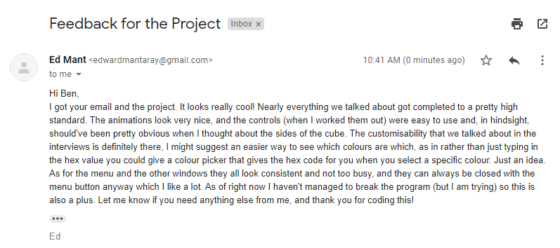

As you can see, Ed seems pretty satisfied with the program. I intend to get more detailed feedback in a final interview. This is to wrap up the project and get a final say on how complete it is according to the end-user’s requirements. The colour picker tool is a good idea and provided below is a template as to how I would do this (may even be implemented later). Most of his boxes seem to be ticked, and I will delve into this in more detail in the interview. This email was also useful in ensuring that the error testing had gone well – Ed said that he had not been able to break the program as of yet, which is definitely a good thing. He commented on the animation and the customisability which we knew was an important thing from the commencement of the project. Ed did comment on the fact he didn’t instantly know the controls but worked them out, which is good in that the program is evidently intuitive, however it should be obvious from the get-go, this could also be added later.

Completion Interview with the End User
- What is your favourite feature of the project that you have seen?
  - Definitely the automated solving and shuffling. It is very satisfying to watch, especially considering it can solve any cube that you give to it, be it through shuffling or through the cube being manually entered in the builder. If you turn up the speed the cube gets solved in under 4 seconds, it’s insane. How customisable the colours and controls are is also a really good thing in my book. I talked about it in the interview how customisability was an extremely important part of it for me, and I am definitely happy with the result.
- What would you improve about the project that you have seen?
  - I mentioned it in the email, but the current method of putting in custom colours is hard for someone who doesn’t know how RGB hex codes work, so a colour sampler would be really helpful for the customizability of colours and things. There is also no way of timing the cube solving at the minute, so adding that may be a useful thing to do too.
- To what extent do you feel that you have been given what you imagined during the first stages of development?
  - The whole thing. Obviously, the removal of the learn mode is a fairly significant thing, but that wasn’t something I specifically requested. It would be cool to learn the Rubik’s Cube but there are plenty of resources out there for that. A proper simulation of how a Rubik’s Cube behaves with all the customisability features provided in this project is absent so far as I can see, especially an offline compiled one. There are plenty of features I asked for in the first interviews and all of them have been delivered at the end of the project, so I am 100% satisfied.
- Do you think this program will be useful to anyone else other than you?
  - Yeah of course. Anyone who likes having fun with Rubik’s Cubes and doesn’t have one of their own can use this program. There are so many possibilities and possible extensions of the program that I think a lot of people might find useful. Ben and I were talking and one of those videos he had to upload to YouTube got a comment asking for details of the program so there is proof that other people want to use the program?
- Have you found any bugs and/or errors during your time with the program?
  - Not any huge ones. Sometimes I find while starting the program and try to open the menu, the program just crashes. This being said, it only happens very rarely and it usually works if I just open it up again. The actual cube works perfectly. I cannot see any glitches with how it moves or with the controls. The cube also solves itself no matter how I shuffle it which, obviously, is a very good thing. I have discovered that if you put a cube into the builder that fulfills the 9 colour valid rule but clearly isn’t a real cube, then the program accepts it and crashes when you try to solve it. This is the only big one that I have found though.
- Are there any features of the program that you think should be removed?
  - Not really. Nothing in the program really annoys me. The menu works fine, and I can make it disappear if it is in the way. Sometimes when you are putting in custom values and you accidently click off it gets reset, but that is due to my error rather than the error of you or the code you’ve written.

End-User Feedback Fulfilment
Colour Sampler
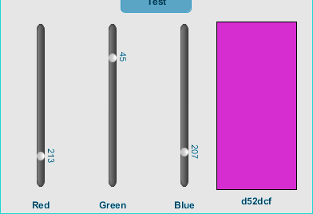
I found the idea of a colour sampler interesting, and relatively easy to do with the tools at my disposal. It took only half an hour to have a fully functioning colour sampler up and running, embedded at the bottom of the menu. I setup three sliders, red, green and blue. These can be changed in conjunction to produce the required colour. The colour displays on the right, with the hex code needed for entry below it. This, as the user requests, enables the user to produce the hex code for entry in the settings without knowledge of how RGB colour codes work.

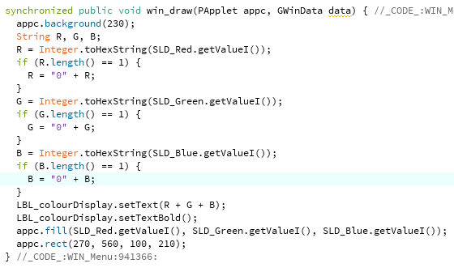
I did this by creating the three sliders, the values you can see being accessed here. I had to make sure any leading 0s were inserted for the display, and then I concatenated the three base 16 values of the sliders. This created the 6-digit hex code required to display. I also set the rectangle colour to this colour by using the three separate integer values as the R, G and B values for the background colour. Updating this any time any slider was moved created the desired effect.

Solve Timer
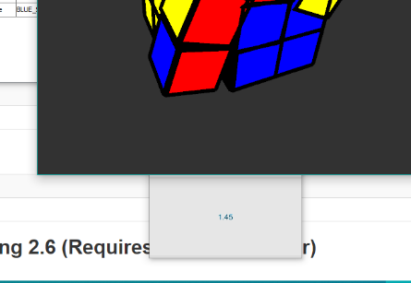
I had always intended to create a way of timing the cube solving, and never got to it as other things were more important to the objectives. When the end-user mentioned it in the interview I’d realised that it would not be very hard at all to achieve. As you can see, I put the timer below the main window, and it appears and disappears according to the mode in which the program is set to. It starts/stops the time depending on the position of the cube, and can be reused every time the cube is shuffled/solved.

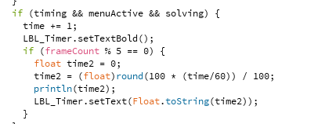
In order to implement this, I created a new window to appear under the main one, and set it up to only increment in time if the timing and solving Booleans are true. The time I calculated by dividing the time variable by the frame rate of the sketch (60) and formatting it using the round function. I updated the timer only every 5 frames as every frame resulted in flickering.

