Question 1 – 20 points

Consider a base ten value C = 113.3. What is the representation of C in single precision IEEE-754 format?

Question 2 – 30 points

A force f is applied to an object to accelerate it by a = 2.2 *m*/ *s*2 .

a. What is the representation of a in single precision IEEE-754 format?

b. Assuming that the mass of the object in kg is given by:

m = 0100 0011 1100 0000 0000 0000 0000 0000

What is the binary representation of the force f in single precision IEEE-754 format, given that f = m * a?

Question 3 – 30 points

Write a sequence of MIPS instructions to implement the following segment of C code:

count = 0;

for(index=head; index<=n; index++)

if(C[index] == target)

count++;

Assume the following register allocation:

$s0 count  
 $s1 index  
 $s2 head  
 $s3 base address of C array  
 $s4 target  
 $s5 n

Question 4 – 5 points

Explain how to derive the PC (program counter) for the instruction following a jump.

Question 5 – 15 points

Different instructions utilize different hardware blocks in the basic single-cycle implementation. Determine the values of control signals (0 or 1) generated by the control for the following instruction and record them in the following table. For ALUOp, write in the function the ALU should perform.

sw $t0, 32($s3)

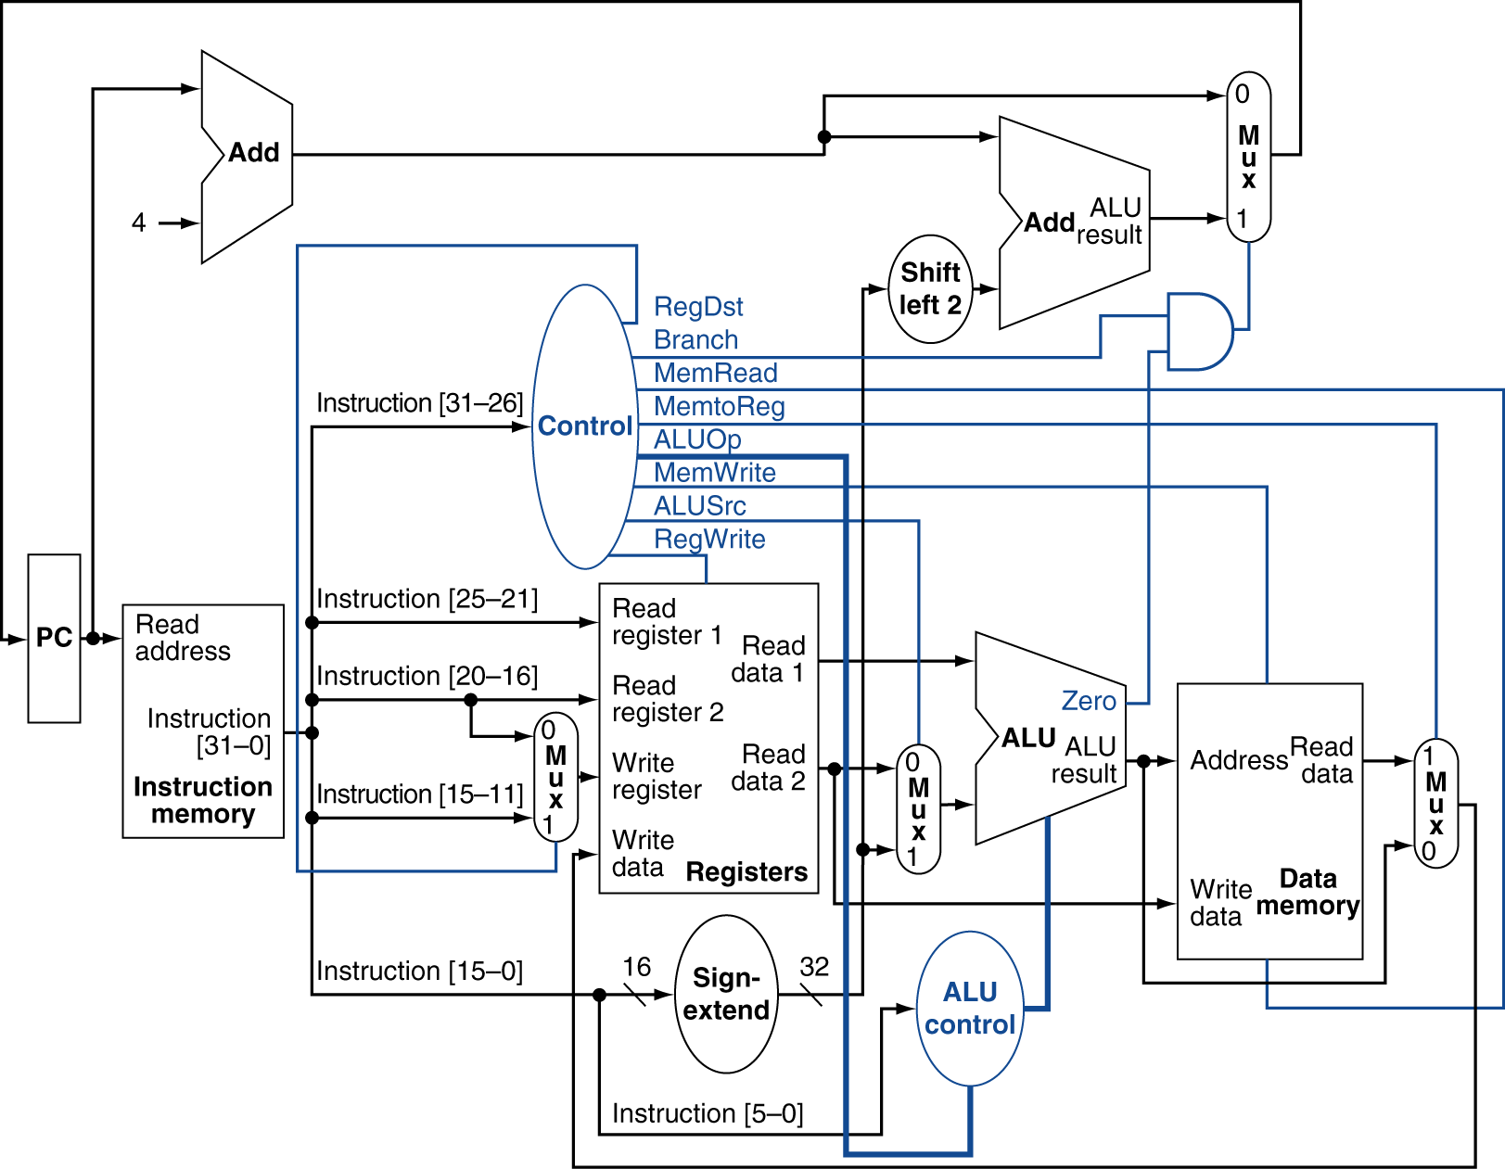

|  |  |  |  |  |  |  |  |
| --- | --- | --- | --- | --- | --- | --- | --- |
| RegDst | Branch | MemRead | MemtoReg | MemWrite | ALUOp | ALUSrc | RegWrite |
|  |  |  |  |  |  |  |  |