

Functional Safety Concept Lane Assistance

**Document Version: 1.0**

**Template Version 1.0, Released on 2017-06-21**



# Document history

|  |  |  |  |
| --- | --- | --- | --- |
| Date | Version | Editor | Description |
| 08/27/2018 | 1.0 | [NOT_PUBLIC] | Firs submission of the completed functional safety concept |
|  |  |  |  |
|  |  |  |  |
|  |  |  |  |
|  |  |  |  |

# Table of Contents

Document history

Table of Contents

Purpose of the Functional Safety Concept

Inputs to the Functional Safety Analysis

Safety goals from the Hazard Analysis and Risk Assessment

Preliminary Architecture

Description of architecture elements

Functional Safety Concept

Functional Safety Analysis

Functional Safety Requirements

Refinement of the System Architecture

Allocation of Functional Safety Requirements to Architecture Elements

Warning and Degradation Concept

# Purpose of the Functional Safety Concept

The functional safety concept is looking at the item from a higher level and considers the general functionality. The safety goals derived from the hazard and risk analysis are refined into functional safety requirements and afterwards allocated to their appropriate place in the item architecture. This could involve expanding the system architecture with new elements. Functional safety requirements have a few attributes that need to be specified in the functional safety concept. The functional safety concept also discusses verification and validation, which is how it is proved that the system actually meets the requirements. Later, functional safety requirements are further boiled down to technical safety requirements.

# Inputs to the Functional Safety Concept

## Safety goals from the Hazard Analysis and Risk Assessment

|  |  |
| --- | --- |
| **ID** | **Safety Goal** |
| Safety_Goal_01 | The oscillating steering torque from the LDW function shall be limited. |
| Safety_Goal_02 | The lane keeping assistance function shall be time limited and the additional steering torque shall end after a given time interval so that the driver cannot misuse the system for autonomous driving. |
| Safety_Goal_03 | The lane keeping assistance function shall apply a smaller torque when the wind (lateral force) is in the direction of the applied torque. |
| Safety_Goal_04 | The lane keeping assistance function shall be deactivated when the camera sensor is not able to detect lane lines. |

## Preliminary Architecture

### Description of architecture elements

|  |  |
| --- | --- |
| **Element** | **Description** |
| Camera Sensor | Captures images and provides them to the Camera Sensor ECU. |
| Camera Sensor ECU | Detects lane lines, identifies the ego lane (lane the vehicle is in), and calculates the vehicle’s distance to the center of the ego lane. Based on that information the Camera Sensor ECU requests a torque to correct the position. |
| Car Display | Provides visual feedback (warning light) to the driver in the display dashboard. |
| Car Display ECU | Controls the Car Display and receives information about the status of the Lane Assistance System in order to show warning lights accordingly. |
| Driver Steering Torque Sensor | Senses the torque already applied to the steering wheel by the driver. |
| Electronic Power Steering ECU | Processes the information received from the Driver Steering Torque Sensor and the torque requested from the Camera Sensor ECU and computes the necessary torque to apply to the steering wheel. |
| Motor | Applies the torque calculated by the Electronic Power Steering ECU to the steering wheel. |

# Functional Safety Concept

The functional safety concept consists of:

* Functional safety analysis
* Functional safety requirements
* Functional safety architecture
* Warning and degradation concept

## Functional Safety Analysis

|  |  |  |  |
| --- | --- | --- | --- |
| **Malfunction ID** | **Main Function of the Item Related to Safety Goal Violations** | **Guidewords (NO, WRONG, EARLY, LATE, MORE, LESS)** | **Resulting Malfunction** |
| Malfunction_01 | Lane Departure Warning (LDW) function shall apply an oscillating steering torque to provide the driver a haptic feedback | MORE | The lane departure warning function applies an oscillating torque with very high torque amplitude (above limit) |
| Malfunction_02 | Lane Departure Warning (LDW) function shall apply an oscillating steering torque to provide the driver a haptic feedback | MORE | The lane departure warning function applies an oscillating torque with very high torque frequency (above limit) |
| Malfunction_03 | Lane Keeping Assistance (LKA) function shall apply the steering torque when active in order to stay in ego lane | NO | The lane keeping assistance function is not limited in time duration which leads to misuse as an autonomous driving function. |

## Functional Safety Requirements

Lane Departure Warning (LDW) Requirements:

|  |  |  |  |  |
| --- | --- | --- | --- | --- |
| **ID** | **Functional Safety Requirement** | **ASIL** | **Fault Tolerant Time Interval** | **Safe State** |
| Functional  Safety  Requirement  01-01 | The lane assistance item shall ensure that the lane departure oscillating torque amplitude is below Max_Torque_Amplitude | C | 50 ms | Lane Assistance functionality deactivated |
| Functional  Safety  Requirement  01-02 | The lane assistance item shall ensure that the lane departure oscillating torque frequency is below Max_Torque_Frequency | C | 50 ms | Lane Assistance functionality deactivated |

Lane Departure Warning (LDW) Verification and Validation Acceptance Criteria:

|  |  |  |
| --- | --- | --- |
| **ID** | **Validation Acceptance**  **Criteria and Method** | **Verification Acceptance**  **Criteria and Method** |
| Functional  Safety  Requirement  01-01 | Test different values of torque amplitude and validate with drivers that the value chosen is high enough to be perceived but low enough to not cause loss of control. | Verify the system turns off in time (50 ms) if Max_Torque_Amplitude is exceeded. |
| Functional  Safety  Requirement  01-02 | Test different values of torque frequency and validate with drivers that the value chosen is high enough to be perceived but low enough to not cause loss of control. | Verify the system turns off in time (50 ms) if Max_Torque_Frequency is exceeded. |

Lane Keeping Assistance (LKA) Requirements:

|  |  |  |  |  |
| --- | --- | --- | --- | --- |
| **ID** | **Functional Safety Requirement** | **ASIL** | **Fault Tolerant Time Interval** | **Safe State** |
| Functional  Safety  Requirement  02-01 | The lane assistance item shall ensure that the lane keeping assistance torque is applied for only Max_Duration | B | 500 ms | Lane Assistance functionality deactivated |

Lane Keeping Assistance (LKA) Verification and Validation Acceptance Criteria:

|  |  |  |
| --- | --- | --- |
| **ID** | **Validation Acceptance**  **Criteria and Method** | **Verification Acceptance**  **Criteria and Method** |
| Functional  Safety  Requirement  02-01 | Test different valued of max duration and validate with drivers that the value dissuades drivers from taking their hands off the steering wheel. | Verify that the system does tun off in time (500 ms) if Max_Duration is exceeded. |

## Refinement of the System Architecture

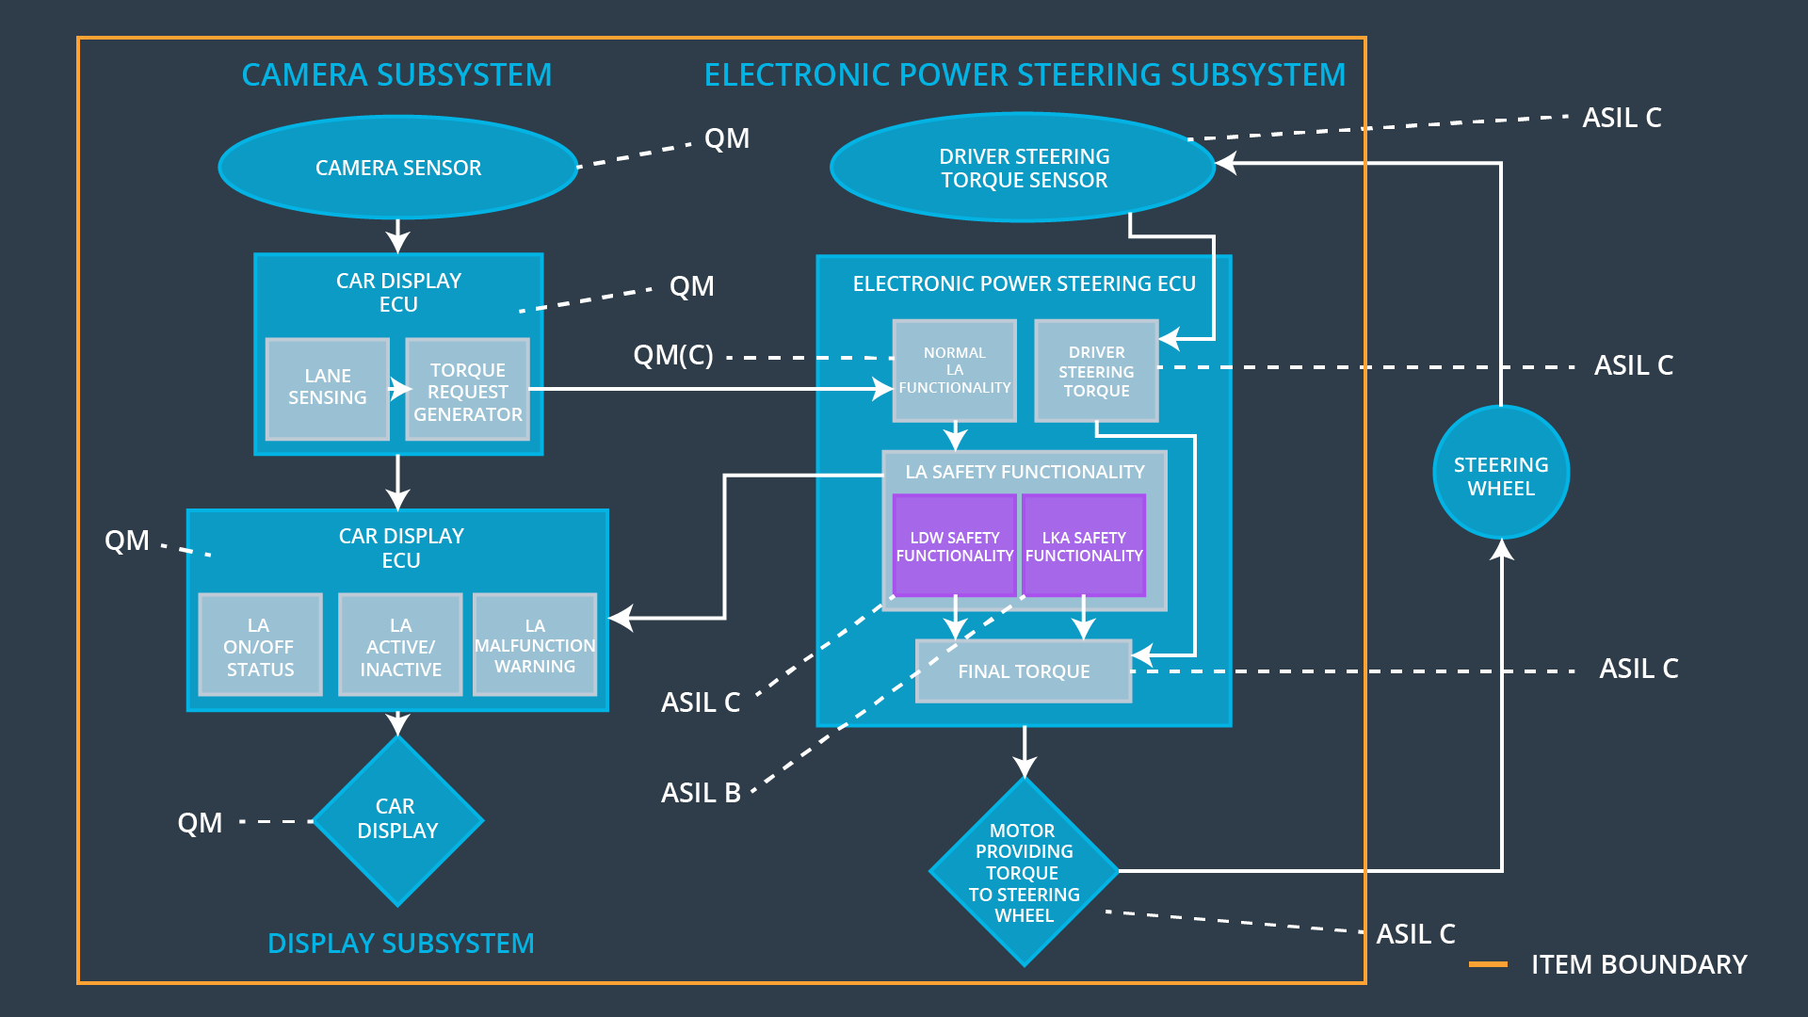

## Allocation of Functional Safety Requirements to Architecture Elements

|  |  |  |  |  |
| --- | --- | --- | --- | --- |
| **ID** | **Functional Safety Requirement** | **Electronic Power Steering ECU** | **Camera ECU** | **Car Display ECU** |
| Functional  Safety  Requirement  01-01 | The electronic power steering ECU shall ensure that the lane departure oscillating torque amplitude is below Max_Torque_Amplitude. | **X** | **–** | **–** |
| Functional  Safety  Requirement  01-02 | The electronic power steering ECU shall ensure that the lane departure oscillating torque frequency is below Max_Torque_Frequency. | **X** | **–** | **–** |
| Functional  Safety  Requirement  02-01 | The electronic power steering ECU shall ensure that the lane keeping assistance torque is applied for only Max_Duration. | **X** | **–** | **–** |

## Warning and Degradation Concept

|  |  |  |  |  |
| --- | --- | --- | --- | --- |
| **ID** | **Degradation Mode** | **Trigger for Degradation Mode** | **Safe State invoked?** | **Driver Warning** |
| WDC-01 | Deactivate the system | Malfunction_01  Malfunction_02 | Yes | Warning light on display dashboard |
| WDC-02 | Deactivate the system | Malfunction_03 | Yes | Warning light on display dashboard |