Globalization and the Multinational Firm
Bento J. Lobo, Ph.D., CFA · The University of Tennessee at Chattanooga
Table of contents

Data in this chapter were last refreshed on 12 November 2026. Every chart names its source and retrieval date beneath it.
Download this chapter as an editable Word file
Before You Read
Answer these three before you know the answers. Write them down. You will almost certainly be wrong on at least one, and the research is clear that attempting an answer before instruction improves what you retain from the instruction that follows.
- Roughly how much foreign currency is traded worldwide on an average day — and how does that compare with the value of goods the world trades in a year?
- A U.S. company sells only to U.S. customers, buys only from U.S. suppliers, and borrows only in dollars. Can it have currency exposure? If so, how?
- The euro is forecast by most banks to weaken over the next year. Does that make it cheaper or more expensive for a U.S. firm to lock in a euro receivable with a forward contract today?

Learning Objectives
After completing this chapter you should be able to:
- Explain why international finance is a distinct field rather than an application of domestic corporate finance, in terms of four specific frictions.
- Describe the scale and composition of global financial activity using primary statistical sources.
- Identify the principal participants in international financial markets and the objective each is pursuing.
- Distinguish the three categories of foreign exchange exposure and recognize which applies to a given business situation.
- Evaluate the claim that globalization has stalled or reversed, using trade, investment, and financial-flow evidence.
- Retrieve current international financial data from an authoritative source and assess its vintage and reliability.
- Explain why artificial intelligence lowers the information friction but not the other three, and why a better cash-flow forecast is not an exchange-rate forecast.

What is macro-finance?
Macro-finance studies the two-way links between financial markets (such as asset prices, credit, and banking) and the aggregate macroeconomy (such as business cycles, recessions, and economic growth). Macro-finance is the core of this textbook.
Module 1 · Why international finance is different

1 What Makes International Finance Different
Domestic corporate finance gives you a powerful toolkit: discounted cash flow, the cost of capital, capital structure, risk management. None of it is wrong when you cross a border. All of it becomes harder, for four reasons that structure this entire book. Exhibit 1.1 is the map; the four sections that follow are the territory.
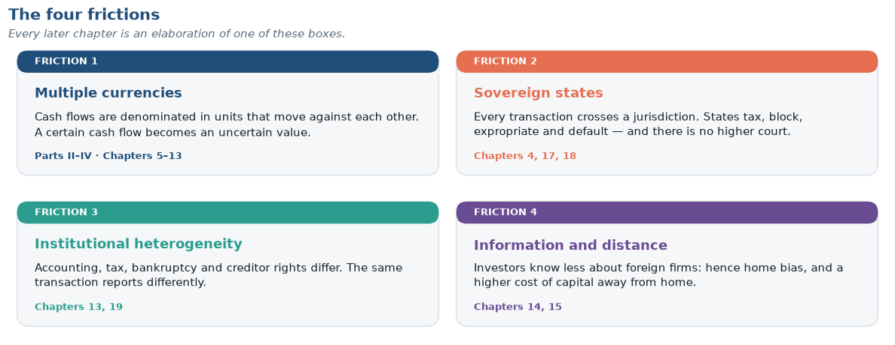
Exhibit 1.1 The four frictions, and where each is developed. If you retain one diagram from this chapter, retain this one — every later chapter is an elaboration of one of these four boxes. Source: original diagram for this book.

Friction 1 · Multiple currencies
A domestic firm’s cash flows are denominated in one unit of account. A multinational’s are not, and the rates of exchange between those units move continuously, unpredictably, and sometimes violently. This creates a risk with no domestic counterpart: the value of a perfectly certain future cash flow becomes uncertain simply because it will arrive in a foreign currency.
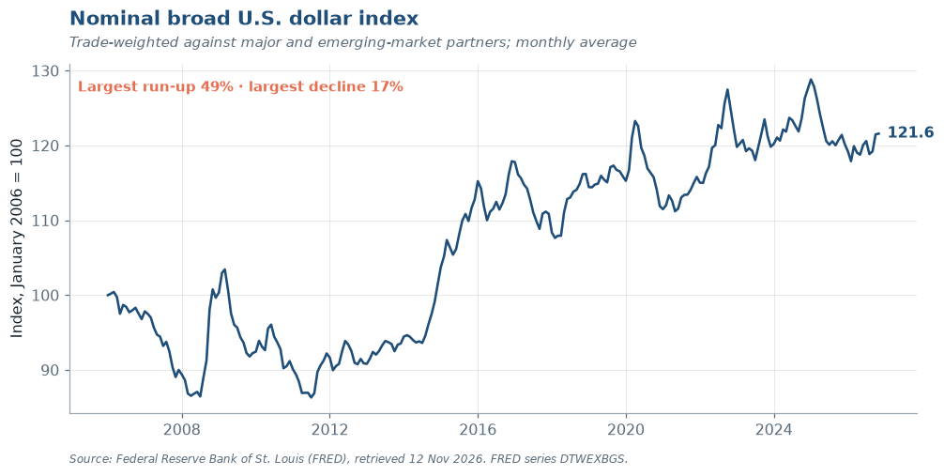
Exhibit 1.2 Nominal broad U.S. dollar index, 2006 to the latest month. A rising line means the dollar is appreciating against a trade-weighted basket — good news for a U.S. importer, painful for a U.S. exporter and for any firm with dollar debt and local-currency revenue. Swings of the size annotated, over a few years, are routine. Source: Federal Reserve Board via FRED, series DTWEXBGS.
Notice the amplitude in that series when you render it. For a firm whose operating margin is 8 percent, a currency move of 20 percent is not a rounding error — it is the difference between a profitable foreign subsidiary and a write-off.
The central asymmetry
Currency risk is not symmetric in its consequences even when it is symmetric in its distribution. A firm that gains 20 percent from a favorable move books an unusually good year. A firm that loses 20 percent may violate a debt covenant, lose access to credit, and be forced to cut investment it would otherwise have made. This asymmetry — not managerial risk aversion — is the standard justification for corporate hedging, and we develop it formally in Chapter 11.

Friction 2 · Sovereign states
Every cross-border transaction crosses a jurisdictional boundary, and jurisdictions have governments. Governments tax, regulate, expropriate, impose capital controls, block repatriation, rewrite tariff schedules, and occasionally default on their own obligations. Collectively these are country risk or political risk, and they have no clean analogue in domestic finance because there is no higher authority to appeal to. A contract between two U.S. firms is enforceable in U.S. courts. A contract between a U.S. firm and a sovereign state is enforceable only to the degree the state consents, or to the degree the firm can seize assets abroad — the subject of Chapter 18.

Friction 3 · Institutional heterogeneity
Accounting standards, bankruptcy codes, disclosure rules, tax treaties, creditor rights and governance norms all differ across countries, and the differences are not cosmetic: the same economic transaction can report different earnings under IFRS and U.S. GAAP (Chapter 13), confer different rights depending on governing law, and face radically different effective tax rates depending on structure (Chapter 19).

Friction 4 · Information and distance
Investors know less about foreign firms than domestic ones, and the gap persists even when the raw disclosures are comparable. This friction explains the home bias puzzle — investors hold far more domestic equity than any standard portfolio model recommends — and it raises the cost of capital for firms raising money abroad (Chapters 14 and 15).

How to read the rest of the book
Every chapter that follows attacks one of these four frictions. When a topic feels unmoored, return to Exhibit 1.1 and ask which friction it addresses. The Top Ten at the front of the book compresses the whole field into ten propositions for exactly that purpose.
Module 2 · How big is global finance

2 How Big Is Global Finance?
Scale matters for intuition, so let us establish benchmarks. The most common measure of real-economy integration is trade openness: exports plus imports as a share of GDP.
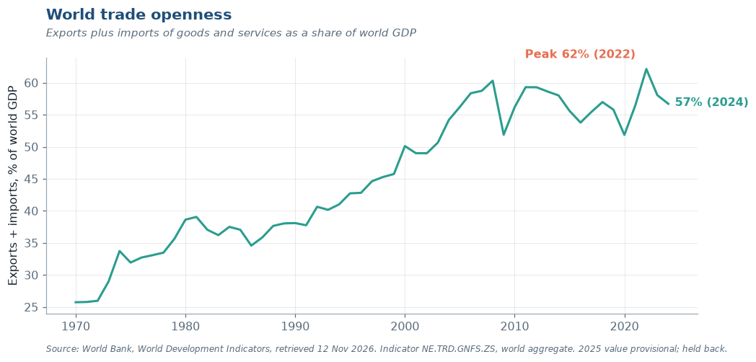
Exhibit 1.3 World trade openness, 1970 to the latest year: exports plus imports as a share of world GDP. Four decades of steep increase, then a plateau after 2008 — the central empirical fact behind the “slowbalization” debate in Section 5. Source: World Bank, World Development Indicators, NE.TRD.GNFS.ZS.
The financial economy is a different order of magnitude.
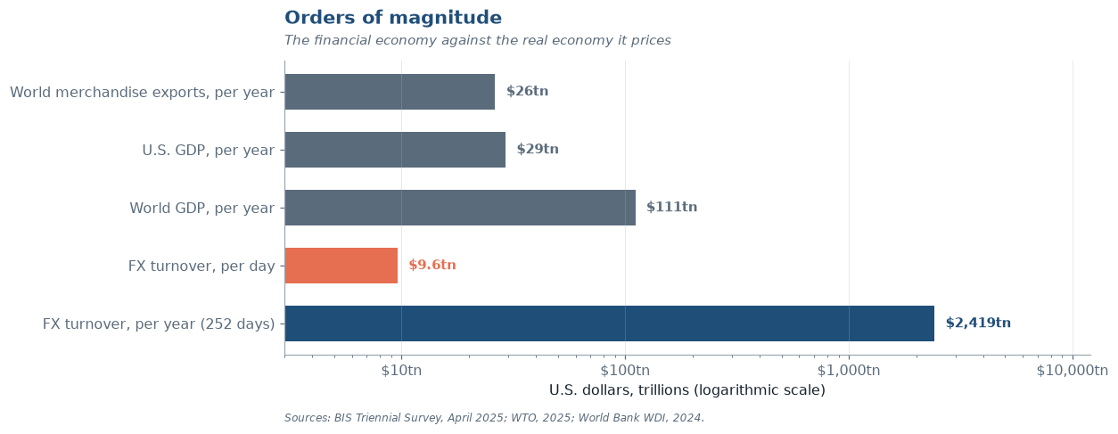
Exhibit 1.4 Orders of magnitude. The horizontal scale is logarithmic. Sources: BIS Triennial Central Bank Survey, 2025; WTO, Global Trade Outlook and Statistics, March 2026; World Bank, GDP (NY.GDP.MKTP.CD).
Market Moment
On a single ordinary business day, the world’s foreign exchange market turns over about $9.6 trillion — a figure that exceeds the annual economic output of every country on earth except the United States and China, and it happens daily. In April 2025 that number was 28 percent higher than three years earlier, measured in a month when tariff announcements sent currencies lurching and hedging demand surging. Alongside it, over-the-counter interest rate derivatives traded $7.9 trillion per day, up 59 percent over the same three years.
These numbers come from the Bank for International Settlements’ Triennial Central Bank Survey, a census conducted every three years across 52 jurisdictions and more than 1,100 banks and other dealers.
Two facts to keep in mind: first, almost none of that turnover is paying for trade in goods. Global merchandise exports run to about $26.3 trillion per year; the FX market clears that much in about 2.7 trading days. Second, a firm with no foreign subsidiary, no foreign sales, and no foreign debt is still exposed to this market because its competitors, its suppliers, and its customers are.

Exhibit 1.5 plots the headline series from the BIS Triennial Survey, the only global census of FX activity.
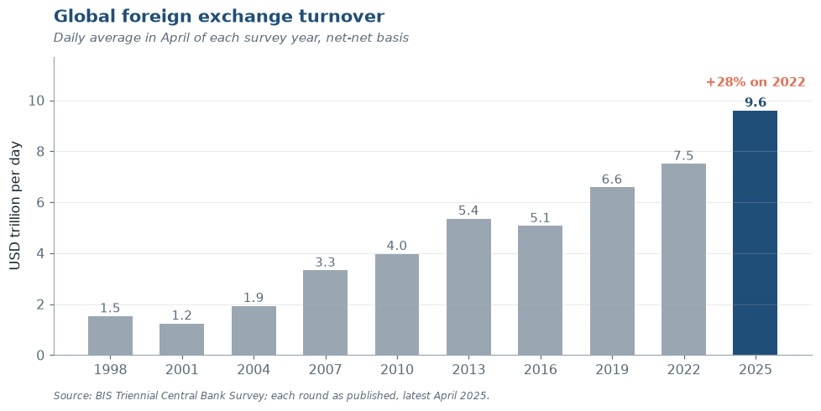
Exhibit 1.5 Global foreign exchange turnover, daily average in April of each survey year. Source: BIS Triennial Central Bank Survey, 2025; earlier rounds as published at the time.
Two features deserve comment. First, the series grows faster than world trade or world GDP over the same period — financial activity has outpaced the real transactions it nominally serves. Second, it is not monotonic: turnover fell between 2013 and 2016, a reminder that the post-crisis regulatory tightening and the retreat of bank balance-sheet capacity had measurable effects on market size. Growth in this market is not a law of nature.
Put the two economies side by side and the asymmetry is stark.
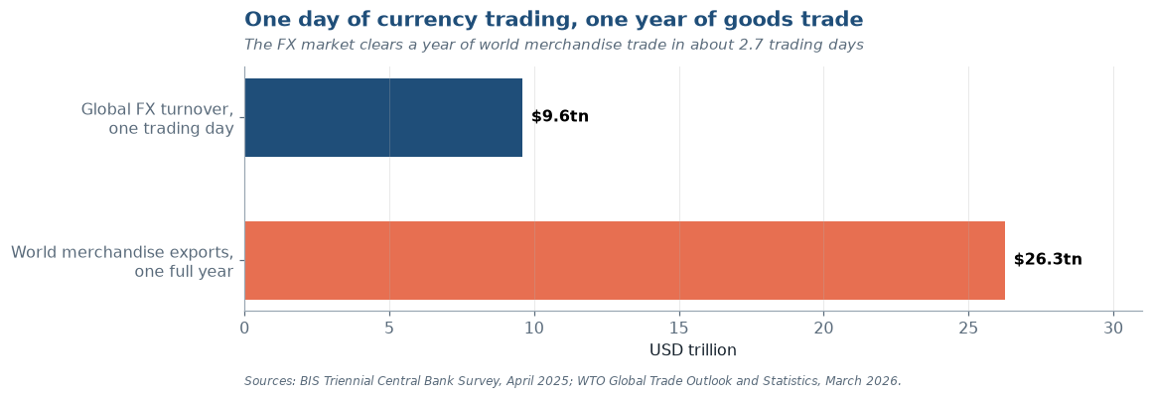
Exhibit 1.6 One trading day of FX turnover against one full year of world merchandise exports. Sources: BIS Triennial Central Bank Survey, 2025; WTO, Global Trade Outlook and Statistics, March 2026.
The ratio is roughly 2.7 trading days of FX turnover per year of world goods trade. If currency trading existed only to settle trade invoices, the market would be about one-hundredth of its observed size. It is not: the overwhelming majority of turnover is dealer-to-dealer position management, hedging of financial rather than commercial exposures, and speculation. We decompose it properly in Chapter 5.
The same survey measures a second market of comparable size.
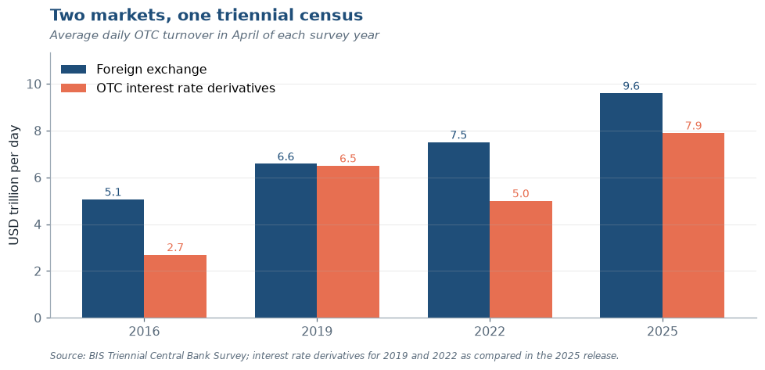
Exhibit 1.7 FX and OTC interest rate derivatives turnover, 2016–2025 survey rounds. The fall and recovery in interest rate derivatives after 2019 track the replacement of LIBOR by overnight index swaps, which by 2025 made up roughly two-thirds of that market. Source: BIS Triennial Central Bank Survey, 2025.
Module 3 · Who is in the market

3 Who Is in This Market?
Six groups transact, and each is pursuing something different. Knowing whose objective function sits on the other side of your trade is what separates a finance professional from a price-taker — and the distribution in Exhibit 1.8 is the first surprise of the course.
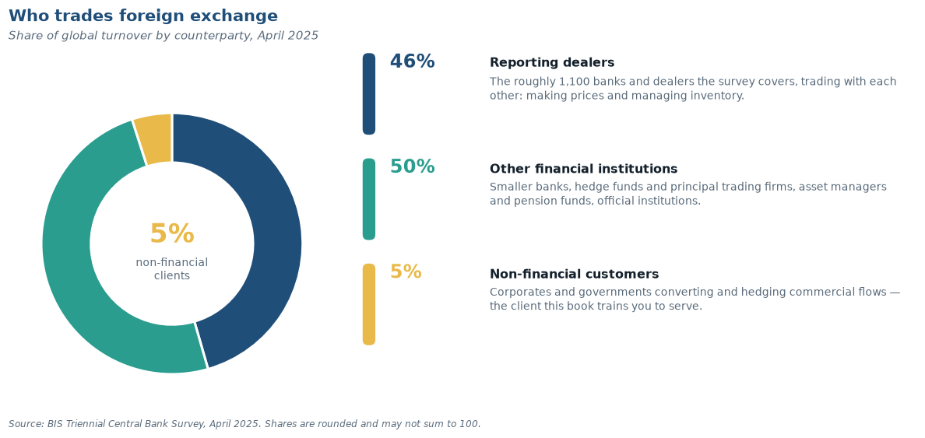
Exhibit 1.8 Who trades, in what proportion, and why. Note the smallest slice: the commercial end users whose needs the market nominally exists to serve. Source: BIS Triennial Central Bank Survey, 2025.
Participant | Primary objective | Typical instrument | Chapter
Non-financial corporations | Convert and protect commercial cash flows | Spot, forwards, options | 11–13
Dealer banks | Earn the spread; manage inventory risk | All; dominate inter-dealer market | 5
Institutional investors | Currency as a by-product of, or a source of, return | Forwards, FX swaps, futures | 15–16
Hedge funds and PTFs | Direct return from currency positions and liquidity provision | Everything, at high frequency | 5, 7
Central banks | Policy objectives: reserves, stability, intervention | Spot, swaps, reserve portfolios | 2, 4, 20
Retail and payments firms | Transaction service for households and small firms | Spot via aggregators | 5
The critical structural fact: the overwhelming majority of turnover is financial, not commercial. Inter-dealer and financial-institution trades dominate; non-financial corporate turnover is a single-digit share of the total. A corporate treasurer executing a $50 million hedge is a small participant in a market whose price is set by other forces, and that is precisely why the treasurer needs to understand those forces.
When the fix was not fixed: the FX benchmark scandal
Between roughly 2008 and 2013, traders at several of the world’s largest dealer banks coordinated through chat rooms, with names like “the Cartel” and “the Bandits’ Club,” to manipulate the WM/Reuters 4 p.m. London rate: the daily fix used to value trillions of dollars of index funds and corporate hedges. They shared client orders and pushed trades through in the short window in which the fix was calculated. Regulators in the United States, the United Kingdom and Switzerland fined the banks involved more than $10 billion in 2014 and 2015, and several banks pleaded guilty to criminal charges in the United States.
This is not the LIBOR scandal, but it is its cousin. The better-known LIBOR scandal, which broke in 2012 with Barclays’ settlement, involved an interest-rate benchmark and a different method: banks submitted false estimates of their own borrowing costs, to help their traders’ positions or to look more creditworthy than they were. In the FX case nobody submitted anything; traders moved the price itself by trading into the fix. The failure is the same, the mechanism is not, and telling the two apart is the point. LIBOR has since been retired and replaced (Exhibit 1.7).
The FX episode produced the FX Global Code, a voluntary set of principles now adhered to by central banks, dealers, and buy-side firms, which we examine in Chapter 5. Two lessons are worth carrying forward. First, benchmarks that are economically important but structurally unsupervised attract manipulation, a pattern seen in FX, in LIBOR, in precious metals fixes, and in oil price assessments. Second, when you select a hedge execution benchmark as a treasurer, you are making a governance decision, not merely an operational one.

Module 4 · Three kinds of currency exposure

4 Three Kinds of Currency Exposure
The managerial core of this book is Part IV, and it rests on a taxonomy students routinely conflate. Exhibit 1.9 states it compactly; read it before the paragraph that follows, not after.
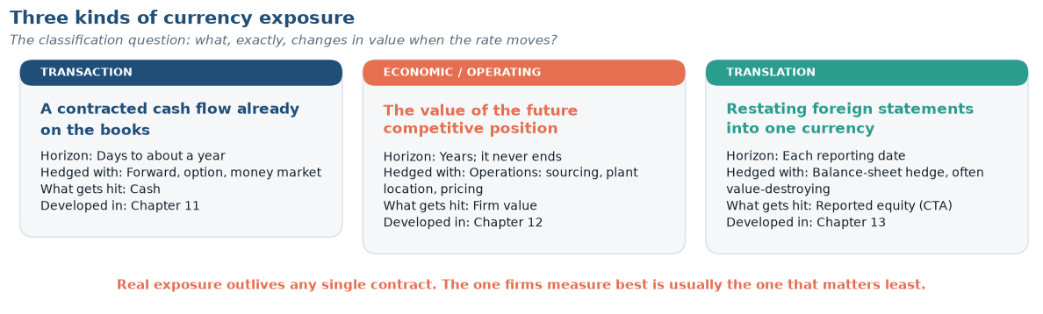
Exhibit 1.9 The three exposures, side by side on the four dimensions that actually distinguish them: horizon, hedging instrument, what gets hit, and where the book treats it. Source: original diagram for this book.
Three examples fix the categories. A U.S. firm has invoiced a German customer €4 million payable in 90 days: the euro amount is certain, the dollar amount is not, and a forward contract hedges it almost exactly — transaction exposure. A U.S. machine-tool maker selling only domestically against a Japanese rival loses pricing power when the yen depreciates, though every invoice it writes is in dollars — economic exposure, larger, longer and unhedgeable with any single contract. A parent restating a Mexican subsidiary’s peso books into dollars reports a different consolidated equity when the peso moves, with no cash crossing any border — translation exposure, a reporting phenomenon with real consequences through covenants, compensation and investor perception.
Classification is not an academic exercise; it determines which instrument is even applicable. Exhibit 1.10 is the diagnostic, and it is worth committing to memory.
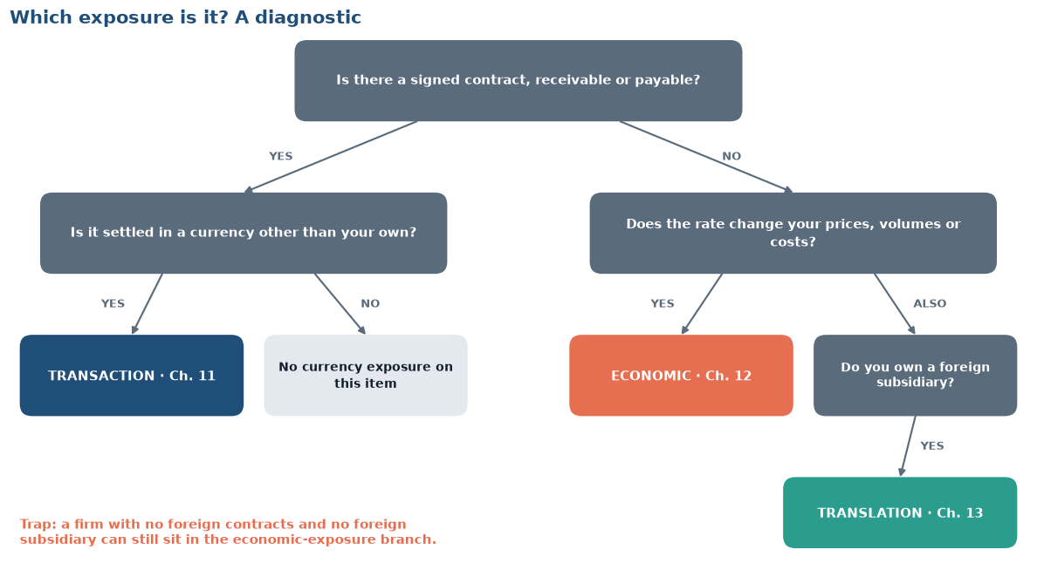
Exhibit 1.10 A two-question diagnostic. Most classification errors occur in the right-hand branch, where a firm with no foreign contracts and no foreign subsidiary concludes, wrongly, that it has no exposure. Source: original diagram for this book.
The single most expensive error in corporate treasury
The error. A treasury carefully hedges its translation exposure, the swing in reported equity when a foreign subsidiary’s books are restated into dollars, and leaves its economic exposure unhedged.
Why it is an error. Translation exposure is mostly an accounting effect: no cash crosses a border. Economic exposure, the damage to future sales and margins when a currency move shifts competitiveness, is real cash and usually far larger. Firms fall into the trap because the exposure that is easiest to measure is almost never the largest, and treasuries are judged on what they can measure.
See it happen. Application 1.1, which follows, ranks one firm’s four exposures. The one that is simplest to hedge turns out to be the smallest.

1.1 · Classifying exposure at a mid-cap manufacturer
Chattanooga Precision Components (CPC) manufactures only in Tennessee. It sells 70 percent domestically and 30 percent to a German distributor, invoicing in euros with 60-day terms. It owns a small Mexican warehousing subsidiary carried at 180 million pesos. Its principal competitor is a Japanese firm selling into the same U.S. customers.
- € receivables outstanding (≈ €2.6 million): transaction exposure. Hedgeable with a 60-day forward; Chapter 11 compares that against a money-market hedge and an option.
- Future European sales not yet invoiced: economic exposure. A sustained euro depreciation reduces the dollar value of the entire European business even after every current receivable settles.
- U.S. sales competing against the Japanese rival: economic exposure, and the one CPC’s CFO is most likely to overlook — the firm has zero yen cash flows yet its U.S. margins are demonstrably a function of USD/JPY. Chapter 12 estimates this by regression.
- Peso-denominated subsidiary net assets: translation exposure, flowing to the cumulative translation adjustment in equity under ASC 830.
Note the ranking: the exposure that is easiest to measure and hedge (the receivable) is very likely the smallest of the four in present-value terms.

Module 5 · Has globalization stalled?

5 Has Globalization Stalled?
Before engaging the question, place it in time. The present moment is the fifth distinct regime in eighty years, and every one of its predecessors felt permanent from the inside.
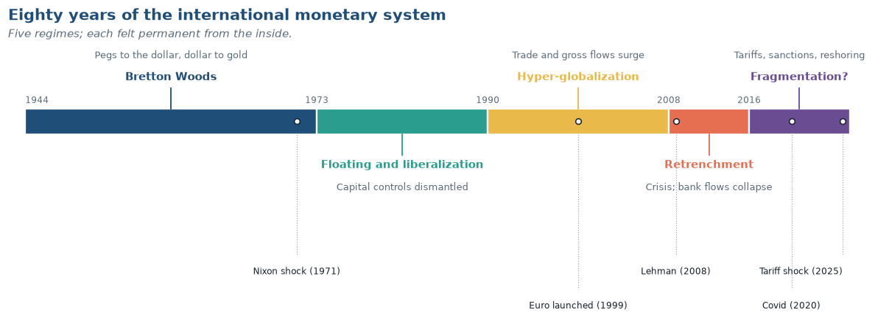
Exhibit 1.11 Eighty years of the international monetary system. Chapter 2 develops each era; the point here is that the current arrangement is neither old nor stable. Source: original diagram for this book; each era is developed in Chapter 2.
A serious senior-level course must engage the claim, now widespread in the business press, that globalization has peaked and is reversing. The evidence does not support a simple answer, and the discipline of separating the three distinct measures is itself the lesson.
Trade. World trade openness rose steeply for four decades and then stopped rising around 2008. It has not collapsed — the level remains near its historic high — but the trend broke. The phenomenon has acquired the label slowbalization. Contributing factors include the maturation of China’s integration, the shortening of supply chains in electronics, the post-2016 tariff cycle, and a composition shift from goods toward services, which the headline goods-trade series understates.
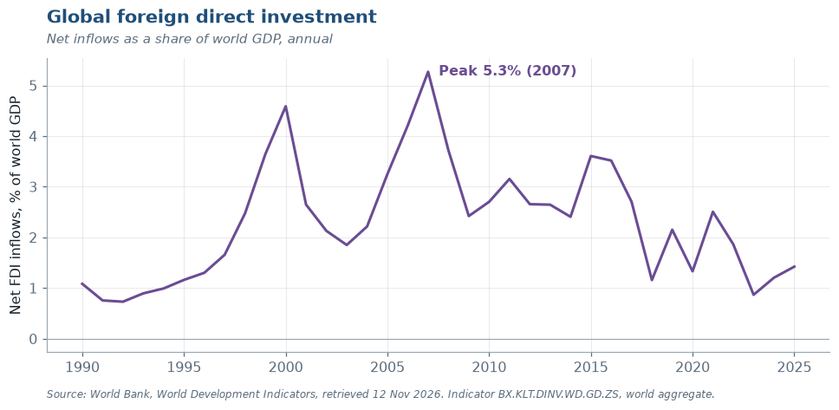
Exhibit 1.12 Global foreign direct investment flows as a share of world GDP. Note the volatility against Exhibit 1.3’s trade series — FDI is the noisiest of the three integration measures and the most contaminated by conduit flows. Source: World Bank, World Development Indicators, BX.KLT.DINV.WD.GD.ZS.
Foreign direct investment. FDI flows are far more volatile than trade. They peaked in 2007, recovered to a secondary high in 2015–16, and have run well below both since. Much of the apparent decline, however, is the unwinding of tax-motivated conduit flows through a handful of financial centers rather than a reduction in real cross-border plant and equipment. The measurement problem here is severe: a large fraction of recorded global FDI passes through special-purpose entities that build nothing.
Financial flows. Gross cross-border financial activity — the subject of Exhibit 1.5 — reached a record in 2025. Cross-border bank claims and international debt issuance have continued to grow. Financial integration has not retreated even where trade integration has plateaued.
Fragmentation or reconfiguration?
The fragmentation view. Tariff escalation, export controls on semiconductors, the weaponization of financial infrastructure through sanctions, and explicit “friend-shoring” industrial policy are fracturing the single global market into blocs. The 2022 freezing of Russian central bank reserves demonstrated that reserve assets are political, and should be expected to accelerate diversification away from the dollar.
The reconfiguration view. Trade is being re-routed, not reduced. Goods that moved directly from China to the United States now move via Vietnam and Mexico, lengthening the measured chain while leaving the underlying production relationships largely intact. The dollar’s share of FX turnover has not declined; reserve diversification has been slow and has gone mostly to small, liquid currencies rather than to a rival anchor.
Your task. The Live Data Lab (Section 8) has you test both views against current data. Note in advance which evidence would change your mind — a discipline we will apply repeatedly, and one that distinguishes analysis from commentary.

In the News
A standing feature. The headlines below come from the public feeds of the financial press and the central banks, filtered for this chapter’s topics. The feed refreshes early every morning, around 6–7 a.m. Eastern, and again whenever the book is rebuilt, so the list you see today may differ from a classmate’s copy from last week.
Latest headlines
- Gold Falls to More Than 1-Year Low As U.S. Dollar, Yields Rise
Wall Street Journal · 12 Nov 2026
- Trump threatens to double tariffs on Mexico over illegal immigration
Financial Times · 12 Nov 2026
- Cash and the digital euro - two sides of the same coin
Bank for International Settlements · 11 Nov 2026
Introductory statement by Mr Piero Cipollone, Member of the Executive Board of the European Central Bank, at the Committee on Economic and Monetary Affairs of the European Parliament, Brussels, 10…
- Boris Vujčić: Integrated, open and resilient: Europe’s strengths in a fragmenting world
European Central Bank · 2 Nov 2026
Updated every morning (around 6–7 a.m. Eastern) and whenever the book is rebuilt.
Headlines retrieved 12 November 2026 from the public feeds of the WSJ, The Economist, the FT, the Federal Reserve, the ECB and the BIS, filtered for this chapter’s topics. Links open the publisher’s site; some articles require a subscription. Your library’s databases give full-text access.

The Chapter 1 dossier
The curated half of this feature has its own page: five sources on the 2026 “dollar story,” chosen by the author and read closely against this chapter, the two exhibits that frame them, and six questions to work. See In the News · Dossiers, Chapter 1.

Module 6 · Data, vintages and AI

6 How This Book Handles Data
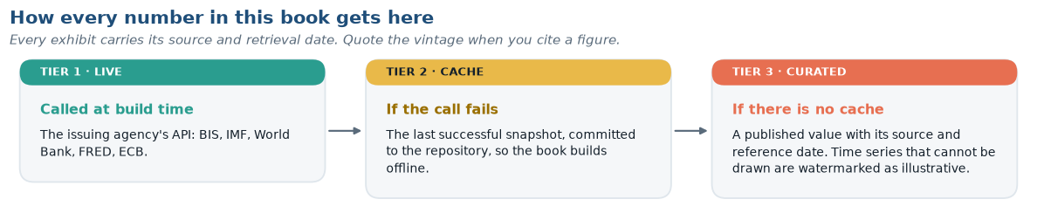
Exhibit 1.13 The three-tier data layer behind every number in this book. A textbook render must never fail because an API is down, and a reader must always be able to tell which vintage they are holding. Source: original diagram for this book.
This is a living textbook. Every statistic, table, and figure in it is generated by code that queries the original statistical agency at the moment the book is built. Nothing is transcribed by hand, which has three consequences you should understand as a reader.
Numbers in the text may differ from those your classmate sees. If your instructor built the course PDF in September and you load the web edition in November, an FX rate or a turnover figure may have changed. Each chapter therefore carries a data-vintage stamp at the top, and each exhibit carries a source note with its retrieval date. Always quote the vintage when you cite a figure in your written work. This build, for example, is stamped 12 November 2026.
The source line is the citation. Every figure names the agency, the series and the date it was retrieved. No number is typed by hand: each one goes straight from the agency’s database into the exhibit, so there is no step at which it could be mistyped — and if you doubt a figure, the source line tells you exactly where to check it.
Primary sources, named. Five institutions supply almost everything in this book, and you should know what each is authoritative for:
Source | Authoritative for | Frequency
BIS | FX and derivatives turnover, cross-border banking, effective exchange rates | Triennial / quarterly
IMF | Balance of payments, reserve composition (COFER), exchange rate regimes | Quarterly / annual
World Bank | Development indicators, trade, FDI, GDP | Annual
FRED (St. Louis Fed) | U.S. and international rates, dollar indices, daily spot FX | Daily / monthly
ECB | Euro reference rates, euro-area financial statistics | Daily

Reading a data vintage
A figure labeled “Source: BIS Triennial Central Bank Survey, April 2025” tells you the reference period — the month the activity occurred. A figure labeled “retrieved 14 September 2026” tells you the retrieval date. These are different, and both matter: statistical agencies revise. Balance-of-payments data in particular are routinely revised for several years after first publication, occasionally enough to reverse the sign of a reported deficit.

7 AI and the Four Frictions
Every chapter closes its core material with a one-page look at how artificial intelligence bears on what the chapter has just developed. For this chapter the answer is short, and it is worth holding onto because the rest of the book depends on it.
Of the four frictions in Section 1, AI attacks only one. Multiple currencies exist because sovereigns issue money (Friction 1); jurisdictional risk exists because states have power (Friction 2); institutional heterogeneity exists because legal systems evolved separately (Friction 3). No model dissolves any of these. Friction 4 is different: it is a cost. Investors know less about foreign firms because reading a filing in another language, under another accounting standard, for another regulator, is expensive — and that is precisely the work current models do cheaply. Technology lowers costs; it does not revoke sovereignty.
If that is right, the home bias of Section 1 should be shrinking as the cost of knowing about foreign firms falls. Whether it is remains an open empirical question, and Chapter 15 gives you the data to examine it.
The best-documented gains so far are inside corporate treasury, where firms report sizable hedging-cost savings — figures on the order of 30 percent in one widely reported pilot — from forecasting their own foreign-currency cash flows more accurately. Keep that forecast separate from a forecast of the exchange rate:
“Our AI forecasts the euro, so we have stopped hedging”
This sentence has been spoken in real treasury meetings, and it contains two separate errors.
The first is a category error. The documented gains are in forecasting the firm’s own cash flows — which are generated by its own order book, its own seasonality, its own customers, and are therefore genuinely predictable. Forecasting the exchange rate is a different problem with a different benchmark, and that benchmark is brutal: proposition 4 of the Top Ten states that no model has reliably beaten a random walk out of sample at horizons that matter, a result that has survived four decades of attempts. Chapter 7 shows you the evidence. A machine-learning model that fits currency history beautifully and fails out of sample is not a new phenomenon; it is the oldest result in the field, arriving in new clothes. The BIS’s own assessment of large language models notes that they can fail elementary reasoning when familiar problems are restated with small changes — which is precisely the situation a regime shift presents.
The second is a theory error. Even a forecast that was accurate would not justify abandoning the hedge, because — proposition 9 of the Top Ten — hedging is not a bet on direction. It is the purchase of left-tail protection against convex distress costs. A firm that stops hedging because it has become confident has not improved its forecast; it has sold insurance to itself.
What to say instead: “Our models have improved our exposure forecast, so we are hedging a tighter notional with less over-coverage.” That claim is defensible and is where the 30 percent came from.

One rule follows for your own work in this course: AI may help you write; it may not be your source. A figure is the agency, the series, the vintage and the retrieval date (Section 6); no model output satisfies that.
Go further · AI in International Finance
The full treatment for this chapter — market structure and algorithmic monoculture, the treasury automation ladder and its governance questions, the AI investment boom as a macroeconomic shock, what AI does not change, and three further problems — is in the companion: AI in International Finance · Chapter 1.

8 Live Data Lab · Taking the temperature of the global economy
Objective. Retrieve three current series, assess their vintage, and form a defensible view on whether global integration is advancing or retreating.
Task 1 — Trade. Retrieve world trade openness (World Bank NE.TRD.GNFS.ZS, aggregate WLD) for 1970 to the present. Identify the peak year and compute the change from peak to the latest observation. Is the decline statistically meaningful relative to the series’ typical annual variation?
Task 2 — Currency. Retrieve the broad nominal dollar index (FRED DTWEXBGS) for the last 20 years. Compute the annualized volatility of monthly log changes. Then compute the maximum drawdown and the maximum run-up. Which is larger, and what does that asymmetry imply for a firm with foreign-currency revenue and dollar debt?
Task 3 — Investment. Retrieve net FDI inflows as a share of GDP (BX.KLT.DINV.WD.GD.ZS) for the world aggregate, the United States, China, Mexico, and Vietnam. Plot all five on one axis since 2000.
Deliverable. In 400 words, state whether the evidence favors the fragmentation view or the reconfiguration view of Section 5. You must cite at least one number against your own position and explain why you nonetheless reject it. Report the retrieval date of every series you use.
Beyond the Page
Films, a tiered reading list, feeds worth following and this chapter’s 400-word media-audit assignment are in the companion: Beyond the Page · Chapter 1.

Summary
- International finance is distinct because of four frictions: multiple currencies, sovereign states, institutional heterogeneity, and informational distance. Every chapter of this book elaborates at least one.
- The FX market turns over roughly $9.6 trillion per day (BIS, April 2025), a 28 percent increase over 2022 and vastly larger than the trade flows it nominally serves. Almost all of this turnover is financial rather than commercial.
- Six participant groups transact with different objectives; dealers and financial institutions, not corporations, set prices.
- Currency exposure comes in three forms — transaction, economic, and translation. Economic exposure is the largest and the most frequently neglected.
- Globalization has plateaued in trade, fallen in measured FDI, and continued to grow in gross financial activity. “Globalization is over” is not supported by the financial data.
- This book regenerates its own data; always check and cite the vintage.
- Artificial intelligence attacks the one friction that is a cost — information — and leaves the three that rest on sovereign authority intact. Its documented gains are in forecasting a firm’s own cash flows, not exchange rates; it does not change the case for hedging; and a model output is never a citable source.

Key Terms
Country risk · Cross-border claim · Data vintage · Economic (operating) exposure · Foreign direct investment (FDI) · Fragmentation · FX Global Code · Home bias · Multinational corporation (MNC) · Slowbalization · Trade openness · Transaction exposure · Translation exposure · Triennial Central Bank Survey · Weaponization of finance

Recall Ledger
Short answers, from memory, no notes. Check them afterwards; record only the ones you missed and redo those alone in one week. This is the spacing that makes the knowledge stick, and it is the whole reason this section exists.
From this chapter
- Name the four frictions that distinguish international finance, and give one chapter of this book that is primarily about each.
- Global FX turnover is roughly $9.6 trillion per day while world merchandise exports are roughly $26.3 trillion per year. Explain, in two sentences, why there is no contradiction in those two numbers.
- A firm hedges every foreign-currency receivable with a forward contract and reports that it is “fully hedged.” State precisely what it is hedged against and what it is not.
Carried forward (these will appear again, and in later chapters you will find questions from Chapter 1 here)
- Non-financial corporations account for only a single-digit share of FX turnover. Why, and why does that make it more important, not less, for a corporate treasurer to understand who else is trading? Give one example from Section 3.
- Of the Top Ten propositions at the front of the book, which one would most change a treasurer’s behavior tomorrow morning? Defend the choice in three sentences.
AI item
- Explain, in two sentences, why artificial intelligence plausibly reduces Friction 4 but not Frictions 1, 2 or 3. Then state one piece of evidence that would show the reduction is actually happening.
Revisit: Before You Read
Your saved pretest answers appear here in the web edition.
Return to the three questions you answered at the start of the chapter. For each one, write (a) what you believed, (b) what the chapter established, and (c) if they differ, the specific assumption that produced your error. The third part is the one that matters. Keep these across the semester; by Chapter 10 the pattern in your own errors will be visible, and it is almost always a single recurring assumption rather than a collection of unrelated gaps.

Chapter Checkpoint
The Checkpoint draws on every module. It opens when all the module checks above are done. You get new numbers on each attempt, up to three attempts, and your best score counts.
The Checkpoint runs in the web edition of this chapter.
Interactive practice · practice-test-ch01.html
The problems below are fixed; the companion practice test is not. It contains eight problem generators — scale and magnitude arithmetic, appreciation and depreciation, trade openness, cross rates, the hedging comparison, exposure classification, gross-versus-net reasoning and data-vintage judgment — and each one draws new numbers every time you open it. That is deliberate. A problem you can only solve once teaches you an answer; a problem that changes teaches you a method. Each attempt is scored, each solution is shown step by step, and a confidence slider records how well calibrated you were. Nothing is uploaded; your attempt history stays in your own browser.
Work the fixed problems below first, because they are the ones your instructor can discuss. Then use the generator until you can do each type without hesitating.

Problems

A · Concept
1.1 State the four frictions that distinguish international from domestic finance, and give one real-world example of each that does not appear in this chapter.
1.2 A firm sells only in its home market, buys only from domestic suppliers, and has no foreign debt. Construct a specific scenario in which it nonetheless suffers materially from a currency movement.
1.3 Distinguish the reference period of a statistic from its retrieval date, and explain why a balance-of-payments figure requires both.
1.4 Why might reported global FDI overstate real cross-border investment in productive capacity?

B · Quantitative
1.5 Global FX turnover was $7.5 trillion per day in April 2022 and $9.6 trillion in April 2025. (a) Compute the total percentage change. (b) Compute the compound annual growth rate. (c) World nominal GDP grew roughly 5 percent per year over the same period; interpret the difference.
1.6 World merchandise exports are approximately $26.3 trillion per year. Using the April 2025 turnover figure and 252 trading days, compute (a) annual FX turnover, (b) the ratio of FX turnover to merchandise trade, and (c) the number of trading days required to clear one year of goods trade.
1.7 A U.S. firm expects €4,000,000 in 90 days. The spot rate is $1.0850/€. (a) Compute the dollar value at spot. (b) Recompute at $1.0200/€ and at $1.1500/€. (c) If the firm’s operating margin on this sale is 9 percent, at what EUR/USD rate does the sale become unprofitable, holding costs fixed?
1.8 Turnover grew from $1.2 trillion (2001) to $9.6 trillion (2025). (a) Compute the CAGR. (b) Turnover fell from $5.4 trillion in 2013 to $5.1 trillion in 2016; compute that annualized rate and propose two explanations consistent with the post-crisis regulatory environment.
1.9 A firm’s foreign subsidiary has net assets of 180 million Mexican pesos. The peso moves from 17.0/USD to 19.5/USD over the year. (a) Compute the translation gain or loss in dollars. (b) State where it appears in the financial statements. (c) Explain why hedging it with a forward contract may create cash flow risk where none existed.

C · Analytical
1.10 Economic exposure is larger than transaction exposure yet is hedged far less often. Give three distinct explanations — one from measurement, one from agency theory, one from instrument availability — and propose an empirical test that could discriminate among them.
1.11 Make the strongest possible case that the dollar’s dominance in FX turnover is self-reinforcing rather than a reflection of U.S. economic size. Then identify the single piece of evidence that would most damage your argument.
1.12 The 2022 freezing of Russian central bank reserves has been described as a turning point for the international monetary system. Using only data available to you now, assess whether reserve-currency behavior has in fact changed. Specify what a genuine shift would look like in the data, and over what horizon it would be detectable.
1.13 The Top Ten, at the front of the book, states that two of its propositions are in genuine tension with each other, and that a third is asserted more confidently than the empirical literature strictly supports. Identify the tension and identify the overstated claim. For the tension, explain the conditions under which each proposition dominates; for the overstatement, specify what evidence would be needed to justify the strong form.

Mini-Case · Volkswagen’s $2 Billion Hedge That Wasn’t
In its 2008 fiscal year, Volkswagen reported a loss of roughly €1.5 billion on currency hedges — in a year when the euro moved sharply against both the dollar and several emerging-market currencies. The company had hedged a substantial fraction of its expected foreign-currency revenue using forward contracts, but revenues came in well below forecast as the global financial crisis collapsed vehicle demand. The hedges, sized to a volume of sales that never materialized, converted from a risk-reducing position into an outright speculative one.
Questions
- Classify the exposure VW was attempting to hedge. Was the instrument appropriate to it?
- The company over-hedged because quantity was uncertain as well as price. Explain why a linear instrument (a forward) is poorly suited to an exposure of uncertain size, and what instrument class addresses this directly. (Preview of Chapter 9.)
- Volume risk and currency risk were correlated here: the same crisis that moved the euro also destroyed demand. Does that correlation make the over-hedge more or less damaging than if the two were independent? Show your reasoning.
- VW’s management argued the loss was an accounting artifact that would reverse. Evaluate that claim. Under what conditions is it true, and under what conditions is it an excuse?
- Propose a hedging policy — stating hedge ratio, horizon, and instrument — that would have reduced the damage without abandoning hedging altogether. Defend the cost.

References and Further Reading
Bank for International Settlements. Triennial Central Bank Survey of Foreign Exchange and Over-the-Counter Derivatives Markets. Basel: BIS, April 2025 round, published September 2025. https://www.bis.org/statistics/rpfx25.htm
Bekaert, Geert, and Robert J. Hodrick. International Financial Management. 3rd ed. Cambridge University Press — Chapter 1.
Eiteman, David K., Arthur I. Stonehill, and Michael H. Moffett. Multinational Business Finance. 16th ed. Pearson — Chapters 1 and 2.
Eun, Cheol S., and Bruce G. Resnick. International Financial Management. 9th ed. McGraw-Hill — Chapter 1.
Goldberg, Linda S., Oliver Hannaoui, and Sneha Parthasarathy. “Are Central Banks Moving Out of Dollar Assets?” Liberty Street Economics, Federal Reserve Bank of New York, 2 September 2026.
International Monetary Fund. Currency Composition of Official Foreign Exchange Reserves (COFER): Data Brief, 2026Q1. Washington, DC: IMF, 1 July 2026.
Krugman, Paul R., Maurice Obstfeld, and Marc J. Melitz. International Economics: Theory and Policy. 12th ed. Pearson — Chapters 1 and 13.
Levich, Richard M. International Financial Markets: Prices and Policies. 2nd ed. McGraw-Hill — Chapters 3 and 4.
Madura, Jeff. International Financial Management. 14th ed. Cengage — Chapter 1.
Obstfeld, Maurice, and Kenneth Rogoff. “The Six Major Puzzles in International Macroeconomics: Is There a Common Cause?” NBER Macroeconomics Annual, 2001.
Shapiro, Alan C., and Peter Moles. International Financial Management. Wiley.
Next chapter: the international monetary system — how the world arrived at the current patchwork of floats, pegs, boards, and currency unions, and why the impossible trinity explains most of it.

