Q1:

As n starts off and is small, f1 has the greatest value, followed by f3 and finally f2.

As n continues to increase, f3 overtakes f1 in value, while f2 is the least but showing exponential growth

As n is very large, f2 has the largest value, and f3 has the second highest, while f1 is the least. f3 and f1 have lower rates of growth than f2.

**Python Code:**

import math

import numpy as np

import matplotlib.pyplot as plt

msize = [5, 15, 50]

# red dashes, blue squares and green triangles

# plt.plot(t, t, 'r--', t, t**3.5 - 2**10, 'bs', t, 100*t**2.1 + 50, 'g^')

for item in msize:

    t = np.arange(0, item, 0.1)

    plt.plot(t, (2**10)*t + (2**10) , 'red', t, t**3.5 - 1000, 'blue', t, 100*t**2.1 + 50, 'green')

    plt.xlim(0, item)

    plt.rcParams["figure.figsize"] = (7,7)

    plt.show()

Q2:

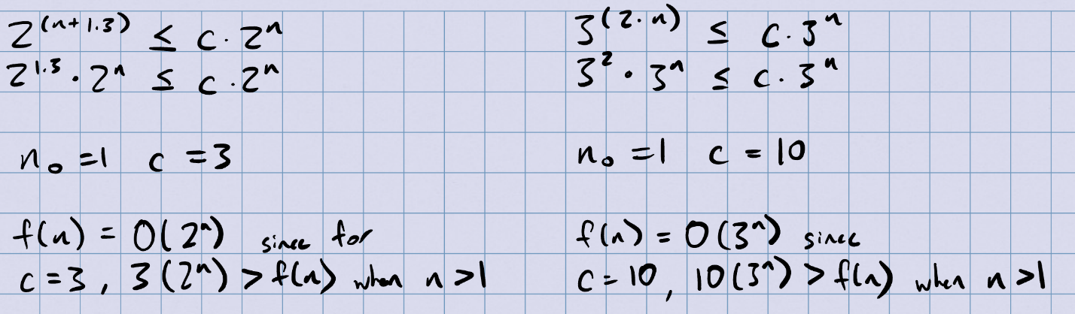

Q4:

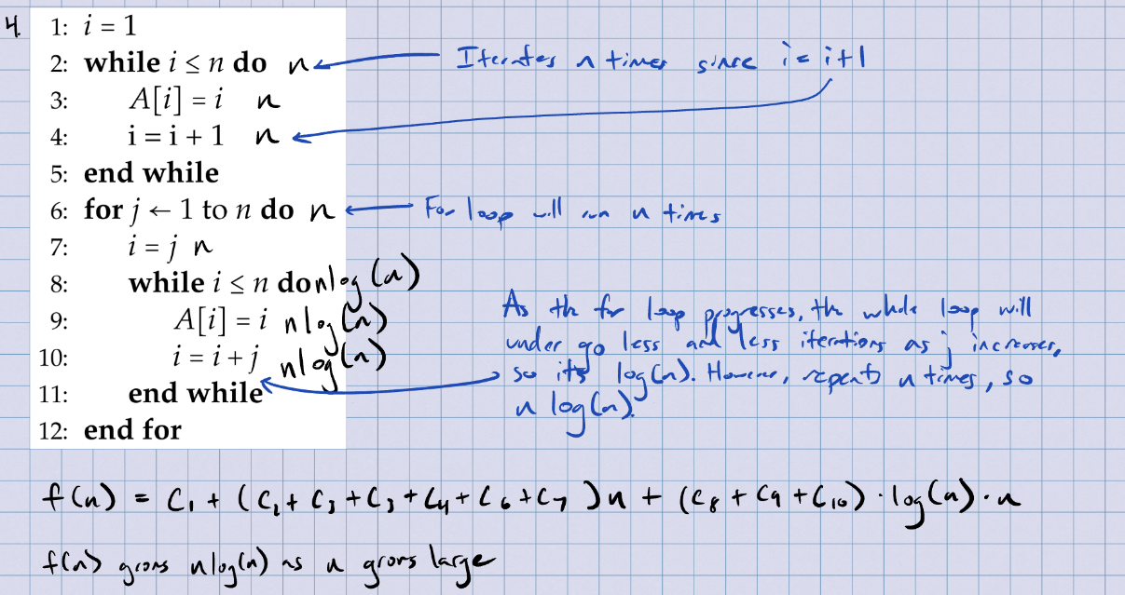

Q5:

