

**CSEE5590/490: Web/Mobile Programming**

**Mobile App Development**

**INSTALLATION**

* Need to install Java Development Kit (JDK) to write Java (and Android) programs
* **Do not install** Java Runtime Environment (JRE); JDK and JRE are different!
* Can download the JDK for your OS at [http://java.oracle.com](http://java.oracle.com/)
* Alternatively, for OS X, Linux:
* OS X:
  + Open */Applications/Utilities/Terminal.app*
  + Type *javac* at command line
  + Install Java when prompt appears
* Linux:
  + Type *sudo apt–get install default–jdk* at command line (Debian, Ubuntu)
* Other distributions: consult distribution’s documentation
* After installing JDK, download Android Studio from <https://developer.android.com/studio/index.html>
* Simplest: download and install Android Studio bundle (including Android SDK) for your OS

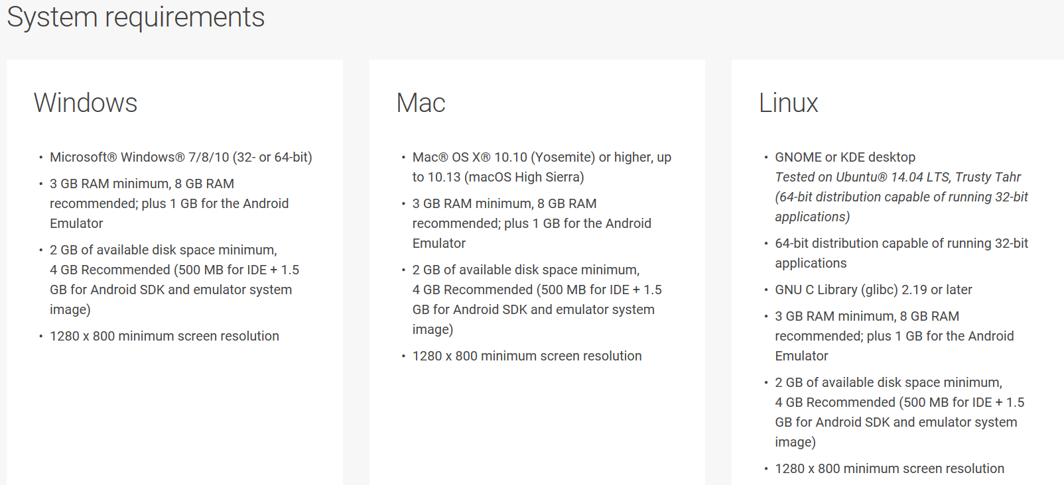

Follow the default instructions while android studio installation. However, below are the reference screenshots for Windows OS

