**Mobile_Lesson4: Accessing the hardware components of the Android system**

Please don't forget to submit your feedback after the class. This helps a lot in increasing the effectiveness of the course. Use the following link to submit your feedback: <https://goo.gl/forms/hVL05z0mQgTg5njg1>

**Lesson Overview:**

In this lesson, we will learn how to access the different components of the Android system such as the camera, location, and sensors. These can be incorporated in any apps to add more features in addition to apps that are built entirely on these components.

**Use Case Description:**

**Android Hardware:** Maps, Camera, Audio, Storage

**Programming Elements:**

Accessing the different hardware components of the Android system(location, camera, microphone, Accelerometer, Gyroscope)

**Source Code:**

<https://umkc.box.com/s/k5xajqyaz6mu6zxtd1fg13w8mrjmad1k>

**In Class Programming:**

We have provided most of the code and you can update the given source code to complete the ICP. However, don't limit yourself to given example screens and you can be more creative.

1. **Google Maps:** 
   1. Modify the **LocationActivity** class to display user's current location with a marker on the map
   2. Hint: Use Location service and Geocoder classes to complete the task
   3. Reference: https://developers.google.com/maps/documentation/android-api/current-place-tutorial

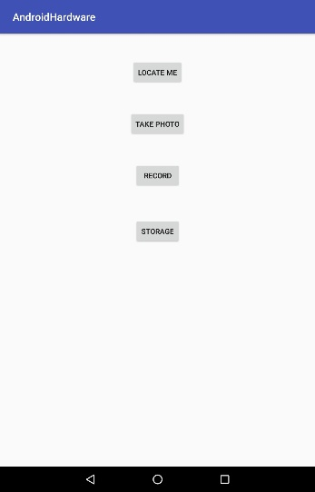 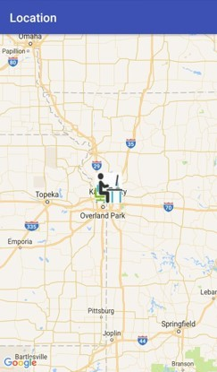

1. **Camera:** Modify the ***CameraActivity*** class to capture the image

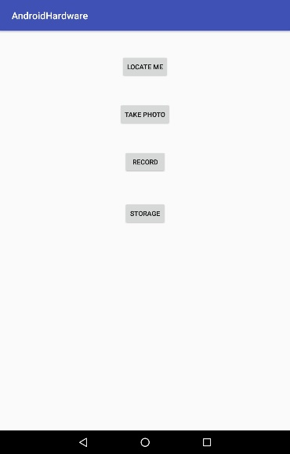 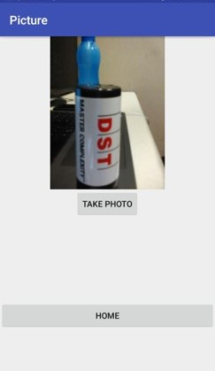

1. **Audio (microphone):** Modify the ***AudioRecordingActivity*** class to record and reply the audio

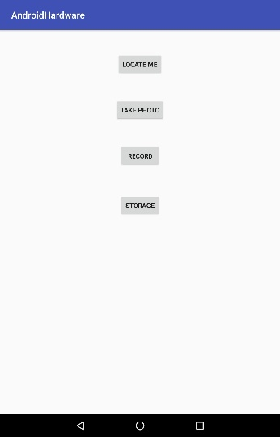 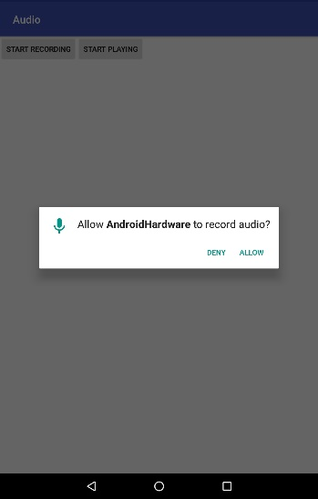 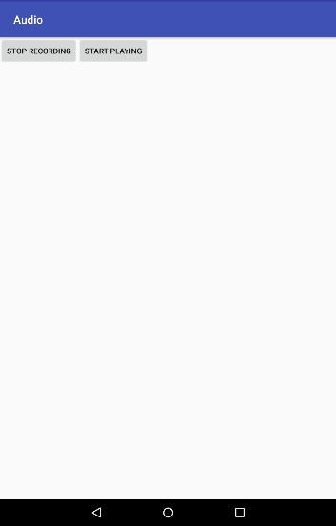 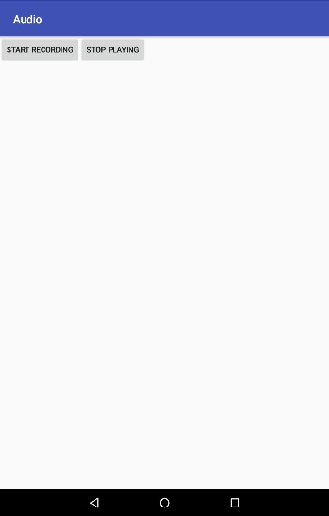

1. **Storage:** Modify the ***StorageActivity*** class to store and display the stored text

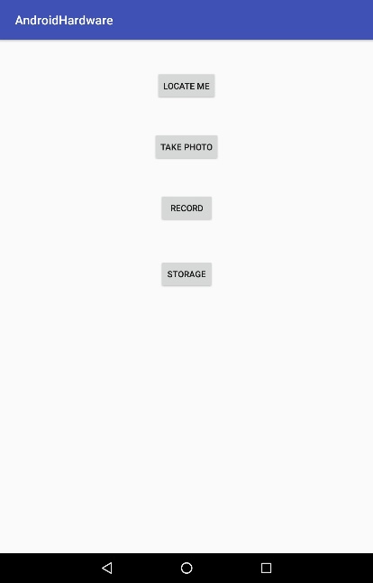 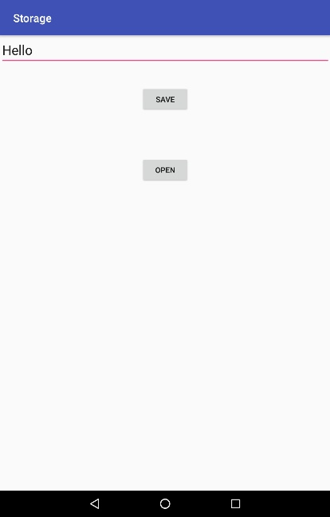 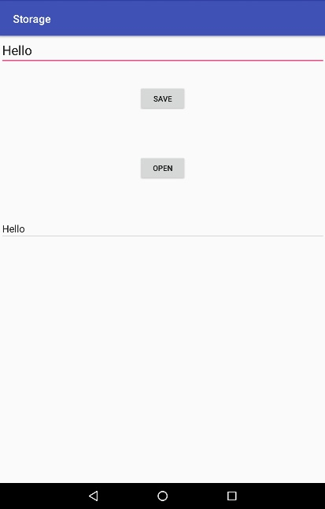

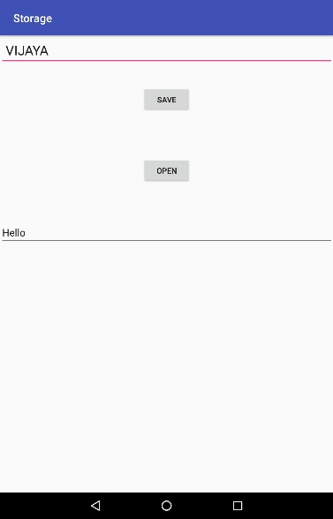 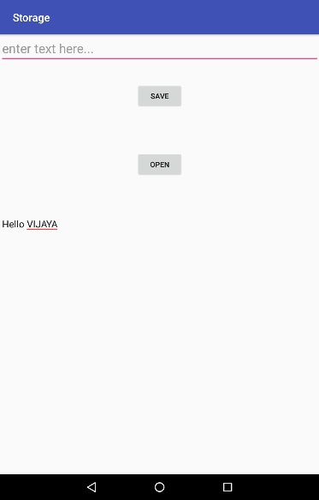 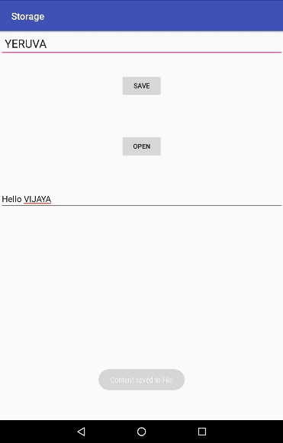 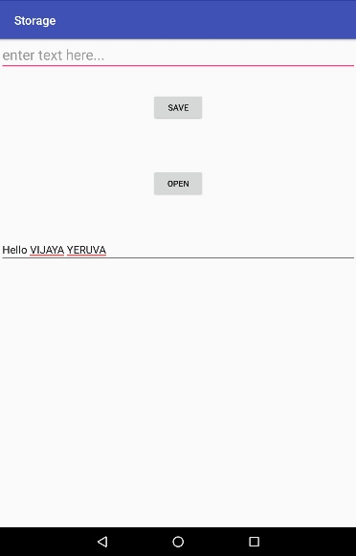

**ICP Submission Guidelines (for In Class students):**

1. ICP submission is in pairs of two students
2. Once completed, must be presented to the TA or Instructor before the completion of the class
3. Submission after class is considered as a late submission. (Check the 'Late Submission Policy' in the syllabus)
4. ICP code with brief explanation should be pushed to the GitHub. Submit the GitHub link through the Feedback Form: <https://goo.gl/forms/hVL05z0mQgTg5njg1>
5. Fill out your request for evaluation (per team) through the link below:

<https://docs.google.com/spreadsheets/d/10srQn20XAZh-bqvDSZ3w0LDYvbVNjnPvZuOEANT2vNE/edit#gid=929404685>

**Online Submission Guidelines (for Online students):**

1. Submit your source code and documentation to the GitHub and represent the work through wiki page properly (submit your screenshots as well. The screenshot should have both the code and the output)
2. Comment your code appropriately (they should be self-explanatory)
3. Video submission (2 – 3 min video showing the demo of the ICP, with the brief voiceover on the code explanation)
4. Submission after class is considered as a late submission. (Check the 'Late Submission Policy' in the syllabus)
5. Use the following Google link to submit your ICP # (GitHub wiki page link for ICP #): <https://goo.gl/forms/HShoVqcBOEyD2YOC3>
6. Fill out your request for evaluation (per team) through the link below:

<https://docs.google.com/spreadsheets/d/10srQn20XAZh-bqvDSZ3w0LDYvbVNjnPvZuOEANT2vNE/edit#gid=929404685>

**ICP Evaluation Criteria:**

1. Completeness of Features
2. Code Quality (<https://en.wikipedia.org/wiki/Best_coding_practices>)
3. Time (before the end of the class)
4. Feedback Submission

**Note:** *Cheating, plagiarism, disruptive behavior and other forms of unacceptable conduct are subject to strong sanctions in accordance with university policy. See detailed description of university policy at the following URL:* [*https://catalog.umkc.edu/special-notices/academic-honesty/*](https://catalog.umkc.edu/special-notices/academic-honesty/)