**Mobile_Lesson2: Developing food ordering applications for android**

Please don't forget to submit your feedback after the class. This helps a lot in increasing the effectiveness of the course. Use the following link to submit your feedback: <https://goo.gl/forms/hVL05z0mQgTg5njg1>

**Lesson Overview:**

In this lesson, we are going to discuss some basics of Android by working on layouts, views, and intents thereby getting familiarized with the management system. Some elements of Java language are also revisited through ICP.

**Use Case Description:**

**My Coffee:** Coffee ordering app

**Programming Elements:**

Basics of Android (Layouts, Views and Intents)

**Source Code:**

<https://umkc.box.com/s/nfb3pvkxe5jq7tu3d5ymad3b7xo2oa5u>

**In Class Programming:**

**My Pizza:** Pizza ordering app

1. Understand the starter code given for ordering coffee and make a simple mobile application to order a pizza with the following requirements.
2. The main activity should look as below (make suitable changes for pizza ordering app!).
3. Add two more options for the toppings.
4. Create the 'ORDER' and 'SUMMARY' buttons beside to each other.
5. When clicked on 'SUMMARY' button, the summary should display in a new activity in a List View
6. When clicked on 'GO TO ORDER' button, the screen should navigate back to order screen
7. After filling the details, when the 'ORDER' button has clicked the option to send an email with the summary of the order should be displayed as follows

**Note:** Use Image, Button, Spinner, Checkbox, Radio Views and Relative/Linear Layouts for completing the task. And include appropriate icon for the app

**Refer the example output:** Don't limit yourself to given example screens and you can be more creative.

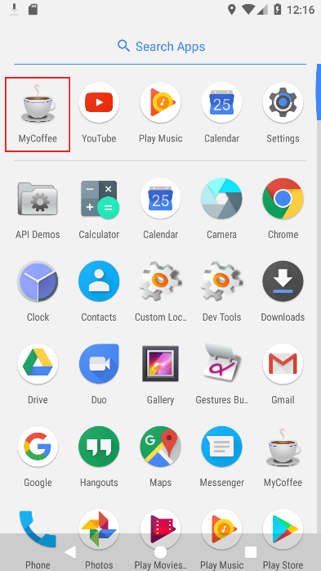 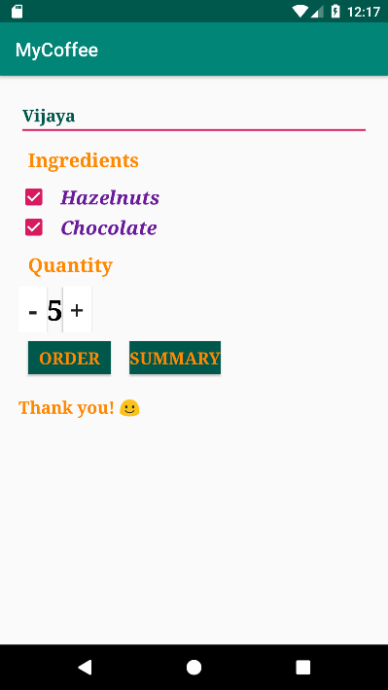 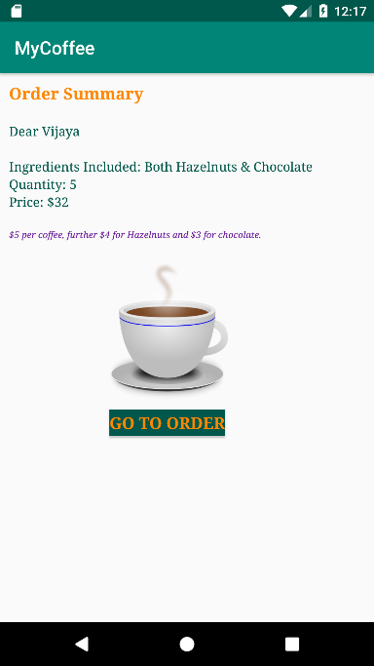 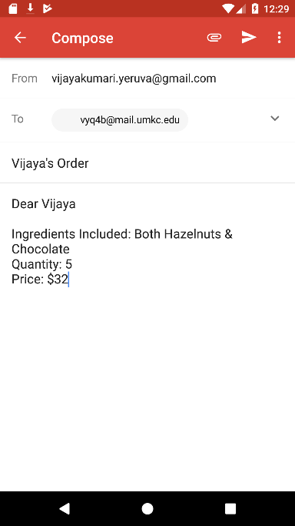

**References to help in ICP:**

<https://developer.android.com/reference/android/widget/Button.html>

<https://stackoverflow.com/questions/15859445/how-do-you-pass-a-string-from-one-activity-to-another>

<https://stackoverflow.com/questions/18146614/how-to-send-string-from-one-activity-to-another>

<https://developer.android.com/guide/components/intents-filters.html>

**ICP Submission Guidelines (for In Class students):**

1. ICP submission is in pairs of two students
2. Once completed, must be presented to the TA or Instructor before the completion of the class
3. Submission after class is considered as a late submission. (Check the 'Late Submission Policy' in the syllabus)
4. ICP code with brief explanation should be pushed to the GitHub. Submit the GitHub link through the Feedback Form: <https://goo.gl/forms/hVL05z0mQgTg5njg1>
5. Fill out your request for evaluation (per team) through the link below:

<https://docs.google.com/spreadsheets/d/10srQn20XAZh-bqvDSZ3w0LDYvbVNjnPvZuOEANT2vNE/edit#gid=929404685>

**Online Submission Guidelines (for Online students):**

1. Submit your source code and documentation to the GitHub and represent the work through wiki page properly (submit your screenshots as well. The screenshot should have both the code and the output)
2. Comment your code appropriately (they should be self-explanatory)
3. Video submission (2 – 3 min video showing the demo of the ICP, with the brief voiceover on the code explanation)
4. Submission after class is considered as a late submission. (Check the 'Late Submission Policy' in the syllabus)
5. Use the following Google link to submit your ICP # (GitHub wiki page link for ICP #): <https://goo.gl/forms/HShoVqcBOEyD2YOC3>
6. Fill out your request for evaluation (per team) through the link below:

<https://docs.google.com/spreadsheets/d/10srQn20XAZh-bqvDSZ3w0LDYvbVNjnPvZuOEANT2vNE/edit#gid=929404685>

**ICP Evaluation Criteria:**

1. Completeness of Features
2. Code Quality (<https://en.wikipedia.org/wiki/Best_coding_practices>)
3. Time (before the end of the class)
4. Feedback Submission

**Note:** *Cheating, plagiarism, disruptive behavior and other forms of unacceptable conduct are subject to strong sanctions in accordance with university policy. See detailed description of university policy at the following URL:* [*https://catalog.umkc.edu/special-notices/academic-honesty/*](https://catalog.umkc.edu/special-notices/academic-honesty/)