Supplementary information for: *Sodium silicate and hexametaphosphate promote the release of (oxyhydr)oxide nanoparticles from corroding iron*

Benjamin F. Trueman, Javier Locsin, Evelyne Doré, Kalli Hood, and Graham A. Gagnon

Centre for Water Resources Studies,\* Department of Civil & Resource Engineering, Dalhousie University, 1360 Barrington St., Halifax, Nova Scotia, Canada B3H 4R2  
   
 \*Corresponding author  
 E-mail: [benjamin.trueman@dal.ca](mailto:benjamin.trueman@dal.ca)  
 <Tel:902.494.6070>  
 Fax: 902.494.3105

This document contains X tables and X figures.

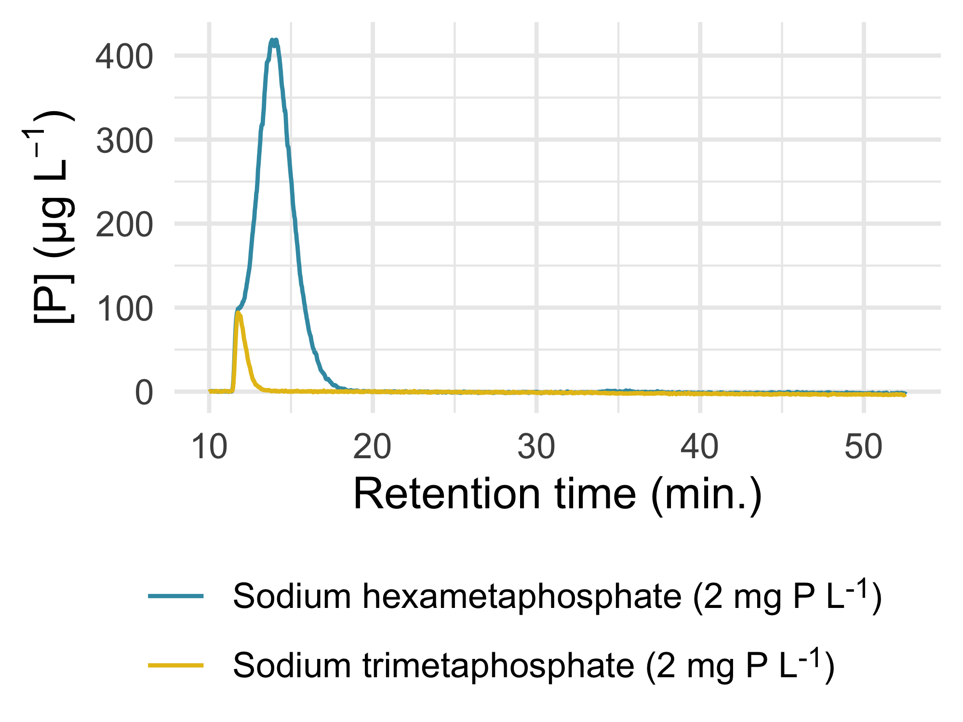

Figure S1: Fractograms representing pure solutions of sodium hexameta- and trimeta-phosphate.