
DATA INTERFACE USER MANUAL
|
The purpose of this management reporting interface is to offer insight into BlueBox’s daily operations and provide the user with a comprehensive understanding of the company’s performance in order to identify areas for future improvement. There are three different views available: Marketing Management, Inventory Management, and Vendor Management.

MARKETING MANAGEMENT VIEW

The Marketing Management View provides users with an overview of customer demographics, such as age, gender, and location. It also provides insight into genre preferences among these different demographics, as well as supporting visualizations.

Step 1. Upon loading the interface, you are prompted with the starting screen. Enter 1 into the terminal to access the Marketing Management View.

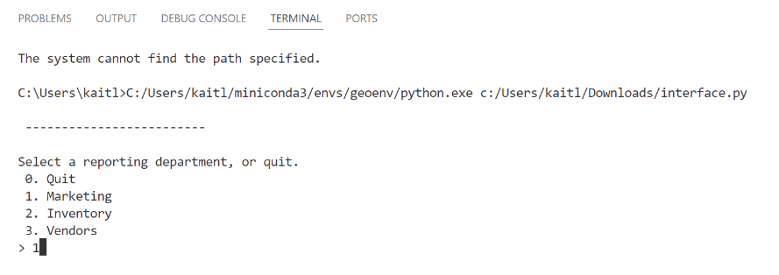
Enter “1” when prompted to access the Marketing Management View.

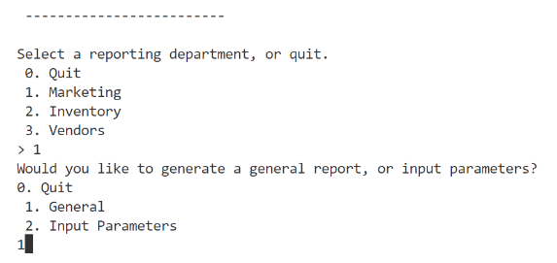
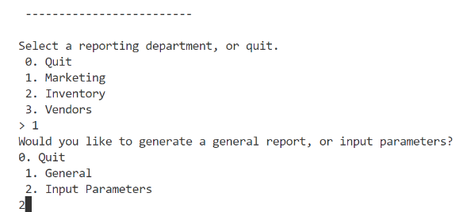
Step 2. From here, you have the option to generate a general report or choose specific parameters for your report. To generate a basic report, enter 1 into the terminal and proceed to step 2a. If you would like to input parameters, select 2 and proceed to step 2b. Otherwise, select 0 to terminate the interface.
OR
Enter “2” to create a more customized report.
Enter “1” to generate a basic report (i.e., non-customizable).

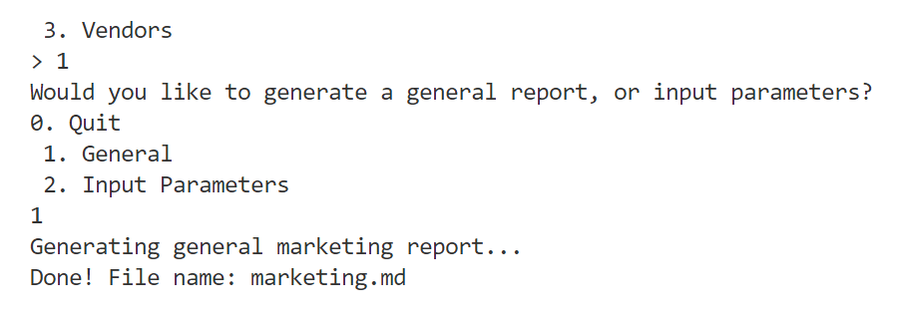
Step 2a. After entering 1 into the terminal, the interface should generate a general marketing report. The task is complete.
The report has been created and can now be accessed.

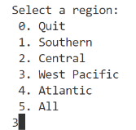
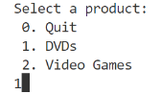
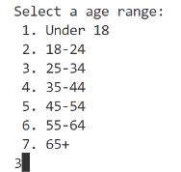
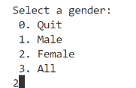
Step 2b. After entering 2 into the terminal, you will now have the option to choose specific parameters for your report. You have the option to select a specific product type, region, gender, and age group. After selecting your desired choices, the interface will generate the customized marketing report. The task is complete.
Then for region.
When prompted, select an option for product type.
And finally, for age range.
Then for gender.

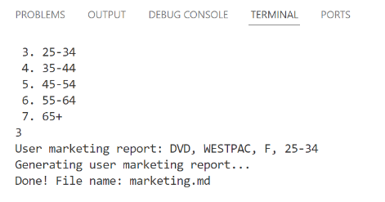
After entering valid options, the report will be generated and can be accessed.
Step 3. Enter 0 into the terminal to exit the reporting interface or select another option and repeat the steps listed.

INVENTORY MANAGEMENT VIEW

The Inventory Management View provides users with an overview of the most popular movies, games, studios, casts, directors, and writers currently stored in inventory.

Step 1. Upon loading the interface, you are prompted with the starting screen. Enter 2 into the terminal to access the Inventory Management View and generate a report.

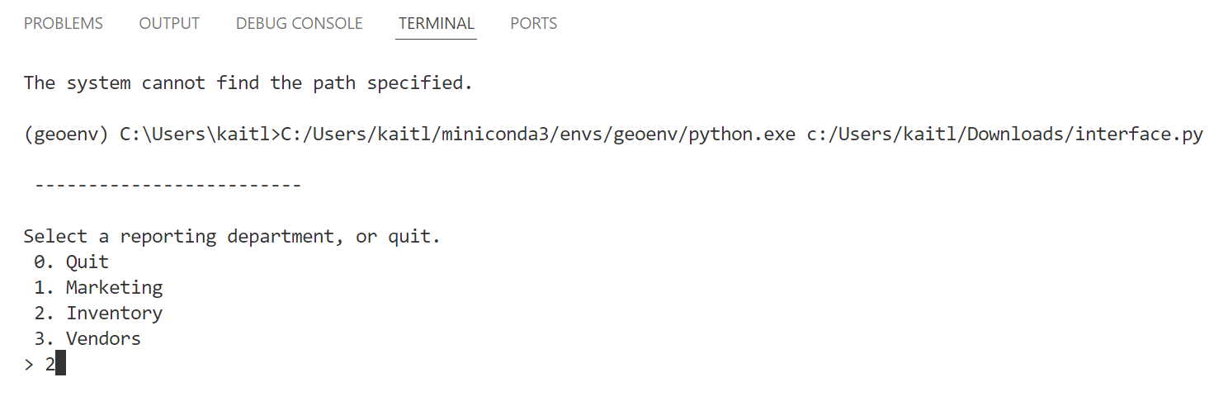
Enter “2” when prompted to access the Inventory Management View.
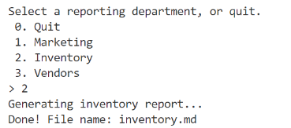
The report will generate and can now be accessed.

Step 2. Enter 0 into the terminal to exit the reporting interface or select another option and repeat the steps listed.

VENDOR MANAGEMENT VIEW

The Vendor Management View provides users with an overview of the most utilized vendors, as well as the most popular movies, games, genres, and game types from each vendor.

Step 1. Upon loading the interface, you are prompted with the starting screen. Enter 1 into the terminal to access the Vendor Management View and generate a report.

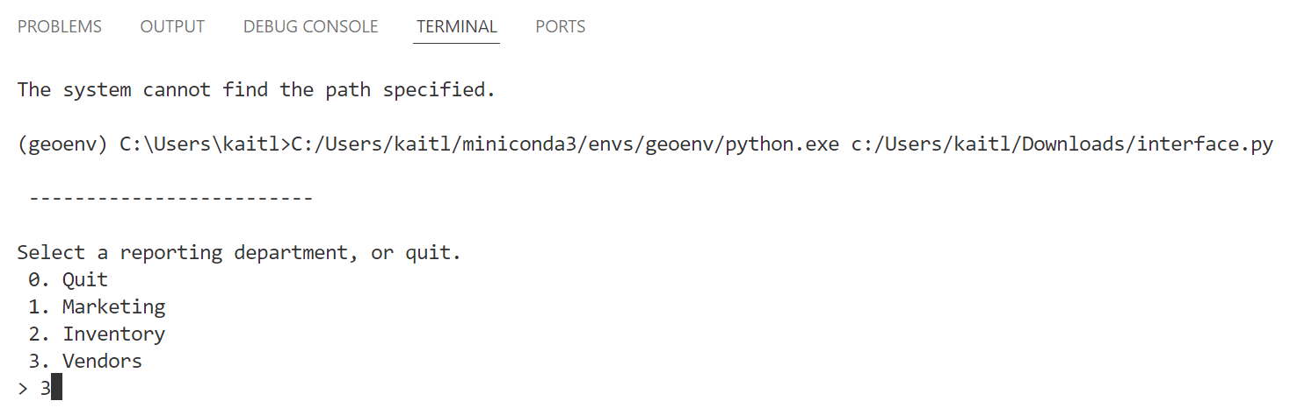
Enter “3” when prompted to access the Vendor Management View.

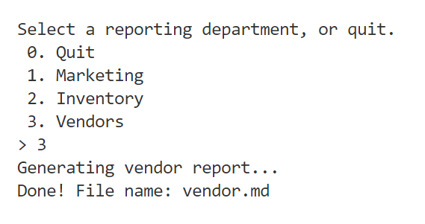
The report will generate and can now be accessed.

Step 2. Enter 0 into the terminal to exit the reporting interface or select another option and repeat the steps listed.

