**Overview of Nitrogen Dioxide (NO2) Air Quality in the United States**

Updated: February 7, 2023

**1. Introduction**

    The overall purpose of this document is to maintain an up-to-date graphical summary of air quality information that supports the review of the National Ambient Air Quality Standards (NAAQS) for oxides of nitrogen, hereafter referred to as the nitrogen dioxide (NO2) NAAQS. In previous reviews of the NO2 NAAQS, this type of information has generally been included in atmospheric sections of the Integrated Science Assessment (ISA) and Policy Assessment (PA) for Oxides of Nitrogen. This stand-alone document will either replace or complement the air quality emissions and monitoring data in the atmospheric sections of future NO2 NAAQS review supporting documents and will be updated at regular intervals as new data becomes available.

     The content of past NAAQS documents’ atmospheric sections has included major sections on emissions and concentration trends utilizing maps and data from the Environmental Protection Agency’s (EPA’s) National Emissions Inventory (NEI) and the EPA’s Air Quality System (AQS) database. In past NAAQS reviews, this often involved adaptation of figures and tables prepared for other reports or development of new figures and tables using data analysis and mapping software. Additionally, the release of updated emission inventories and ambient air monitoring data may not coincide with the schedule for the development of NAAQS review supporting documents. As a result, data access and resources can limit the availability of the most recent information for inclusion in NAAQS review supporting documents.

     This stand-alone document allows the content to be updated as soon as new data becomes available, rather than relying on information that is available at the time of development of the NAAQS review supporting documents. It also ensures that the public will have access to a consistent set of maps and figures for each NAAQS pollutant that are updated on a routine basis, rather than separated by several years because of the disparate schedules of the various NAAQS reviews for each pollutant. Moreover, a stand-alone document can be expanded to include new air quality analyses as they are completed, rather than following the timeline for the public release of the NAAQS review supporting documents. Finally, this document takes advantage of a more flexible digital format for the routinely prepared maps and trends figures with an end product that more strongly emphasizes visual presentation of data and reduces the amount of text, while also creating a more interactive presentation of the information through the use of external links.

     This document follows an organizational structure similar to that of the atmospheric sections of past NO2 NAAQS review supporting documents. The subsequent sections are as follows: 2. Atmospheric Chemistry; 3. Sources and Emissions of NOX; 4. Ambient Air Monitoring Requirements and Monitoring Networks; 5. Data Handling Conventions and Computations for Determining Whether the Standards are Met; and 6. NO2 Concentrations Measured at Ambient Air Monitoring Sites Across the U.S. These sections are broad enough in scope to communicate relevant information about NO2 air quality, including scientific advances, but specific enough that the information needed to develop NAAQS review supporting documents can be quickly and readily retrieved.

**2. Atmospheric Chemistry**

     This document generally focuses on NO2, as it is the current NAAQS indicator for oxides of nitrogen and the most relevant to health effects. Ambient concentrations of NO2 are influenced by both direct NO2 emissions and by emissions of nitric oxide (NO), with the subsequent conversion of NO to NO2 primarily though reaction with ozone (O3). The initial reaction between NO and O3 to form NO2 occurs fairly quickly during the daytime, with reaction times on the order of minutes. However, NO2 can also be photolyzed to reform NO, creating new O3 in the process. A large number of oxidized nitrogen species in the atmosphere are formed from the oxidation of NO and NO2. These include nitrate radicals (NO3), nitrous acid (HONO), nitric acid (HNO3), dinitrogen pentoxide (N2O5), nitryl chloride (ClNO2), peroxynitric acid (HNO4), peroxyacetyl nitrate and its homologues (PANs), other organic nitrates, such as alkyl nitrates (including isoprene nitrates), and pNO3. The sum of these reactive oxidation products (collectively referred to as NOZ) and NO plus NO2 (collectively referred to as NOX) comprise NOY.

     Due to the close relationship between NO and NO2, and their ready interconversion, these species are often grouped together and referred to as NOX. The majority of NOX emissions are in the form of NO. For example, 90% or more of tail-pipe NOX emissions are in the form of NO, with only about 2 to 10% emitted as NO2. As noted above, NOX emissions require time and sufficient O3 concentrations for the conversion of NO to NO2. Higher temperatures and concentrations of reactants result in shorter conversion times (e.g., less than one minute under some conditions), while dispersion and depletion of reactants results in longer conversion times. The time required to transport emissions away from a roadway can vary from less than one minute (e.g., under open conditions) to about one hour (e.g., for certain urban street canyons). These factors can affect the locations where the highest NO2 concentrations occur. In particular, while ambient NO2 concentrations are often elevated near important sources of NOX emissions, such as major roadways, the highest measured ambient concentrations in a given urban area may not always occur immediately adjacent to those sources. Ambient NO2 concentrations around stationary sources of NOX emissions are similarly impacted by the availability of O3 and by meteorological conditions, although surface-level NO2 concentrations can be less impacted in cases where stationary source NOX emissions are emitted from locations elevated substantially above ground level.

     The near-road environment provides a clear example of the interplay between NOX emissions, meteorology, and the atmospheric chemistry that impacts ambient NO2 concentrations. Vehicular emissions tend to peak during the morning and afternoon commutes, while peak O3 concentrations generally occur in the late morning to early evenings. In addition, atmospheric mixing tends to be the strongest during the daytime, rapidly diluting roadway emissions. Given the relative timing of O3 availability and peak atmospheric mixing conditions, the highest near-road NO2 concentrations often occur during the early morning hours (i.e., before atmospheric mixing can rapidly dilute emissions). The conversion of NOX into the species that make up NOZ typically takes place on a much longer time scale than do interconversions between NO and NO2. NOX emitted during morning rush hour by vehicles can be converted almost completely into these products by late afternoon during warm, sunny conditions.

     Oxidized nitrogen compounds are ultimately lost from the atmosphere by wet and dry deposition to the Earth’s surface. Soluble species are taken up by aqueous aerosols and cloud droplets and are removed by wet deposition by rainout (i.e., incorporation into cloud droplets that eventually coagulate into falling rain drops). Both soluble and insoluble species are removed by washout (i.e., impaction with falling rain drops, another component of wet deposition), and by dry deposition (i.e., impaction with the surface and gas exchange with plants). NO and NO2 are not very soluble, and therefore wet deposition is not a major removal process for them. However, a major NOX reservoir species, HNO3, is extremely soluble, and its deposition (both wet and dry) represents a major sink for NOY.

**3. Sources and Emissions of NOX**

     Figure 1 shows the relative contributions of various sources to total U.S. NOX emissions in 2017. Anthropogenic sources account for a large majority of NOX emissions in the U.S., with highway vehicles (30%), off-highway vehicles (70%), and stationary fuel combustion (22%) identified as the largest contributors. More specifically, highway vehicles include all on-road vehicles, including light duty as well as heavy duty vehicles, both gasoline- and diesel-powered. Non-road mobile sources include aircraft, commercial marine vessels, locomotives, and non-road equipment. Fuel combustion includes electric generating units (EGUs), which generate electricity from fossil fuels, primarily coal, as well as commercial/institutional, industrial, and residential combustion of biomass, coal, natural gas, oil, and other fuels. Other anthropogenic NOX sources include agricultural field burning, prescribed fires, and various industrial processes such as cement manufacturing and oil and gas production. Natural sources of NOX include emissions from plants and soil (biogenics) and wildfires.

     The [National Emissions Inventory (NEI)](https://www.epa.gov/air-emissions-inventories) is a comprehensive and detailed estimate of air emissions of criteria pollutants, precursors to criteria pollutants, and hazardous air pollutants from air emissions sources. The NEI is released every three years based primarily upon data provided by State, Local, and Tribal air agencies for sources in their jurisdictions and supplemented by data developed by the EPA. The NEI is built using the EPA’s Emissions Inventory System (EIS) first to collect the data from State, Local, and Tribal air agencies and then to blend that data with other data sources.

     Accuracy in an emissions inventory reflects the extent to which the inventory represents the actual emissions that occurred. Anthropogenic emissions of air pollutants result from a variety of sources such as power plants, industrial sources, motor vehicles and agriculture. The emissions from any individual source typically vary in both time and space. For the thousands of sources that make up the NEI, there is uncertainty in one or both of these factors. For some sources, such as power plants, direct emission measurements enable the emission factors derived from them to be more certain than sources without such direct measurements. However, it is not practically possible to directly monitor each of the emission sources individually and, therefore, emission inventories necessarily contain assumptions, interpolation and extrapolation from a limited set of sample data.

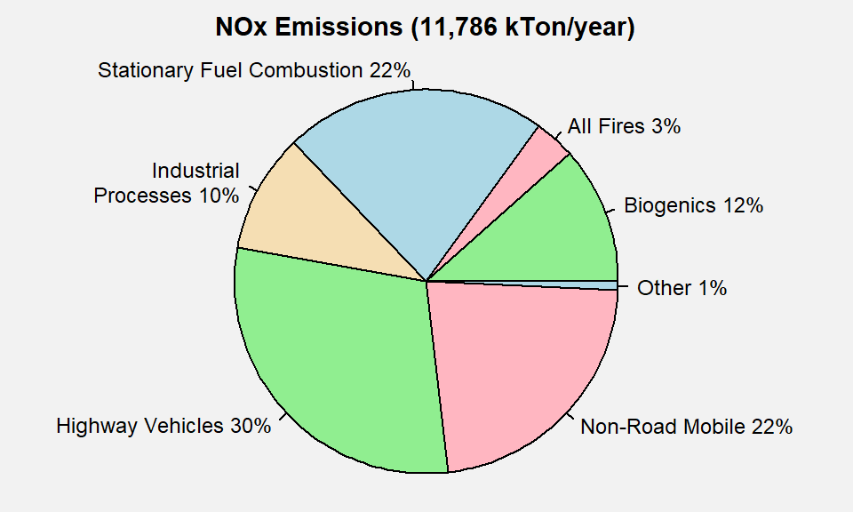

**Figure 1.** U.S. NOX emissions by sector. **Source:** [2017 NEI](https://www.epa.gov/air-emissions-inventories/2017-national-emissions-inventory-nei-data).

     Figure 2 below shows the national trend in U.S. anthropogenic NOX emissions from 2002 to 2021.1 Nationwide estimates indicate a 68% decrease in anthropogenic NOX emissions from 2002 to 2021 as a result of multiple regulatory programs implemented over the past two decades, including the NOX SIP Call, the Cross-State Air Pollution Rule (CSAPR), and the Tier 3 Light-duty Vehicle Emissions and Fuel Standards. The overall decrease in NOX emissions has been driven primarily by decreases from the three largest emissions sectors. Specifically, compared to the 2002 NEI, estimates for 2021 indicate a 78% reduction in NOX emissions from highway vehicles, a 62% reduction in NOX emissions from non-road mobile sources, and a 69% reduction in NOX emissions from stationary fuel combustion.

     Figure 3 shows the NOX emissions density in tons/mi2/year for each U.S. county based on the 2017 NEI. The majority of NOX emissions tend to be located near urban areas, which tend to have the most vehicle traffic and industrial sources. However, there are also some counties in rural areas with higher NOX emissions due to the presence of large stationary sources such as EGUs or oil and gas extraction.

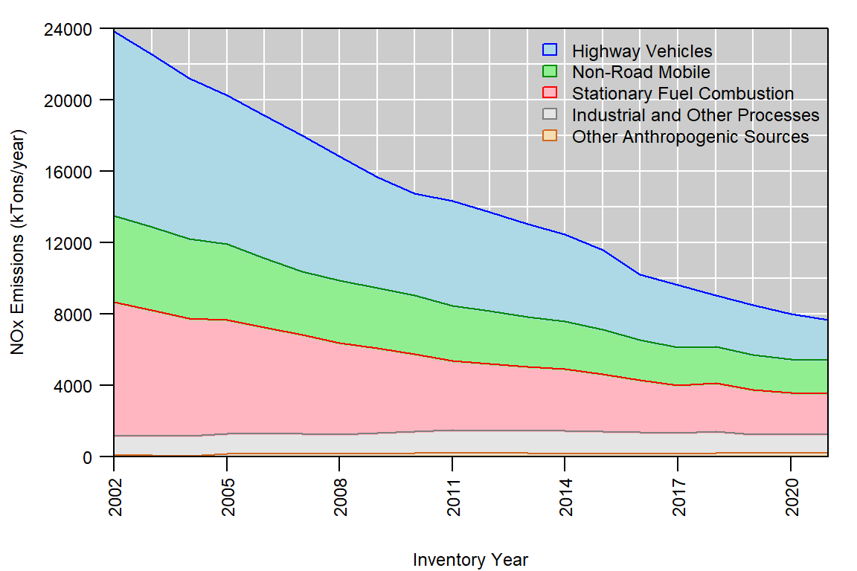

**Figure 2.** U.S. anthropogenic NOX emissions trend, 2002-2021. **Source:** [EPA’s Air Pollutant Emissions Trends Data](https://www.epa.gov/air-emissions-inventories/air-pollutant-emissions-trends-data)

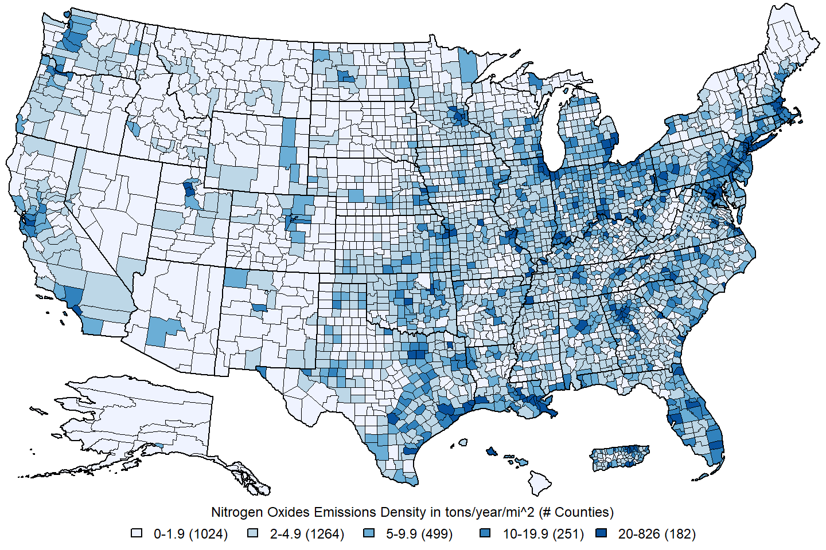 **Figure 3.** U.S. county-level NOX emissions density estimates in tons/year/mi2. **Source:** [2017 NEI](https://www.epa.gov/air-emissions-inventories/2017-national-emissions-inventory-nei-data)

**4. Ambient Air Monitoring Requirements and Monitoring Networks**

     Ambient NO2 concentrations are measured by monitoring networks operated by State, Local, and Tribal air agencies, which are typically funded in part by the EPA. The EPA provides monitoring requirements for NO2 and other pollutants in [40 CFR Part 58](https://www.ecfr.gov/current/title-40/part-58). There were 491 monitoring sites reporting hourly NO2 concentration data to the EPA during the 2019-2021 period. The locations of these monitoring sites are shown in Figure 4. The main network of monitors providing ambient data for use in implementation activities related to the NAAQS is the State and Local Air Monitoring Stations (SLAMS) network, which comprises over 80% of all NO2 monitoring sites. This network relies on a chemiluminescent Federal Reference Method (FRM) and on Federal Equivalent Methods (FEM) that use either chemiluminescence or direct measurement methods of NO2. Data produced by chemiluminescent analyzers include NO, NO2, and NOX measurements, which are all routinely reported by State and Local air monitoring agencies.

     Two important subsets of SLAMS sites separately make up the [National Core (NCore)](https://www.epa.gov/amtic/ncore-monitoring-network) multi-pollutant monitoring network and the [Photochemical Assessment Monitoring Stations (PAMS)](https://www.epa.gov/amtic/photochemical-assessment-monitoring-stations-pams) network. The NCore network consists of approximately 60 urban monitoring stations and 20 rural monitoring stations, and each State is required to have at least one NCore station. At each NCore site located in a MSA with a population of 1 million or more (based on the most recent census), a PAMS network site is required.2 Monitoring sites in the PAMS network are required to measure NO, NO2, NOY, and other O3 precursors during the months of June, July and August, although some precursor monitoring may be required for longer periods of time.

     Another important subset of SLAMS sites is the [near-road monitoring network](https://www.epa.gov/amtic/near-road-monitoring), which was required as part of the 2010 NO2 NAAQS review and began operating in 2014. Near-road sites are required in each metropolitan statistical area (MSA) with a population of 1,000,000 or greater, and an additional near-road site is required in each MSA with a population of 2,500,000 or greater or with one or more roadway segments that have an average daily traffic volume of 250,000 or more vehicles per day. There were 73 monitors in operation during the 2019-2021 period.

     Finally, there are also a number of Special Purpose Monitors (SPMs), which are not required but are often operated by air agencies for short periods of time (i.e., less than 3 years) to collect data for human health and welfare studies, as well as other types of monitoring sites, including monitors operated by tribes and industrial sources. The SPMs are typically not used to assess compliance with the NAAQS.

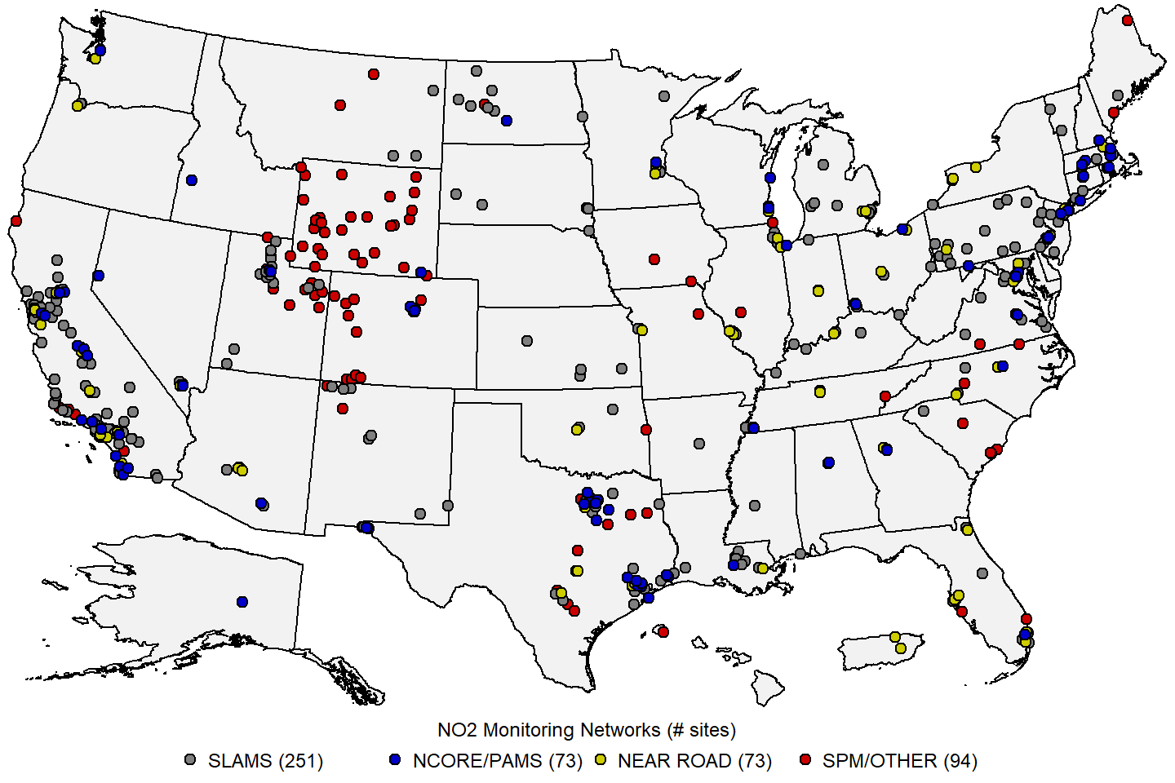 **Figure 4:** Map of U.S. NO2 monitoring sites reporting data to the EPA during the 2019-2021 period. **Source:** [AQS](https://www.epa.gov/aqs).

     To provide an assessment of data quality, monitoring agencies must perform quality assurance (QA) checks at least once every two weeks to derive estimates of precision and bias for NO2 and the other gaseous criteria pollutant measurements using calibration gas. For NO2 monitors, the data quality goal for precision and bias is 15 percent. Ambient air quality data and associated QA data are reported to the EPA via the [Air Quality System (AQS)](https://www.epa.gov/aqs).3 Data are reported quarterly and must be submitted to AQS within 90 days after the end of each calendar quarter (i.e. Jan/Feb/Mar, Apr/May/Jun, Jul/Aug/Sep, Oct/Nov/Dec). Additionally, each monitoring agency is required to certify all FRM/FEM data that is submitted to AQS annually, taking into consideration any QA findings, and a data certification letter must be sent to the EPA Regional Administrator by May 1st of the following year.

     The traditional chemiluminescence FRM is subject to potential measurement biases resulting from interference by NOZ species. However, within metropolitan areas, where a majority of the NO2 monitoring network is located, NO2 concentrations tend to be most heavily influenced by strong local NOX sources, thus the potential for NOZ related measurement bias is relatively small. There have been recent advances in methods that provide measurements of NO2 with less potential for interference. These newer methods include photolytic-chemiluminescent methods that rely on photodissociation of NO2 using specific wavelengths of light, and direct measurements of NO2, including cavity attenuated phase shift spectrometry and cavity ring-down spectroscopy. It should be noted that the direct NO2 measurement methods do not provide NO or NOX measurements. These newer methods are expected to gradually replace the older FRMs as those monitors age.

**5. Data Handling Conventions and Computations for Determining Whether the Standards are Met**

     To assess whether a monitoring site or geographic area (usually a county or urban area) meets or exceeds a NAAQS, the monitoring data are analyzed consistent with the established regulatory requirements for the handling of monitoring data for the purposes of deriving a design value. A design value summarizes ambient air concentrations for an area in terms of the indicator, averaging time and form for a given standard such that its comparison to the level of the standard indicates whether the area meets or exceeds the standard. There are currently two primary NO2 NAAQS in effect: the annual NAAQS (established in 1971) and the 1-hour NAAQS (established in 2010). The procedures for calculating design values for both NO2 primary NAAQS are detailed in [Appendix S to 40 CFR Part 50](https://www.ecfr.gov/current/title-40/part-50/appendix-Appendix%20S%20to%20Part%2050) and are summarized below.

     Hourly NO2 measurement data collected at an ambient air monitoring site using FRMs or FEMs, meeting all applicable requirements in [40 CFR Part 58](https://www.ecfr.gov/current/title-40/part-58) and reported to AQS in parts per billion (ppb) with decimal digits after the first decimal place truncated are used in design value calculations. If multiple monitors collect measurements at the same site, one monitor is designated as the primary monitor. Measurement data collected with the primary monitor are used to calculate the design value, and may be supplemented with data from collocated monitors only if (a) the primary monitor did not collect sufficient data to determine a valid design value, or (b) the primary monitor has been discontinued and replaced by another monitor.

     The design value for the annual NO2 NAAQS is simply the mean of all hourly concentration values reported for a single year, rounded to the nearest integer in ppb. The annual design value is considered valid when hourly concentrations are reported for at least 75% of the hours in the year, or if the design value is greater than 53 ppb, the level of the NAAQS.

     For the 1-hour NO2 NAAQS, the maximum hourly concentration is determined for each day (i.e., the “daily maximum value”) in a given 3-year period. For each year, the 98th percentile of the daily maximum values is determined, and the design value is the average of the three annual 98th percentile values, rounded to the nearest integer in ppb. The 1-hour NO2 NAAQS are met when the design value is less than or equal to 100 ppb, the level of the NAAQS.

     In addition, the 1-hour design value must meet data completeness requirements in order to be considered valid. Specifically, a sample day is considered complete when at least 18 hourly measurements are reported. For each calendar quarter, the quarter is considered complete if at least 75% of the days in the quarter have complete data. The 1-hour NO2 design value is considered complete when all 12 calendar quarters in the 3-year period have complete data. In addition, there are two data substitution tests specified in Appendix S to 40 CFR Part 50 which may be used to yield a valid design value above or below the NAAQS, respectively, in the event that a site falls short of the minimum data completeness requirement.

**6. NO2 Concentrations Measured at Ambient Air Monitoring Sites Across the U.S.**

     Table 1 below presents summary statistics based on the two daily NO2 NAAQS metrics: the daily maximum 1-hour (MDA1) metric and the daily 24-hour average (DA24) metric. These statistics are presented for year-round and each season (winter=Dec/Jan/Feb, spring=Mar/Apr/May, summer=Jun/Jul/Aug, autumn=Sep/Oct/Nov) based on data reported to AQS for 2019-2021. Table 2 presents the same summary statistics for the MDA1 and DA24 metrics for each [NOAA Climate Region](https://www.ncei.noaa.gov/monitoring-references/maps/us-climate-regions)4. Finally, Table 3 presents the same set of summary statistics for the two daily NO2 metrics based on three types of sites: near-road sites, urban NCore and PAMS sites, and rural sites.

**Table 1.** National distribution of NO2 concentrations in ppb by season for 2019-2021. 5 **Source:** [AQS](https://www.epa.gov/aqs).

|  |  |  |  |  |  |  |  |  |  |  |  |  |  |  |  |  |  |  |
| --- | --- | --- | --- | --- | --- | --- | --- | --- | --- | --- | --- | --- | --- | --- | --- | --- | --- | --- |
| metric | season | N.sites | N.obs | mean | SD | min | p1 | p5 | p10 | p25 | p50 | p75 | p90 | p95 | p98 | p99 | max | max.site |
| MDA1 | all | 414 | 435,874 | 16.5 | 12.3 | -5.0 | 0.5 | 1.6 | 2.8 | 6.5 | 14.0 | 24.2 | 34.0 | 39.7 | 46.0 | 50.4 | 315.3 | 201950001 |
| MDA1 | winter | 407 | 106,484 | 19.9 | 13.0 | -5.0 | 0.7 | 2.0 | 3.8 | 9.0 | 18.7 | 29.0 | 37.5 | 42.4 | 48.2 | 53.0 | 269.2 | 220330009 |
| MDA1 | spring | 403 | 108,226 | 15.2 | 11.8 | -5.0 | 0.3 | 1.3 | 2.3 | 5.6 | 12.2 | 22.5 | 32.6 | 38.1 | 44.0 | 48.0 | 94.9 | 340030010 |
| MDA1 | summer | 399 | 106,499 | 13.1 | 9.9 | -3.0 | 0.5 | 1.4 | 2.5 | 5.3 | 10.7 | 18.6 | 27.0 | 32.8 | 39.0 | 43.4 | 93.1 | 290950034 |
| MDA1 | autumn | 401 | 106,192 | 17.8 | 13.0 | -3.4 | 0.5 | 1.6 | 3.0 | 7.2 | 15.5 | 25.9 | 35.9 | 42.0 | 49.2 | 54.2 | 315.3 | 201950001 |
| DA24 | all | 414 | 435,874 | 7.9 | 7.0 | -5.0 | 0.0 | 0.6 | 1.2 | 2.7 | 5.8 | 11.0 | 17.4 | 22.0 | 27.4 | 31.4 | 140.7 | 220330009 |
| DA24 | winter | 407 | 106,484 | 10.3 | 8.1 | -5.0 | 0.1 | 0.9 | 1.7 | 4.0 | 8.4 | 14.7 | 21.5 | 26.1 | 31.8 | 35.7 | 140.7 | 220330009 |
| DA24 | spring | 403 | 108,226 | 6.6 | 5.9 | -5.0 | 0.0 | 0.5 | 1.0 | 2.3 | 4.9 | 9.2 | 14.8 | 18.6 | 23.5 | 26.5 | 58.5 | 080310027 |
| DA24 | summer | 399 | 106,499 | 6.0 | 5.2 | -4.1 | 0.0 | 0.6 | 1.0 | 2.3 | 4.5 | 8.2 | 13.0 | 16.4 | 20.8 | 24.0 | 80.6 | 080677003 |
| DA24 | autumn | 401 | 106,192 | 8.6 | 7.5 | -4.5 | 0.0 | 0.6 | 1.2 | 3.0 | 6.7 | 12.2 | 18.8 | 23.6 | 29.3 | 33.4 | 62.0 | 060374008 |

N.sites = number of sites; N.obs = number of observations; SD = standard deviation; min = minimum; p1, p5, p10, p25, p50, p90, p95, p98, p99 = 1st, 5th, 10th, 25th, 50th, 90th, 95th, 98th, 99th percentiles; max = maximum; max.site = AQS ID number for the monitoring site corresponding to the observation in the max column. winter = December/January/February; spring = March/April/May; summer = June/July/August; autumn = September/October/November.

**Table 2.** National distribution of NO2 concentrations in ppb by climate region for 2019-2021. 5 **Source:** [AQS](https://www.epa.gov/aqs).

|  |  |  |  |  |  |  |  |  |  |  |  |  |  |  |  |  |  |  |
| --- | --- | --- | --- | --- | --- | --- | --- | --- | --- | --- | --- | --- | --- | --- | --- | --- | --- | --- |
| metric | region | N.sites | N.obs | mean | SD | min | p1 | p5 | p10 | p25 | p50 | p75 | p90 | p95 | p98 | p99 | max | max.site |
| MDA1 | all | 414 | 435,874 | 16.5 | 12.3 | -5.0 | 0.5 | 1.6 | 2.8 | 6.5 | 14.0 | 24.2 | 34.0 | 39.7 | 46.0 | 50.4 | 315.3 | 201950001 |
| MDA1 | Central | 32 | 33,717 | 18.9 | 11.1 | -0.6 | 1.7 | 3.6 | 5.4 | 10.0 | 17.5 | 26.5 | 34.2 | 38.7 | 44.0 | 47.8 | 93.1 | 290950034 |
| MDA1 | East North Central | 16 | 16,451 | 17.1 | 11.0 | 0.1 | 0.8 | 1.6 | 2.8 | 8.2 | 16.2 | 24.6 | 32.0 | 36.7 | 41.9 | 45.5 | 80.0 | 261630098 |
| MDA1 | Northeast | 67 | 70,565 | 18.3 | 11.8 | -3.0 | 1.0 | 2.6 | 4.0 | 8.9 | 16.9 | 26.2 | 34.6 | 39.3 | 45.0 | 49.0 | 110.2 | 340030010 |
| MDA1 | Northwest | 6 | 6,391 | 21.5 | 9.8 | 1.6 | 4.0 | 6.7 | 9.2 | 14.2 | 20.8 | 27.7 | 34.3 | 38.2 | 43.2 | 46.1 | 83.3 | 530330030 |
| MDA1 | South | 67 | 69,423 | 14.2 | 10.8 | -2.6 | 0.7 | 2.0 | 3.1 | 5.9 | 11.4 | 20.1 | 29.9 | 35.5 | 41.4 | 45.6 | 315.3 | 201950001 |
| MDA1 | Southeast | 39 | 40,621 | 16.2 | 10.3 | -1.0 | 0.8 | 2.2 | 3.9 | 7.9 | 14.9 | 23.1 | 30.6 | 35.1 | 40.1 | 43.3 | 94.8 | 120110035 |
| MDA1 | Southwest | 52 | 55,400 | 17.0 | 13.8 | -5.0 | 0.0 | 1.4 | 2.6 | 6.0 | 13.0 | 25.5 | 38.1 | 44.0 | 50.0 | 54.7 | 116.0 | 490353006 |
| MDA1 | West | 101 | 107,587 | 19.1 | 13.2 | -2.0 | 1.0 | 2.4 | 4.0 | 8.4 | 16.6 | 27.7 | 37.9 | 43.5 | 50.2 | 55.0 | 101.6 | 060710027 |
| MDA1 | West North Central | 34 | 35,719 | 5.2 | 5.9 | -1.8 | 0.0 | 0.6 | 0.9 | 1.5 | 3.1 | 6.5 | 12.4 | 17.4 | 23.8 | 28.8 | 87.6 | 381010003 |
| DA24 | all | 414 | 435,874 | 7.9 | 7.0 | -5.0 | 0.0 | 0.6 | 1.2 | 2.7 | 5.8 | 11.0 | 17.4 | 22.0 | 27.4 | 31.4 | 140.7 | 220330009 |
| DA24 | Central | 32 | 33,717 | 9.1 | 6.1 | -0.8 | 0.8 | 1.6 | 2.4 | 4.5 | 7.8 | 12.4 | 17.8 | 21.3 | 25.1 | 27.6 | 44.5 | 170313103 |
| DA24 | East North Central | 16 | 16,451 | 8.6 | 6.0 | -0.4 | 0.3 | 0.9 | 1.6 | 3.8 | 7.6 | 12.4 | 16.8 | 19.9 | 23.4 | 25.6 | 48.8 | 270530962 |
| DA24 | Northeast | 67 | 70,565 | 9.0 | 6.9 | -4.1 | 0.1 | 1.0 | 1.8 | 3.7 | 7.3 | 12.7 | 18.5 | 22.4 | 27.0 | 30.3 | 55.8 | 340130003 |
| DA24 | Northwest | 6 | 6,391 | 11.0 | 5.7 | 1.0 | 2.1 | 3.2 | 4.3 | 6.7 | 10.2 | 14.6 | 18.6 | 21.5 | 24.6 | 27.3 | 53.6 | 530330030 |
| DA24 | South | 67 | 69,423 | 6.2 | 5.3 | -2.6 | -0.3 | 0.7 | 1.3 | 2.5 | 4.7 | 8.4 | 13.4 | 16.9 | 21.4 | 24.3 | 140.7 | 220330009 |
| DA24 | Southeast | 39 | 40,621 | 7.6 | 5.6 | -1.6 | 0.5 | 1.0 | 1.7 | 3.3 | 6.2 | 10.7 | 15.6 | 18.7 | 22.4 | 24.9 | 40.7 | 517600025 |
| DA24 | Southwest | 52 | 55,400 | 7.9 | 8.2 | -5.0 | 0.0 | 0.6 | 1.0 | 2.3 | 5.0 | 10.7 | 19.7 | 25.8 | 32.4 | 36.7 | 80.6 | 080677003 |
| DA24 | West | 101 | 107,587 | 9.6 | 8.0 | -2.2 | 0.0 | 1.0 | 1.9 | 3.7 | 7.2 | 13.3 | 20.8 | 25.8 | 31.7 | 35.6 | 62.0 | 060374008 |
| DA24 | West North Central | 34 | 35,719 | 1.9 | 2.1 | -2.2 | -0.1 | 0.1 | 0.3 | 0.6 | 1.3 | 2.5 | 4.2 | 5.7 | 8.3 | 10.8 | 28.3 | 460710001 |

N.sites = number of sites; N.obs = number of observations; SD = standard deviation; min = minimum; p1, p5, p10, p25, p50, p90, p95, p98, p99 = 1st, 5th, 10th, 25th, 50th, 90th, 95th, 98th, 99th percentiles; max = maximum; max.site = AQS ID number for the monitoring site corresponding to the observation in the max column. Central = Illinois, Indiana, Kentucky, Missouri, Ohio, Tennessee, West Virginia; East North Central = Iowa, Minnesota, Michigan, Wisconsin; Northeast = Connecticut, Delaware, Maine, Maryland, Massachusetts, New Hampshire, New Jersey, New York, Pennsylvania, Rhode Island, Vermont; Northwest = Alaska, Idaho, Oregon, Washington; South = Arkansas, Kansas, Louisiana, Mississippi, Oklahoma, Texas; Southeast = Alabama, Florida, Georgia, North Carolina, South Carolina, Virginia; Southwest = Arizona, Colorado, New Mexico, Utah; West = California, Hawaii, Nevada; West North Central = Montana, Nebraska, North Dakota, South Dakota, Wyoming.

**Table 3.** National distribution of NO2 concentrations in ppb by site type for 2019-2021.5 **Source:** [AQS](https://www.epa.gov/aqs).

|  |  |  |  |  |  |  |  |  |  |  |  |  |  |  |  |  |  |  |
| --- | --- | --- | --- | --- | --- | --- | --- | --- | --- | --- | --- | --- | --- | --- | --- | --- | --- | --- |
| **metric** | **site.type** | **N.sites** | **N.obs** | **mean** | **SD** | **min** | **p1** | **p5** | **p10** | **p25** | **p50** | **p75** | **p90** | **p95** | **p98** | **p99** | **max** | **max.site** |
| MDA1 | All Sites | 414 | 435,874 | 16.5 | 12.3 | -5.0 | 0.5 | 1.6 | 2.8 | 6.5 | 14.0 | 24.2 | 34.0 | 39.7 | 46.0 | 50.4 | 315.3 | 201950001 |
| MDA1 | Near Road | 67 | 70,391 | 25.0 | 11.9 | -2.5 | 4.2 | 8.0 | 10.8 | 16.2 | 23.6 | 32.1 | 40.7 | 46.2 | 53.4 | 58.5 | 110.2 | 340030010 |
| MDA1 | NCore/PAMS | 58 | 61,163 | 16.6 | 11.2 | -3.0 | 1.0 | 3.0 | 4.4 | 8.0 | 14.0 | 23.2 | 33.0 | 38.5 | 44.5 | 48.7 | 92.3 | 481410044 |
| MDA1 | Rural Sites | 38 | 39,712 | 4.6 | 5.8 | -2.0 | 0.0 | 0.6 | 1.0 | 1.4 | 2.9 | 5.4 | 10.4 | 15.5 | 23.0 | 27.3 | 315.3 | 201950001 |
| DA24 | All Sites | 414 | 435,874 | 7.9 | 7.0 | -5.0 | 0.0 | 0.6 | 1.2 | 2.7 | 5.8 | 11.0 | 17.4 | 22.0 | 27.4 | 31.4 | 140.7 | 220330009 |
| DA24 | Near Road | 67 | 70,391 | 13.8 | 8.0 | -2.5 | 1.9 | 3.8 | 5.2 | 8.1 | 12.3 | 17.9 | 24.5 | 29.2 | 35.2 | 39.3 | 63.5 | 080310028 |
| DA24 | NCore/PAMS | 58 | 61,163 | 7.4 | 5.7 | -4.1 | 0.1 | 1.2 | 1.9 | 3.4 | 5.9 | 9.8 | 14.9 | 18.7 | 23.9 | 27.3 | 55.8 | 340130003 |
| DA24 | Rural Sites | 38 | 39,712 | 1.9 | 2.3 | -2.2 | 0.0 | 0.1 | 0.3 | 0.6 | 1.3 | 2.3 | 4.2 | 6.1 | 9.3 | 11.8 | 31.0 | 350010029 |

N.sites = number of sites; N.obs = number of observations; SD = standard deviation; min = minimum; p1, p5, p10, p25, p50, p90, p95, p98, p99 = 1st, 5th, 10th, 25th, 50th, 90th, 95th, 98th, 99th percentiles; max = maximum; max.site = AQS ID number for the monitoring site corresponding to the observation in the max column.

     Figure 5 below shows a map of the annual NO2 design values at U.S. ambient air monitoring sites based on data from 2021 and Figure 6 shows a map of the 1-hour NO2 design values based on data from the 2019-2021 period. There were no sites with design values exceeding either NAAQS. The maximum annual design value was 30 ppb, while the maximum 1-hour design value was 80 ppb. Both of these maximum design values occurred at near-road sites in the Los Angeles, CA metropolitan area.

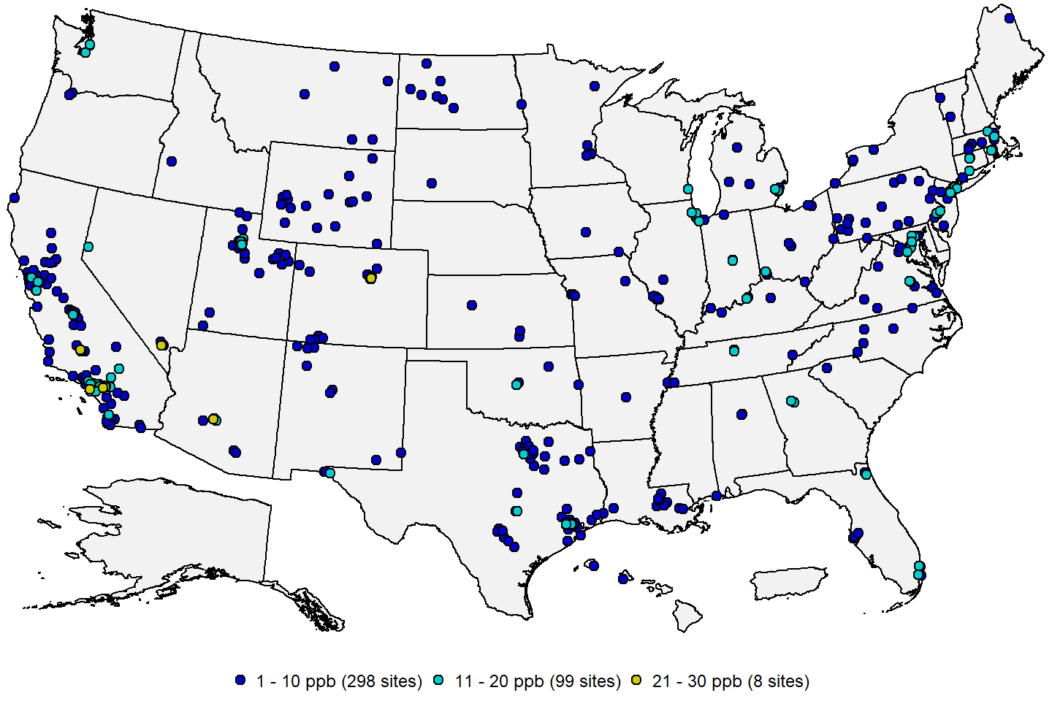 **Figure 5:** Annual NO2 design values in ppb based on data from 2021. **Source:** [AQS](https://www.epa.gov/aqs).

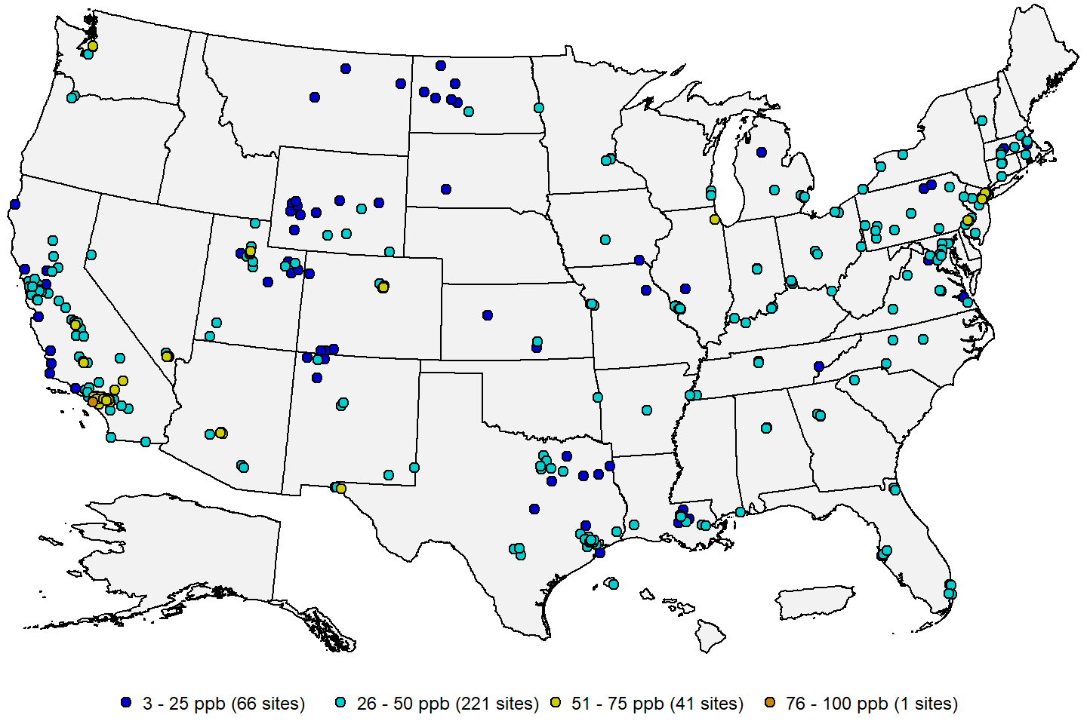 **Figure 6:** 1-hour NO2 design values in ppb for the 2019-2021 period. **Source:** [AQS](https://www.epa.gov/aqs).

     Figure 7 below shows a map of the site-level trends in the annual NO2 design values at U.S. monitoring sites having valid design values in at least 17 years from 2000 through 2021. Figure 8 shows a map of the site-level trends in the 1-hour NO2 design values at U.S. monitoring sites having valid design values in at least 15 of the 20 3-year periods from 2000 through 2021. The trends were computed using the Thiel-Sen estimator, and tests for significance (p-value < 0.05) were computed using the Mann-Kendall test. From these figures it is apparent that NO2 concentrations have been decreasing at nearly all sites in the U.S. Two sites in North Dakota showed an increasing trend in the annual design value (one of these sites also had an increasing trend in the 1-hour design value), which is likely due to an increase in NOX emissions from oil and gas extraction activity in the region.

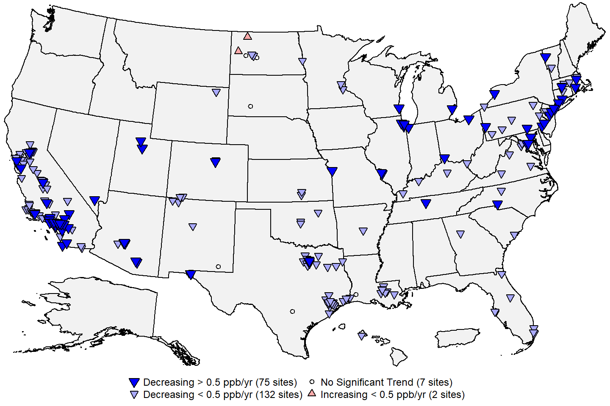 **Figure 7:** Site-level trends in annual NO2 design values based on data from 2000 through 2021. **Source:** [AQS](https://www.epa.gov/aqs), trends computed using R statistical software.

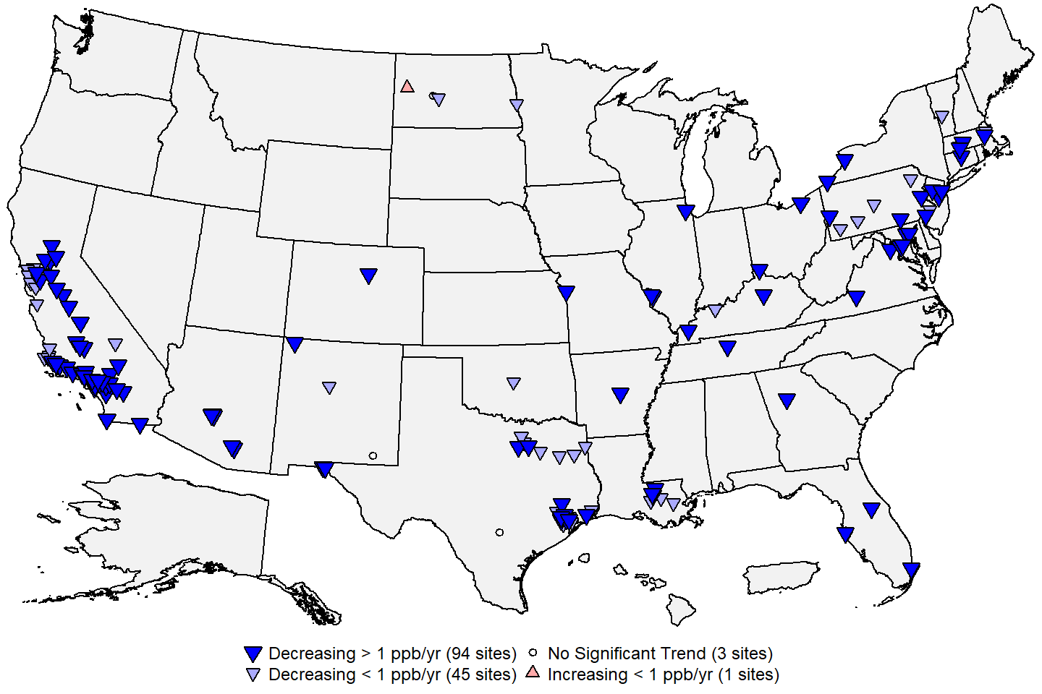 **Figure 8:** Site-level trends in 1-hour NO2 design values based on data from 2000 through 2021. **Source:** [AQS](https://www.epa.gov/aqs), trends computed using R statistical software.

     Figure 9 below shows the national trends in the annual and 1-hour NO2 design values based on the 216 sites shown in Figure 7 and the 144 sites shown in Figure 8, respectively. The national median of the annual design values has decreased by 57% from about 15.8 ppb in 2000 to about 6.9 ppb in 2021. The national median of the 1-hour design values has decreased by 39% from 61 ppb in 2000 to 37 ppb in 2021.

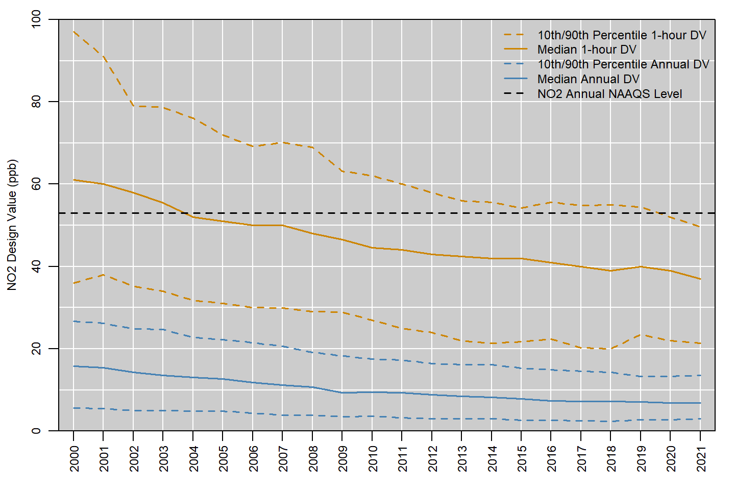 **Figure 9:** National trends in NO2 design values in ppb, 2000 to 2021. **Source:** [AQS](https://www.epa.gov/aqs).

     Figure 10 below shows the national distribution of the annual 98th percentile MDA1 NO2 concentrations reported in each year from 1980 to 2021, while Figure 11 shows the national distribution of the annual mean NO2 concentrations reported to EPA during the same period.6 The red line shows the number of sites included in the boxplot for each year. These figures show that NO2 concentrations have decreased steadily over the past 40 years as older cars were replaced with newer models with lower NOX emissions, and power plants and other industrial sources have added emissions controls and transitioned to cleaner burning fuels. The median 98th percentile MDA1 NO2 concentration decreased by 61 percent, from 93.5 ppb in 1980 to 36.9 ppb in 2021. Similarly, the median annual mean NO2 concentration decreased by 70 percent, from 23.2 ppb in 1980 to 6.9 ppb in 2021. No sites have exceeded the 1-hour NO2 NAAQS since 2008, and no sites have exceeded the annual NO2 NAAQS since 1991. The size of the NO2 monitoring network increased from 1980 through the early 2000s, decreased slightly between 2002 and 2011, then increased again over the next few years as the near-road network was implemented. Over the past decade, annual mean and 98th percentile MDA1 NO2 concentrations have been relatively constant at levels well below the NAAQS. This is likely due to higher concentrations measured at near-road sites offsetting continued reductions in NO2 concentrations associated with reductions in NOX emissions (see Figure 2). Slight decreases in annual mean and 98th percentile MDA1 concentrations were observed in 2020 and 2021, possibly due to emissions reductions resulting from the COVID pandemic.

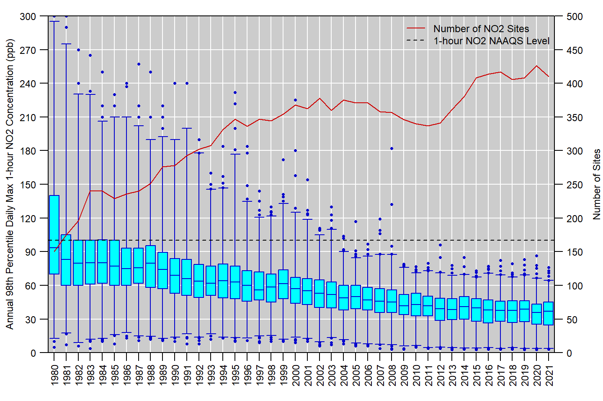 **Figure 10:** Distribution of annual 98th percentile MDA1 NO2 concentrations measured at U.S. monitoring sites, 1980 to 2021. Boxes represent the median and interquartile range, whiskers extend to the 1st and 99th percentiles, and values outside this range are shown as circles. The red line shows the number of NO2 monitoring sites reporting data to EPA in each year. **Source:** [AQS](https://www.epa.gov/aqs).

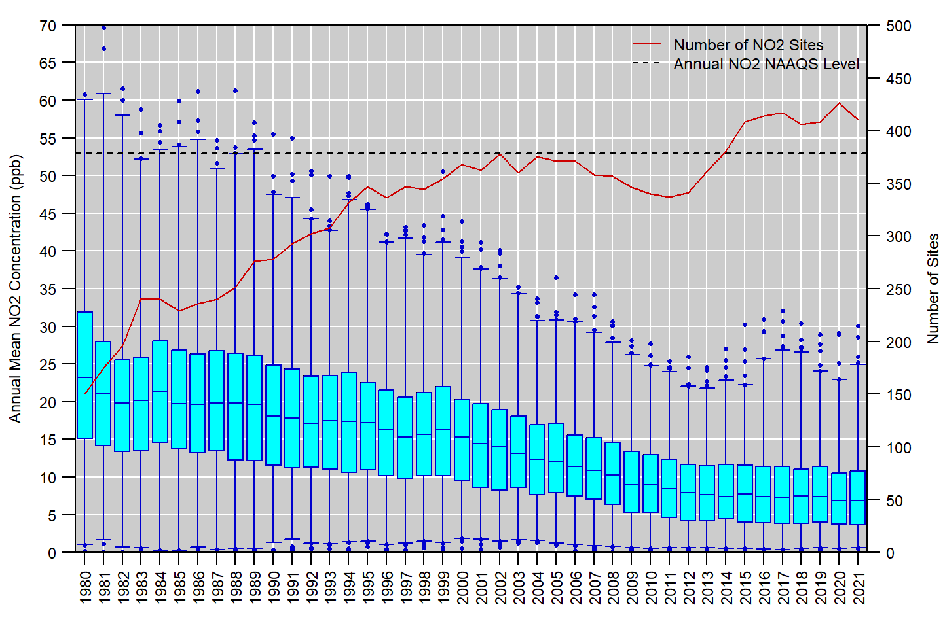 **Figure 11:** Distribution of annual mean NO2 concentrations measured at U.S. monitoring sites, 1980 to 2021. Boxes represent the median and interquartile range, whiskers extend to the 1st and 99th percentiles, and values outside this range are shown as circles. The red line shows the number of NO2 monitoring sites reporting data to EPA in each year. **Source:** [AQS](https://www.epa.gov/aqs).

**References**

U.S. EPA. [Integrated Science Assessment for Oxides of Nitrogen - Health Criteria (Final Report, January 2016)](https://ordspub.epa.gov/ords/eims/eimscomm.getfile?p_download_id=526855). U.S. Environmental Protection Agency, Washington, DC, EPA/600/R-15/068, 2016.

U.S. EPA. [Policy Assessment for the Review of the Primary NAAQS for Oxides of Nitrogen (Final Report, April 2017)](https://www.epa.gov/naaqs/policy-assessment-review-primary-national-ambient-air-quality-standards-oxides-nitrogen). U.S. Environmental Protection Agency, Research Triangle Park, NC, EPA-452/R-17-003, 2017.

**Additional Resources**

* [Nitrogen Dioxide (NO2) Pollution](https://www.epa.gov/no2-pollution)
* [Nitrogen Dioxide (NO2) Primary Air Quality Standards](https://www.epa.gov/naaqs/nitrogen-dioxide-no2-primary-air-quality-standards)
* [National Emissions Inventory (NEI)](https://www.epa.gov/air-emissions-inventories/national-emissions-inventory-nei)
* [Ambient Monitoring Technology Information Center (AMTIC)](https://www.epa.gov/amtic)
* [Air Quality Design Values](https://www.epa.gov/air-trends/air-quality-design-values)
* [National Air Quality: Status and Trends of Key Air Pollutants](https://www.epa.gov/air-trends)
* [Air Data: Air Quality Data Collected at Outdoor Monitors Across the U.S.](https://www.epa.gov/outdoor-air-quality-data)

**Footnotes:**

1. Data for Figure 2 come from the EPA’s [Air Pollutant Emissions Trends Data](https://www.epa.gov/air-emissions-inventories/air-pollutant-emissions-trends-data). Note that emissions for some sectors are interpolated between inventory years, and the emissions for some sectors are held constant beyond the most recent inventory year (for details, see the “Development of Data” table in the [national emissions trends data file](https://www.epa.gov/sites/default/files/2021-03/national_tier1_caps.xlsx). For the purposes of this document, wildfires are considered to be natural emissions and thus are not included in Figure 2.↩︎
2. The requirements for PAMS, which were most recently updated in 2015, is fully described in section 5 of [Appendix D to 40 CFR Part 58](https://www.ecfr.gov/current/title-40/part-58/appendix-Appendix%20D%20to%20Part%2058).↩︎
3. Quality assurance requirements for monitors used in evaluations of the NAAQS are provided in [Appendix A to 40 CFR Part 58](https://www.ecfr.gov/current/title-40/part-58/appendix-Appendix%20A%20to%20Part%2058). Annual summary reports of precision and bias can be obtained for each monitoring site at the EPA’s [Air Data website](https://www.epa.gov/outdoor-air-quality-data/single-point-precision-and-bias-report).↩︎
4. For Table 2, monitoring sites in Alaska were assigned to the Northwest Region, monitoring sites in Hawaii were assigned to the West region, and monitoring sites in Puerto Rico were assigned to the Southeast region.↩︎
5. Negative concentration values may appear in AQS datasets down to the negative of the lower detection limit (LDL) to allow for normal instrument variability at very low concentrations. Data that exceed the negative of the LDL is typically indicative of a malfunction or another issue that affects the data defensibility.↩︎
6. For this analysis, the annual mean and 98th percentile MDA1 NO2 concentrations were retrieved from AQS for all U.S. sites for years that had at least 75% annual data completeness.↩︎