**Overview of Ozone (O3) Air Quality in the United States**

Updated: February 7, 2023

**1. Introduction**

    The overall purpose of this document is to maintain an up-to-date graphical summary of air quality information that supports the review of the National Ambient Air Quality Standards (NAAQS) for ozone (O3). In previous reviews of the O3 NAAQS, this type of information has generally been included in atmospheric sections of the Integrated Science Assessment (ISA) and Policy Assessment (PA) for O3 and related photochemical oxidants. This stand-alone document will either replace or complement the air quality emissions and monitoring data in the atmospheric sections of future O3 NAAQS review supporting documents and will be updated at regular intervals as new data becomes available.

     The content of past NAAQS documents’ atmospheric sections has included major sections on emissions and concentration trends utilizing maps and data from the Environmental Protection Agency’s (EPA’s) National Emissions Inventory (NEI) and the EPA’s Air Quality System (AQS) database. In past NAAQS reviews, this often involved adaptation of figures and tables prepared for other reports or development of new figures and tables using data analysis and mapping software. Additionally, the release of updated emission inventories and ambient air monitoring data may not coincide with the schedule for the development of NAAQS review supporting documents. As a result, data access and resources can limit the availability of the most recent information for inclusion in NAAQS review supporting documents.

     This stand-alone document allows the content to be updated as soon as new data becomes available, rather than relying on information that is available at the time of development of the NAAQS review supporting documents. It also ensures that the public will have access to a consistent set of maps and figures for each NAAQS pollutant that are updated on a routine basis, rather than separated by several years because of the disparate schedules of the various NAAQS reviews for each pollutant. Moreover, a stand-alone document can be expanded to include new air quality analyses as they are completed, rather than following the timeline for the public release of the NAAQS review supporting documents. Finally, this document takes advantage of a more flexible digital format for the routinely prepared maps and trends figures with an end product that more strongly emphasizes visual presentation of data and reduces the amount of text, while also creating a more interactive presentation of the information through the use of external links.

     This document follows an organizational structure similar to that of the atmospheric sections of past O3 NAAQS review supporting documents. The subsequent sections are as follows: 2. Atmospheric Chemistry; 3. Sources and Emissions of O3 Precursors; 4. Ambient Air Monitoring Requirements and Monitoring Networks; 5. Data Handling Conventions and Computations for Determining Whether the Standards are Met; and 6. O3 Concentrations Measured at Ambient Air Monitoring Sites Across the U.S. These sections are broad enough in scope to communicate relevant information about O3 air quality, including scientific advances, but specific enough that the information needed to develop NAAQS review supporting documents can be quickly and readily retrieved.

**2. Atmospheric Chemistry**

     O3 is one of a group of photochemical oxidants formed in the troposphere1 by photochemical reactions of precursor gases in the presence of sunlight and is generally not directly emitted from specific sources.2 Tropospheric O3 and other oxidants, such as peroxyacetyl nitrate (PAN) and hydrogen peroxide, form in polluted areas by atmospheric reactions involving two main classes of precursor pollutants: volatile organic compounds (VOCs) and nitrogen oxides (NOX). This occurs especially during the summer, as a result of the photolysis of primary pollutants such as nitrogen dioxide (NO2). The reaction is disrupted by the presence of VOCs, the radical that results from methane (CH4) oxidation; or a reaction between carbon monoxide (CO) and the hydroxyl radical (OH) in the atmosphere. Thus, the substances NOX, VOC, CH4 and CO are considered to be the primary precursors of tropospheric O3. The formation of O3, other oxidants and oxidation products from these precursors is a complex, nonlinear function of many factors including (1) the intensity and spectral distribution of sunlight; (2) atmospheric mixing; (3) concentrations of precursors in the ambient air and the rates of chemical reactions of these precursors; and (4) processing on cloud and aerosol particles.

     O3 is present not only in polluted urban atmospheres, but throughout the troposphere, even in remote areas of the globe. The same basic processes involving photochemical reactions of NOX, VOCs, and CO contribute to O3 formation throughout the troposphere. These processes also lead to the formation of other photochemical products, such as PAN, HNO3, and H2SO4, and to other gaseous compounds, such as HCHO and other carbonyl compounds, as well as a number of particulate compounds.

     Prior to 1979, the indicator for the NAAQS for photochemical oxidants was total photochemical oxidants. Early ambient air monitoring indicated similarities between O3 measurements and the photochemical oxidant measurements, as well as reduced precision and accuracy of the latter. To address these issues, the EPA established O3 as the indicator for the NAAQS for photochemical oxidants in 1979, and it is currently the only photochemical oxidant other than NO2 that is routinely monitored in a national ambient air monitoring network.

     Rather than varying directly with emissions of its precursors, O3 changes in a nonlinear fashion with the concentrations of its precursors. Emissions of NOX lead to both the formation and destruction of O3, depending on the local quantities of NOX, VOCs, radicals, and sunlight. O3 chemistry is often described in terms of which precursors most directly impact formation rates. A NOX-limited regime indicates that O3 concentrations will decrease in response to decreases in ambient NOX concentrations and vice-versa. These conditions tend to occur when NOX concentrations are generally low compared to VOC concentrations and during warm, sunny conditions when NOX photochemistry is relatively fast. NOX-limited conditions are more common during daylight hours, in the summertime, in suburban and rural areas, and in portions of the country with high biogenic VOC emissions like the Southeast. In contrast, NOX-saturated conditions (also referred to as VOC-limited or radical-limited) indicate that O3 will increase as a result of NOX reductions but will decrease as a result of VOC reductions. NOx-saturated conditions occur at times and locations with lower levels of available sunlight, resulting in slower photochemical formation of O3, and when NOX concentrations are in excess compared to VOC concentrations. NOX-saturated conditions are more common during nighttime hours, in the wintertime, and in densely populated urban areas or industrial plumes. These varied relationships between precursor emissions and O3 chemistry result in localized areas in which O3 concentrations are suppressed compared to surrounding areas, but which contain NO2 that contributes to subsequent O3 formation further downwind. Consequently, O3 response to reductions in NOX emissions is complex and may include decreases in O3 concentrations at some times and locations and increases in O3 concentrations at other times and locations. Over the past decade, there have been substantial decreases in NOX emissions in the U.S. and many locations have transitioned from NOX-saturated to NOX-limited during times of year that are conducive to O3 formation (generally summer). As these NOX emissions reductions have occurred, lower O3 concentrations have generally increased while the higher O3 concentrations have generally decreased, resulting in a compressed O3 distribution, relative to historical conditions.

     As mentioned above, the formation of O3 from precursor emissions is also affected by meteorological parameters such as the intensity of sunlight and atmospheric mixing. Major episodes of high O3 concentrations in the eastern U.S. are often associated with slow-moving high-pressure systems which can persist for several days. High pressure systems during the warmer seasons are associated with the sinking of air, resulting in warm, generally cloudless skies, with light winds. The sinking of air results in the development of stable conditions near the surface which inhibit or reduce the vertical mixing of O3 precursors, concentrating them near the surface. Photochemical activity involving these precursors is enhanced because of higher temperatures and the availability of sunlight during the warmer seasons. In the eastern U.S., concentrations of O3 and other photochemical oxidants are determined by meteorological and chemical processes extending typically over areas of several hundred thousand square kilometers. Therefore, O3 episodes are often regarded as regional in nature, although more localized episodes often occur in some areas, largely the result of local pollution sources during summer. In addition, in some parts of the U.S. (e.g., Los Angeles, CA), mountain barriers limit O3 dispersion and result in a higher frequency and duration of days with elevated O3 concentrations.

     More recently, high O3 concentrations of up to 150 parts per billion (ppb) have been measured during the wintertime in two western U.S. mountain basins. Wintertime mountain basin O3 episodes occur on cold winter days with low wind speeds, clear skies, substantial snow cover, extremely shallow boundary layers driven by strong temperature inversions, and substantial precursor emissions activity from the oil and gas sector. The results of recent modeling studies suggest that photolysis of VOCs provides the source of reactive chemical species (radicals) needed to initiate the chemistry driving these wintertime O3 episodes. This mechanism is markedly different from the chemistry driving summertime O3 formation, which is initiated with the photolysis of NO2 followed by the formation of the OH radicals.

     O3 concentrations in a region are affected both by local formation and by transport of O3 and its precursors from upwind areas. O3 transport occurs on many spatial scales including local transport within urban areas, regional transport over large regions of the U.S., and long-range transport which may also include international transport. In addition, O3 can be transferred into the troposphere from the stratosphere, which is rich in naturally occurring O3, through stratosphere-troposphere exchange (STE). These intrusions usually occur behind cold fronts, bringing stratospheric air with them and typically affect O3 concentrations in higher elevation areas (e.g., above 1500 m) more than areas at lower elevations.

**3. Sources and Emissions of O3 Precursors**

     Sources of emissions of O3 precursor compounds can be divided into anthropogenic and natural source categories, with natural sources further divided into emissions from biological processes of living organisms (e.g., plants, microbes, and animals) and emissions from chemical or physical processes (e.g., biomass burning, lightning, and geogenic sources). Anthropogenic emissions associated with combustion processes, including mobile sources and power plants, accounted for the majority of U.S. NOX and CO emissions in 2017 (Figure 1). Anthropogenic sources are also important for VOC emissions, though in some locations and times of the year (e.g., southeastern states during summer) the majority of VOC emissions come from vegetation.3 CH4 is mostly emitted from anthropogenic sources, including production and consumption of fossil fuels for energy, agriculture and waste disposal systems. In practice, the distinction between natural and anthropogenic sources is often unclear, as human activities directly or indirectly affect emissions from what would have been considered natural sources during the preindustrial era. Thus, precursor emissions from plants, animals, and wildfires could be considered either natural or anthropogenic, depending on whether emissions result from agricultural practices, forest management practices, lightning strikes, or other types of events. Additional challenges are presented because much O3 results from reactions between anthropogenic and natural precursors.

     The [National Emissions Inventory (NEI)](https://www.epa.gov/air-emissions-inventories) is a comprehensive and detailed estimate of air emissions of criteria pollutants, precursors to criteria pollutants, and hazardous air pollutants from air emissions sources. The NEI is released every three years based primarily upon data provided by State, Local, and Tribal air agencies for sources in their jurisdictions and supplemented by data developed by the EPA. The NEI is built using the EPA’s Emissions Inventory System (EIS) first to collect the data from State, Local, and Tribal air agencies and then to blend that data with other data sources.

     Accuracy in an emissions inventory reflects the extent to which the inventory represents the actual emissions that occurred. Anthropogenic emissions of air pollutants result from a variety of sources such as power plants, industrial sources, motor vehicles and agriculture. The emissions from any individual source typically vary in both time and space. For the thousands of sources that make up the NEI, there is uncertainty in one or both of these factors. For some sources, such as power plants, direct emission measurements enable the emission factors derived from them to be more certain than sources without such direct measurements. However, it is not practically possible to directly monitor each of the emission sources individually and, therefore, emission inventories necessarily contain assumptions, interpolation and extrapolation from a limited set of sample data.

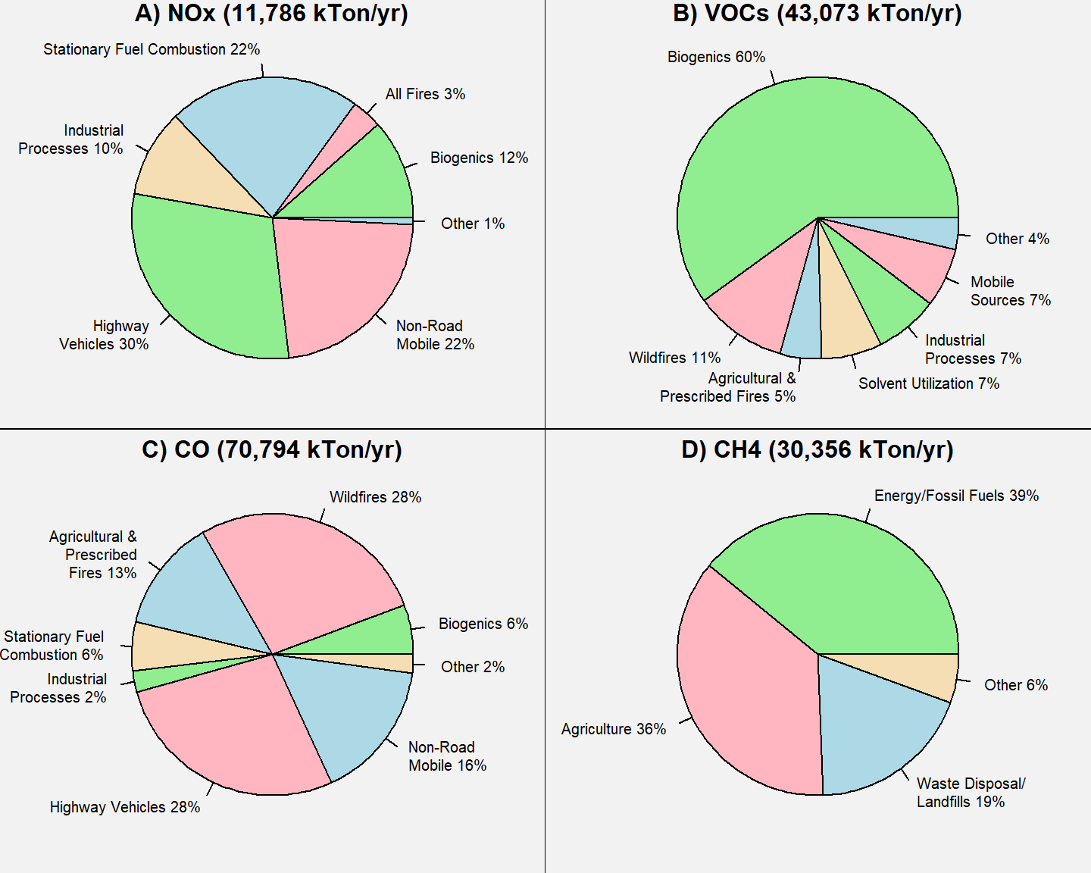 **Figure 1.** U.S. O3 precursor emissions by sector: A) NOX; B) CO; C) VOCs; D) CH4. **Source:** [2017 NEI](https://www.epa.gov/air-emissions-inventories/2017-national-emissions-inventory-nei-data) for panels A)-C), [Inventory of U.S. Greenhouse Gas Emissions and Sinks: 1990-2020](https://www.epa.gov/ghgemissions/inventory-us-greenhouse-gas-emissions-and-sinks-1990-2020) for panel D).

     Figure 2 below shows the national trend in U.S. anthropogenic NOX, VOC, CO, and CH4 emissions from 2002 to 2021.4 Anthropogenic emissions of NOX from mobile and stationary sources have declined appreciably since 2002, largely as a result of multiple regulatory programs implemented over the past two decades, including the NOX SIP Call, the Cross-State Air Pollution Rule (CSAPR), and the Tier 3 Light-duty Vehicle Emissions and Fuel Standards. Similarly, EPA regulatory programs have contributed to a substantial reduction in mobile source CO emissions over the past two decades. The EPA’s regulatory programs have also led to reductions in VOC emissions from mobile sources, however, industrial sources, which are the largest anthropogenic source of VOCs, have stayed relatively constant during this time period. Anthropogenic CH4 emissions have decreased only slightly since 2002, as reductions in the energy sector have largely been offset by increasing emissions in the agricultural sector.

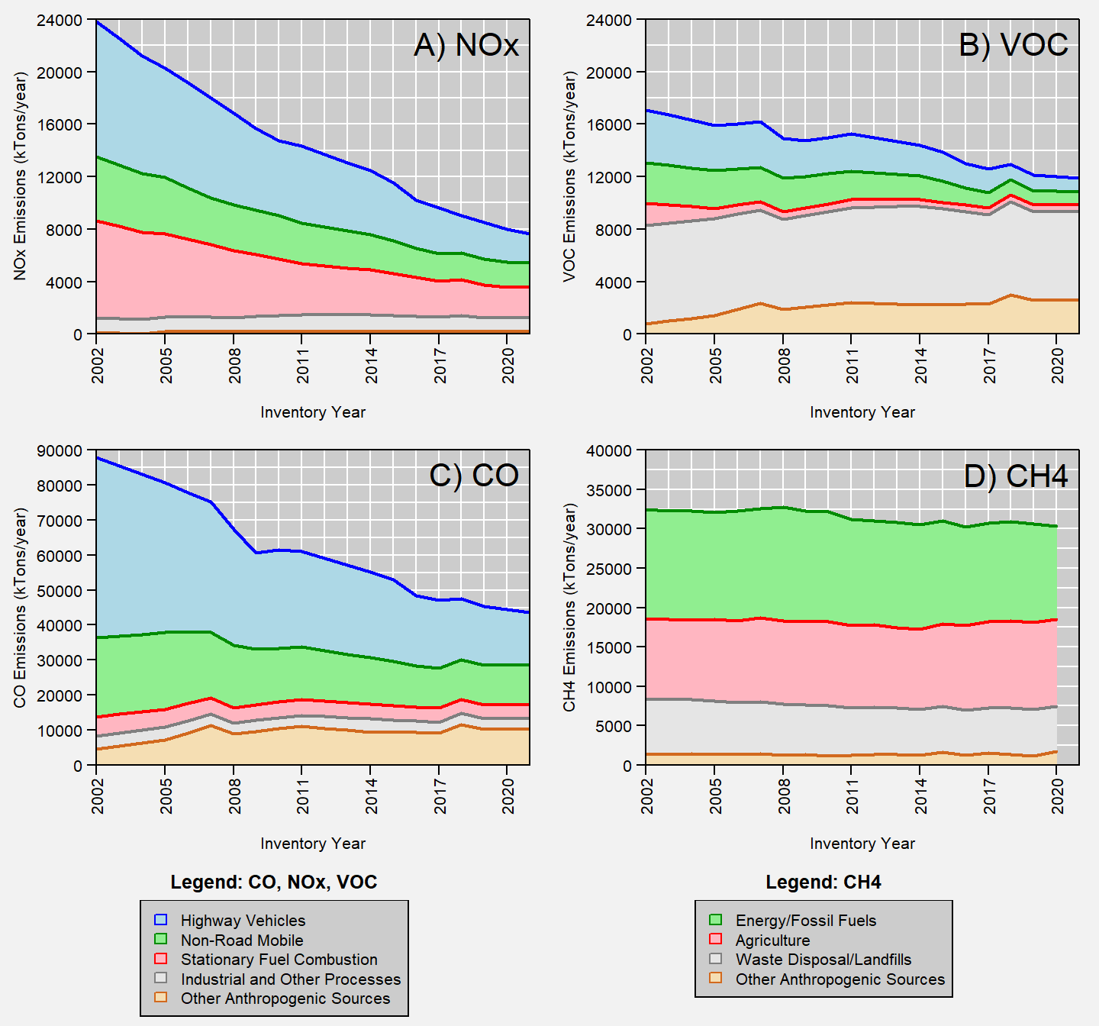 **Figure 2.** U.S. anthropogenic O3 precursor emissions trends for: A) NOX; B) CO; C) VOCs; and D) CH4. **Source:** [EPA’s Air Pollutant Emissions Trends Data](https://www.epa.gov/air-emissions-inventories/air-pollutant-emissions-trends-data) for panels A)-C), [Inventory of U.S. Greenhouse Gas Emissions and Sinks: 1990-2020](https://www.epa.gov/ghgemissions/inventory-us-greenhouse-gas-emissions-and-sinks-1990-2020) for panel D).

     Figure 3, Figure 4 and Figure 5 show county-level estimates of U.S. emissions densities (in tons/year/mi2) for CO, NOX, and VOCs, respectively. In general, CO and NOx emissions tend to be highest in urban areas which typically have the most anthropogenic sources of these precursors, however, CO emissions may be higher in some rural areas due to fires, and similarly NOX emissions may be higher in some rural areas due to sources such as electricity generation, oil and gas extraction, and traffic along major highways. While there are some significant anthropogenic sources of VOC emissions in urban areas, in rural areas the vast majority of VOC emissions come from plants and trees (biogenics), particularly in the southeastern U.S. In other areas of the U.S., such as the Great Plains region and parts of the inter-mountain west, areas with higher levels of VOC emissions are largely due to oil and gas extraction.

     It should be noted that O3 levels in a given area are impacted by both local emissions of precursors that form O3 in the area as well as remote emissions of precursors that form O3 which is then transported into the area. Biogenic VOC emissions that lead to O3 formation may vary greatly depending on the type and amount of vegetation, which is generally much lower in urban areas than in rural areas. However, biogenic VOC emissions that are upwind of an urban area can have a significant impact on urban O3 levels. Thus, while the county-level maps shown in Figure 3, Figure 4 and Figure 5 illustrate the variability in precursor emissions in the U.S., it is not sufficient to look only at the patterns in local emissions when considering the impact on O3 concentrations.

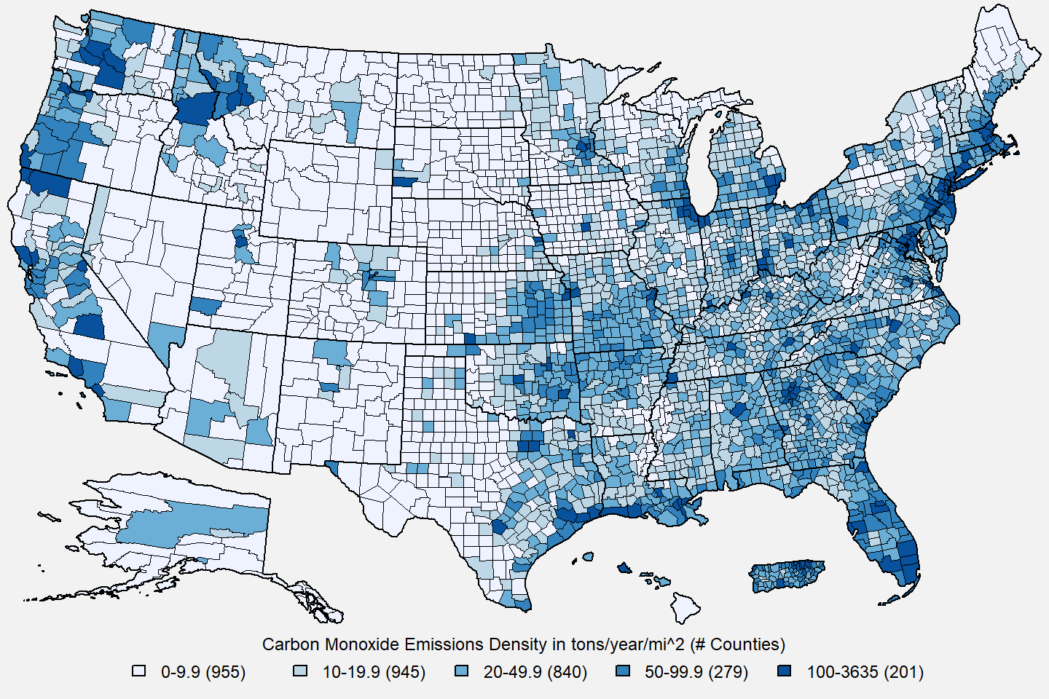 **Figure 3.** U.S. county-level CO emissions density estimates in tons/year/mi2. **Source:** [2017 NEI](https://www.epa.gov/air-emissions-inventories/2017-national-emissions-inventory-nei-data)

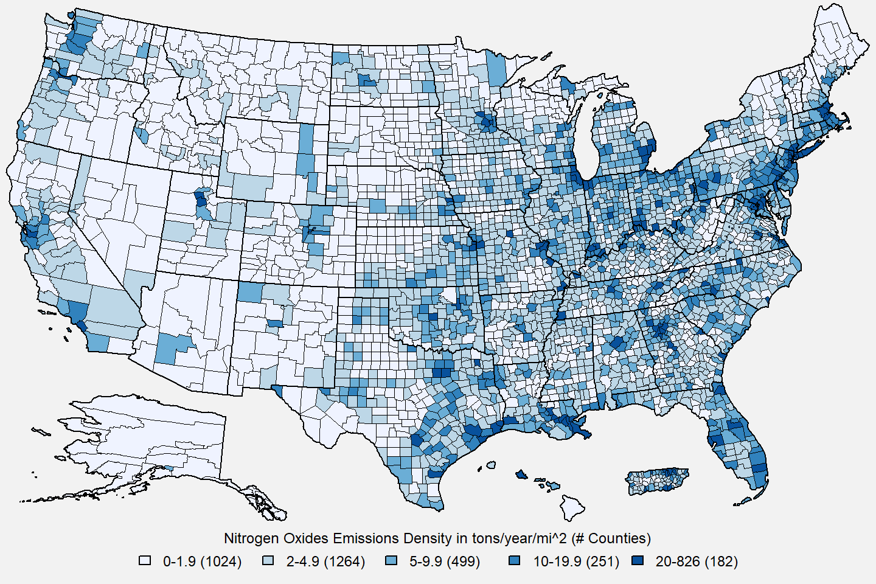 **Figure 4.** U.S. county-level NO~~ emissions density estimates in tons/year/mi2. **Source:** [2017 NEI](https://www.epa.gov/air-emissions-inventories/2017-national-emissions-inventory-nei-data)

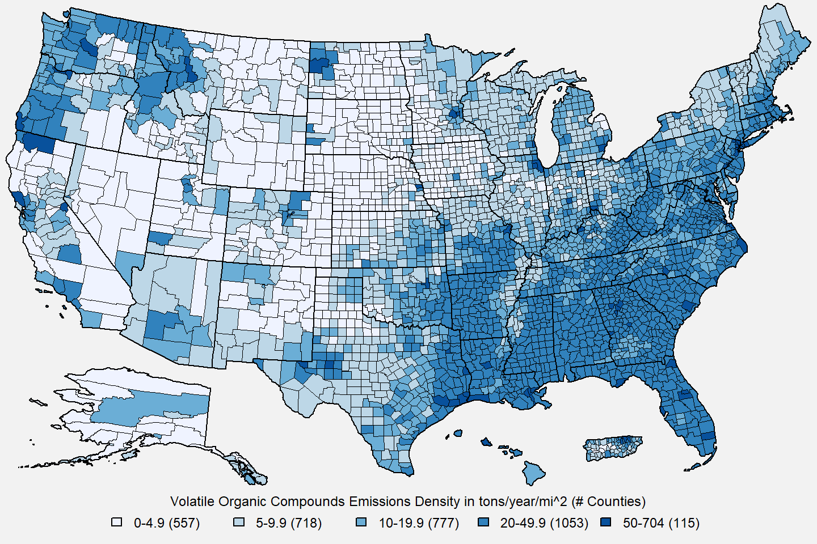 **Figure 5.** U.S. county-level VOC emissions density estimates in tons/year/mi2. **Source:** [2017 NEI](https://www.epa.gov/air-emissions-inventories/2017-national-emissions-inventory-nei-data)

**4. Ambient Air Monitoring Requirements and Monitoring Networks**

     Ambient O3 concentrations are measured by monitoring networks operated by State, Local and Tribal air agencies, which are typically funded in part by the EPA. The EPA provides monitoring requirements for O3 and other pollutants in [40 CFR Part 58](https://www.ecfr.gov/current/title-40/part-58). Nearly all of the air monitoring stations that currently report data to the EPA use ultraviolet Federal Equivalent Methods (FEMs). The Federal Reference Method (FRM) was revised in 2015 to include a new chemiluminescence by nitric oxide (NO-CL) method. The previous ethylene (ET-CL) method, while still included in the CFR as an acceptable method, is no longer used due to lack of availability and safety concerns with ethylene.

     In 2021, there were over 1,300 monitors reporting O3 concentrations to the EPA. Figure 6 shows the locations of such monitoring sites that reported data to the EPA at any time during the 2019-2021 period. The main network of monitors providing ambient data for use in implementation activities related to the NAAQS is the State and Local Air Monitoring Stations (SLAMS) network, which comprises over 80% of all O3 monitoring sites. The requirements for the SLAMS network depend on the population and most recent O3 design values5 in the area. The minimum number of O3 monitors required in a metropolitan statistical area (MSA) ranges from zero monitors for areas with a population less than 350,000 and no recent history of an O3 design value greater than 85 percent of the level of the standard, to four monitors for areas with a population greater than 10 million and an O3 design value greater than 85 percent of the standard level.6 At least one site in each MSA must be designed to record the maximum concentration for that particular metropolitan area.

     Two important subsets of SLAMS sites separately make up the [National Core (NCore)](https://www.epa.gov/amtic/ncore-monitoring-network) multi-pollutant monitoring network and the [Photochemical Assessment Monitoring Stations (PAMS)](https://www.epa.gov/amtic/photochemical-assessment-monitoring-stations-pams) network. Each State is required to have at least one NCore station, and O3 monitors at NCore sites are required to operate year-round. At each NCore site located in a MSA with a population of 1 million or more (based on the most recent census), a PAMS network site is required.7 At a minimum, monitoring sites in the PAMS network are required to measure certain O3 precursors during the months of June, July and August, although some precursor monitoring may be required for longer periods of time to improve the usefulness of data collected during an area’s O3 season. In addition to reporting O3 concentrations, the NCore and PAMS networks provide data on O3 precursor chemicals. The NCore sites feature co-located measurements of chemical species such as nitrogen oxide and total reactive nitrogen, along with various meteorological measurements. The additional data collected at the PAMS sites include measurements of NOX, and a target set of VOCs. The enhanced monitoring at sites in these two networks informs our understanding of local O3 formation.

     While the SLAMS network has a largely urban and population-based focus, there are monitoring sites in other networks that can be used to track compliance with the NAAQS in rural areas. For example, the [Clean Air Status and Trends Network (CASTNET)](https://www.epa.gov/castnet) sites are located in rural areas. There were 83 CASTNET sites operating in 2021, with most of the sites in the eastern U.S. being operated by the EPA, and most of the sites in the western U.S. being operated by the National Park Service (NPS). Finally, there are also a number of Special Purpose Monitors (SPMs), which are not required but are often operated by air agencies for short periods of time (i.e., less than 3 years) to collect data for human health and welfare studies, as well as other types of monitoring sites, including monitors operated by tribes and industrial sources. The SPMs are typically not used to assess compliance with the NAAQS.8

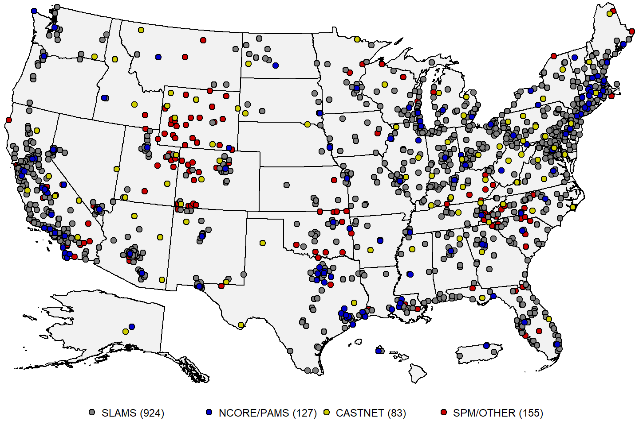 **Figure 6:** Map of U.S. O3 monitoring sites reporting data to the EPA during the 2019-2021 period. **Source:** [AQS](https://www.epa.gov/aqs).

      Since the highest O3 concentrations tend to be associated with a particular season for various locations, the EPA requires O3 monitoring only during specific O3 monitoring seasons, as shown in Figure 7. The O3 monitoring seasons vary by State and range in length from five months (May to September in Oregon and Washington) to all twelve months (in 11 states), with the most common season being March to October (in 27 states).9

     To provide an assessment of data quality, monitoring agencies must perform quality assurance (QA) checks at least once every two weeks to derive estimates of precision and bias for O3 and the other gaseous criteria pollutant measurements using calibration gas. For O3 monitors, the data quality goal for precision and bias is 7 percent. Ambient air quality data and associated QA data are reported to the EPA via the [Air Quality System (AQS)](https://www.epa.gov/aqs).10 Data are reported quarterly and must be submitted to AQS within 90 days after the end of each calendar quarter (i.e. Jan/Feb/Mar, Apr/May/Jun, Jul/Aug/Sep, Oct/Nov/Dec). Additionally, each monitoring agency is required to certify all FRM/FEM data that is submitted to AQS annually, taking into consideration any QA findings, and a data certification letter must be sent to the EPA Regional Administrator by May 1st of the following year.

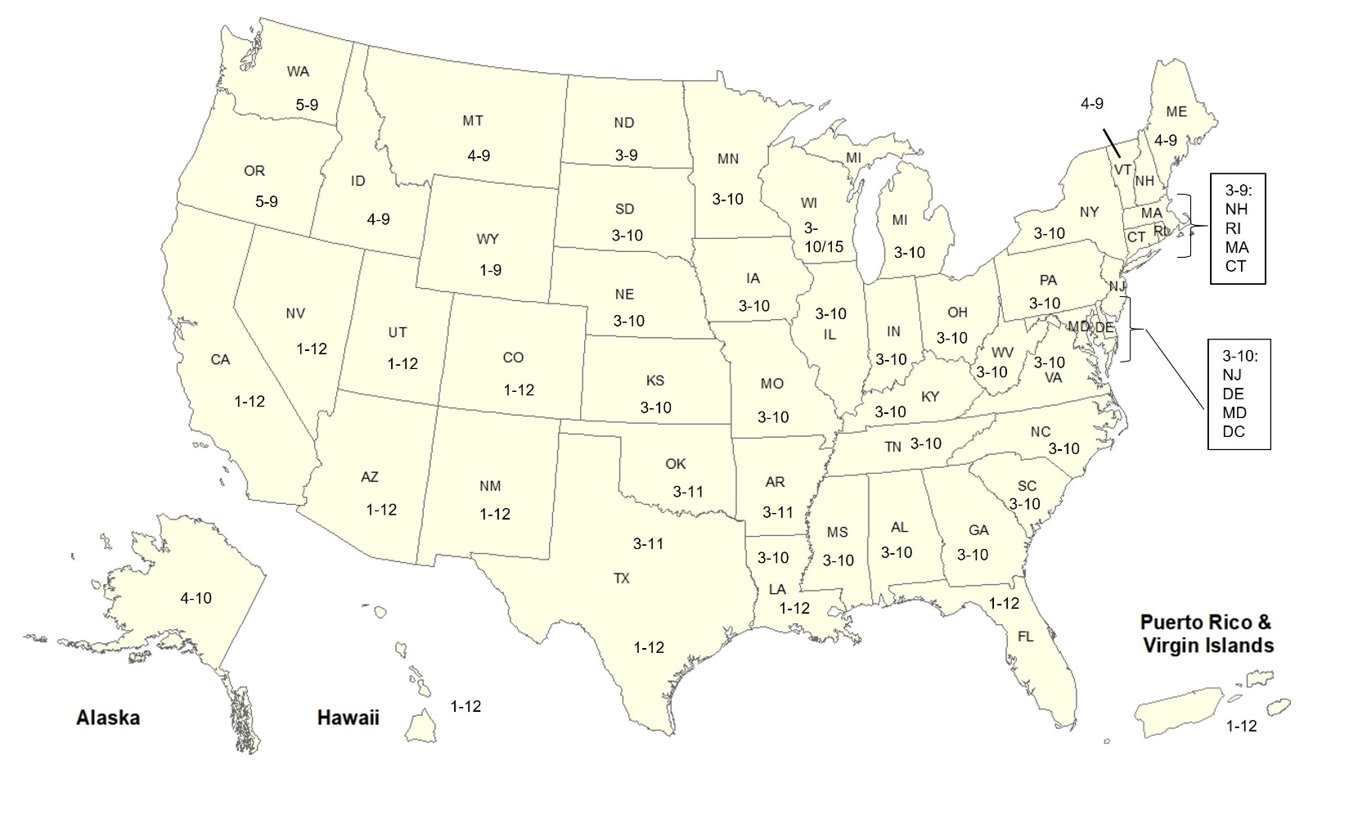 **Figure 7:** Current O3 monitoring seasons in the U.S. Numbers in each State indicate the months of the year the State is required to monitor for O3 (e.g., 3-10 means O3 monitoring is required from March through October).

**5. Data Handling Conventions and Computations for Determining Whether the Standards are Met**

     To assess whether a monitoring site or geographic area (usually a county or urban area) meets or exceeds a NAAQS, the monitoring data are analyzed consistent with the established regulatory requirements for the handling of monitoring data for the purposes of deriving a design value. A design value summarizes ambient air concentrations for an area in terms of the indicator, averaging time and form for a given standard such that its comparison to the level of the standard indicates whether the area meets or exceeds the standard. The procedures for calculating design values for the current O3 NAAQS (established in 2015) are detailed in [Appendix U to 40 CFR Part 50](https://www.ecfr.gov/current/title-40/part-50/appendix-Appendix%20U%20to%20Part%2050) and are summarized below.

     Hourly average O3 concentrations at the monitoring sites used for assessing whether an area meets or exceeds the NAAQS are required to be reported in parts per million (ppm) to the third decimal place, with additional digits truncated, consistent with the typical measurement precision associated with most O3 monitoring instruments. Monitored hourly O3 concentrations flagged by the States as having been affected by an exceptional event, having been the subject of a demonstration submitted by the State, and having received concurrence from the appropriate EPA Regional Office, are excluded from design value calculations consistent with [40 CFR 50.14](https://www.ecfr.gov/current/title-40/section-50.14).11 The hourly concentrations are used to compute moving 8-hour averages, which are stored in the first hour of each 8-hour period (e.g., the 8-hour average for the 7:00 AM to 3:00 PM period is stored in the 7:00 AM hour), and digits to the right of the third decimal place are truncated. Each 8-hour average is considered valid if six or more hourly concentrations are available for the 8-hour period.

     Next, the daily maximum 8-hour average (MDA8) concentration for each day is identified as the highest of the 17 consecutive, valid 8-hour average concentrations beginning at 7:00 AM and ending at 11:00 PM (which includes hourly O3 concentrations from the subsequent day). MDA8 values are considered valid if at least 13 valid 8-hour averages are available for the day, or if the MDA8 value is greater than the level of the NAAQS. Finally, the O3 design value is calculated as the 3-year average of the annual 4th highest MDA8 value.12 An O3 design value less than or equal to the level of the NAAQS is considered to be valid if valid MDA8 values are available for at least 90% of the days in the O3 monitoring season (as defined for each State and shown in Figure 7) on average over the 3 years, with a minimum of 75% data completeness in any individual year. Design values greater than the level of the NAAQS are always considered to be valid. The current level of the O3 NAAQS is 70 ppb.

     An O3 monitoring site meets the NAAQS if it has a valid design value less than or equal to the level of the standard, and it exceeds the NAAQS if it has a design value greater than the level of the standard. A geographic area meets the NAAQS if all ambient air monitoring sites in the area have valid design values meeting the standard. Conversely, if one or more monitoring sites has a design value exceeding the standard, then the area exceeds the NAAQS.

**6. O3 Concentrations Measured at Ambient Air Monitoring Sites Across the U.S.**

     Table 1 below presents summary statistics based on three daily O3 metrics commonly used in health studies, the daily maximum 1-hour (MDA1) metric, the daily maximum 8-hour (MDA8) metric, and the daily 24-hour average (DA24) metric. These statistics are presented for year-round and each season (winter=Dec/Jan/Feb, spring=Mar/Apr/May, summer=Jun/Jul/Aug, autumn=Sep/Oct/Nov) for monitors that have complete year-round data (defined as having at least 75% data completeness based on a year-round O3 monitoring season) in AQS for 2019-2021. Table 2 presents the same summary statistics as Table 1 for each [NOAA Climate Region](https://www.ncei.noaa.gov/monitoring-references/maps/us-climate-regions)13 based on monitoring sites with at least 75% data completeness during the May - September period (i.e., the months where every State is required to monitor for O3). Finally, Table 3 the same set of summary statistics based on the May-September period for the three daily O3 metrics for four subsets of sites: urban NCore and PAMS sites versus rural CASTNET sites, both in the eastern U.S. versus the in western U.S.14

     Table 1 shows that the distribution of O3 concentrations observed in the U.S. in recent years is nearly symmetric: the mean and median concentrations are within 2 ppb of each other for all combinations of metric and season. The highest median and mean O3 concentrations generally occur in the spring and summer months, while the highest peak O3 concentrations generally occur in the summer, and sometimes in the late spring or early fall when sunlight and temperature conditions are most favorable to O3 production. Winter O3 concentrations are generally lower, except for sporadic episodes occurring in mountain basins in the western U.S. under the right conditions as noted in section 2. Fewer low O3 concentrations are observed in the spring, when background O3 concentrations tend to be highest.

**Table 1.** National distribution of O3 concentrations in ppb from the year-round dataset for 2019-2021.15 **Source:** [AQS](https://www.epa.gov/aqs).

|  |  |  |  |  |  |  |  |  |  |  |  |  |  |  |  |  |  |  |
| --- | --- | --- | --- | --- | --- | --- | --- | --- | --- | --- | --- | --- | --- | --- | --- | --- | --- | --- |
| metric | season | N.sites | N.obs | mean | SD | min | p1 | p5 | p10 | p25 | p50 | p75 | p90 | p95 | p98 | p99 | max | max.site |
| MDA1 | all | 782 | 829,874 | 45 | 14 | -4 | 17 | 25 | 29 | 36 | 43 | 52 | 61 | 68 | 77 | 85 | 185 | 060371103 |
| MDA1 | winter | 756 | 197,489 | 37 | 9 | 0 | 14 | 22 | 26 | 32 | 38 | 43 | 47 | 50 | 54 | 57 | 132 | 121171002 |
| MDA1 | spring | 764 | 207,072 | 48 | 10 | 0 | 24 | 32 | 36 | 42 | 48 | 54 | 60 | 65 | 71 | 76 | 146 | 080677003 |
| MDA1 | summer | 772 | 208,878 | 50 | 16 | -4 | 19 | 25 | 30 | 39 | 50 | 60 | 70 | 78 | 88 | 96 | 179 | 300750001 |
| MDA1 | autumn | 772 | 205,297 | 43 | 14 | 0 | 17 | 24 | 28 | 34 | 41 | 50 | 60 | 67 | 77 | 85 | 185 | 060371103 |
| MDA8 | all | 782 | 827,111 | 40 | 12 | -1 | 14 | 21 | 25 | 32 | 39 | 48 | 56 | 61 | 68 | 73 | 139 | 060710005 |
| MDA8 | winter | 754 | 196,487 | 33 | 9 | -1 | 10 | 18 | 21 | 27 | 34 | 39 | 44 | 46 | 49 | 52 | 105 | 490472003 |
| MDA8 | spring | 764 | 206,423 | 44 | 10 | 0 | 20 | 28 | 32 | 38 | 44 | 50 | 56 | 59 | 64 | 67 | 116 | 060714003 |
| MDA8 | summer | 772 | 208,071 | 45 | 14 | 0 | 16 | 22 | 26 | 34 | 45 | 54 | 63 | 68 | 75 | 81 | 139 | 060710005 |
| MDA8 | autumn | 772 | 204,646 | 38 | 12 | 0 | 13 | 20 | 24 | 30 | 37 | 45 | 53 | 59 | 66 | 72 | 138 | 060370016 |
| DA24 | all | 782 | 829,874 | 30 | 10 | -4 | 8 | 14 | 17 | 23 | 30 | 37 | 44 | 48 | 52 | 55 | 102 | 060570005 |
| DA24 | winter | 756 | 197,489 | 26 | 9 | -2 | 5 | 10 | 13 | 19 | 26 | 32 | 38 | 41 | 44 | 46 | 89 | 490472003 |
| DA24 | spring | 764 | 207,072 | 35 | 8 | 0 | 16 | 21 | 24 | 30 | 35 | 41 | 45 | 48 | 52 | 54 | 90 | 490472003 |
| DA24 | summer | 772 | 208,878 | 33 | 11 | -4 | 11 | 15 | 18 | 25 | 33 | 41 | 48 | 52 | 56 | 60 | 102 | 060570005 |
| DA24 | autumn | 772 | 205,297 | 27 | 10 | -1 | 8 | 13 | 16 | 21 | 27 | 33 | 40 | 44 | 49 | 53 | 83 | 060710005 |

N.sites = number of sites; N.obs = number of observations; SD = standard deviation; min = minimum; p1, p5, p10, p25, p50, p90, p95, p98, p99 = 1st, 5th, 10th, 25th, 50th, 90th, 95th, 98th, 99th percentiles; max = maximum; max.site = AQS ID number for the monitoring site corresponding to the observation in the max column. winter = December/January/February; spring = March/April/May; summer = June/July/August; autumn = September/October/November.

**Table 2.** National distribution of O3 concentrations in ppb from the May-September dataset for 2019-2021.15 **Source:** [AQS](https://www.epa.gov/aqs).

|  |  |  |  |  |  |  |  |  |  |  |  |  |  |  |  |  |  |  |
| --- | --- | --- | --- | --- | --- | --- | --- | --- | --- | --- | --- | --- | --- | --- | --- | --- | --- | --- |
| metric | region | N.sites | N.obs | mean | SD | min | p1 | p5 | p10 | p25 | p50 | p75 | p90 | p95 | p98 | p99 | max | max.site |
| MDA1 | all | 1,157 | 520,101 | 49 | 14 | -4 | 20 | 27 | 31 | 39 | 48 | 57 | 66 | 73 | 82 | 90 | 185 | 060371103 |
| MDA1 | Central | 185 | 83,709 | 48 | 11 | 1 | 25 | 31 | 35 | 41 | 48 | 55 | 62 | 67 | 73 | 77 | 115 | 295100085 |
| MDA1 | East North Central | 86 | 38,698 | 46 | 12 | 1 | 21 | 27 | 31 | 37 | 45 | 53 | 61 | 67 | 73 | 78 | 115 | 550590019 |
| MDA1 | Northeast | 189 | 85,335 | 46 | 13 | 0 | 21 | 27 | 31 | 37 | 45 | 53 | 62 | 68 | 75 | 81 | 136 | 090019003 |
| MDA1 | Northwest | 25 | 11,115 | 42 | 12 | 2 | 19 | 24 | 28 | 34 | 41 | 50 | 58 | 63 | 71 | 76 | 110 | 410050004 |
| MDA1 | South | 137 | 61,264 | 45 | 14 | -4 | 18 | 23 | 27 | 35 | 44 | 54 | 63 | 69 | 77 | 82 | 141 | 482011039 |
| MDA1 | Southeast | 186 | 83,169 | 43 | 12 | 0 | 18 | 23 | 26 | 34 | 43 | 51 | 58 | 62 | 68 | 72 | 108 | 131210055 |
| MDA1 | Southwest | 120 | 53,752 | 59 | 11 | 0 | 35 | 43 | 47 | 52 | 58 | 65 | 73 | 78 | 85 | 90 | 143 | 080077004 |
| MDA1 | West | 182 | 81,893 | 56 | 19 | 0 | 19 | 28 | 34 | 43 | 54 | 66 | 79 | 89 | 100 | 109 | 185 | 060371103 |
| MDA1 | West North Central | 47 | 21,166 | 49 | 10 | 4 | 24 | 33 | 37 | 43 | 50 | 56 | 62 | 66 | 71 | 74 | 179 | 300750001 |
| MDA8 | all | 1,157 | 518,362 | 43 | 13 | 0 | 17 | 23 | 27 | 34 | 43 | 52 | 60 | 65 | 71 | 76 | 139 | 060710005 |
| MDA8 | Central | 185 | 83,455 | 43 | 10 | 1 | 21 | 27 | 30 | 36 | 43 | 50 | 57 | 61 | 66 | 69 | 100 | 295100085 |
| MDA8 | East North Central | 86 | 38,626 | 41 | 11 | 4 | 17 | 24 | 27 | 33 | 40 | 48 | 56 | 61 | 66 | 70 | 104 | 550590019 |
| MDA8 | Northeast | 189 | 84,885 | 41 | 11 | 0 | 17 | 24 | 27 | 33 | 40 | 48 | 55 | 60 | 65 | 69 | 99 | 090019003 |
| MDA8 | Northwest | 25 | 11,066 | 38 | 11 | 0 | 15 | 21 | 24 | 30 | 37 | 45 | 52 | 56 | 63 | 66 | 96 | 530330023 |
| MDA8 | South | 137 | 61,043 | 40 | 13 | 1 | 15 | 20 | 23 | 30 | 39 | 48 | 56 | 61 | 66 | 70 | 114 | 484390075 |
| MDA8 | Southeast | 186 | 82,846 | 38 | 11 | 0 | 16 | 20 | 23 | 29 | 38 | 46 | 53 | 56 | 60 | 63 | 94 | 131210055 |
| MDA8 | Southwest | 120 | 53,643 | 54 | 9 | 0 | 31 | 39 | 43 | 48 | 54 | 59 | 65 | 69 | 74 | 78 | 108 | 040131004 |
| MDA8 | West | 182 | 81,710 | 49 | 16 | 0 | 16 | 25 | 30 | 38 | 49 | 59 | 69 | 76 | 84 | 90 | 139 | 060710005 |
| MDA8 | West North Central | 47 | 21,088 | 46 | 10 | 3 | 20 | 29 | 33 | 39 | 46 | 52 | 58 | 61 | 66 | 69 | 85 | 310550019 |
| DA24 | all | 1,157 | 520,101 | 32 | 10 | -4 | 11 | 16 | 19 | 25 | 31 | 39 | 45 | 49 | 54 | 58 | 102 | 060570005 |
| DA24 | Central | 185 | 83,709 | 31 | 8 | 0 | 14 | 19 | 21 | 26 | 31 | 36 | 41 | 45 | 48 | 50 | 76 | 170317002 |
| DA24 | East North Central | 86 | 38,698 | 31 | 9 | 0 | 13 | 18 | 20 | 25 | 31 | 37 | 43 | 46 | 51 | 54 | 78 | 551170006 |
| DA24 | Northeast | 189 | 85,335 | 30 | 9 | 0 | 12 | 17 | 19 | 24 | 30 | 36 | 41 | 45 | 48 | 51 | 68 | 360310002 |
| DA24 | Northwest | 25 | 11,115 | 28 | 9 | 1 | 10 | 15 | 17 | 22 | 27 | 34 | 40 | 44 | 48 | 51 | 65 | 160230101 |
| DA24 | South | 137 | 61,264 | 28 | 10 | -4 | 10 | 14 | 16 | 21 | 28 | 35 | 41 | 45 | 48 | 51 | 72 | 484390075 |
| DA24 | Southeast | 186 | 83,169 | 26 | 9 | 0 | 10 | 13 | 15 | 20 | 26 | 33 | 39 | 43 | 47 | 49 | 65 | 371990004 |
| DA24 | Southwest | 120 | 53,752 | 42 | 8 | 0 | 23 | 29 | 32 | 37 | 42 | 47 | 52 | 54 | 58 | 61 | 78 | 080590011 |
| DA24 | West | 182 | 81,893 | 36 | 11 | 0 | 13 | 19 | 23 | 28 | 36 | 44 | 51 | 56 | 62 | 66 | 102 | 060570005 |
| DA24 | West North Central | 47 | 21,166 | 37 | 9 | 2 | 15 | 22 | 26 | 31 | 37 | 43 | 48 | 52 | 56 | 58 | 76 | 560019991 |

N.sites = number of sites; N.obs = number of observations; SD = standard deviation; min = minimum; p1, p5, p10, p25, p50, p90, p95, p98, p99 = 1st, 5th, 10th, 25th, 50th, 90th, 95th, 98th, 99th percentiles; max = maximum; max.site = AQS ID number for the monitoring site corresponding to the observation in the max column. Central = Illinois, Indiana, Kentucky, Missouri, Ohio, Tennessee, West Virginia; East North Central = Iowa, Minnesota, Michigan, Wisconsin; Northeast = Connecticut, Delaware, Maine, Maryland, Massachusetts, New Hampshire, New Jersey, New York, Pennsylvania, Rhode Island, Vermont; Northwest = Alaska, Idaho, Oregon, Washington; South = Arkansas, Kansas, Louisiana, Mississippi, Oklahoma, Texas; Southeast = Alabama, Florida, Georgia, North Carolina, South Carolina, Virginia; Southwest = Arizona, Colorado, New Mexico, Utah; West = California, Hawaii, Nevada; West North Central = Montana, Nebraska, North Dakota, South Dakota, Wyoming.

**Table 3.** Distribution of O3 concentrations in ppb from the May-September dataset by eastern vs. western U.S. and urban vs. rural sites for 2019-2021. 15 **Source:** [AQS](https://www.epa.gov/aqs).

|  |  |  |  |  |  |  |  |  |  |  |  |  |  |  |  |  |  |  |  |
| --- | --- | --- | --- | --- | --- | --- | --- | --- | --- | --- | --- | --- | --- | --- | --- | --- | --- | --- | --- |
| metric | region | site.type | N.sites | N.obs | mean | SD | min | p1 | p5 | p10 | p25 | p50 | p75 | p90 | p95 | p98 | p99 | max | max.site |
| MDA1 | All Sites | All Sites | 1,157 | 520,101 | 49 | 14 | -4 | 20 | 27 | 31 | 39 | 48 | 57 | 66 | 73 | 82 | 90 | 185 | 060371103 |
| MDA1 | Eastern U.S. | Urban | 66 | 29,742 | 46 | 14 | 0 | 19 | 25 | 29 | 36 | 46 | 55 | 64 | 71 | 78 | 84 | 141 | 482011039 |
| MDA1 | Eastern U.S. | Rural | 48 | 21,757 | 44 | 11 | 1 | 20 | 26 | 29 | 36 | 44 | 51 | 58 | 62 | 67 | 70 | 98 | 240339991 |
| MDA1 | Western U.S. | Urban | 33 | 14,681 | 55 | 17 | 0 | 20 | 30 | 35 | 44 | 55 | 65 | 77 | 85 | 94 | 100 | 185 | 060371103 |
| MDA1 | Western U.S. | Rural | 32 | 14,422 | 54 | 12 | 11 | 27 | 35 | 40 | 48 | 54 | 60 | 68 | 73 | 82 | 88 | 130 | 061070009 |
| MDA8 | All Sites | All Sites | 1,157 | 518,362 | 43 | 13 | 0 | 17 | 23 | 27 | 34 | 43 | 52 | 60 | 65 | 71 | 76 | 139 | 060710005 |
| MDA8 | Eastern U.S. | Urban | 66 | 29,651 | 41 | 13 | 1 | 16 | 21 | 25 | 32 | 40 | 49 | 57 | 62 | 67 | 72 | 107 | 482011039 |
| MDA8 | Eastern U.S. | Rural | 48 | 21,584 | 39 | 11 | 1 | 17 | 22 | 25 | 32 | 39 | 47 | 53 | 57 | 61 | 64 | 82 | 090159991 |
| MDA8 | Western U.S. | Urban | 33 | 14,643 | 49 | 14 | 0 | 17 | 26 | 31 | 39 | 49 | 58 | 67 | 72 | 78 | 83 | 118 | 060371103 |
| MDA8 | Western U.S. | Rural | 32 | 14,375 | 50 | 11 | 11 | 24 | 32 | 37 | 44 | 51 | 57 | 63 | 68 | 74 | 78 | 114 | 061070009 |
| DA24 | All Sites | All Sites | 1,157 | 520,101 | 32 | 10 | -4 | 11 | 16 | 19 | 25 | 31 | 39 | 45 | 49 | 54 | 58 | 102 | 060570005 |
| DA24 | Eastern U.S. | Urban | 66 | 29,742 | 29 | 9 | 0 | 11 | 15 | 17 | 22 | 29 | 35 | 40 | 44 | 48 | 50 | 71 | 170971007 |
| DA24 | Eastern U.S. | Rural | 48 | 21,757 | 30 | 9 | 0 | 11 | 15 | 18 | 23 | 30 | 37 | 42 | 46 | 49 | 52 | 66 | 361099991 |
| DA24 | Western U.S. | Urban | 33 | 14,681 | 35 | 9 | 0 | 13 | 19 | 23 | 28 | 35 | 41 | 46 | 50 | 54 | 56 | 73 | 060190011 |
| DA24 | Western U.S. | Rural | 32 | 14,422 | 43 | 10 | 5 | 18 | 25 | 30 | 37 | 44 | 50 | 56 | 59 | 64 | 67 | 91 | 061070009 |

N.sites = number of sites; N.obs = number of observations; SD = standard deviation; min = minimum; p1, p5, p10, p25, p50, p90, p95, p98, p99 = 1st, 5th, 10th, 25th, 50th, 90th, 95th, 98th, 99th percentiles; max = maximum; max.site = AQS ID number for the monitoring site corresponding to the observation in the max column. Region is defined such that the eastern U.S. includes sites east of 100 degrees west longitude and the western U.S. includes sites west of 100 degrees west longitude; site.type = Urban includes Urban NCore and PAMS sites; Site.type = Rural includes CASTNET sites.

     Figure 8 below shows a map of the O3 design values at U.S. ambient air monitoring sites based on data from the 2019-2021 period. From the figure it is apparent that many monitoring sites have design values exceeding the current NAAQS, and that most of these sites are located in or near urban areas. The highest design values occurred in California, Texas, along the shoreline of Lake Michigan, and near large urban areas in the northeastern and western U.S. There are also high design values associated with wintertime O3 in the Uinta Basin in Utah. The lowest design values occurred in the north central region of the U.S., rural parts of New England and the southeastern U.S., and along the Pacific Ocean, including Alaska and Hawaii.

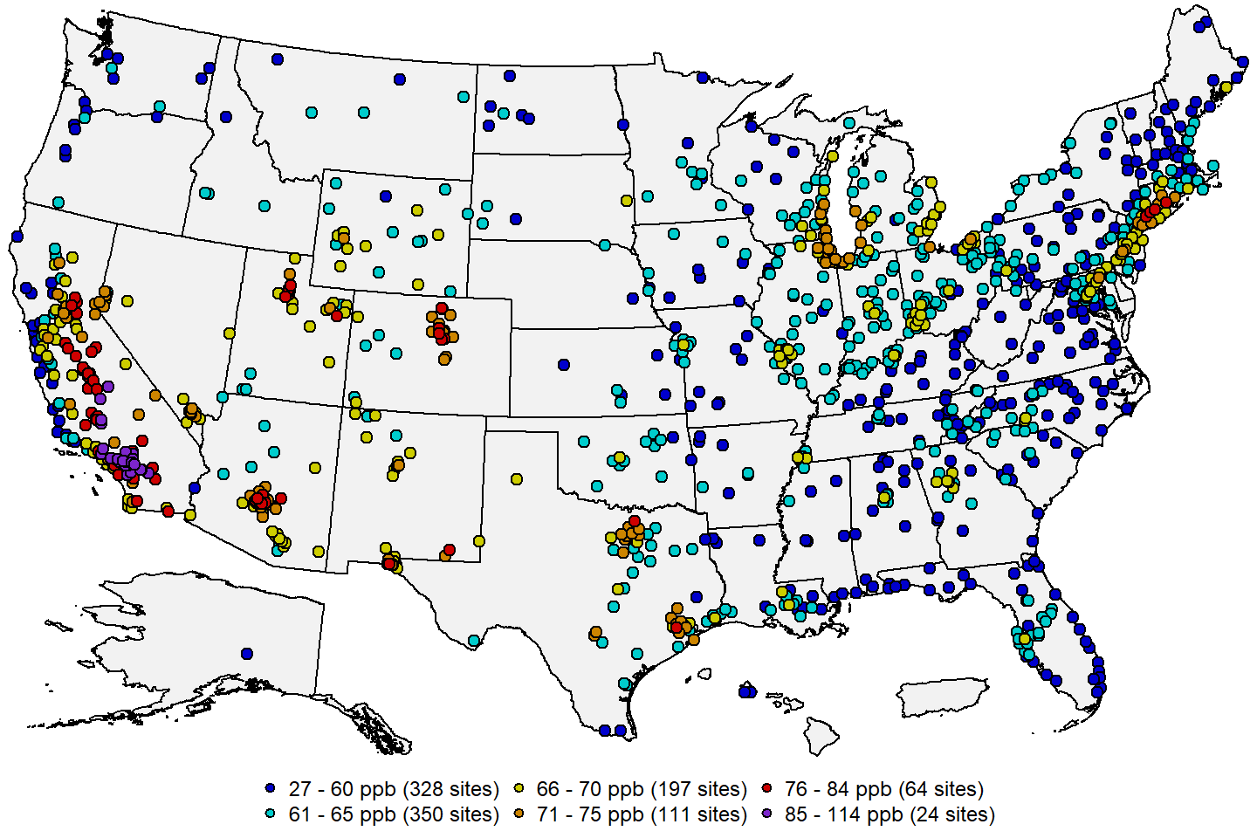 **Figure 8:** O3 design values in ppb for the 2019-2021 period. **Source:** [AQS](https://www.epa.gov/aqs).

     Figure 9 below shows a map of the site-level trends in the O3 design values at U.S. monitoring sites having valid design values in at least 15 of the 20 3-year periods from 2000 through 2021. The trends were computed using the Thiel-Sen estimator, and tests for significance (p-value < 0.05) were computed using the Mann-Kendall test. From this figure it is apparent that design values have decreased significantly over most of the eastern U.S. during this period. These decreases are in part due to EPA programs such as the Clean Air Interstate Rule (CAIR) and the Cross-State Air Pollution Rule (CSAPR) with the goal of achieving broad, regional reductions in summertime NOX emissions, as well as mobile emission reductions from federal motor vehicle emissions and fuel standards and local controls resulting from implementation of the existing O3 standards. Other areas of the country have also experienced decreases in design values, most notably in California and near urban areas in the intermountain west.

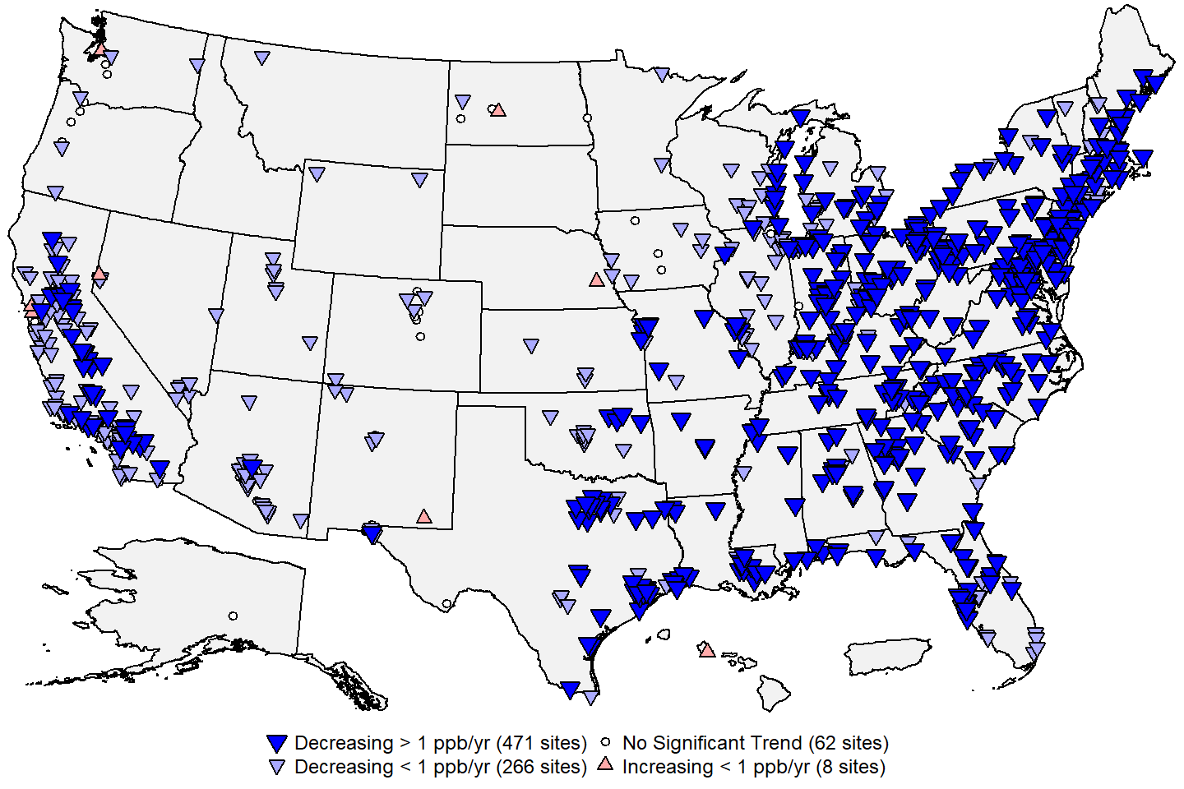 **Figure 9:** Site-level trends in O3 design values based on data from 2000 through 2021. **Source:** [AQS](https://www.epa.gov/aqs), trends computed using R statistical software.

     Figure 10 below shows the national trend in the design values based on the 807 monitoring sites shown in Figure 9. The U.S. median design value decreased by 26% from 2000 (86 ppb) to 2021 (64 ppb). Additional information from the published literature has examined trends in MDA8 concentrations across the distribution of high and low O3 days. O3 metrics impacted by high hourly O3 concentrations, such as the design value, decreased at most U.S. sites during the time periods studied. Concurrently, metrics that are impacted by averaging longer time periods of hourly O3 measurements were more varied with fewer sites exhibiting decreases and most other sites exhibiting no trend.

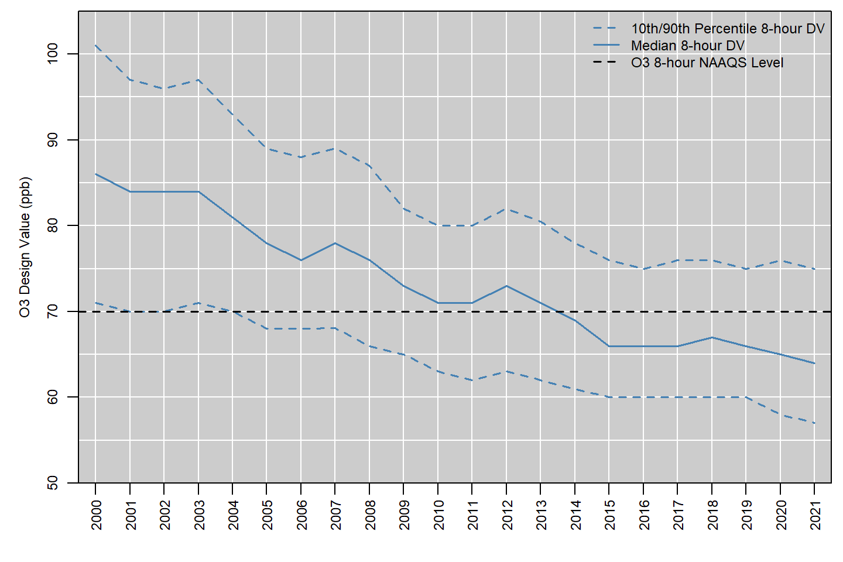 **Figure 10:** National trend in O3 design values in ppb, 2000 to 2021. **Source:** [AQS](https://www.epa.gov/aqs).

     Figure 11 below shows the national distribution of the annual 4th highest MDA8 O3 concentrations reported in each year from 1980 to 2021.16 The red line shows the number of sites included in the boxplot for each year. The median annual 4th highest MDA8 O3 concentration decreased by 30 percent, from 93 ppb in 1980 to 65 ppb in 2021. While the magnitude of the highest O3 concentrations declined between 1980 and the early 2000s, the center of the distribution stayed relatively constant, with over 75% of sites measuring annual 4th highest MDA8 O3 concentrations above the current NAAQS level. Since 2003, regional control programs such as the NOX SIP Call and CSAPR have contributed to reduced concentrations over the eastern U.S., so that roughly 75% of all sites have been meeting the NAAQS each year since 2013. The size of the O3 monitoring network increased from 1980 through the early 2000s and has stayed relatively constant at around 1,200 sites since then.

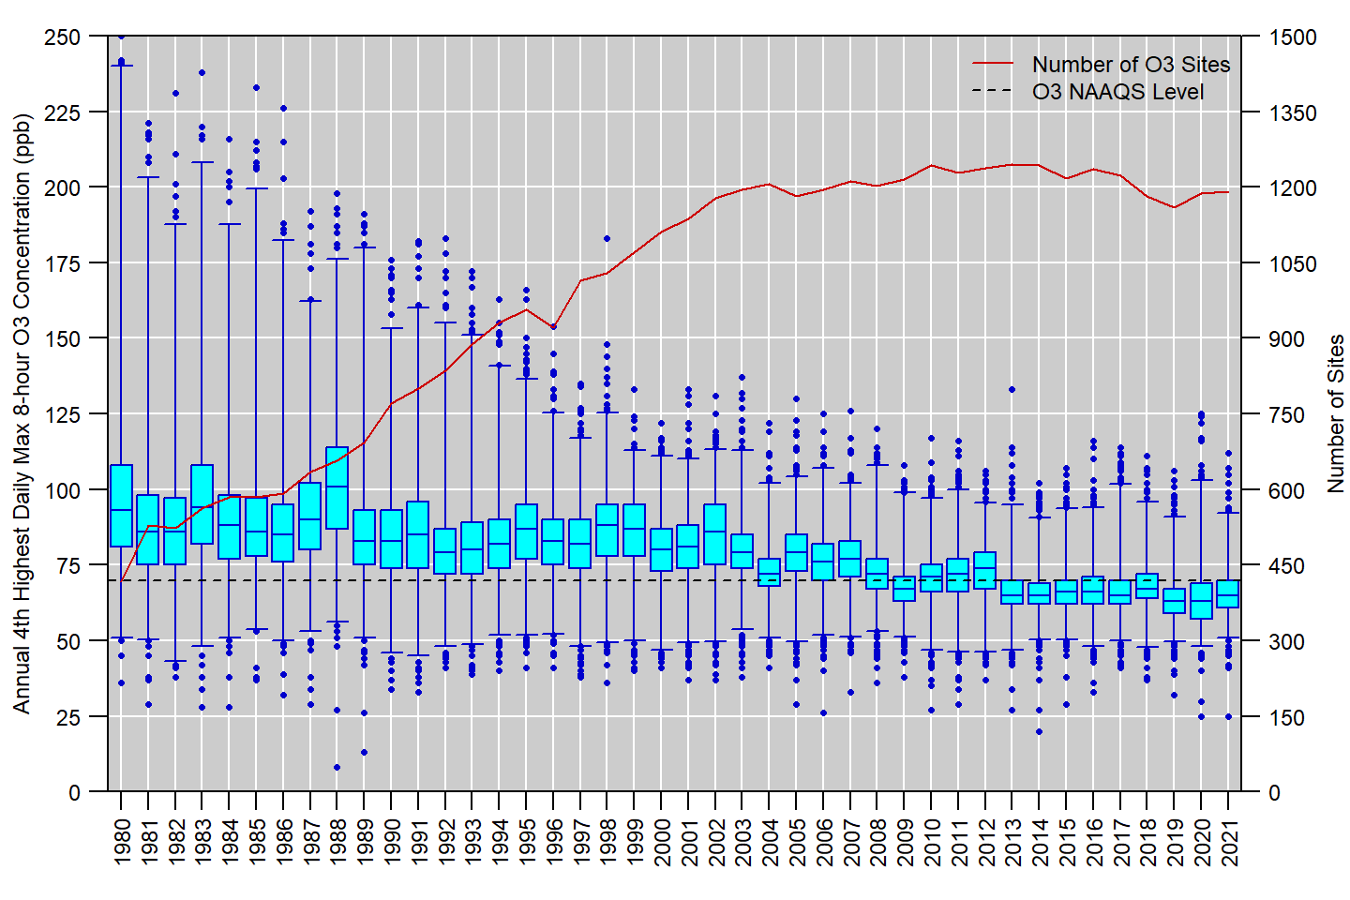 **Figure 11:** Distribution of annual 4th highest MDA8 O3 concentrations measured at U.S. monitoring sites, 1980 to 2021. Boxes represent the median and interquartile range, whiskers extend to the 1st and 99th percentiles, and values outside this range are shown as circles. The red line shows the number of O3 monitoring sites reporting data to EPA in each year. **Source:** [AQS](https://www.epa.gov/aqs).

**References**

U.S. EPA. [Integrated Science Assessment for Ozone and Related Photochemical Oxidants (Final Report, April 2020)](https://cfpub.epa.gov/ncea/isa/recordisplay.cfm?deid=348522). U.S. Environmental Protection Agency, Washington, DC, EPA/600/R-20/012, 2020.

U.S. EPA. [Policy Assessment for the Review of the Ozone NAAQS (Final Report, May 2020)](https://www.epa.gov/sites/default/files/2020-05/documents/o3-final_pa-05-29-20compressed.pdf). U.S. Environmental Protection Agency, Research Triangle Park, NC, EPA-452/R-20-001, 2020.

**Additional Resources**

* [Ground-level Ozone Pollution](https://www.epa.gov/ground-level-ozone-pollution)
* [Ozone (O3) Air Quality Standards](https://www.epa.gov/naaqs/ozone-o3-air-quality-standards)
* [National Emissions Inventory (NEI)](https://www.epa.gov/air-emissions-inventories/national-emissions-inventory-nei)
* [Ambient Monitoring Technology Information Center (AMTIC)](https://www.epa.gov/amtic)
* [Air Quality Design Values](https://www.epa.gov/air-trends/air-quality-design-values)
* [National Air Quality: Status and Trends of Key Air Pollutants](https://www.epa.gov/air-trends)
* [Air Data: Air Quality Data Collected at Outdoor Monitors Across the U.S.](https://www.epa.gov/outdoor-air-quality-data)

**Footnotes:**

1. O3 also occurs in the stratosphere, where it serves the beneficial role of absorbing the sun’s harmful ultraviolet radiation and preventing the majority of this radiation from reaching the Earth’s surface.↩︎
2. The only other appreciable source of O3 to the troposphere is transport from the stratosphere.↩︎
3. It should be noted that the definition of VOCs used in this section does not include CH4 because it is excluded from the EPA’s regulatory definition of VOCs in [40 CFR 51.100(s)](https://www.ecfr.gov/current/title-40/chapter-I/subchapter-C/part-51/subpart-F#p-51.100(s)).↩︎
4. NOX, VOC, and CO data for Figure 2 come from the EPA’s [Air Pollutant Emissions Trends Data](https://www.epa.gov/air-emissions-inventories/air-pollutant-emissions-trends-data). Note that emissions for some sectors are interpolated between inventory years, and the emissions for some sectors are held constant beyond the most recent inventory year (for details, see the “Development of Data” table in the [national emissions trends data file](https://www.epa.gov/sites/default/files/2021-03/national_tier1_caps.xlsx). For the purposes of this document, wildfires are considered to be natural emissions and thus are not included in Figure 2.↩︎
5. A design value is a statistic that summarizes the air quality data for a given area in terms of the indicator, averaging time, and form of the standard. Design values can be compared to the level of the standard and are typically used to designate areas as meeting or not meeting the standard and assess progress towards meeting the NAAQS.↩︎
6. The SLAMS minimum monitoring requirements to meet the O3 design criteria are specified in [Appendix D to 40 CFR Part 58](https://www.ecfr.gov/current/title-40/part-58/appendix-Appendix%20D%20to%20Part%2058).↩︎
7. The requirements for PAMS, which were most recently updated in 2015, is fully described in section 5 of [Appendix D to 40 CFR Part 58](https://www.ecfr.gov/current/title-40/part-58/appendix-Appendix%20D%20to%20Part%2058).↩︎
8. SPMs that use federal reference or equivalent methods, meet all applicable requirements in [40 CFR Part 58](https://www.ecfr.gov/current/title-40/part-58), and operate continuously for at least 3 years may be used to assess compliance with the NAAQS.↩︎
9. The required O3 monitoring seasons for each State are listed in Table D-3 of [Appendix D to 40 CFR Part 58](https://www.ecfr.gov/current/title-40/part-58/appendix-Appendix%20D%20to%20Part%2058).↩︎
10. Quality assurance requirements for monitors used in evaluations of the NAAQS are provided in [Appendix A to 40 CFR Part 58](https://www.ecfr.gov/current/title-40/part-58/appendix-Appendix%20A%20to%20Part%2058). Annual summary reports of precision and bias can be obtained for each monitoring site at the EPA’s [Air Data website](https://www.epa.gov/outdoor-air-quality-data/single-point-precision-and-bias-report).↩︎
11. A variety of resources and guidance documents related to identification and consideration of exceptional events in design value calculations are available at [<https://www.epa.gov/air-quality-analysis/final-2016-exceptional-events-rule-supporting-guidance-documents-updated-faqs>].↩︎
12. Design values are reported in ppm to the third decimal place, with additional digits truncated. This truncation step also applies to the initially calculated 8-hour average concentrations.↩︎
13. For Table 2, monitoring sites in Alaska were assigned to the Northwest Region and monitoring sites in Hawaii were assigned to the West region.↩︎
14. For Table 3, the eastern U.S. is defined as east of 100 degrees West longitude and the western U.S. is defined as west of 100 degrees West longitude.↩︎
15. Negative concentration values may appear in AQS datasets down to the negative of the lower detection limit (LDL) to allow for normal instrument variability at very low concentrations. Data that exceed the negative of the LDL is typically indicative of a malfunction or another issue that affects the data defensibility. ↩︎
16. For this analysis, the annual 4th highest MDA8 O3 concentrations were retrieved from AQS for all U.S. sites for years that had at least 75% annual data completeness during the O3 monitoring season.↩︎