**Overview of Particulate Matter (PM) Air Quality in the United States**

Updated: February 7, 2023

**1. Introduction**

     The overall purpose of this document is to maintain an up-to-date graphical summary of air quality information that supports the review of the National Ambient Air Quality Standards (NAAQS) for particulate matter (PM). In previous reviews of the PM NAAQS, this type of information has generally been included in atmospheric sections of the Integrated Science Assessment (ISA) and Policy Assessment (PA) for PM. This stand-alone document will either replace or complement the air quality emissions and monitoring data in the atmospheric sections of future PM NAAQS review supporting documents and will be updated at regular intervals as new data becomes available.

     The content of past NAAQS documents’ atmospheric sections has included major sections on emissions and concentration trends utilizing maps and data from the Environmental Protection Agency’s (EPA’s) National Emissions Inventory (NEI) and the EPA’s Air Quality System (AQS) database. In past NAAQS reviews, this often involved adaptation of figures and tables prepared for other reports or development of new figures and tables using data analysis and mapping software. Additionally, the release of updated emission inventories and ambient air monitoring data may not coincide with the schedule for the development of NAAQS review supporting documents. As a result, data access and resources can limit the availability of the most recent information for inclusion in NAAQS review supporting documents.

     This stand-alone document allows the content to be updated as soon as new data becomes available, rather than relying on information that is available at the time of development of the NAAQS review supporting documents. It also ensures that the public will have access to a consistent set of maps and figures for each NAAQS pollutant that are updated on a routine basis, rather than separated by several years because of the disparate schedules of the various NAAQS reviews for each pollutant. Moreover, a stand-alone document can be expanded to include new air quality analyses as they are completed, rather than following the timeline for the public release of the NAAQS review supporting documents. Finally, this document takes advantage of a more flexible digital format for the routinely prepared maps and trends figures with an end product that more strongly emphasizes visual presentation of data and reduces the amount of text, while also creating a more interactive presentation of the information through the use of external links.

     This document follows an organizational structure similar to that of the atmospheric sections of past PM NAAQS review supporting documents. The subsequent sections are as follows: 2. Atmospheric Chemistry; 3. Sources and Emissions of PM in Ambient Air; 4. Ambient Air Monitoring Requirements and Monitoring Networks; 5. Data Handling Conventions and Computations for Determining Whether the Standards are Met; and 6. PM Concentrations Measured at Ambient Air Monitoring Sites Across the U.S. These sections are broad enough in scope to communicate relevant information about PM air quality, including scientific advances, but specific enough that the information needed to develop NAAQS review supporting documents can be quickly and readily retrieved.

**2. Atmospheric Chemistry**

     In ambient air, PM is a mixture of substances suspended as small liquid and/or solid particles. Particle size is an important consideration for PM, as distinct health and welfare effects have been linked with exposures to particles of different sizes. Particles in the atmosphere range in size from less than 0.01 to more than 10 micrometers (μm) in diameter. When describing PM, subscripts are used to denote the aerodynamic diameter1 of the particle size range in micrometers (μm) of 50% cut points of sampling devices. The EPA defines PM2.5, also referred to as fine particles, as particles with aerodynamic diameters generally less than or equal to 2.5 μm. The size range for PM10-2.5, also referred to as coarse particles, includes those particles with aerodynamic diameters generally greater than 2.5 μm and less than or equal to 10 μm. PM10, which is comprised of both fine and coarse fractions, includes those particles with aerodynamic diameters generally less than or equal to 10 μm. Figure 1 provides perspective on these particle size fractions. In addition, ultrafine particles (UFP) are often defined as particles with a diameter of less than 0.1 μm.

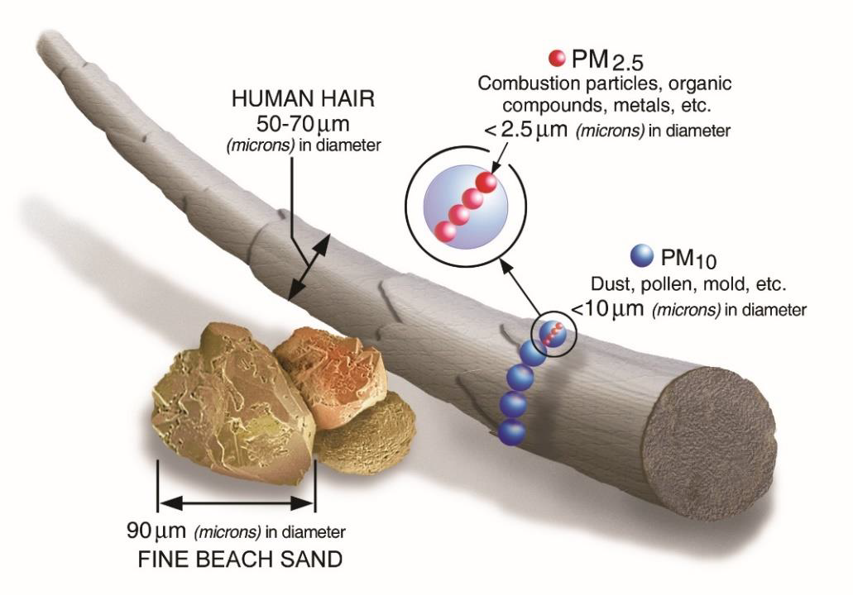

**Figure 1.** Comparisons of PM2.5 and PM10 diameters to human hair and beach sand. Reproduced from Figure 2-1 of the [2020 PM PA](https://www.epa.gov/system/files/documents/2021-10/final-policy-assessment-for-the-review-of-the-pm-naaqs-01-2020.pdf).

     Atmospheric distributions of particle size generally exhibit three distinct modes (“nucleation mode”, “accumulation mode”, and “coarse mode”) that roughly align with the PM size fractions defined above. Figure 2 below shows an example of the particle size distribution for each of these three modes. The nucleation mode is made up of freshly generated particles, formed either during combustion or by atmospheric reactions of precursor gases. The nucleation mode is especially prominent near sources like heavy traffic, industrial emissions, biomass burning, or cooking. While nucleation mode particles are only a minor contributor to overall ambient PM mass and surface area, they are the main contributors to ambient particle number. By number, most nucleation mode particles fall into the UFP size range, though some fraction of the nucleation mode number distribution can extend above 0.1 μm in diameter. Nucleation mode particles can grow rapidly through coagulation or uptake of gases by particle surfaces, giving rise to the accumulation mode. The accumulation mode is typically the predominant contributor to PM2.5 mass and surface area, though only a minor contributor to particle number. PM2.5 sampling methods measure most of the accumulation mode mass, although a small fraction of particles that make up the accumulation mode are greater than 2.5 μm in diameter. Coarse mode particles are formed by mechanical generation, and through processes like dust resuspension and sea spray formation. Most coarse mode mass is captured by PM10-2.5 sampling, but small fractions of coarse mode mass can be smaller than 2.5 μm or greater than 10 μm in diameter.

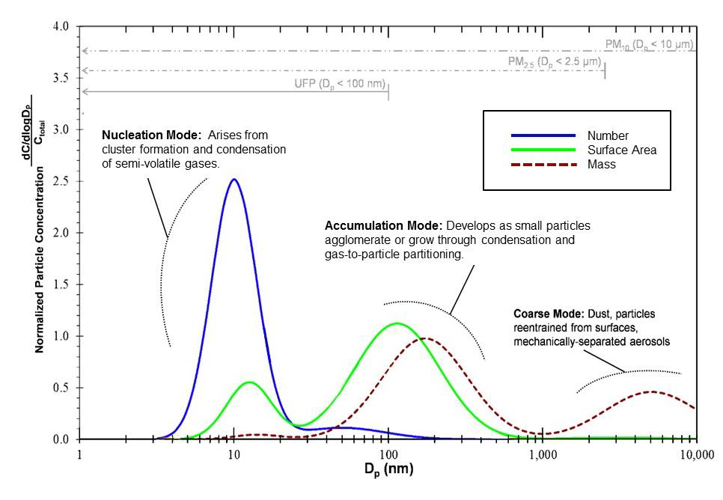

**Figure 2.** Comparison of particle size distribution by particle number, surface area, and mass. Ctotal = total particle concentration; Dp = particle diameter. Reproduced from Figure 2-1 of the [2019 PM ISA](https://cfpub.epa.gov/ncea/isa/recordisplay.cfm?deid=347534).

     Most particles are found in the lower troposphere, where they can have residence times ranging from a few hours to weeks. Particles are removed from the atmosphere by wet deposition, such as when they are carried by rain or snow, or by dry deposition, such as gravitational settling or surface collision. Atmospheric lifetimes are generally longest for PM2.5, which often remains in the atmosphere for days to weeks before being removed by wet or dry deposition. In contrast, atmospheric lifetimes for UFP and PM10-2.5 are shorter. Within hours, UFP can undergo coagulation and condensation that lead to formation of larger particles in the accumulation mode, or can be removed from the atmosphere by evaporation, deposition, or reactions with other atmospheric components. PM10-2.5 are also generally removed from the atmosphere within hours, through wet or dry deposition.

     PM is composed of both primary and secondary components. Primary PM is derived from direct particle emissions from specific sources while secondary PM originates from gas-phase chemical compounds present in the atmosphere that have participated in new particle formation or condensed onto existing particles. Secondary PM, which accounts for a substantial fraction of PM2.5 mass, forms through atmospheric photochemical oxidation reactions of both inorganic and organic gas-phase precursors such as sulfur dioxide (SO2), nitrogen oxides (NOX), and ammonia (NH3). Reactions leading to sulfate (SO42-) production from SO2, nitrate (NO3-) production from NOX, and the gas-to-particle equilibrium between ammonia (NH3) and ammonium (NH4+) are relatively well understood, while formation of secondary organic PM, often referred to as secondary organic aerosols (SOA), is less well resolved.

**3. Sources and Emissions of PM**

     Both primary PM and the gas-phase compounds contributing to secondary PM formation are emitted from both anthropogenic and natural sources. Anthropogenic sources of PM include both stationary and mobile sources. Stationary sources include fuel combustion for electricity production and other purposes, industrial processes, agricultural activities, and road and building construction and demolition. Mobile sources of PM include diesel- and gasoline-powered highway vehicles and other engine-driven sources (e.g., ships, aircraft, and construction and agricultural equipment). Both stationary and mobile sources directly emit primary PM to ambient air, along with secondary PM precursors (e.g., SO2, NOX) that contribute to the secondary formation of PM in the atmosphere.

     Natural sources of PM include dust from the wind erosion of natural surfaces, sea salt, wildfires, primary biological aerosol particles (PBAP) such as bacteria and pollen, oxidation of biogenic hydrocarbons such as isoprene and terpenes to produce SOA, and geogenic sources such as sulfate formed from volcanic emissions of SO2. Natural emissions sources contributing to PM2.5 concentrations can be interconnected with anthropogenic emissions through atmospheric chemistry, such as the modulation of biogenic SOA production by anthropogenic NOX and SO2 emissions.

     Generally, the sources of PM for different size fractions vary. While PM2.5 in ambient air is largely emitted directly by sources such as those described above or through secondary PM formation in the atmosphere, PM10-2.5 is emitted almost entirely from primary sources (i.e., directly emitted) and is produced by surface abrasion or by suspension of sea spray or biological materials such as microorganisms, pollen, and plant and insect debris.

     The major components of PM2.5 mass include sulfate, nitrate, elemental or black carbon (EC or BC), organic carbon (OC), crustal materials, and sea salt. Some of these PM components are emitted directly to the air (e.g., EC/BC) while others are formed secondarily through reactions by gaseous precursors (e.g., sulfate, nitrate). Anthropogenic SO2 and NOX are the predominant precursor gases in the formation of secondary PM2.5 sulfate and nitrate, and ammonia is the gas-phase precursor for PM2.5 ammonium. Atmospheric oxidation of volatile organic compounds (VOCs), both anthropogenic and biogenic, is an important source of SOA, particularly in summer.

     The [National Emissions Inventory (NEI)](https://www.epa.gov/air-emissions-inventories) is a comprehensive and detailed estimate of air emissions of criteria pollutants, precursors to criteria pollutants, and hazardous air pollutants from air emissions sources. The NEI is released every three years based primarily upon data provided by State, Local, and Tribal air agencies for sources in their jurisdictions and supplemented by data developed by the EPA. The NEI is built using the EPA’s Emissions Inventory System (EIS) first to collect the data from State, Local, and Tribal air agencies and then to blend that data with other data sources.

     Accuracy in an emissions inventory reflects the extent to which the inventory represents the actual emissions that occurred. Anthropogenic emissions of air pollutants result from a variety of sources such as power plants, industrial sources, motor vehicles and agriculture. The emissions from any individual source typically vary in both time and space. For the thousands of sources that make up the NEI, there is uncertainty in one or both of these factors. For some sources, such as power plants, direct emission measurements enable the emission factors derived from them to be more certain than sources without such direct measurements. However, it is not practically possible to directly monitor each of the emission sources individually and, therefore, emission inventories necessarily contain assumptions, interpolation and extrapolation from a limited set of sample data.

     Figure 3 shows the main sources contributing to primary PM2.5, primary PM10, SO2, and NOX emissions in the U.S. Fires, which include wildfires, prescribed fires, and agricultural fires, contributed about 44% of primary PM2.5 emissions and 17% of primary PM10 emissions in 2017. Dust particles from roads, agriculture, and construction contributed 30% of primary PM2.5 emissions and 69% of primary PM10 emissions, while most of the remaining primary PM emissions came from stationary fuel combustion (e.g., coal combustion for electricity), industrial and mobile sources. Regarding precursors to secondary PM formation, the main sources of SO2 and NOX are stationary fuel combustion (64% of total SO2 emissions; 22% of total NOX emissions), industrial processes (19% of total SO2 emissions; 10% of total NOX emissions) and mobile sources (8% of total SO2 emissions; 52% of total NOX emissions).

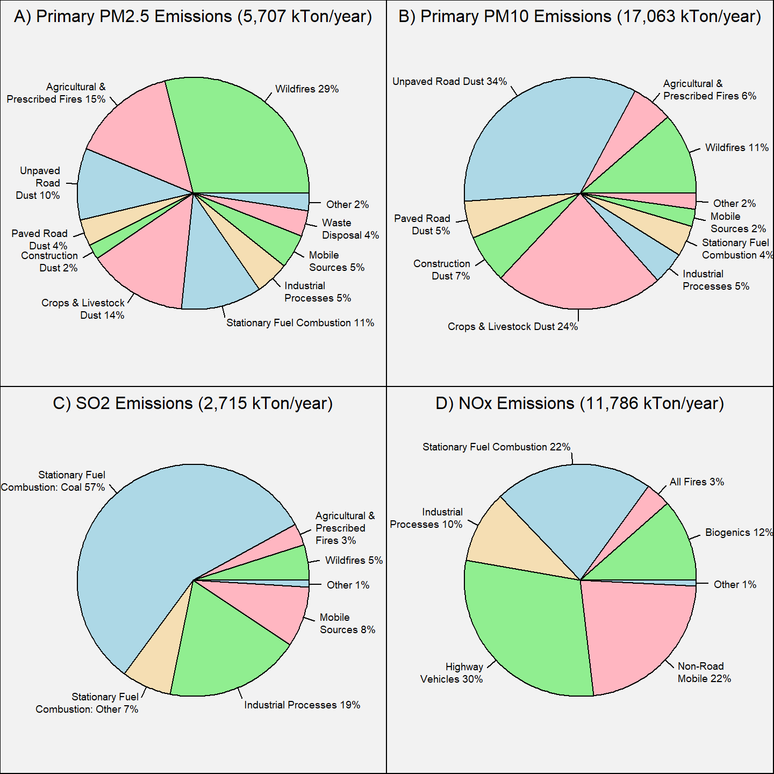 **Figure 3:** U.S. emissions for A) Primary PM2.5; B) Primary PM10; C) SO2; and D) NOX by sector. **Source:** [2017 NEI](https://www.epa.gov/air-emissions-inventories/2017-national-emissions-inventory-nei-data).

     Figure 4 shows the national trends in U.S. anthropogenic primary PM2.5, primary PM10, SO2, and NOX emissions from 2002 to 2021.2 Primary PM2.5 emissions reached a maximum of 5.2 million tons per year in 2007 and have decreased by 24% to 3.9 million tons per year in 2021. Similarly, direct PM10 emissions reached a maximum of 20.7 million tons per year in 2007 and have decreased by 322% to approximately 14.4 million tons per year in 2021. SO2 emissions have decreased by 88% since 2002, while NOX emissions have decreased by 68% since 2002. The large reductions in NOX and SO2 emissions are largely due to reductions in the electricity generation and transportation sectors resulting from EPA programs such as the Clean Air Interstate Rule and the Cross-State Air Pollution Rule for electric generating units, as well as the adoption of more stringent fuel economy standards and low sulfur diesel fuel standards for mobile sources.

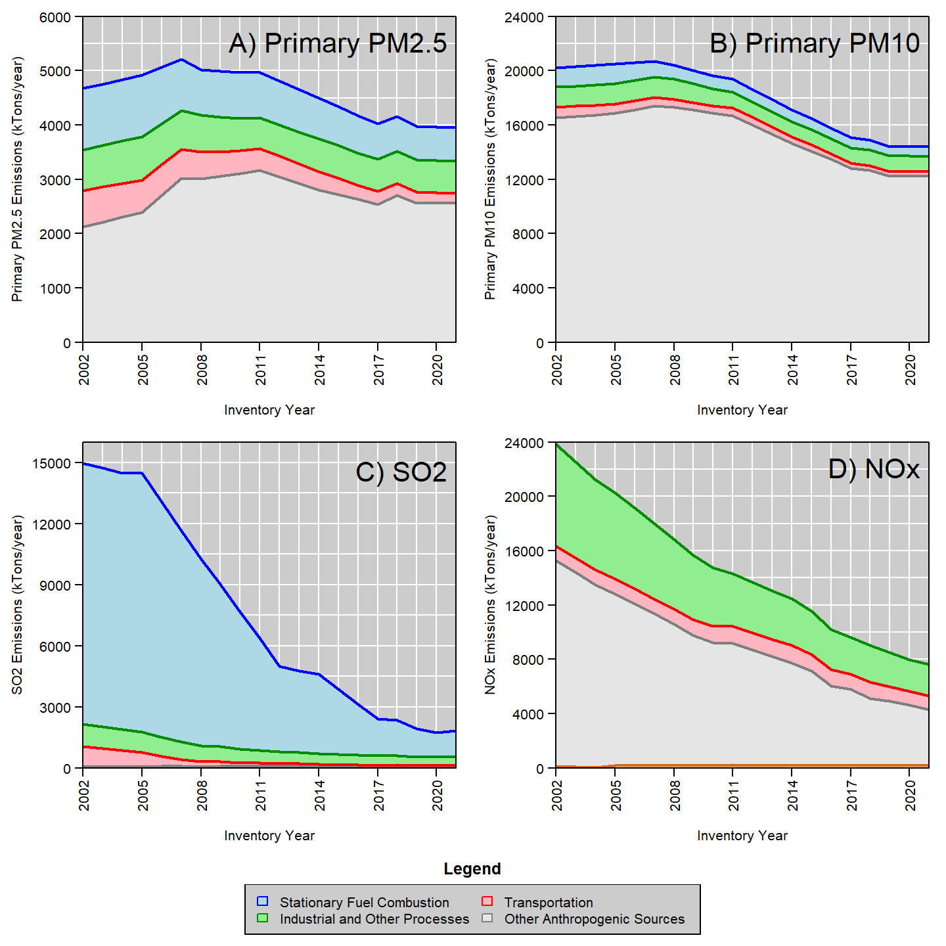 **Figure 4.** U.S. anthropogenic emissions trends for: A) Primary PM2.5; B) Primary PM10; C) SO2; and D) NOX. **Source:** [EPA’s Air Pollutant Emissions Trends Data](https://www.epa.gov/air-emissions-inventories/air-pollutant-emissions-trends-data)

     Figure 5 through Figure 8 show county-level estimates of U.S. emissions densities (in tons/year/mi2) for primary PM2.5, primary PM10, SO2, and NOX emissions, respectively based on the 2017 NEI. Primary PM emissions tended to be highest near urban areas due to the larger number of industrial sources and vehicles, and near the center of the country due to dust from roads and agricultural sources. Parts of the northwest U.S. and California also experienced higher primary PM emissions due to wildfires in 2017. The highest SO2 emissions tend to be located near large point sources such as coal-fired power plants or large industrial facilities, while the highest NOX emissions tend to be located near urban areas and large point sources.

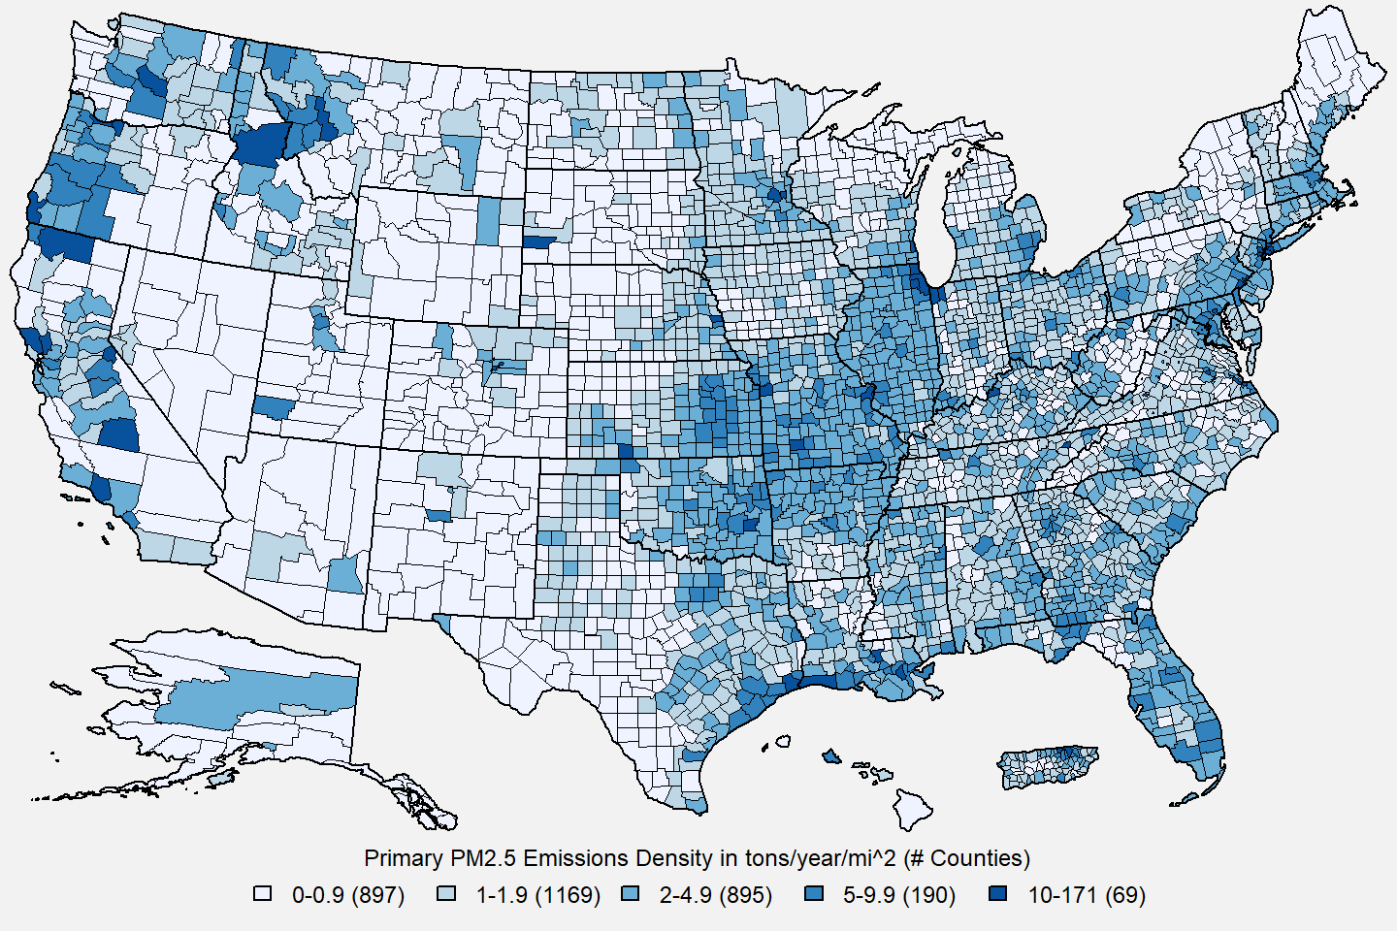

**Figure 5.** U.S. county-level primary PM2.5 emissions density estimates in tons/year/mi2. **Source:** [2017 NEI](https://www.epa.gov/air-emissions-inventories/2017-national-emissions-inventory-nei-data)

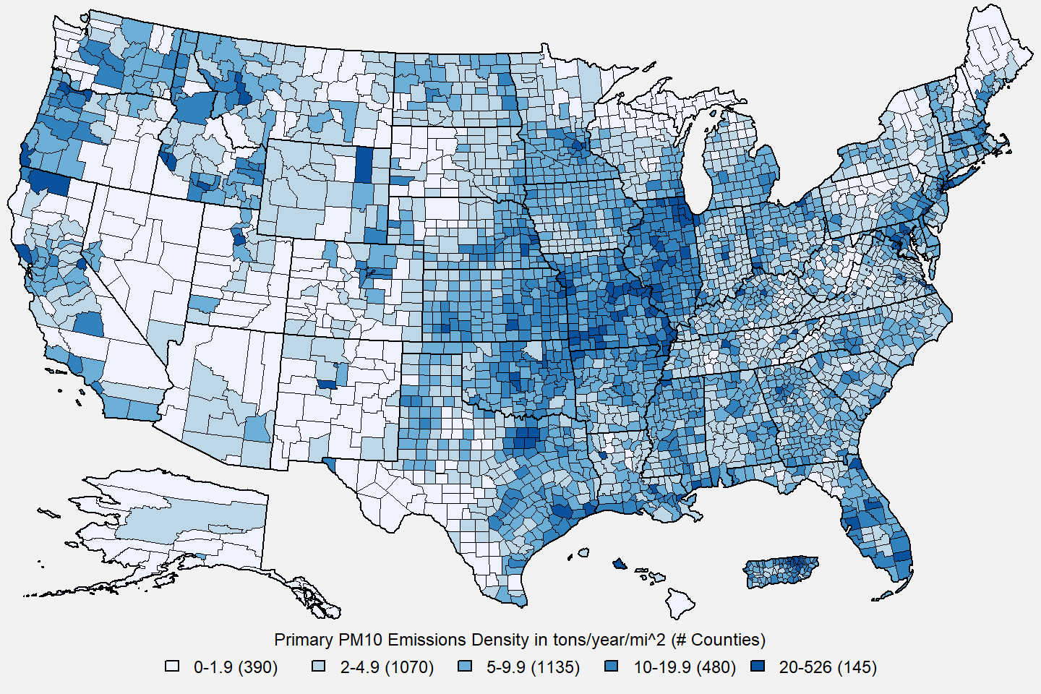

**Figure 6.** U.S. county-level primary PM10 emissions density estimates in tons/year/mi2. **Source:** [2017 NEI](https://www.epa.gov/air-emissions-inventories/2017-national-emissions-inventory-nei-data)

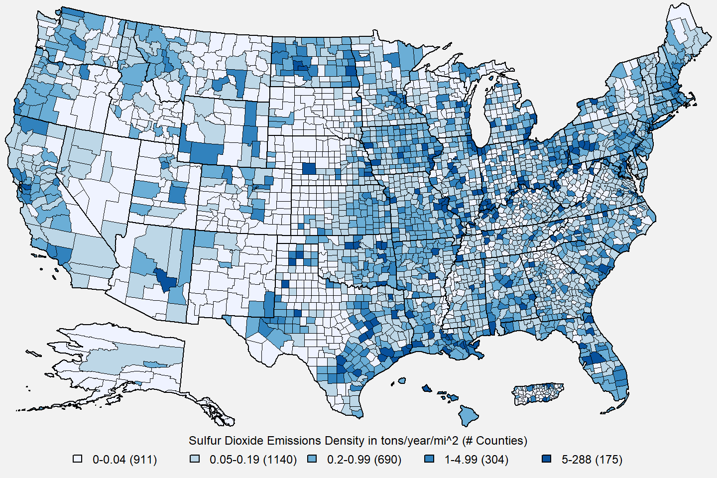

**Figure 7.** U.S. county-level SO2 emissions density estimates in tons/year/mi2. **Source:** [2017 NEI](https://www.epa.gov/air-emissions-inventories/2017-national-emissions-inventory-nei-data)

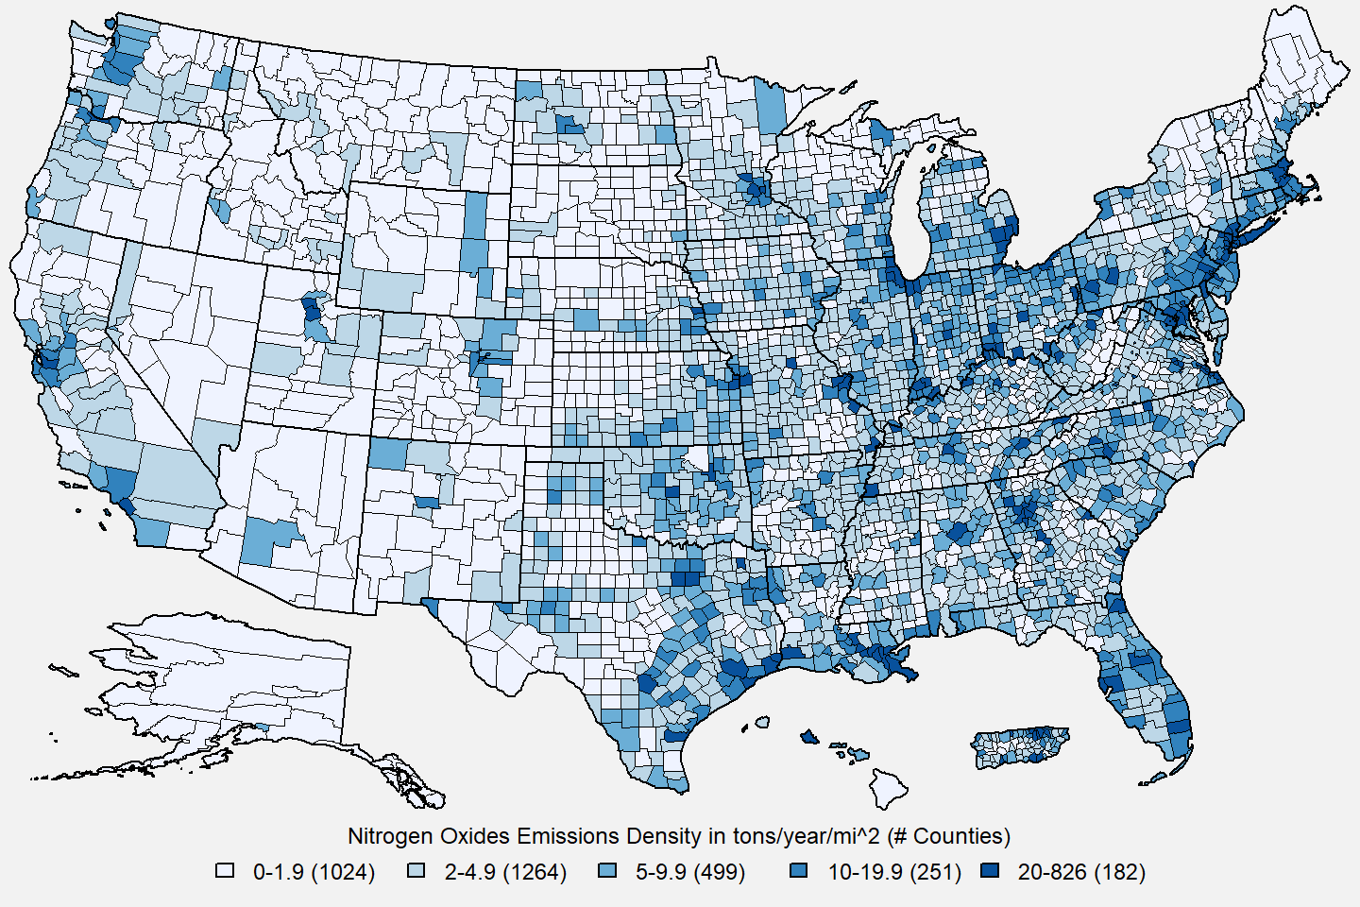

**Figure 8.** U.S. county-level NOx emissions density estimates in tons/year/mi2. **Source:** [2017 NEI](https://www.epa.gov/air-emissions-inventories/2017-national-emissions-inventory-nei-data)

**4. Ambient Air Monitoring Requirements and Monitoring Networks**

     The EPA and its partners at State, Local, and Tribal monitoring agencies manage and operate the nation’s ambient air monitoring networks. The EPA provides minimum monitoring requirements for PM and other pollutants in 40 CFR Part 58. Monitoring agencies carry out and perform ambient air monitoring in accordance with the EPA’s requirements and guidance. Federal Reference Methods (FRMs) and Federal Equivalence Methods (FEMs) are monitoring methods that have been approved for use by States and other monitoring organizations to assess NAAQS compliance and implementation. The FRMs for measuring PM10, PM2.5, and PM10-2.5 are specified in CFR 40 Part 50, Appendices J, L, and O, respectively, while performance requirements for the approval of FRM and FEMs are in 40 CFR Part 53.

     The EPA and monitoring agencies manage and operate robust national monitoring networks for both PM10 and PM2.5, as these are the two measurement programs directly supporting the PM NAAQS. PM10 measurements are based on gravimetric mass, while PM2.5 measurements include gravimetric mass and chemical speciation. A smaller network of stations is operating and reporting data for PM10-2.5 gravimetric mass and a few monitors are operated to support special projects, including pilot studies, for continuous speciation and particle count data.

     The EPA first established NAAQS for PM in 1971 based on total suspended particulates, or TSP. The TSP NAAQS was replaced by the PM10 NAAQS in 1987. TSP sampling remains in operation at a limited number of locations primarily to provide measurements for the Lead (Pb) NAAQS as well as for instances where a State may continue to have State standards for TSP. The size of the TSP network peaked in the mid-1970s when over 4,300 TSP samplers were in operation. There were 133 monitoring sites reporting Pb TSP data to EPA during the 2019-2021 period.

     To support the 1987 PM10 NAAQS, the EPA and its State and Local partners implemented the first size-selective PM monitoring network in 1990 with the establishment of a PM10 network consisting of mainly high-volume samplers. The PM10 monitoring network peaked in size in 1995 with 1,665 stations reporting data. There were 724 monitoring sites reporting PM10 data to EPA during the 2019-2021 period. Figure 9 shows the locations of these monitoring sites. Approximately 61% of these monitoring sites operate FEMs which report continuous PM10 data while the remaining sites operate FRMs which typically collect samples every day, every 3rd day, or every 6th day.3

     To support the 1997 PM NAAQS, the first PM NAAQS with PM2.5 as an indicator, the EPA and States implemented a PM2.5 monitoring network consisting of ambient air monitoring sites with PM2.5 mass and/or chemical speciation measurements. Network operation began in 1999 with nearly 1,000 monitoring stations operating FRMs to measure fine particle mass. The PM2.5 monitoring program remains one of the largest ambient air monitoring programs in the U.S. There were 1,067 monitoring sites reporting PM2.5 data to EPA during the 2019-2021 period. Figure 10 shows the locations of these monitoring sites. Approximately 50% of these monitoring sites operate FEMs which report continuous PM2.5 data while the remaining sites operate FRMs which typically collect samples every day, every 3rd day, or every 6th day.3

      To provide an assessment of data quality, monitoring agencies must perform quality assurance (QA) checks, such as flow checks and leak tests, to ensure the monitors are operating within performance specifications and meeting measurement quality objectives. Estimates of precision and bias for continuous PM monitors are determined through independent audits and collocated sampling against the federal reference method.4Ambient air quality data are reported to the EPA via the [Air Quality System (AQS)](https://www.epa.gov/aqs). Data are reported quarterly and must be submitted to AQS within 90 days after the end of each calendar quarter (i.e. Jan/Feb/Mar, Apr/May/Jun, Jul/Aug/Sep, Oct/Nov/Dec). Additionally, each monitoring agency is required to certify all FRM/FEM data that is submitted to AQS annually, taking into consideration any QA findings, and a data certification letter must be sent to the EPA Regional Administrator by May 1st of the following year.

     The main network of monitors providing ambient data for use in implementation activities related to the NAAQS is the State and Local Air Monitoring Stations (SLAMS) network, which comprises about 87% of PM2.5 and 75% of PM10 monitoring sites. Two important subsets of SLAMS sites are the [National Core (NCore) multipollutant monitoring network](https://www.epa.gov/amtic/ncore-monitoring-network) and the [near-road monitoring network](https://www.epa.gov/amtic/near-road-monitoring). The NCore network was designed to collect consistent measurements of criteria pollutants for trends and NAAQS compliance purposes. NCore was fully operational as of 2011 and consists of approximately 60 urban monitoring stations and 20 rural monitoring stations. Each State is required to have at least one NCore station. PM2.5 monitoring was required for near-road network sites as part of the 2012 PM NAAQS review and these sites monitors were phased into the network between 2015 and 2017. Near-road sites are required in each metropolitan statistical area (MSA) with a population of 1,000,000 or greater.

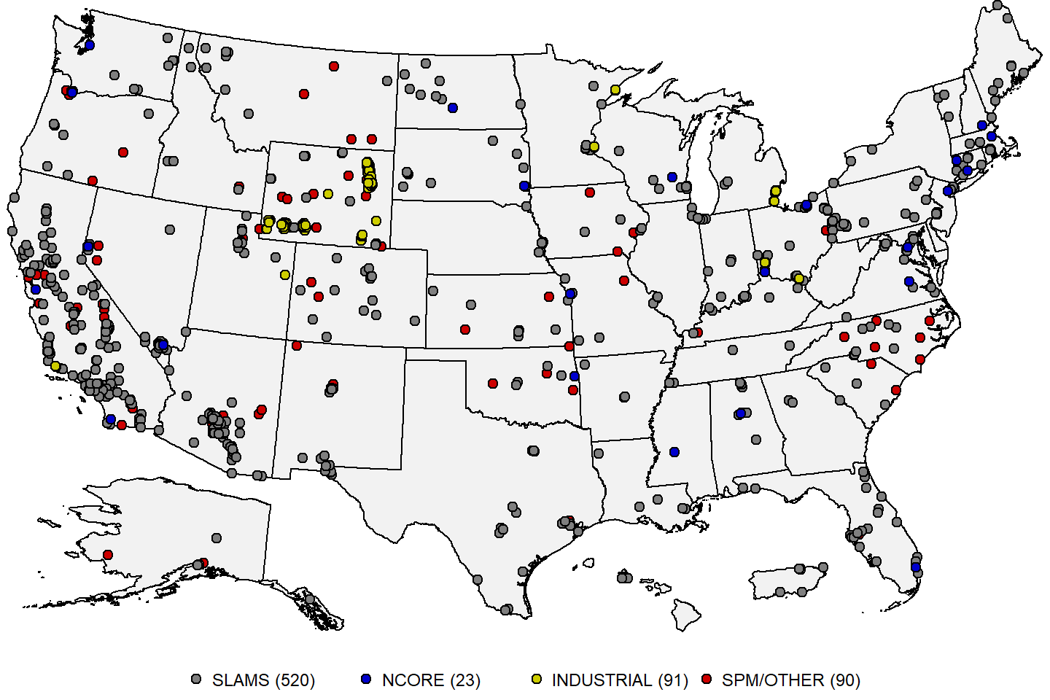

**Figure 9:** Map of U.S. PM10 monitoring sites reporting data to the EPA during the 2019-2021 period. **Source:** [AQS](https://www.epa.gov/aqs).

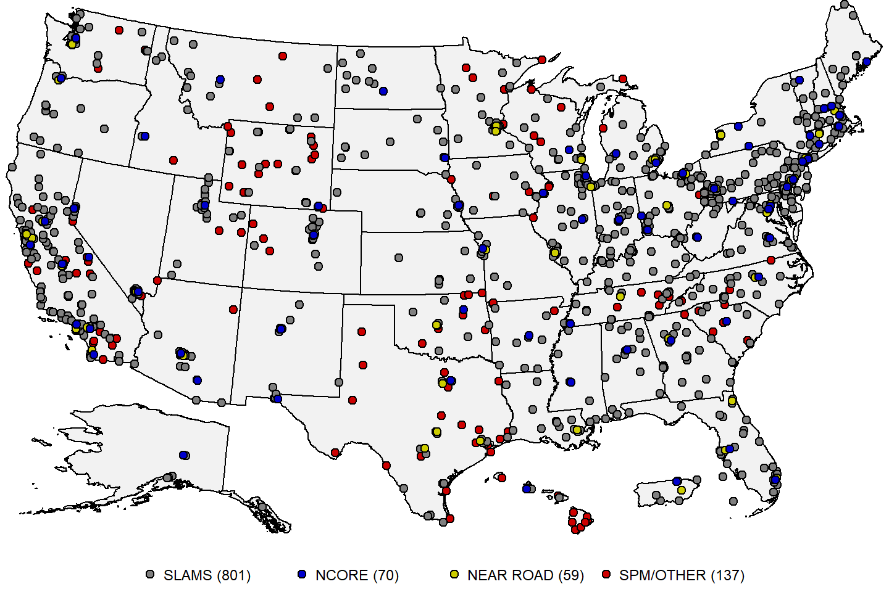

**Figure 10:** Map of U.S. PM2.5 monitoring sites reporting data to the EPA during the 2019-2021 period. **Source:** [AQS](https://www.epa.gov/aqs).

     Due to the complex nature of fine particles, the EPA and States implemented the [Chemical Speciation Network (CSN)](https://www.epa.gov/amtic/chemical-speciation-network-csn) to better understand the components of fine particle mass at selected locations across the country. The CSN was first piloted at 13 sites in 2000, and after the pilot phase, the program continued with deployment of the Speciation Trends Network (STN) later that year. The CSN ultimately grew to 54 trends sites and peaked in operation in 2005 with 252 stations: the 54 trends stations and nearly 200 supplemental stations. The locations of the CSN sites reporting data to the EPA during the 2019-2021 period are shown in Figure 11. Additionally, PM2.5 speciation measurements are collected at NCore stations, which are also shown in Figure 11.

     Specific components of fine particles are also measured through the [Interagency Monitoring of Protected Visual Environments (IMPROVE)](http://vista.cira.colostate.edu/Improve/) monitoring program, which supports the regional haze program and tracks changes in visibility in Federal Class I areas as well as many other rural and some urban areas. CSN and IMPROVE data can also be used to better understand visibility through calculation of light extinction using the IMPROVE algorithm5 to support reviews of the secondary PM NAAQS. The locations of the IMPROVE sites reporting data to the EPA during the 2019-2021 period are shown in Figure 11.

     As a result of the 2006 PM NAAQS review, the EPA promulgated a new FRM for the measurement of PM10-2.5 mass in ambient air. Although the standard for coarse particles uses a PM10 indicator, a new FRM for PM10-2.5 mass was developed to provide a basis for approving FEMs and to promote the gathering of scientific data to support future reviews of the PM NAAQS. PM10-2.5 measurements are currently reported at NCore stations, IMPROVE monitoring stations, and at a few additional locations where State or Local agencies choose to operate a PM10-2.5 monitoring method. There were 287 monitoring sites reporting PM10-2.5 data to EPA during the 2019-2021 period. Figure 12 shows the locations of these monitoring sites. Additionally, some sites that operate both PM10 and PM2.5 monitors also report PM10-2.5 concentrations by taking the difference of the two measurements.

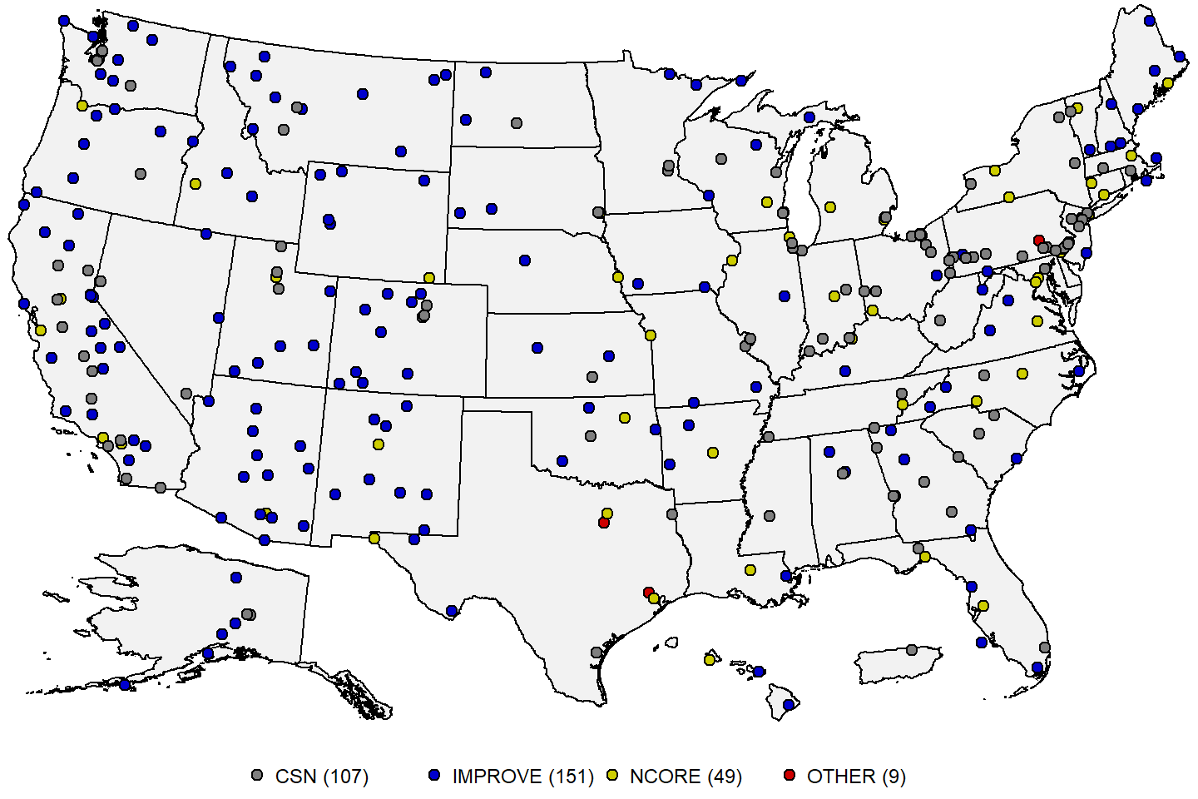

**Figure 11:** Map of U.S. PM2.5 speciation monitoring sites reporting data to the EPA during the 2019-2021 period. **Source:** [AQS](https://www.epa.gov/aqs).

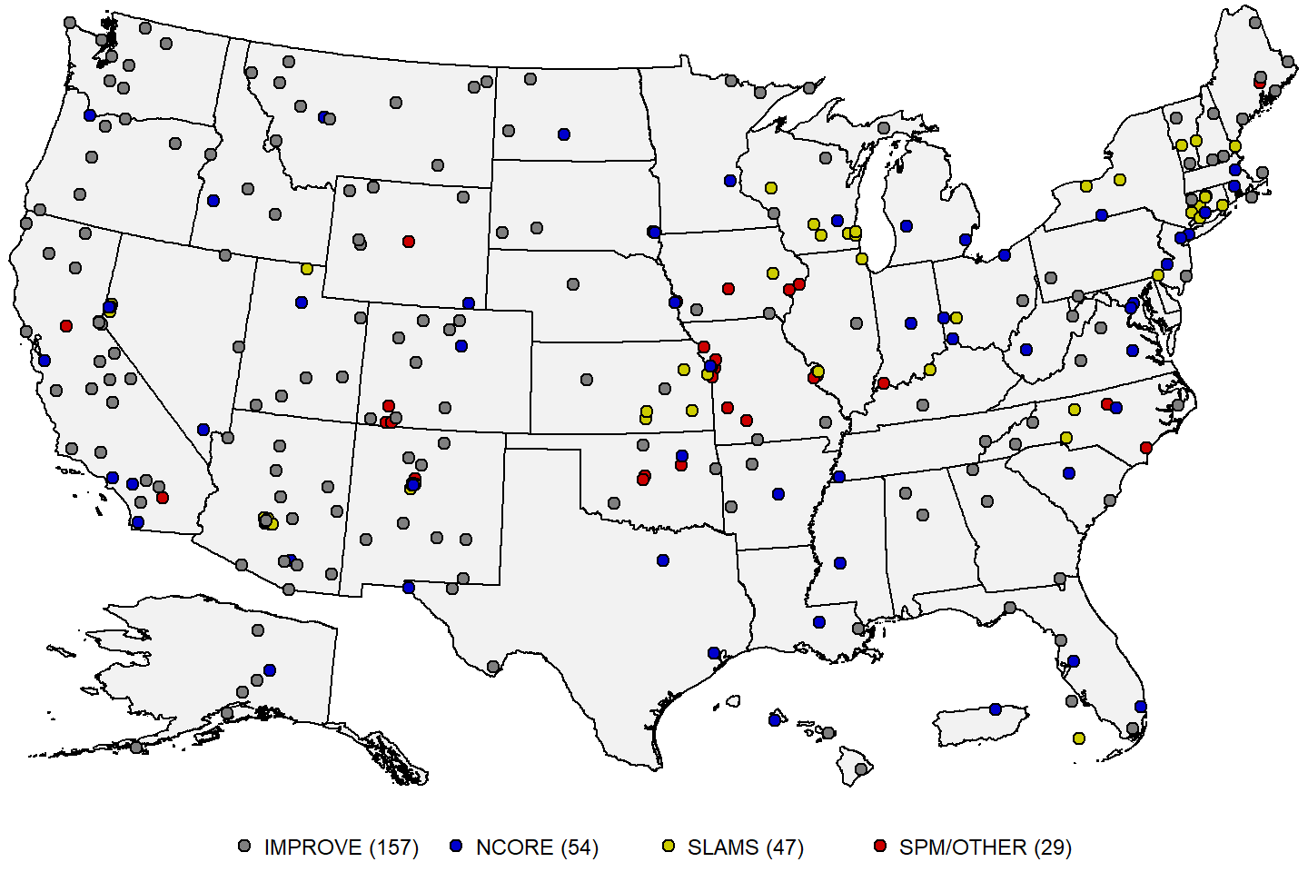

**Figure 12:** Map of U.S. PM10-2.5 monitoring sites reporting data to the EPA during the 2019-2021 period. **Source:** [AQS](https://www.epa.gov/aqs).

**5. Data Handling Conventions and Computations for Determining Whether the Standards are Met**

     To assess whether a monitoring site or geographic area (usually a county or urban area) meets or exceeds a NAAQS, the monitoring data are analyzed consistent with the established regulatory requirements for the handling of monitoring data for the purposes of deriving a design value. A design value summarizes ambient air concentrations for an area in terms of the indicator, averaging time and form for a given standard such that its comparison to the level of the standard indicates whether the area meets or exceeds the standard. The procedures for calculating design values for the current PM NAAQS (established in 2012) are detailed in [Appendix K to 40 CFR Part 50](https://www.ecfr.gov/current/title-40/part-50/appendix-Appendix%20K%20to%20Part%2050) for PM10 and in [Appendix N to 40 CFR Part 50](https://www.ecfr.gov/current/title-40/part-50/appendix-Appendix%20N%20to%20Part%2050) for PM2.5.

     Daily 24-hour PM10 samples collected at an ambient air monitoring site using FRMs or FEMs, meeting all applicable requirements in 40 CFR Part 58, and reported to AQS in micrograms per meter cubed (μg/m3) with decimal digits truncated (i.e., removed) are used in design value calculations. Monitored 24-hour PM10 concentrations flagged by the States as having been affected by an exceptional event, having been the subject of a demonstration submitted by the State, and having received concurrence from the appropriate EPA Regional Office, are excluded from design value calculations consistent with [40 CFR 50.14](https://www.ecfr.gov/current/title-40/section-50.14).6 If there are multiple monitors at a site, a separate design value is calculated for each monitor. First, the number of exceedances of the NAAQS is determined for each calendar quarter over a 3-year period. The level of the PM10 NAAQS is 150 μg/m3, but monitored concentrations are rounded to the nearest 10 μg/m3 when compared to the NAAQS, so an exceedance occurs when measured concentrations are 155 μg/m3 or greater.

     To correct for missing data, the observed number of exceedances in each calendar quarter is adjusted by dividing it by the data completeness rate during that quarter and rounded to the nearest hundredth, which is the expected number of exceedances for that quarter. This adjustment is performed regardless of sampling schedule, for example, a monitoring site that has an every 3rd day sampling schedule will have a minimum of 3 expected exceedances for each observed exceedance even if the data completeness rate is 100%. The annual number of expected exceedances is the sum of the expected exceedances over the four calendar quarters, and the design value is the average of the annual expected exceedances over three consecutive years, rounded to the nearest tenth. The PM10 NAAQS is met when the design value is less or equal to 1.0.

     A PM10 design value meeting the NAAQS must meet minimum data completeness requirements in order to be considered valid. Specifically, a monitor must have reported concentrations for a minimum of 75% of the scheduled sampled days in each calendar quarter of the 3-year period in order to be considered valid. A PM10 design value greater than the NAAQS is always considered valid. Appendix K to 40 CFR Part 50 has additional language describing situations where a valid design value may be derived for a monitor which does not meet these minimum data completeness criteria.

     Daily 24-hour PM2.5 samples collected at an ambient air monitoring site using FRMs or FEMs, meeting all applicable requirements in 40 CFR Part 58, and reported to AQS in μg/m3 with decimal digits after the first decimal place truncated are used in design value calculations. Monitored 24-hour PM2.5 concentrations flagged by the States as having been affected by an exceptional event, having been the subject of a demonstration submitted by the State, and having received concurrence from the appropriate EPA Regional Office, are excluded from design value calculations consistent with [40 CFR 50.14](https://www.ecfr.gov/current/title-40/section-50.14).5 If hourly samples are reported from a continuous PM2.5 monitor, 24-hour average concentrations will be calculated from the hourly data. A calculated 24-hour average concentration is considered valid if hourly concentrations are available for at least 18 of the 24 hours in a given calendar day, or, if after substituting zero for the missing hourly concentrations, the resulting average is greater than the level of the 24-hour PM2.5 NAAQS. If multiple monitors are operating at a site, one monitor is designated as the primary monitor. Daily values from collocated monitors are substituted on days where data is missing for the primary monitor to create a site-level data record.

     For the annual PM2.5 NAAQS, the 24-hour concentrations from the site-level data record are averaged over each calendar quarter for a consecutive 3-year period. The four quarterly averages are then averaged over each year to calculate an annual average, and finally the annual PM2.5 design value is the average of the three annual average values, rounded to the nearest tenth. The annual PM2.5 NAAQS are met when the design value is less than or equal to 12.0 μg/m3. Annual PM2.5 design values must have a minimum of 75% data completeness in each calendar quarter (according to the sampling schedule for the site) in order to be considered valid. In addition, for sites which fail to meet the 75% quarterly minimum data completeness, there are two data substitution tests in Appendix N to 40 CFR Part 50 by which an annual design value above or below the NAAQS, respectively, may be considered valid.

     For the 24-hour PM2.5 NAAQS, the 98th percentile of the 24-hour concentrations from the site-level data record is calculated for each of the three years. The 24-hour PM2.5 design value is the average of the three 98th percentile values, rounded to the nearest integer. The 24-hour PM2.5 NAAQS are met when the design value is less than or equal to 35 μg/m3. Similar to the annual PM2.5 design values, 24-hour PM2.5 design values must have a minimum of 75% data completeness in each calendar quarter to be considered valid. In addition, a site with a design value meeting the NAAQS may also be considered valid if it is able to pass the 24-hour PM2.5 NAAQS data substitution test in Appendix N to 40 CFR Part 50.

**6. PM Concentrations Measured at Ambient Air Monitoring Sites Across the U.S.**

Table 1 below presents summary statistics based on daily PM10, PM2.5, and PM10-2.5 monitoring data reported to AQS for 2019 to 2021 for the full year and for each calendar quarter. There are two daily metrics for PM10 and PM2.5: the daily 24-hour average (DA24) metric, which is available for both filter-based and continuous monitoring instruments, and the maximum daily 1-hour average (MDA1) metric, which is available only for continuous monitoring instruments. For PM10-2.5, most of the measurements are filter-based, thus only the DA24 metric is shown. Table 2 presents summary statistics for the same daily metrics based on 2019-2021 PM10, PM2.5, and PM10-2.5 monitoring data for each [NOAA Climate Region](https://www.ncei.noaa.gov/monitoring-references/maps/us-climate-regions).7 Finally, Table 3 presents summary statistics for the DA24 metric based on 2019-2021 PM10 and PM2.5 monitoring data by type of site, including urban (CSN) versus rural (IMPROVE) sites located in the eastern U.S. versus western U.S., as well as near-road sites for PM2.5.8

     Table 1 shows that PM concentrations are typically highest in the 3rd quarter (July-September), which coincides with the period of highest wildfire frequency in the western U.S. PM2.5 concentrations tend to be lowest in the 2nd quarter (April-June), while PM10 and PM10-2.5 concentrations tend to be lowest in the 1st quarter (January-March). MDA1 concentrations are typically 2-3 times higher than DA24 concentrations. Table 2 shows that PM10 concentrations are generally highest in the Southwest and West regions. The Northwest and West North Central regions have the lowest median PM10 concentrations, while the two easternmost regions (Northeast and Southeast) have the lowest peak PM10 concentrations. For PM2.5 the median concentrations are comparable across the nine climate regions, while there is greater disparity in the peak concentrations, with the western regions generally having higher peak PM2.5 concentrations than the eastern regions. Table 3 shows that there is a much sharper gradient between urban and rural PM concentrations in the western U.S. than in the eastern U.S. Though median PM concentrations are lower in rural parts of the west than in the east, peak concentrations are higher in the western U.S., most likely because of widespread wildfire activity in the western U.S. in 2020 and 2021. Near-road sites had slightly higher median PM2.5 concentrations than urban sites located away from roads.

**Table 1.** National distribution of PM concentrations in μg/m3 by quarter based on monitoring data from 2019 to 2021.9 **Source:** [AQS](https://www.epa.gov/aqs).

|  |  |  |  |  |  |  |  |  |  |  |  |  |  |  |  |  |  |  |  |
| --- | --- | --- | --- | --- | --- | --- | --- | --- | --- | --- | --- | --- | --- | --- | --- | --- | --- | --- | --- |
| pollutant | metric | quarter | N.sites | N.obs | mean | SD | min | p1 | p5 | p10 | p25 | p50 | p75 | p90 | p95 | p98 | p99 | max | max.site |
| PM10 | DA24 | all | 902 | 580,284 | 20.0 | 25.0 | -41.0 | 1.0 | 3.0 | 5.0 | 9.0 | 15.0 | 25.0 | 39.0 | 52.0 | 72.0 | 93.0 | 6,287.0 | 261390005 |
| PM10 | DA24 | 1st quarter | 881 | 144,177 | 15.0 | 27.0 | -5.0 | 1.0 | 2.0 | 4.0 | 7.0 | 12.0 | 19.0 | 30.0 | 39.0 | 53.0 | 65.0 | 6,287.0 | 261390005 |
| PM10 | DA24 | 2nd quarter | 877 | 143,483 | 19.0 | 23.0 | -41.0 | 1.0 | 4.0 | 6.0 | 10.0 | 15.0 | 24.0 | 36.0 | 46.0 | 60.0 | 75.0 | 3,956.0 | 060510011 |
| PM10 | DA24 | 3rd quarter | 872 | 146,323 | 26.0 | 27.0 | -1.0 | 3.0 | 6.0 | 8.0 | 13.0 | 19.0 | 31.0 | 47.0 | 62.0 | 88.0 | 114.0 | 2,310.0 | 060510011 |
| PM10 | DA24 | 4th quarter | 876 | 146,301 | 20.0 | 23.0 | -8.0 | 1.0 | 3.0 | 4.0 | 8.0 | 14.0 | 25.0 | 42.0 | 57.0 | 82.0 | 106.0 | 1,343.0 | 060510011 |
| PM10 | MDA1 | all | 490 | 443,386 | 57.0 | 154.0 | -7.0 | 6.0 | 10.0 | 14.0 | 21.0 | 34.0 | 60.0 | 107.0 | 160.0 | 268.0 | 397.0 | 35,585.0 | 060510011 |
| PM10 | MDA1 | 1st quarter | 470 | 110,094 | 45.0 | 156.0 | -4.0 | 5.0 | 8.0 | 11.0 | 17.0 | 28.0 | 48.0 | 82.0 | 119.0 | 197.0 | 282.0 | 26,803.0 | 060510011 |
| PM10 | MDA1 | 2nd quarter | 473 | 109,948 | 56.0 | 176.0 | 0.0 | 7.0 | 11.0 | 15.0 | 21.0 | 34.0 | 58.0 | 101.0 | 149.0 | 256.0 | 384.0 | 35,585.0 | 060510011 |
| PM10 | MDA1 | 3rd quarter | 471 | 111,558 | 68.0 | 162.0 | 0.0 | 10.0 | 15.0 | 18.0 | 26.0 | 40.0 | 70.0 | 127.0 | 191.0 | 326.0 | 483.0 | 28,161.0 | 040213014 |
| PM10 | MDA1 | 4th quarter | 475 | 111,786 | 60.0 | 117.0 | -7.0 | 6.0 | 9.0 | 13.0 | 20.0 | 34.0 | 64.0 | 117.0 | 174.0 | 285.0 | 423.0 | 11,508.0 | 060510011 |
| PM2.5 | DA24 | all | 1,397 | 1,097,980 | 8.0 | 10.0 | -69.3 | 0.5 | 1.7 | 2.5 | 4.2 | 6.5 | 9.6 | 13.8 | 17.6 | 24.2 | 32.1 | 824.1 | 060510005 |
| PM2.5 | DA24 | 1st quarter | 1,367 | 270,247 | 7.4 | 5.2 | -69.3 | 0.3 | 1.4 | 2.3 | 4.0 | 6.3 | 9.4 | 13.5 | 16.8 | 21.5 | 25.4 | 222.4 | 040130019 |
| PM2.5 | DA24 | 2nd quarter | 1,369 | 272,850 | 6.5 | 4.2 | -10.3 | 0.5 | 1.6 | 2.3 | 3.7 | 5.7 | 8.4 | 11.5 | 13.8 | 17.1 | 20.0 | 134.2 | 350130022 |
| PM2.5 | DA24 | 3rd quarter | 1,356 | 278,192 | 10.1 | 17.2 | -11.7 | 0.9 | 2.3 | 3.2 | 4.9 | 7.3 | 10.8 | 15.9 | 21.9 | 38.4 | 61.5 | 824.1 | 060510005 |
| PM2.5 | DA24 | 4th quarter | 1,359 | 276,691 | 8.0 | 6.6 | -4.0 | 0.4 | 1.6 | 2.4 | 4.2 | 6.6 | 10.0 | 14.7 | 18.5 | 24.5 | 30.1 | 487.4 | 060510001 |
| PM2.5 | MDA1 | all | 1,064 | 995,053 | 16.6 | 21.3 | -6.4 | 2.9 | 4.8 | 6.0 | 8.6 | 12.8 | 18.9 | 28.0 | 37.0 | 56.0 | 79.3 | 1,467.2 | 060510001 |
| PM2.5 | MDA1 | 1st quarter | 1,024 | 243,985 | 16.0 | 13.5 | -3.0 | 2.7 | 4.9 | 6.0 | 9.0 | 13.0 | 19.3 | 28.0 | 35.5 | 48.0 | 60.5 | 822.0 | 480290676 |
| PM2.5 | MDA1 | 2nd quarter | 1,036 | 247,532 | 13.4 | 11.9 | -5.0 | 2.6 | 4.1 | 5.3 | 7.7 | 11.0 | 16.0 | 22.7 | 28.4 | 39.0 | 51.0 | 896.0 | 230030014 |
| PM2.5 | MDA1 | 3rd quarter | 1,031 | 252,414 | 19.7 | 34.4 | -5.0 | 3.2 | 5.0 | 6.3 | 9.0 | 13.1 | 19.5 | 30.6 | 47.4 | 93.0 | 150.0 | 1,467.2 | 060510001 |
| PM2.5 | MDA1 | 4th quarter | 1,040 | 251,122 | 17.1 | 16.6 | -6.4 | 3.0 | 5.0 | 6.0 | 9.0 | 13.6 | 20.3 | 30.5 | 40.0 | 55.0 | 70.3 | 1,464.4 | 060510001 |
| PM10-2.5 | DA24 | all | 202 | 62,767 | 5.2 | 6.2 | -12.9 | 0.0 | 0.2 | 0.5 | 1.4 | 3.3 | 6.7 | 11.9 | 16.4 | 22.8 | 28.7 | 162.0 | 060190011 |
| PM10-2.5 | DA24 | 1st quarter | 202 | 15,300 | 3.4 | 4.8 | -3.0 | -0.1 | 0.1 | 0.2 | 0.7 | 1.8 | 4.2 | 8.4 | 12.3 | 17.8 | 22.5 | 108.1 | 230190002 |
| PM10-2.5 | DA24 | 2nd quarter | 202 | 15,508 | 5.6 | 5.6 | -2.6 | 0.1 | 0.5 | 0.9 | 2.0 | 4.1 | 7.4 | 12.2 | 16.2 | 21.2 | 25.5 | 96.0 | 530390003 |
| PM10-2.5 | DA24 | 3rd quarter | 199 | 16,150 | 6.7 | 6.6 | -12.9 | 0.3 | 1.0 | 1.6 | 2.7 | 4.9 | 8.5 | 14.2 | 18.4 | 24.7 | 30.9 | 162.0 | 060190011 |
| PM10-2.5 | DA24 | 4th quarter | 197 | 15,809 | 4.8 | 7.0 | -5.7 | 0.0 | 0.1 | 0.3 | 0.9 | 2.5 | 5.9 | 11.7 | 17.7 | 26.1 | 32.7 | 106.9 | 060190011 |

N.sites = number of sites; N.obs = number of observations; SD = standard deviation; min = minimum; p1, p5, p10, p25, p50, p90, p95, p98, p99 = 1st, 5th, 10th, 25th, 50th, 90th, 95th, 98th, 99th percentiles; max = maximum; max.site = AQS ID number for the monitoring site corresponding to the observation in the max column. 1st quarter = January/February/March; 2nd quarter = April/May/June; 3rd quarter = July/August/September; 4th quarter = October/November/December.

**Table 2.** National distribution of PM concentrations in μg/m3 by climate region based on monitoring data from 2019 to 2021.9 **Source:** [AQS](https://www.epa.gov/aqs).

|  |  |  |  |  |  |  |  |  |  |  |  |  |  |  |  |  |  |  |  |
| --- | --- | --- | --- | --- | --- | --- | --- | --- | --- | --- | --- | --- | --- | --- | --- | --- | --- | --- | --- |
| **pollutant** | **metric** | **region** | **N.sites** | **N.obs** | **mean** | **SD** | **min** | **p1** | **p5** | **p10** | **p25** | **p50** | **p75** | **p90** | **p95** | **p98** | **p99** | **max** | **max.site** |
| PM10 | DA24 | all | 725 | 488,628 | 21.0 | 25.0 | -48.0 | 2.0 | 4.0 | 6.0 | 10.0 | 16.0 | 26.0 | 41.0 | 54.0 | 75.0 | 97.0 | 3,956.0 | 060510011 |
| PM10 | DA24 | Central | 66 | 33,203 | 20.0 | 13.0 | 0.0 | 3.0 | 6.0 | 7.0 | 11.0 | 16.0 | 24.0 | 35.0 | 44.0 | 58.0 | 68.0 | 205.0 | 295100093 |
| PM10 | DA24 | East North Central | 41 | 22,683 | 19.0 | 13.0 | 0.0 | 3.0 | 6.0 | 8.0 | 11.0 | 16.0 | 24.0 | 34.0 | 43.0 | 56.0 | 68.0 | 169.0 | 191630017 |
| PM10 | DA24 | Northeast | 57 | 30,335 | 14.0 | 9.0 | 0.0 | 2.0 | 4.0 | 6.0 | 8.0 | 12.0 | 18.0 | 24.0 | 30.0 | 38.0 | 45.0 | 161.0 | 230031011 |
| PM10 | DA24 | Northwest | 35 | 22,647 | 18.0 | 27.0 | -1.0 | 1.0 | 3.0 | 4.0 | 8.0 | 13.0 | 21.0 | 34.0 | 46.0 | 68.0 | 94.0 | 1,012.0 | 530050002 |
| PM10 | DA24 | South | 51 | 23,779 | 20.0 | 15.0 | 0.0 | 3.0 | 6.0 | 8.0 | 12.0 | 17.0 | 24.0 | 35.0 | 44.0 | 57.0 | 71.0 | 440.0 | 201950001 |
| PM10 | DA24 | Southeast | 75 | 49,264 | 17.0 | 9.0 | 0.0 | 3.0 | 6.0 | 8.0 | 11.0 | 15.0 | 20.0 | 26.0 | 32.0 | 42.0 | 51.0 | 453.0 | 720330004 |
| PM10 | DA24 | Southwest | 97 | 85,641 | 28.0 | 26.0 | -2.0 | 3.0 | 5.0 | 8.0 | 13.0 | 22.0 | 35.0 | 51.0 | 65.0 | 88.0 | 110.0 | 1,228.0 | 040213014 |
| PM10 | DA24 | West | 167 | 120,598 | 26.0 | 38.0 | -48.0 | 2.0 | 4.0 | 6.0 | 11.0 | 19.0 | 32.0 | 50.0 | 68.0 | 102.0 | 133.0 | 3,956.0 | 060510011 |
| PM10 | DA24 | West North Central | 136 | 100,478 | 16.0 | 17.0 | -3.0 | 1.0 | 3.0 | 4.0 | 6.0 | 11.0 | 20.0 | 33.0 | 45.0 | 62.0 | 76.0 | 1,354.0 | 560370013 |
| PM10 | MDA1 | all | 440 | 396,413 | 59.0 | 161.0 | -6.0 | 6.0 | 10.0 | 14.0 | 21.0 | 34.0 | 61.0 | 111.0 | 166.0 | 280.0 | 417.0 | 35,585.0 | 060510011 |
| PM10 | MDA1 | Central | 30 | 27,088 | 47.0 | 60.0 | 2.0 | 8.0 | 12.0 | 15.0 | 21.0 | 31.0 | 51.0 | 87.0 | 124.0 | 196.0 | 272.0 | 2,000.0 | 390170020 |
| PM10 | MDA1 | East North Central | 24 | 18,655 | 44.0 | 49.0 | 2.0 | 8.0 | 12.0 | 14.0 | 20.0 | 30.0 | 49.0 | 84.0 | 119.0 | 181.0 | 234.0 | 985.0 | 270531909 |
| PM10 | MDA1 | Northeast | 27 | 25,438 | 31.0 | 30.0 | 1.0 | 6.0 | 10.0 | 12.0 | 16.0 | 24.0 | 36.0 | 57.0 | 79.0 | 108.0 | 139.0 | 1,278.0 | 090092123 |
| PM10 | MDA1 | Northwest | 26 | 21,924 | 50.0 | 82.0 | 0.0 | 5.0 | 8.0 | 11.0 | 18.0 | 31.0 | 53.0 | 95.0 | 139.0 | 244.0 | 365.0 | 4,366.0 | 530050002 |
| PM10 | MDA1 | South | 24 | 19,706 | 42.0 | 66.0 | 1.0 | 8.0 | 12.0 | 15.0 | 22.0 | 31.0 | 47.0 | 72.0 | 98.0 | 154.0 | 217.0 | 4,205.0 | 201950001 |
| PM10 | MDA1 | Southeast | 56 | 46,479 | 34.0 | 28.0 | -6.0 | 9.0 | 13.0 | 15.0 | 20.0 | 27.0 | 38.0 | 57.0 | 76.0 | 108.0 | 137.0 | 1,140.0 | 120952002 |
| PM10 | MDA1 | Southwest | 70 | 72,099 | 94.0 | 198.0 | 0.0 | 8.0 | 14.0 | 19.0 | 32.0 | 55.0 | 97.0 | 173.0 | 271.0 | 495.0 | 766.0 | 28,161.0 | 040213014 |
| PM10 | MDA1 | West | 125 | 114,882 | 70.0 | 240.0 | -1.0 | 7.0 | 11.0 | 15.0 | 24.0 | 41.0 | 72.0 | 127.0 | 191.0 | 314.0 | 475.0 | 35,585.0 | 060510011 |
| PM10 | MDA1 | West North Central | 58 | 50,142 | 44.0 | 65.0 | 0.0 | 4.0 | 6.0 | 8.0 | 14.0 | 26.0 | 49.0 | 93.0 | 141.0 | 229.0 | 313.0 | 1,719.0 | 560010800 |
| PM2.5 | DA24 | all | 1,067 | 801,756 | 8.1 | 8.1 | -6.7 | 0.5 | 2.0 | 2.8 | 4.5 | 6.7 | 9.9 | 14.1 | 17.8 | 24.1 | 31.0 | 824.1 | 060510005 |
| PM2.5 | DA24 | Central | 164 | 110,189 | 8.9 | 4.7 | -4.9 | 1.9 | 3.3 | 4.1 | 5.7 | 8.0 | 11.1 | 14.8 | 17.7 | 21.6 | 24.8 | 89.5 | 180890022 |
| PM2.5 | DA24 | East North Central | 92 | 71,955 | 7.7 | 5.6 | -5.1 | 0.2 | 1.8 | 2.7 | 4.2 | 6.5 | 9.7 | 13.9 | 17.3 | 22.0 | 25.8 | 208.7 | 270072304 |
| PM2.5 | DA24 | Northeast | 171 | 141,143 | 7.5 | 4.6 | -4.0 | 1.0 | 2.3 | 3.1 | 4.6 | 6.6 | 9.3 | 12.7 | 15.5 | 19.8 | 24.0 | 129.2 | 230030014 |
| PM2.5 | DA24 | Northwest | 51 | 37,484 | 8.6 | 17.3 | -3.0 | 0.4 | 1.5 | 2.1 | 3.4 | 5.4 | 9.0 | 15.5 | 21.9 | 34.1 | 55.4 | 593.0 | 410130100 |
| PM2.5 | DA24 | South | 107 | 76,755 | 8.8 | 5.0 | -1.0 | 1.8 | 3.2 | 4.0 | 5.6 | 7.8 | 10.9 | 14.6 | 17.6 | 21.8 | 25.5 | 110.6 | 482010024 |
| PM2.5 | DA24 | Southeast | 163 | 109,669 | 7.9 | 4.1 | -4.5 | 1.5 | 3.0 | 3.8 | 5.2 | 7.1 | 9.7 | 12.9 | 15.3 | 18.8 | 21.7 | 60.7 | 132150012 |
| PM2.5 | DA24 | Southwest | 77 | 66,204 | 7.6 | 6.2 | -3.6 | 1.0 | 2.0 | 2.7 | 4.0 | 6.0 | 9.0 | 14.0 | 18.6 | 25.5 | 32.3 | 222.4 | 040130019 |
| PM2.5 | DA24 | West | 165 | 134,561 | 9.1 | 13.4 | -6.7 | 0.3 | 1.5 | 2.2 | 3.8 | 6.4 | 10.4 | 16.6 | 23.7 | 38.3 | 55.0 | 824.1 | 060510005 |
| PM2.5 | DA24 | West North Central | 75 | 53,294 | 5.8 | 7.2 | -4.8 | -0.7 | 0.5 | 1.1 | 2.4 | 4.2 | 6.9 | 11.5 | 16.5 | 24.9 | 34.4 | 276.5 | 300530018 |
| PM2.5 | MDA1 | all | 781 | 695,394 | 16.3 | 18.6 | -6.4 | 3.0 | 5.0 | 6.1 | 9.0 | 13.0 | 18.9 | 27.4 | 36.0 | 53.0 | 72.8 | 1,467.2 | 060510001 |
| PM2.5 | MDA1 | Central | 93 | 87,972 | 17.4 | 13.0 | -0.4 | 4.8 | 6.8 | 8.1 | 10.9 | 15.0 | 20.7 | 28.1 | 34.5 | 45.2 | 55.9 | 622.4 | 180890022 |
| PM2.5 | MDA1 | East North Central | 71 | 61,418 | 14.9 | 15.2 | -2.0 | 3.0 | 4.4 | 5.7 | 8.0 | 12.0 | 18.0 | 26.1 | 33.0 | 44.0 | 56.3 | 876.0 | 191530030 |
| PM2.5 | MDA1 | Northeast | 134 | 132,871 | 13.9 | 10.7 | -1.8 | 3.4 | 5.0 | 6.0 | 8.3 | 12.0 | 16.9 | 23.0 | 28.1 | 37.0 | 46.0 | 916.0 | 230030014 |
| PM2.5 | MDA1 | Northwest | 33 | 27,264 | 19.1 | 29.2 | -1.0 | 3.0 | 5.0 | 6.0 | 8.0 | 12.0 | 20.0 | 35.0 | 51.0 | 83.9 | 128.3 | 943.0 | 530330080 |
| PM2.5 | MDA1 | South | 72 | 65,132 | 17.3 | 14.1 | -1.0 | 4.7 | 6.8 | 8.0 | 10.7 | 14.4 | 20.0 | 28.0 | 35.0 | 48.9 | 64.5 | 621.4 | 482011039 |
| PM2.5 | MDA1 | Southeast | 104 | 86,880 | 15.1 | 10.9 | -5.0 | 4.7 | 6.2 | 7.2 | 9.4 | 13.0 | 17.7 | 24.0 | 29.9 | 40.7 | 52.2 | 727.0 | 371230001 |
| PM2.5 | MDA1 | Southwest | 68 | 63,106 | 17.1 | 19.6 | -1.1 | 2.7 | 4.7 | 6.0 | 8.3 | 12.5 | 19.5 | 31.0 | 41.9 | 63.0 | 86.4 | 836.0 | 350130022 |
| PM2.5 | MDA1 | West | 140 | 120,137 | 19.3 | 30.2 | -5.0 | 3.0 | 5.0 | 6.0 | 9.0 | 13.0 | 20.7 | 34.0 | 48.5 | 80.0 | 124.0 | 1,467.2 | 060510001 |
| PM2.5 | MDA1 | West North Central | 65 | 50,265 | 14.4 | 16.3 | -6.4 | 2.0 | 3.9 | 4.8 | 6.7 | 10.1 | 17.0 | 27.0 | 36.9 | 55.1 | 73.0 | 673.5 | 301110087 |
| PM10-2.5 | DA24 | all | 202 | 54,632 | 5.3 | 6.2 | -3.8 | 0.0 | 0.2 | 0.5 | 1.4 | 3.4 | 6.9 | 12.2 | 16.7 | 22.9 | 28.9 | 162.0 | 060190011 |
| PM10-2.5 | DA24 | Central | 13 | 3,437 | 5.4 | 4.7 | -0.5 | 0.2 | 0.9 | 1.3 | 2.3 | 4.3 | 6.9 | 10.8 | 14.0 | 19.5 | 23.3 | 42.9 | 390350060 |
| PM10-2.5 | DA24 | East North Central | 15 | 4,547 | 7.4 | 7.5 | -2.0 | 0.0 | 0.3 | 0.6 | 1.9 | 5.0 | 10.3 | 17.7 | 22.3 | 27.9 | 31.6 | 74.4 | 191550009 |
| PM10-2.5 | DA24 | Northeast | 26 | 6,624 | 3.9 | 3.8 | -1.0 | 0.1 | 0.4 | 0.8 | 1.5 | 3.1 | 5.3 | 7.9 | 10.0 | 13.2 | 16.0 | 108.1 | 230190002 |
| PM10-2.5 | DA24 | Northwest | 25 | 7,103 | 3.2 | 5.4 | -3.8 | -0.1 | 0.0 | 0.2 | 0.6 | 1.6 | 3.7 | 7.2 | 11.1 | 19.3 | 28.4 | 96.0 | 530390003 |
| PM10-2.5 | DA24 | South | 14 | 3,420 | 6.7 | 5.8 | -2.0 | 0.2 | 0.8 | 1.4 | 2.8 | 5.3 | 8.8 | 13.5 | 16.9 | 22.3 | 27.4 | 69.8 | 481090101 |
| PM10-2.5 | DA24 | Southeast | 21 | 5,435 | 5.4 | 5.0 | -3.0 | 0.1 | 0.6 | 1.1 | 2.3 | 4.3 | 6.9 | 10.6 | 13.6 | 19.6 | 24.2 | 56.8 | 130499000 |
| PM10-2.5 | DA24 | Southwest | 38 | 10,863 | 5.8 | 6.7 | -2.6 | 0.0 | 0.2 | 0.5 | 1.5 | 3.5 | 7.8 | 14.3 | 18.6 | 24.9 | 30.7 | 100.3 | 040139997 |
| PM10-2.5 | DA24 | West | 29 | 7,746 | 6.7 | 8.3 | -0.3 | 0.0 | 0.3 | 0.6 | 1.5 | 4.2 | 9.2 | 15.6 | 20.2 | 28.8 | 36.5 | 162.0 | 060190011 |
| PM10-2.5 | DA24 | West North Central | 20 | 5,201 | 3.0 | 3.8 | -0.9 | 0.0 | 0.1 | 0.2 | 0.6 | 1.7 | 3.9 | 7.5 | 10.2 | 15.0 | 18.2 | 48.0 | 300779000 |

N.sites = number of sites; N.obs = number of observations; SD = standard deviation; min = minimum; p1, p5, p10, p25, p50, p90, p95, p98, p99 = 1st, 5th, 10th, 25th, 50th, 90th, 95th, 98th, 99th percentiles; max = maximum; max.site = AQS ID number for the monitoring site corresponding to the observation in the max column. Central = Illinois, Indiana, Kentucky, Missouri, Ohio, Tennessee, West Virginia; East North Central = Iowa, Minnesota, Michigan, Wisconsin; Northeast = Connecticut, Delaware, Maine, Maryland, Massachusetts, New Hampshire, New Jersey, New York, Pennsylvania, Rhode Island, Vermont; Northwest = Alaska, Idaho, Oregon, Washington; South = Arkansas, Kansas, Louisiana, Mississippi, Oklahoma, Texas; Southeast = Alabama, Florida, Georgia, North Carolina, South Carolina, Virginia; Southwest = Arizona, Colorado, New Mexico, Utah; West = California, Hawaii, Nevada; West North Central = Montana, Nebraska, North Dakota, South Dakota, Wyoming.

**Table 3.** National distribution of PM concentrations in μg/m3 by type of site based on monitoring data from 2019 to 2021.9 **Source:** [AQS](https://www.epa.gov/aqs).

|  |  |  |  |  |  |  |  |  |  |  |  |  |  |  |  |  |  |  |  |  |
| --- | --- | --- | --- | --- | --- | --- | --- | --- | --- | --- | --- | --- | --- | --- | --- | --- | --- | --- | --- | --- |
| *pollutant* | *metric* | *region* | *network* | *N.sites* | *N.obs* | *mean* | *SD* | *min* | *p1* | *p5* | *p10* | *p25* | *p50* | *p75* | *p90* | *p95* | *p98* | *p99* | *max* | max.site |
| PM10 | DA24 | all | all | 902 | 580,284 | 20.0 | 25.0 | -41.0 | 1.0 | 3.0 | 5.0 | 9.0 | 15.0 | 25.0 | 39.0 | 52.0 | 72.0 | 93.0 | 6,287.0 | 261390005 |
| PM10 | DA24 | Eastern U.S. | CSN | 71 | 49,533 | 17.0 | 10.0 | -2.0 | 3.0 | 6.0 | 8.0 | 11.0 | 16.0 | 21.0 | 29.0 | 35.0 | 44.0 | 51.0 | 220.0 | 201730010 |
| PM10 | DA24 | Eastern U.S. | IMPROVE | 48 | 19,927 | 11.0 | 9.0 | -1.0 | 1.0 | 2.0 | 3.0 | 5.0 | 9.0 | 14.0 | 20.0 | 25.0 | 33.0 | 41.0 | 440.0 | 201950001 |
| PM10 | DA24 | Western U.S. | CSN | 37 | 29,535 | 27.0 | 24.0 | -8.0 | 3.0 | 6.0 | 8.0 | 13.0 | 21.0 | 34.0 | 52.0 | 67.0 | 94.0 | 118.0 | 439.0 | 060290014 |
| PM10 | DA24 | Western U.S. | IMPROVE | 104 | 37,696 | 10.0 | 16.0 | -1.0 | 0.0 | 1.0 | 1.0 | 3.0 | 6.0 | 12.0 | 23.0 | 33.0 | 49.0 | 68.0 | 788.0 | 060270002 |
| PM2.5 | DA24 | all | all | 1,397 | 1,097,980 | 8.0 | 10.0 | -69.3 | 0.5 | 1.7 | 2.5 | 4.2 | 6.5 | 9.6 | 13.8 | 17.6 | 24.2 | 32.1 | 824.1 | 060510005 |
| PM2.5 | DA24 | Eastern U.S. | CSN | 110 | 98,940 | 8.8 | 5.0 | -4.9 | 1.6 | 3.1 | 3.9 | 5.5 | 7.7 | 10.9 | 14.7 | 17.7 | 22.2 | 26.1 | 115.5 | 460990009 |
| PM2.5 | DA24 | Eastern U.S. | IMPROVE | 48 | 28,316 | 6.0 | 4.2 | -2.5 | 0.5 | 1.3 | 1.9 | 3.1 | 5.0 | 7.7 | 11.0 | 13.5 | 17.3 | 20.5 | 75.4 | 550410007 |
| PM2.5 | DA24 | Western U.S. | CSN | 47 | 45,582 | 9.8 | 12.5 | -4.3 | 0.2 | 1.8 | 2.6 | 4.2 | 6.8 | 11.4 | 18.4 | 25.9 | 39.2 | 52.2 | 465.4 | 410510080 |
| PM2.5 | DA24 | Western U.S. | IMPROVE | 104 | 41,208 | 4.3 | 8.3 | -3.3 | 0.1 | 0.4 | 0.6 | 1.3 | 2.6 | 4.7 | 8.3 | 12.5 | 22.4 | 34.1 | 341.3 | 530390003 |
| PM2.5 | DA24 | all | Near Road | 59 | 53,756 | 9.3 | 7.3 | -1.7 | 2.0 | 3.3 | 4.1 | 5.7 | 8.0 | 11.2 | 15.3 | 18.9 | 24.5 | 30.5 | 373.0 | 410670005 |

N.sites = number of sites; N.obs = number of observations; SD = standard deviation; min = minimum; p1, p5, p10, p25, p50, p90, p95, p98, p99 = 1st, 5th, 10th, 25th, 50th, 90th, 95th, 98th, 99th percentiles; max = maximum; max.site = AQS ID number for the monitoring site corresponding to the observation in the max column.

     Figure 13 and Figure 14 show maps of the annual and 24-hour PM2.5 design values, respectively, at U.S. ambient air monitoring sites based on monitoring data from the 2019-2021 period. All sites in the eastern U.S. were meeting both the annual PM2.5 NAAQS of 12.0 μg/m3 and the 24-hour PM2.5 NAAQS of 35 μg/m3 during this period. Many sites in the western U.S. were still violating the 24-hour PM2.5 NAAQS in 2019-2021, while a smaller number of sites were also violating the annual PM2.5 NAAQS. Large areas of the western U.S. were impacted by smoke from wildfires in 2020 and 2021. The highest annual PM2.5 design values are located in the San Joaquin Valley of California, while the highest 24-hour PM2.5 design values are located in Mono County, California, which was heavily impacted by wildfire smoke in 2020.

     The PM10 NAAQS is unique in that the form of the standard is expressed in terms of expressed in terms of expected exceedances rather than a concentration-based value. Alternatively, a “design concentration” can be used to show PM10 concentrations that would be expected at each site based on the averaging time and form of the NAAQS. The design concentration for PM10 is determined using a table lookup procedure.10 For example, for a PM10 monitor with 3 years of complete daily sampling data, the design concentration is the 4th highest 24-hour average concentration measured during the 3-year period. Figure 15 shows a map of the PM10 design concentrations based on monitoring data from the 2019-2021 period. The overall pattern appears similar to the 24-hour PM2.5 design values in Figure 14, with generally lower design concentrations in the eastern U.S. and higher concentrations in parts of the western U.S. One notable difference is the presence of several sites with high PM10 design concentrations in the central U.S., which is likely due to higher emissions of coarse particles in those regions. This is corroborated by Figure 16, which shows the average annual PM10-2.5 concentrations measured at U.S. monitoring sites during the 2019-2021 period.

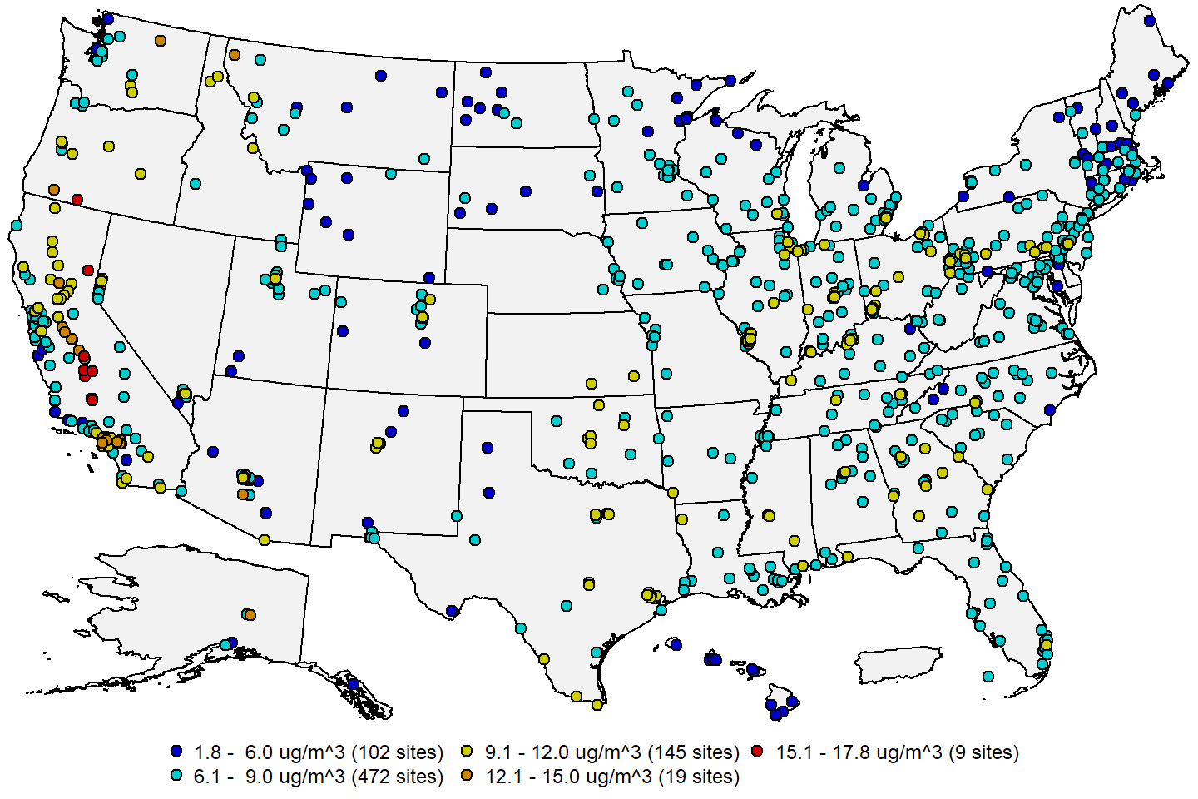

**Figure 13:** Annual PM2.5 design values in μg/m3 for the 2019-2021 period. **Source:** [AQS](https://www.epa.gov/aqs).

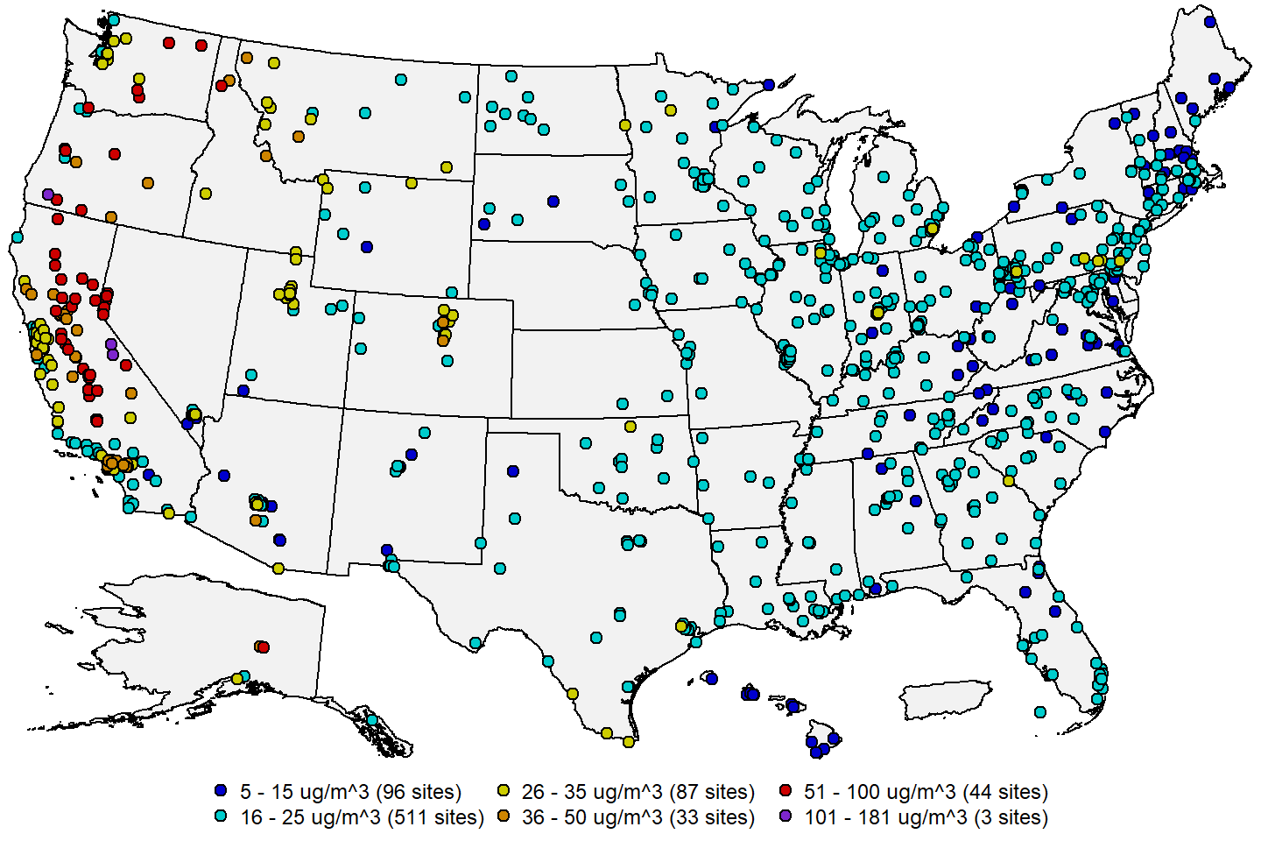

**Figure 14:** 24-hour PM2.5 design values in μg/m3 for the 2019-2021 period. **Source:** [AQS](https://www.epa.gov/aqs).

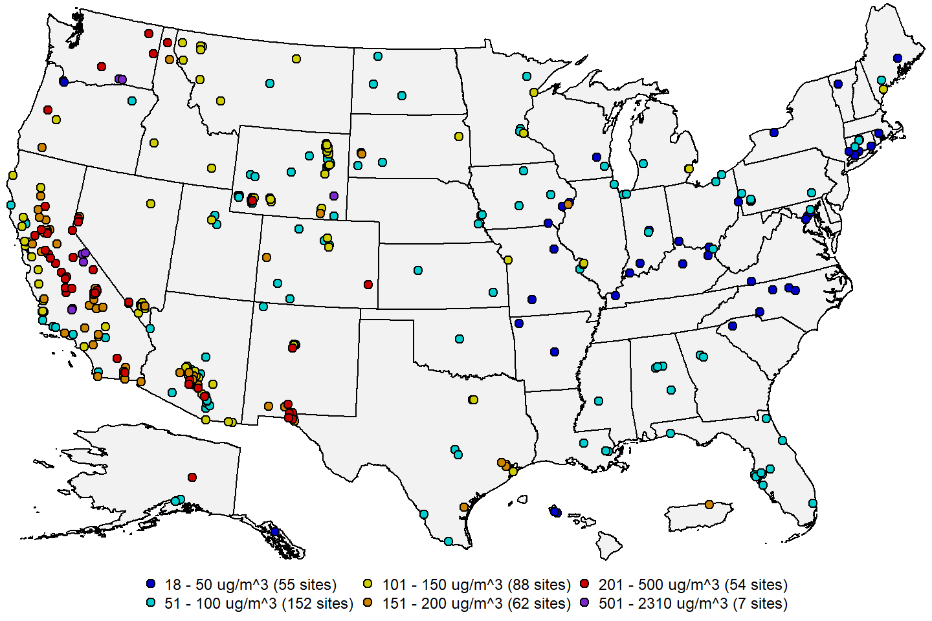

**Figure 15:** 24-hour PM10 design concentrations in μg/m3 for the 2019-2021 period. **Source:** [AQS](https://www.epa.gov/aqs).

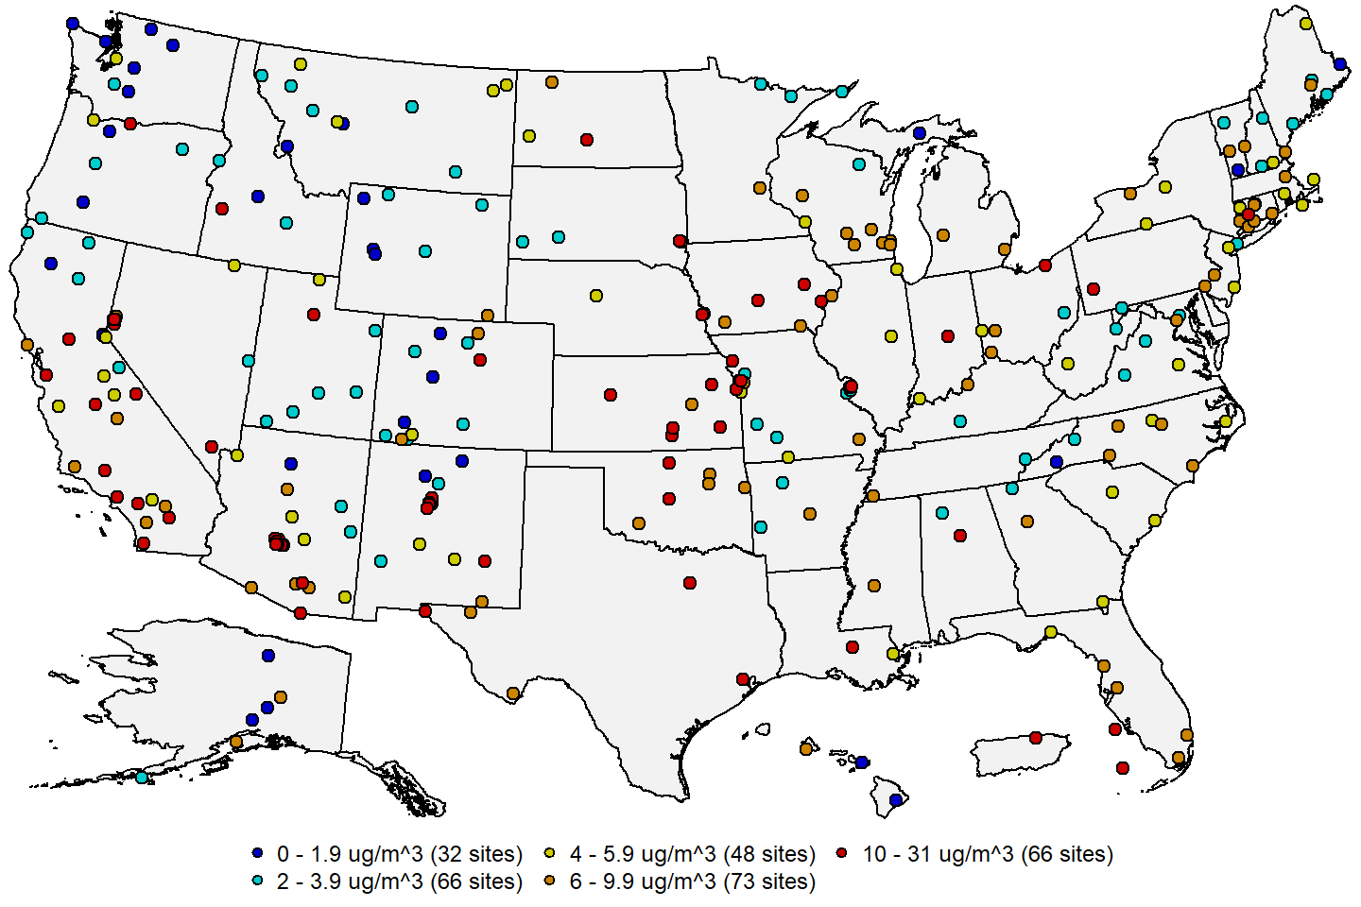

**Figure 16:** Average annual PM10-2.5 concentrations in μg/m3 for the 2019-2021 period. **Source:** [AQS](https://www.epa.gov/aqs).

     Figure 17 and Figure 18 show site-level trends in the annual and 24-hour PM2.5 design values, respectively, for sites having valid design values in at least 15 of the 20 3-year periods from 2000-2002 through 2019- 2021. The trends were computed using the Thiel-Sen estimator, and tests for significance (p-value < 0.05) were computed using the Mann-Kendall test. From this figure it is apparent that most of the U.S. has experienced significant decreasing trends in both the annual and 24-hour PM2.5 design values over the past two decades, especially in the eastern U.S., where regional control programs such as the Clean Air Interstate Rule (CAIR) and the Cross-State Air Pollution Rule (CSAPR) have enabled large reductions in NOX and SO2 emissions, which led to long-term reductions in secondary PM2.5 components. There has been less progress in the western U.S., where most controls to-date have focused on local reductions, and emissions from wildfires in recent years have caused increases in PM2.5 concentrations in some areas.

     Figure 19 shows site-level trends in the 24-hour PM10 design concentrations for sites having valid design values in at least 17 of the 22 3-year periods from 1998-2000 through 2019-2021, while Figure 20 shows site-level trends in annual average PM10-2.5 concentrations for sites having data for at least 13 of the 17 years from 2005 to 2021. The trends in the 24-hour PM10 design concentrations are much more variable than those for PM2.5. While trends in the eastern U.S. are decreasing in most locations, there is no clear pattern in the western U.S., with sites even in close proximity sometimes having trends in opposite directions. Nationally, over half of the sites had no significant trend. The reason for this is apparent from Figure 20, which shows no clear trend the annual average PM10-2.5 concentrations at the vast majority of U.S. monitoring sites.

     Figure 21 shows the national trends in the annual and 24-hour PM2.5 design values based on the 381 sites in Figure 17 and the 419 sites in Figure 18. Both the annual and 24-hour PM2.5 design values exhibited steady decreases from 2002 to 2016. In recent years, the median annual PM2.5 design value has remained relatively constant at about 8 μg/m3 while the 10th and 90th percentile trends have also remained relatively flat at about 6 μg/m3 and 10 μg/m3, respectively. The 10th percentile and median of the 24-hour PM2.5 design values, which are based on the annual 98th percentile, have also remained relatively constant at about 15 μg/m3 and 20 μg/m3, respectively, since 2016. However, the 90th percentile of the 24-hour PM2.5 design values has increased substantially in the past 5 years largely as a result of increased wildfire activity in the western U.S.

     Figure 22 shows the national trend in the 24-hour PM10 design concentrations based on the 438 sites in Figure 19. The national median of the 24-hour PM10 design concentrations has remained relatively constant over the past two decades, though there has been an increase of about 20 μg/m3 since 2016. The 10th percentile 24-hour PM10 design concentration has decreased slowly over the full trends period, while the 90th percentile has been highly variable, most likely as a result of year-to-year fluctuations in weather conditions and wildfire emissions.

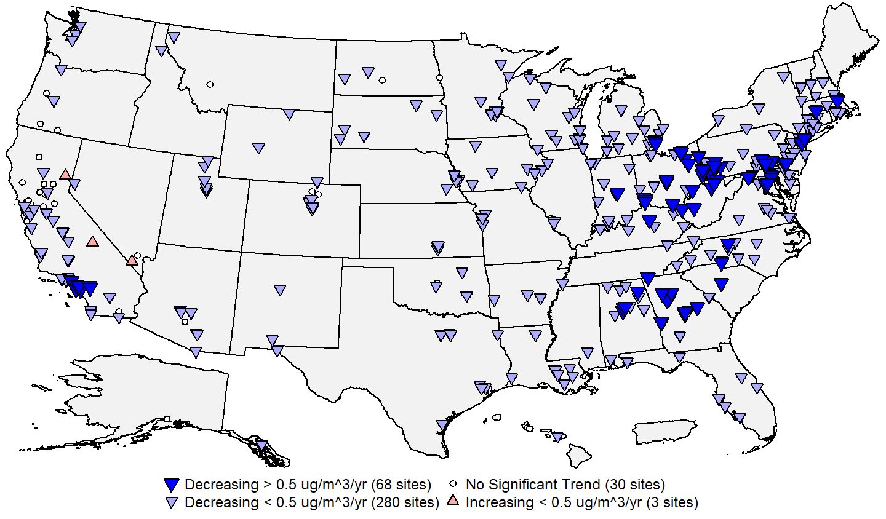

**Figure 17:** Site-level trends in annual PM2.5 design values based on data from 2002 through 2021. **Source:** [AQS](https://www.epa.gov/aqs), trends computed using R statistical software.

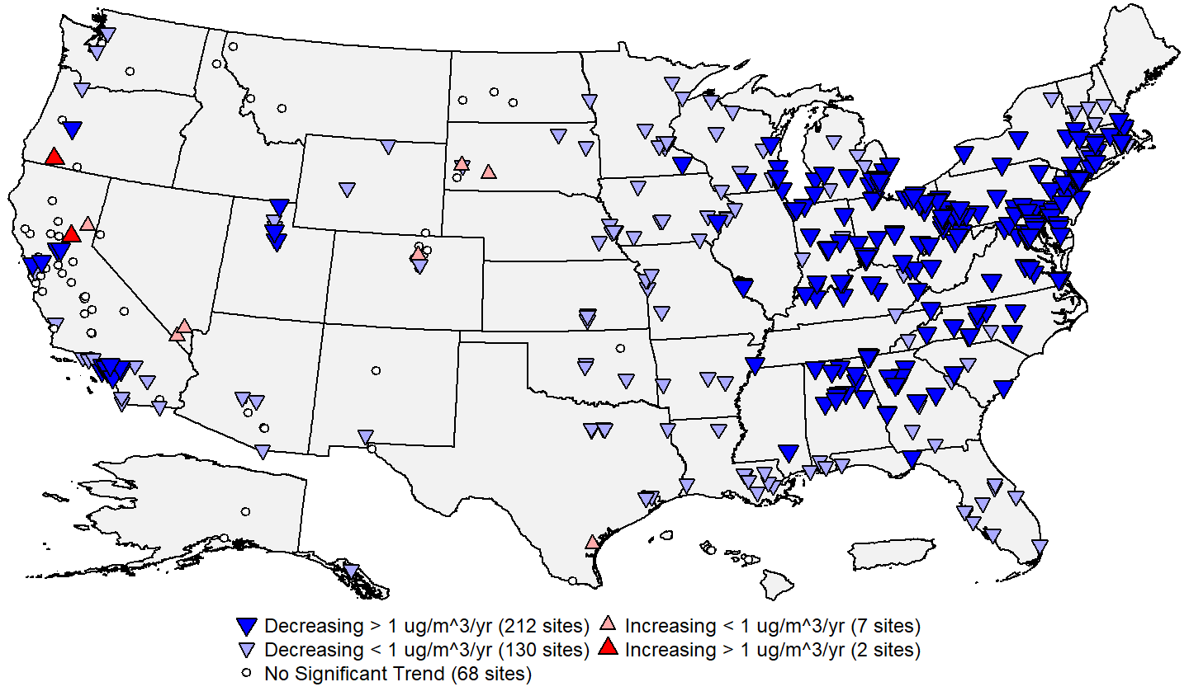

**Figure 18:** Site-level trends in 24-hour PM2.5 design values based on data from 2002 through 2021. **Source:** [AQS](https://www.epa.gov/aqs), trends computed using R statistical software.

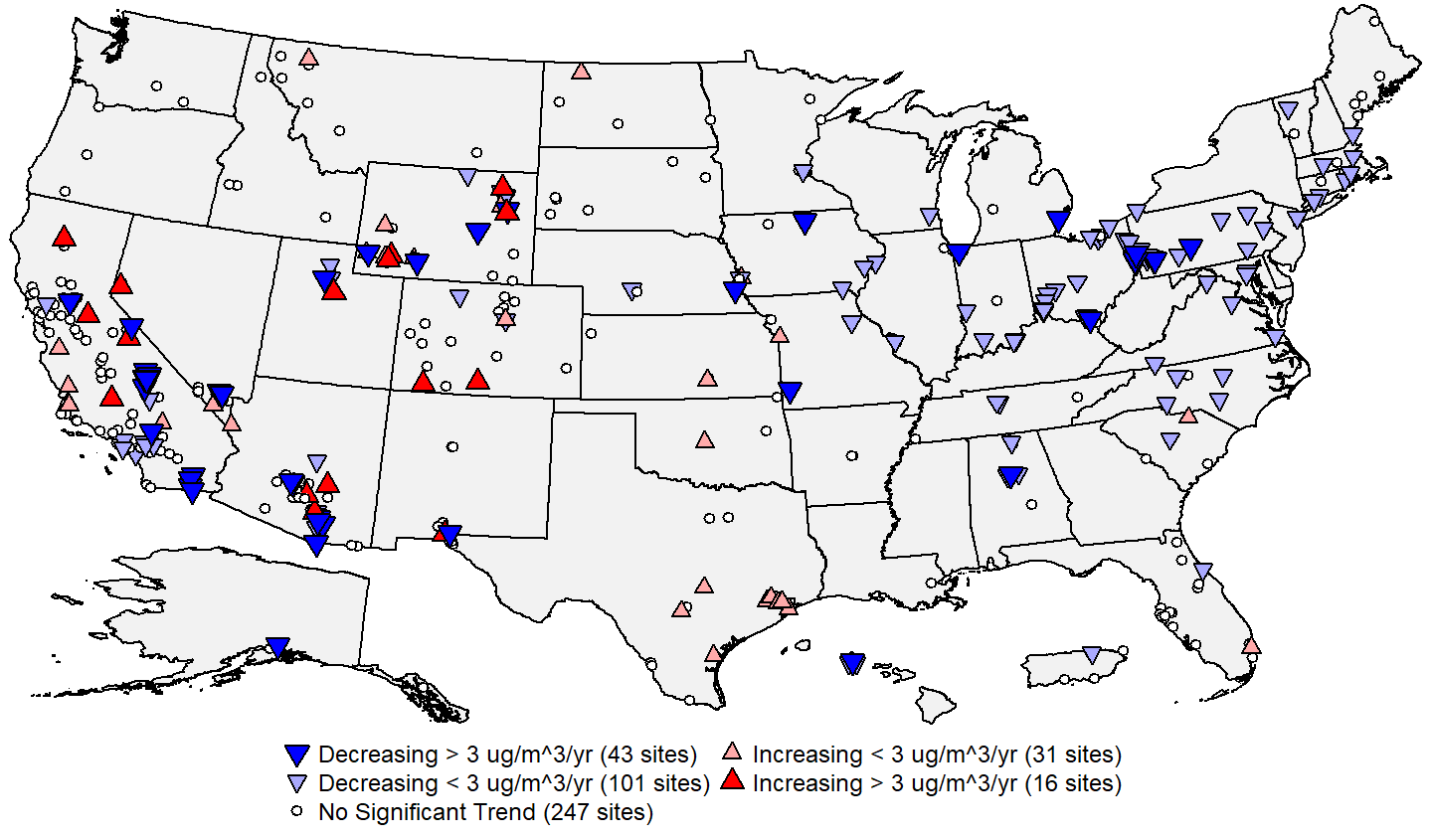

**Figure 19:** Site-level trends in 24-hour PM10 design concentrations based on data from 2000 through 2021. **Source:** [AQS](https://www.epa.gov/aqs), trends computed using R statistical software.

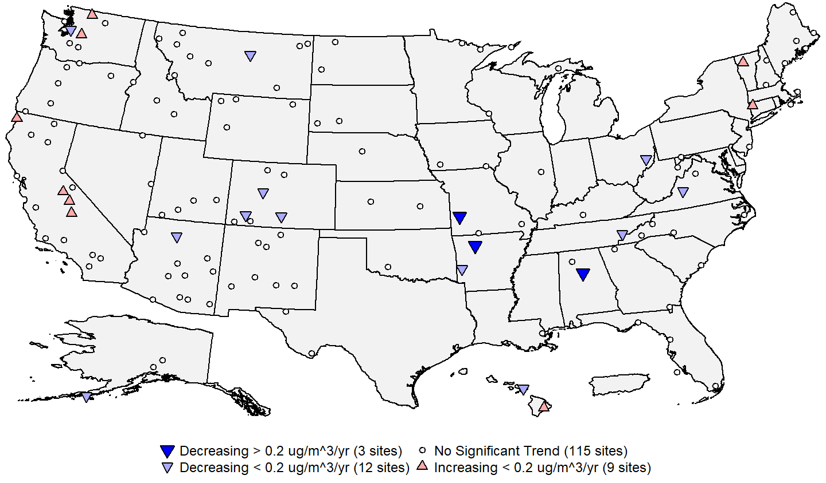

**Figure 20:** Site-level trends in annual average PM10-2.5 concentrations based on data from 2005 through 2021. **Source:** [AQS](https://www.epa.gov/aqs), trends computed using R statistical software.

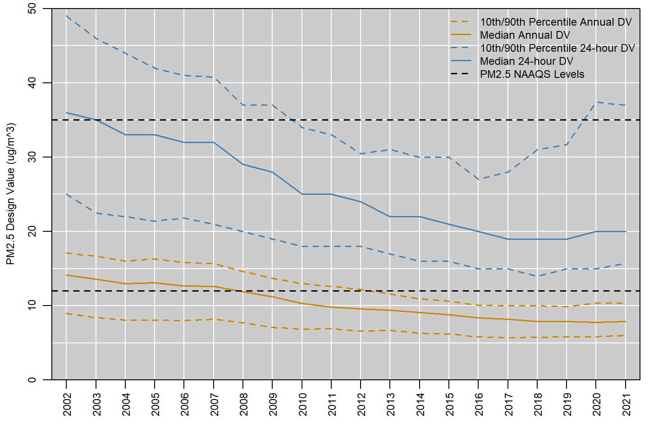

**Figure 21:** National trend in PM2.5 design values in μg/m3, 2002 to 2021. **Source:** [AQS](https://www.epa.gov/aqs).

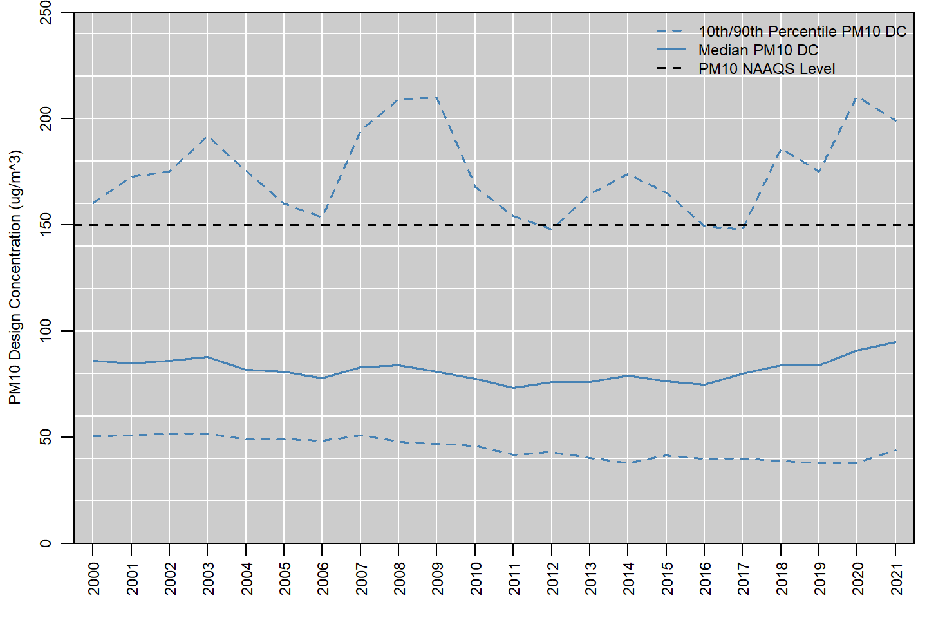

**Figure 22:** National trend in 24-hour PM10 design concentrations in μg/m3, 2000 to 2021. **Source:** [AQS](https://www.epa.gov/aqs).

     Figure 23 shows the national distribution of the annual average PM2.5 concentrations along with the number of PM2.5 monitoring sites reporting data in each year, while Figure 24 shows the national distribution of the annual 98th percentile 24-hour PM2.5 concentrations reported in each year from 2000 to 2021 along with the number of PM2.5 monitoring sites reporting data in each year.11 The median of the annual average PM2.5 concentrations decreased by 38 percent, from 12.8 μg/m3 in 2000 to 8 μg/m3 in 2021. Similarly, the median of the annual 98th percentile 24-hour PM2.5 concentrations decreased by 35 percent, from 32 μg/m3 in 2000 to 21 μg/m3 in 2021. Both the annual average and 98th percentile 24-hour PM2.5 concentrations decreased steadily from the early 2000s until 2016, and have fluctuated in recent years, especially in the upper tail of the distribution. These fluctuations are largely due to large-scale wildfire events that have occurred in recent years. The size of the PM2.5 monitoring network increased rapidly following the establishment of a PM2.5 NAAQS in 1997, and network has been relatively stable at around 1,200 sites since 2002.

     Figure 25 below shows the national distribution of the annual 2nd highest 24-hour PM10 concentrations reported in each year from 1990 to 2021 along with the number of PM10 monitoring sites reporting data in each year.12 The median of the annual 2nd highest 24-hour PM10 concentration decreased by 6 percent, from 63 μg/m3 in 1990 to 59 μg/m3 in 2021. Note, however, that many sites in the western U.S. were influenced by smoke from wildfires in 2020 and 2021, and the median concentration in 2019 was only 41 μg/m3. The PM10 monitoring network grew in size from its inception in the mid-1980’s to a maximum size of around 1,400 sites in the mid-1990’s. Following the establishment of a PM2.5 NAAQS in 1997 along with new requirements for PM2.5 monitoring, many PM10 sites were discontinued in 1998 and 1999. Over the past two decades, the PM10 monitoring network has slowly decreased in size over time as priorities have shifted toward PM2.5 monitoring, and the geographic distribution of the PM10 network has shifted toward the western U.S., where higher concentrations are often measured due to the prevalence of wildfires and dust storms.

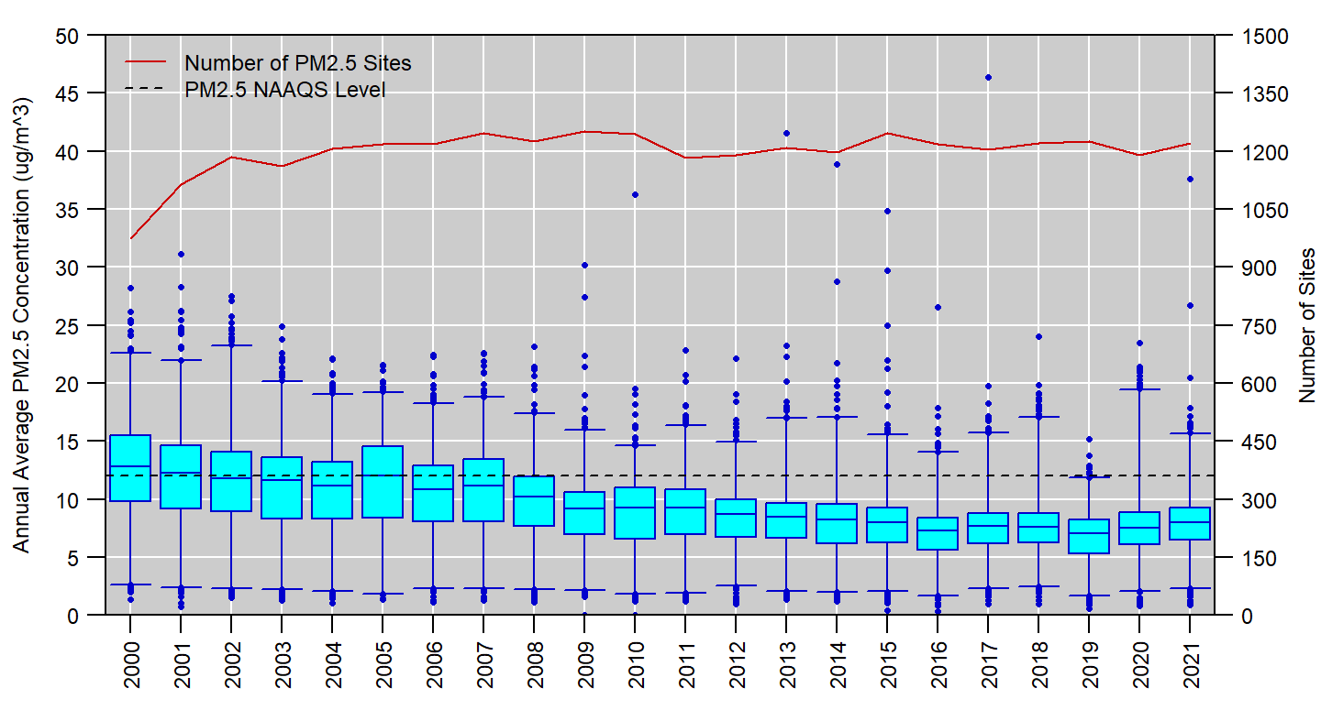

**Figure 23:** Distribution of annual average PM2.5 concentrations measured at U.S. monitoring sites, 2000 to 2021. Boxes represent the median and interquartile range, whiskers extend to the 1st and 99th percentiles, and values outside this range are shown as circles. The red line shows the number of PM2.5 monitoring sites reporting data to EPA in each year. **Source:** [AQS](https://www.epa.gov/aqs).

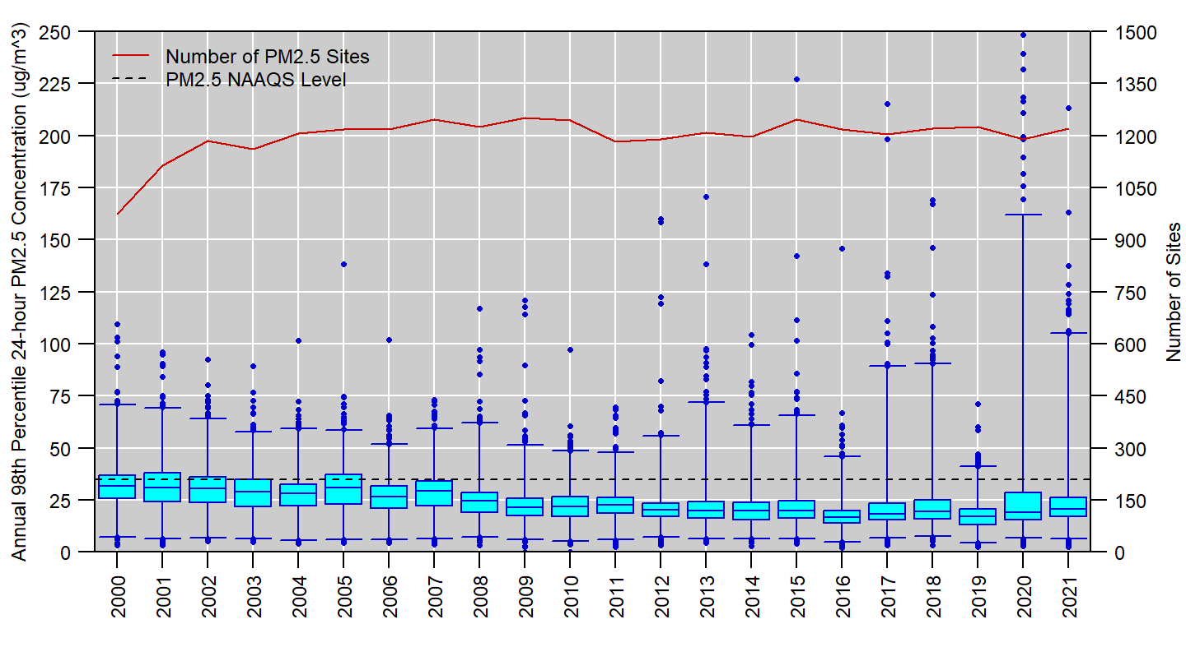

**Figure 24:** Distribution of annual 98th percentile 24-hour PM2.5 concentrations measured at U.S. monitoring sites, 2000 to 2021. Boxes represent the median and interquartile range, whiskers extend to the 1st and 99th percentiles, and values outside this range are shown as circles. The red line shows the number of PM2.5 monitoring sites reporting data to EPA in each year. **Source:** [AQS](https://www.epa.gov/aqs).

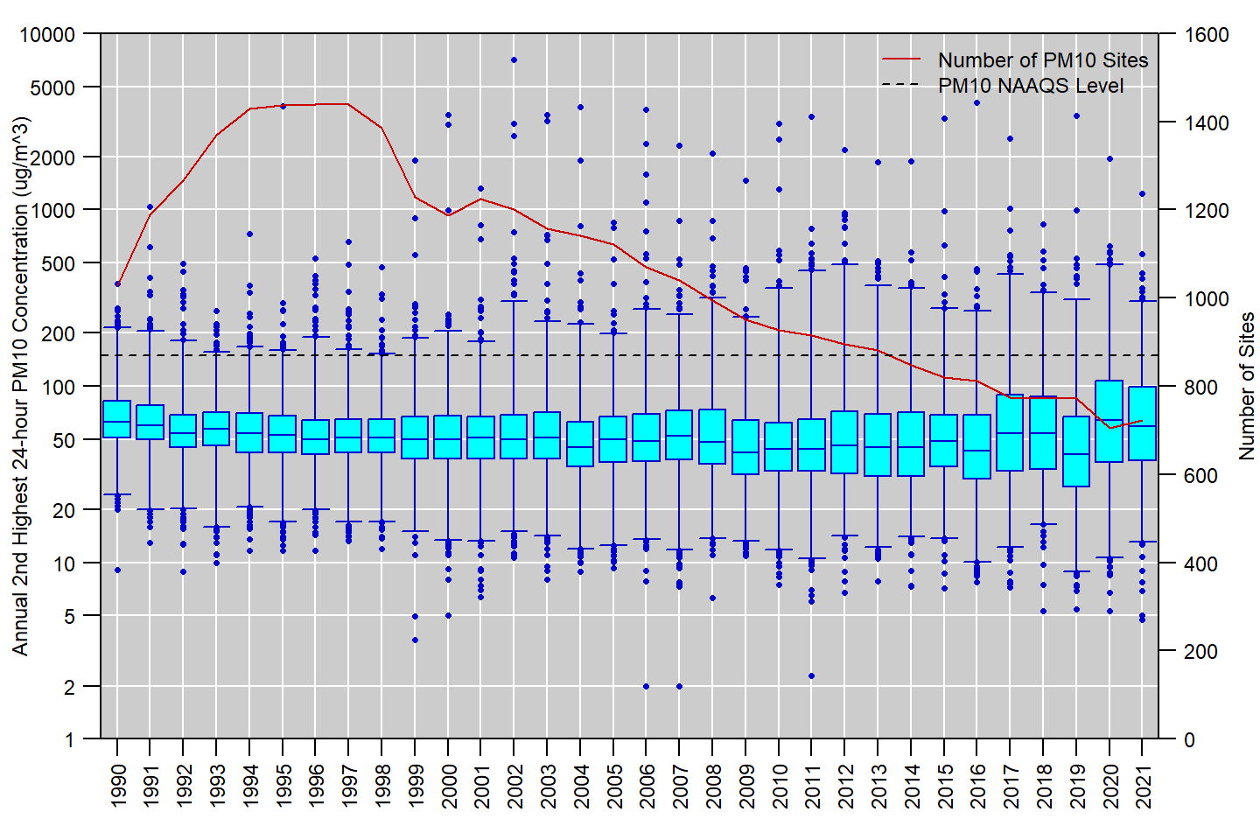

**Figure 25:** Distribution of annual 2nd highest 24-hour PM10 concentrations measured at U.S. monitoring sites, 1990 to 2021. Boxes represent the median and interquartile range, whiskers extend to the 1st and 99th percentiles, and values outside this range are shown as circles. The red line shows the number of PM10 monitoring sites reporting data to EPA in each year. **Source:** [AQS](https://www.epa.gov/aqs).

     Table 4 presents summary statistics based on daily measurements of PM2.5 species reported to AQS for 2019 to 2021 for the full year and each calendar quarter. Sulfate and nitrate have opposite seasonal patterns, with sulfate typically having the highest concentrations during the summer months and nitrate typically having the highest concentrations during the winter months. EC has a relatively small contribution to total PM2.5 mass and a less distinct seasonal pattern, with the highest concentrations typically occurring during the summer and fall. OC is the largest contributor to total PM2.5 mass and has the highest concentrations during the summer, which is also peak wildfire season in the western U.S. On average, crustal material has roughly the same contribution to total PM2.5 mass as sulfate and nitrate, with the highest concentrations occurring in the spring and summer months. Finally, sea salt is the smallest contributor to total PM2.5 mass with very low concentrations typically measured away from coastal areas, and a slight seasonal pattern with the highest concentrations measured during the winter months.

     Figure 26 shows a map with pie charts showing the major PM2.5 species as a fraction of total PM2.5 mass as measured at selected NCore, CSN, and IMPROVE sites during the 2019 to 2021 period. The six species shown are sulfate (SO4), nitrate (NO3), elemental carbon (EC), organic carbon (OC), crustal material, and sea salt. The pie charts are located at each monitoring site on the map. This figure portrays several aspects of regional variability in PM2.5, for example, large portions of total PM2.5 mass can be attributed to sulfate in the Appalachian region, nitrate in the upper Midwest, OC in the Pacific Northwest, crustal material in the southwest, and sea salt in coastal areas.

     Figure 27 shows the average concentrations for four PM2.5 components (sulfate, nitrate, EC, and OC) based on data collected during the 2019 to 2021 period. From this figure it is apparent that sulfate concentrations are highest in the Ohio River valley and along the Gulf of Mexico, while nitrate concentrations are highest in the upper Midwest, along the northeast urban corridor, and in parts of California. EC and OC are spatially more variable, with the highest concentrations scattered across the country. EC concentrations tend to be higher near urban areas, especially those with large industrial sources, while OC tends to be more concentrated in rural areas, with impacts from prescribed burns, wildfires, and residential wood smoke.

     Figure 28 shows trends in annual average concentrations for sulfate, nitrate, EC, and OC based on sites that collected data for at least 12 out of 16 years from 2006 to 2021.13 Broad national reductions in SO2 emissions have resulted in significant reductions in sulfate concentrations nationally and especially in the eastern U.S. Similarly, reductions in NOX emissions have resulted in significant decreasing trends in nitrate concentrations in most of the U.S., especially in areas where nitrate concentrations were historically highest. EC and OC concentrations were more variable, with some sites showing significant decreases and the remaining sites having no clear trend.

**Table 4.** National distribution of PM2.5 species concentrations in μμg/m3 by quarter based on monitoring data from 2019 to 2021. **Source:** [AQS](https://www.epa.gov/aqs).

|  |  |  |  |  |  |  |  |  |  |  |  |  |  |  |  |  |  |  |
| --- | --- | --- | --- | --- | --- | --- | --- | --- | --- | --- | --- | --- | --- | --- | --- | --- | --- | --- |
| species | quarter | N.sites | N.obs | mean | SD | min | p1 | p5 | p10 | p25 | p50 | p75 | p90 | p95 | p98 | p99 | max | max.site |
| SO4 | all | 314 | 86,972 | 0.71 | 0.64 | -0.01 | 0.04 | 0.10 | 0.16 | 0.30 | 0.55 | 0.94 | 1.44 | 1.82 | 2.35 | 2.81 | 42.92 | 060371103 |
| SO4 | 1st quarter | 309 | 21,378 | 0.67 | 0.67 | 0.00 | 0.02 | 0.07 | 0.12 | 0.25 | 0.50 | 0.88 | 1.38 | 1.81 | 2.41 | 3.00 | 22.94 | 420030064 |
| SO4 | 2nd quarter | 309 | 21,281 | 0.73 | 0.55 | 0.00 | 0.07 | 0.16 | 0.21 | 0.35 | 0.58 | 0.96 | 1.42 | 1.74 | 2.22 | 2.59 | 6.67 | 483550034 |
| SO4 | 3rd quarter | 306 | 22,362 | 0.87 | 0.73 | -0.01 | 0.09 | 0.19 | 0.26 | 0.42 | 0.70 | 1.15 | 1.70 | 2.09 | 2.65 | 3.09 | 42.92 | 060371103 |
| SO4 | 4th quarter | 304 | 21,639 | 0.55 | 0.51 | 0.00 | 0.03 | 0.08 | 0.11 | 0.21 | 0.41 | 0.74 | 1.15 | 1.48 | 1.95 | 2.32 | 8.53 | 420030064 |
| NO3 | all | 310 | 86,741 | 0.63 | 1.26 | -0.03 | 0.01 | 0.03 | 0.04 | 0.10 | 0.24 | 0.58 | 1.54 | 2.61 | 4.50 | 6.22 | 32.63 | 060371103 |
| NO3 | 1st quarter | 305 | 21,299 | 1.08 | 1.74 | -0.03 | 0.01 | 0.02 | 0.05 | 0.13 | 0.43 | 1.26 | 2.84 | 4.35 | 6.63 | 8.48 | 31.46 | 060190011 |
| NO3 | 2nd quarter | 306 | 21,212 | 0.39 | 0.60 | -0.01 | 0.01 | 0.04 | 0.05 | 0.11 | 0.21 | 0.42 | 0.85 | 1.36 | 2.12 | 2.95 | 11.62 | 060371103 |
| NO3 | 3rd quarter | 303 | 22,319 | 0.29 | 0.44 | -0.02 | 0.01 | 0.03 | 0.05 | 0.09 | 0.18 | 0.32 | 0.56 | 0.86 | 1.48 | 2.18 | 10.59 | 060379034 |
| NO3 | 4th quarter | 300 | 21,599 | 0.77 | 1.56 | -0.02 | 0.00 | 0.02 | 0.03 | 0.09 | 0.26 | 0.77 | 1.93 | 3.25 | 5.43 | 7.43 | 32.63 | 060371103 |
| EC | all | 297 | 83,768 | 0.40 | 0.70 | -0.02 | 0.00 | 0.02 | 0.03 | 0.08 | 0.21 | 0.49 | 0.92 | 1.33 | 1.99 | 2.54 | 38.54 | 530370004 |
| EC | 1st quarter | 295 | 20,751 | 0.37 | 0.52 | -0.01 | 0.00 | 0.01 | 0.03 | 0.07 | 0.19 | 0.47 | 0.92 | 1.32 | 1.95 | 2.44 | 10.01 | 020900035 |
| EC | 2nd quarter | 288 | 20,338 | 0.28 | 0.35 | -0.01 | -0.01 | 0.02 | 0.03 | 0.07 | 0.17 | 0.37 | 0.64 | 0.87 | 1.26 | 1.56 | 8.27 | 482030002 |
| EC | 3rd quarter | 288 | 21,435 | 0.48 | 1.05 | -0.02 | -0.01 | 0.03 | 0.06 | 0.12 | 0.27 | 0.57 | 0.96 | 1.36 | 2.03 | 2.91 | 38.54 | 530370004 |
| EC | 4th quarter | 288 | 20,934 | 0.46 | 0.65 | -0.01 | 0.00 | 0.01 | 0.03 | 0.08 | 0.23 | 0.59 | 1.18 | 1.69 | 2.37 | 3.01 | 14.04 | 060670006 |
| OC | all | 297 | 83,768 | 1.46 | 2.43 | -0.12 | 0.03 | 0.13 | 0.21 | 0.45 | 0.96 | 1.76 | 2.89 | 3.93 | 6.17 | 9.26 | 165.94 | 530390003 |
| OC | 1st quarter | 295 | 20,751 | 1.02 | 1.39 | -0.06 | 0.01 | 0.08 | 0.13 | 0.29 | 0.66 | 1.31 | 2.21 | 3.05 | 4.41 | 5.53 | 58.90 | 120179000 |
| OC | 2nd quarter | 288 | 20,338 | 1.14 | 1.14 | -0.11 | 0.07 | 0.16 | 0.25 | 0.45 | 0.86 | 1.52 | 2.36 | 2.94 | 3.74 | 4.47 | 59.81 | 350039000 |
| OC | 3rd quarter | 288 | 21,435 | 2.28 | 3.91 | -0.12 | 0.09 | 0.31 | 0.48 | 0.86 | 1.45 | 2.41 | 3.91 | 6.32 | 12.20 | 16.99 | 165.94 | 530390003 |
| OC | 4th quarter | 288 | 20,934 | 1.38 | 1.89 | -0.07 | 0.02 | 0.11 | 0.19 | 0.40 | 0.89 | 1.72 | 3.00 | 4.06 | 5.76 | 7.75 | 43.84 | 061071001 |
| Crustal | all | 313 | 86,623 | 0.63 | 1.07 | -0.17 | 0.00 | 0.03 | 0.05 | 0.14 | 0.32 | 0.70 | 1.41 | 2.15 | 3.55 | 4.91 | 33.31 | 060270002 |
| Crustal | 1st quarter | 309 | 21,257 | 0.38 | 0.64 | -0.11 | 0.00 | 0.02 | 0.04 | 0.09 | 0.21 | 0.42 | 0.82 | 1.28 | 2.09 | 2.86 | 21.07 | 480430101 |
| Crustal | 2nd quarter | 308 | 21,171 | 0.75 | 1.21 | -0.17 | 0.01 | 0.05 | 0.09 | 0.21 | 0.44 | 0.87 | 1.61 | 2.28 | 3.57 | 5.14 | 32.75 | 130499000 |
| Crustal | 3rd quarter | 304 | 22,074 | 0.84 | 1.23 | -0.08 | 0.01 | 0.05 | 0.09 | 0.23 | 0.48 | 0.95 | 1.87 | 2.88 | 4.59 | 6.26 | 21.95 | 060190011 |
| Crustal | 4th quarter | 303 | 21,839 | 0.53 | 1.03 | -0.10 | 0.00 | 0.02 | 0.03 | 0.10 | 0.24 | 0.55 | 1.20 | 1.96 | 3.32 | 4.63 | 33.31 | 060270002 |
| Sea_Salt | all | 314 | 87,616 | 0.18 | 0.49 | -0.01 | 0.00 | 0.00 | 0.01 | 0.02 | 0.05 | 0.14 | 0.41 | 0.79 | 1.52 | 2.20 | 38.12 | 060371103 |
| Sea_Salt | 1st quarter | 309 | 21,460 | 0.22 | 0.52 | 0.00 | 0.00 | 0.00 | 0.01 | 0.02 | 0.06 | 0.20 | 0.52 | 0.94 | 1.75 | 2.42 | 19.70 | 040139997 |
| Sea_Salt | 2nd quarter | 309 | 21,368 | 0.19 | 0.51 | -0.01 | 0.00 | 0.00 | 0.01 | 0.02 | 0.04 | 0.13 | 0.42 | 0.84 | 1.60 | 2.36 | 12.46 | 060410002 |
| Sea_Salt | 3rd quarter | 307 | 22,509 | 0.14 | 0.48 | 0.00 | 0.00 | 0.00 | 0.01 | 0.02 | 0.04 | 0.10 | 0.28 | 0.57 | 1.23 | 1.79 | 38.12 | 060371103 |
| Sea_Salt | 4th quarter | 304 | 22,000 | 0.18 | 0.46 | 0.00 | 0.00 | 0.00 | 0.00 | 0.01 | 0.04 | 0.15 | 0.42 | 0.78 | 1.46 | 2.12 | 11.94 | 420030064 |

N.sites = number of sites; N.obs = number of observations; SD = standard deviation; min = minimum; p1, p5, p10, p25, p50, p90, p95, p98, p99 = 1st, 5th, 10th, 25th, 50th, 90th, 95th, 98th, 99th percentiles; max = maximum; max.site = AQS ID number for the monitoring site corresponding to the observation in the max column. 1st quarter = January/February/March; 2nd quarter = April/May/June; 3rd quarter = July/August/September; 4th quarter = October/November/December.

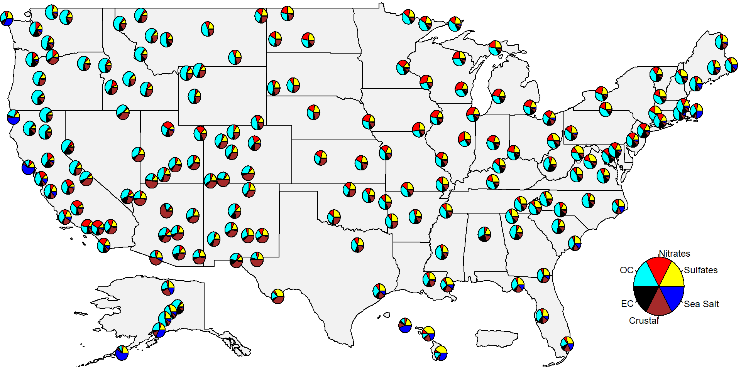

**Figure 26:** Map showing pie charts of PM2.5 component species at selected U.S. monitoring sites based on 2019-2021 data. Source: [AQS](https://www.epa.gov/aqs).

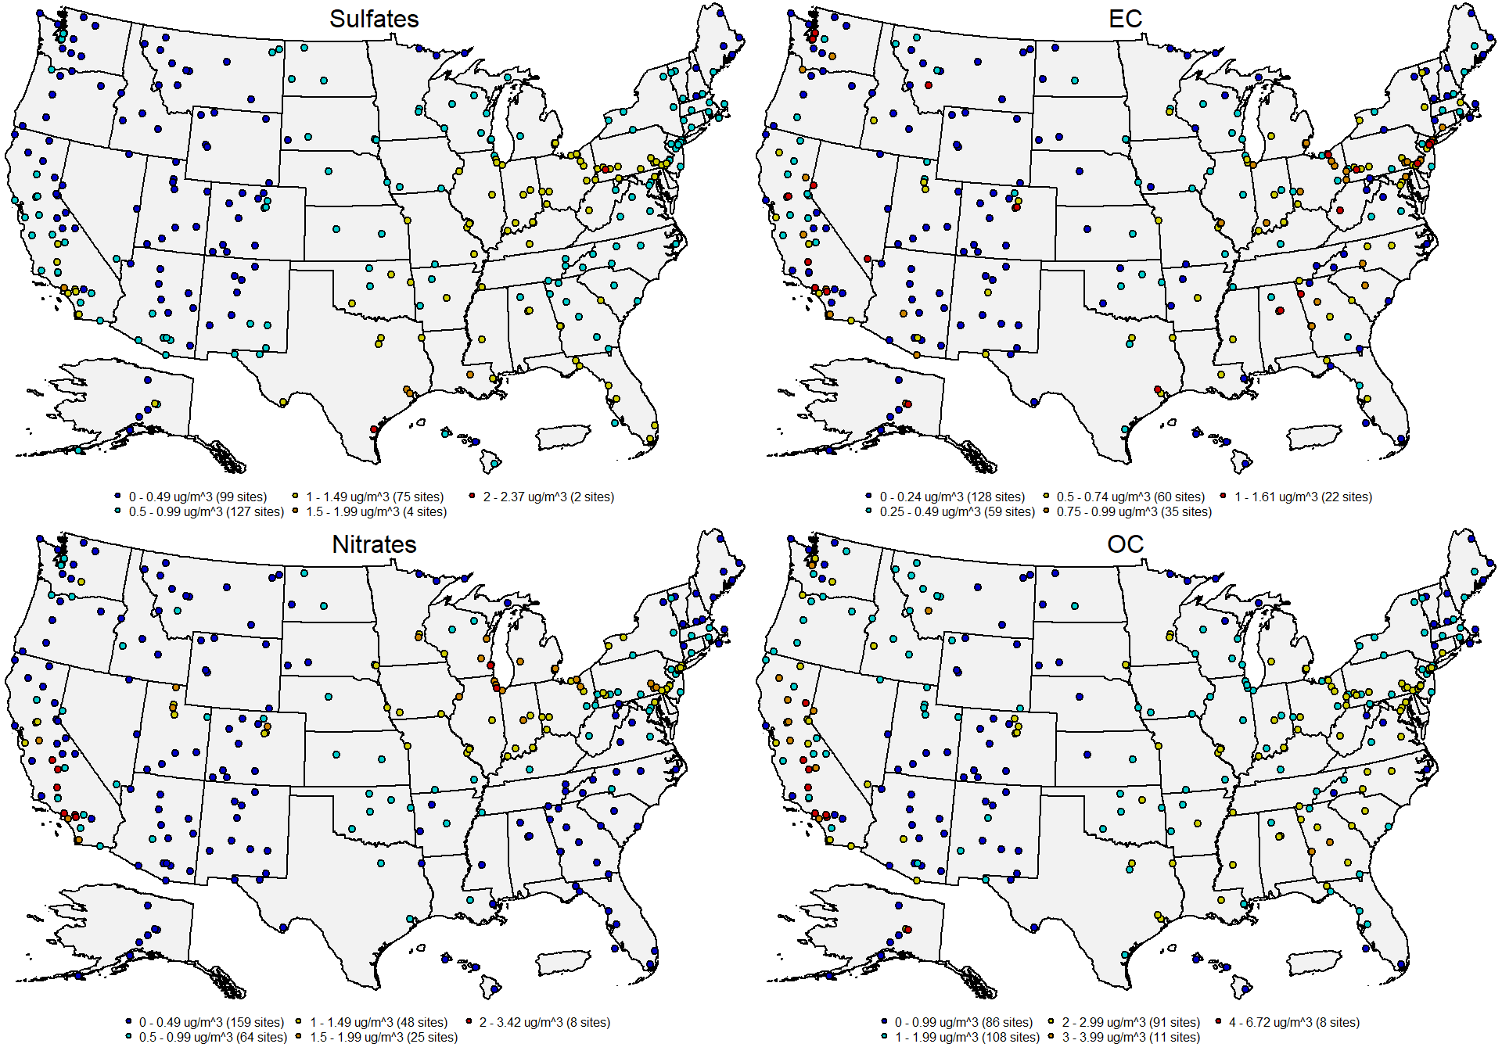

**Figure 27:** Average concentrations for sulfates (top left), nitrates (bottom left), elemental carbon (top right), and organic carbon (bottom right) at U.S. monitoring sites based on 2019-2021 data. Source: [AQS](https://www.epa.gov/aqs).

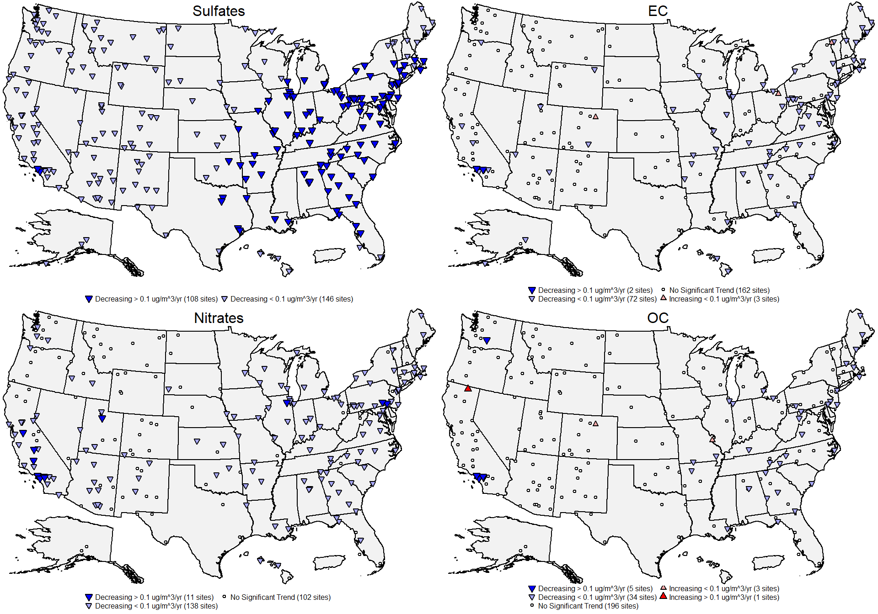

**Figure 28:** Site-level trends in annual average concentrations for sulfates (top left), nitrates (bottom left), elemental carbon (top right), and organic carbon (bottom right) based on data from 2006 through 2021. Source: [AQS](https://www.epa.gov/aqs), trends computed using R statistical software.

**References**

U.S. EPA. [Integrated Science Assessment for Particulate Matter (Final Report, December 2019)](https://cfpub.epa.gov/ncea/isa/recordisplay.cfm?deid=347534). U.S. Environmental Protection Agency, Washington, DC, EPA/600/R-19/188, 2019.

U.S. EPA. [Policy Assessment for the Review of the PM NAAQS (Final Report, January 2020)](https://www.epa.gov/system/files/documents/2021-10/final-policy-assessment-for-the-review-of-the-pm-naaqs-01-2020.pdf). U.S. Environmental Protection Agency, Research Triangle Park, NC, EPA-452/R-20-002, 2020.

**Additional Resources**

* [Particulate Matter (PM) Pollution](https://www.epa.gov/pm-pollution)
* [Particulate Matter (PM) Air Quality Standards](https://www.epa.gov/naaqs/particulate-matter-pm-air-quality-standards)
* [National Emissions Inventory (NEI)](https://www.epa.gov/air-emissions-inventories/national-emissions-inventory-nei)
* [Ambient Monitoring Technology Information Center (AMTIC)](https://www.epa.gov/amtic)
* [Air Quality Design Values](https://www.epa.gov/air-trends/air-quality-design-values)
* [National Air Quality: Status and Trends of Key Air Pollutants](https://www.epa.gov/air-trends)
* [Air Data: Air Quality Data Collected at Outdoor Monitors Across the U.S.](https://www.epa.gov/outdoor-air-quality-data)

**Footnotes:**

1. Aerodynamic diameter is the size of a sphere of unit density (i.e., 1 g/cm3) that has the same terminal settling velocity as the particle of interest.↩︎
2. Data for Figure 4 come from the EPA’s [Air Pollutant Emissions Trends Data](https://www.epa.gov/air-emissions-inventories/air-pollutant-emissions-trends-data). Note that emissions for some sectors are interpolated between inventory years, and the emissions for some sectors are held constant beyond the most recent inventory year (for details, see the “Development of Data” table in the [national emissions trends data file](https://www.epa.gov/sites/default/files/2021-03/national_tier1_caps.xlsx). For the purposes of this document, wildfires are considered to be natural emissions and thus are not included in Figure 4.↩︎
3. Some PM10 and PM2.5 monitoring sites operate both FEM and FRM instruments.↩︎
4. Quality assurance requirements for monitors used in evaluations of the NAAQS are provided in [Appendix A to 40 CFR Part 58](https://www.ecfr.gov/current/title-40/part-58/appendix-Appendix%20A%20to%20Part%2058). Annual summary reports of precision and bias can be obtained for each monitoring site at the EPA’s [Air Data website](https://www.epa.gov/outdoor-air-quality-data/single-point-precision-and-bias-report).↩︎
5. The IMPROVE algorithm is an equation to estimate light extinction based on the measured concentration of several PM components and is used to track visibility progress in the Regional Haze Rule. More information about the IMPROVE algorithm is available at the [IMPROVE website](http://vista.cira.colostate.edu/Improve/the-improve-algorithm).↩︎
6. A variety of resources and guidance documents related to identification and consideration of exceptional events in design value calculations are available at [<https://www.epa.gov/air-quality-analysis/final-2016-exceptional-events-rule-supporting-guidance-documents-updated-faqs>].↩︎
7. For Table 2, monitoring sites in Alaska were assigned to the Northwest Region and monitoring sites in Hawaii were assigned to the West region.↩︎
8. The MDA1 metric is not included in Table 3 because very few IMPROVE sites operate continuous PM10 and/or PM2.5 instruments. PM2.5 concentrations measured by the IMPROVE network are non-regulatory and thus may not meet all of the EPA’s ambient air monitoring requirements in 40 CFR Part 58.↩︎
9. Negative concentration values may appear in AQS datasets down to the negative of the lower detection limit (LDL) to allow for normal instrument variability at very low concentrations. Data that exceed the negative of the LDL is typically indicative of a malfunction or another issue that affects the data defensibility.↩︎
10. The table lookup procedure is documented in Section 6.3 of the 1987 EPA guidance document [*PM10 SIP Development Guideline*](https://nepis.epa.gov/Exe/ZyPURL.cgi?Dockey=P1006IKV.TXT).↩︎
11. For this analysis, the annual average and 98th percentile 24-hour PM2.5 concentrations were retrieved from AQS for all U.S. sites for years that had at least 75% annual data completeness.↩︎
12. For this analysis, the annual 2nd highest 24-hour PM10 concentrations were retrieved from AQS for all U.S. sites for years that had at least 75% annual data completeness.↩︎
13. Although PM2.5 speciation monitoring has been conducted since 2000, the trends in Figure 28 begin in 2006 to avoid excluding CSN sites, which experienced a change in EC and OC sampling methods between 2007 and 2010.↩︎