**Overview of Sulfur Dioxide (SO2) Air Quality in the United States**

Updated: February 7, 2023

**1. Introduction**

    The overall purpose of this document is to maintain an up-to-date graphical summary of air quality information that supports the review of the National Ambient Air Quality Standards (NAAQS) for oxides of sulfur, hereafter referred to as the sulfur dioxide (SO2) NAAQS. In previous reviews of the SO2 NAAQS, this type of information has generally been included in atmospheric sections of the Integrated Science Assessment (ISA) and Policy Assessment (PA) for Sulfur Oxides. This stand-alone document will either replace or complement the air quality emissions and monitoring data in the atmospheric sections of future SO2 NAAQS review supporting documents and will be updated at regular intervals as new data becomes available.

     The content of past NAAQS documents’ atmospheric sections has included major sections on emissions and concentration trends utilizing maps and data from the Environmental Protection Agency’s (EPA’s) National Emissions Inventory (NEI) and the EPA’s Air Quality System (AQS) database. In past NAAQS reviews, this often involved adaptation of figures and tables prepared for other reports or development of new figures and tables using data analysis and mapping software. Additionally, the release of updated emission inventories and ambient air monitoring data may not coincide with the schedule for the development of NAAQS review supporting documents. As a result, data access and resources can limit the availability of the most recent information for inclusion in NAAQS review supporting documents.

     This stand-alone document allows the content to be updated as soon as new data becomes available, rather than relying on information that is available at the time of development of the NAAQS review supporting documents. It also ensures that the public will have access to a consistent set of maps and figures for each NAAQS pollutant that are updated on a routine basis, rather than separated by several years because of the disparate schedules of the various NAAQS reviews for each pollutant. Moreover, a stand-alone document can be expanded to include new air quality analyses as they are completed, rather than following the timeline for the public release of the NAAQS review supporting documents. Finally, this document takes advantage of a more flexible digital format for the routinely prepared maps and trends figures with an end product that more strongly emphasizes visual presentation of data and reduces the amount of text, while also creating a more interactive presentation of the information through the use of external links.

     This document follows an organizational structure similar to that of the atmospheric sections of past SO2 NAAQS review supporting documents. The subsequent sections are as follows: 2. Atmospheric Chemistry; 3. Sources and Emissions of SO2; 4. Ambient Air Monitoring Requirements and Monitoring Networks; 5. Data Handling Conventions and Computations for Determining Whether the Standards are Met; and 6. SO2 Concentrations Measured at Ambient Air Monitoring Sites Across the U.S. These sections are broad enough in scope to communicate relevant information about SO2 air quality, including scientific advances, but specific enough that the information needed to develop NAAQS review supporting documents can be quickly and readily retrieved.

**2. Atmospheric Chemistry**

     Sulfur oxides are a group of closely related sulfur-containing gas-phase compounds [e.g., sulfur dioxide (SO2), sulfur monoxide (SO), disulfur monoxide (S2O), and sulfur trioxide (SO3)]. Sulfur oxides also appear in the particle phase, as components of particulate matter (PM). The current indicator for the sulfur oxides NAAQS is SO2, because, of the sulfur oxides, SO2 is the most abundant in the atmosphere, the most important in atmospheric chemistry, and the one most clearly linked to human health effects. Sulfur dioxide is both a primary gas-phase pollutant (when formed during fuel combustion) and a secondary pollutant (when formed as the product of atmospheric gas- or aqueous-phase oxidation of reduced sulfur compounds, called sulfides).

     The important gas-phase sulfur oxides in the troposphere are SO2 and sulfuric acid (H2SO4). SO3 is known to be present in the emissions of coal-fired power plants, factories, and refineries, but it reacts with water vapor in the stacks or immediately after release into the atmosphere within seconds to form H2SO4, which makes it difficult to detect in the ambient atmosphere. Gas-phase H2SO4, the product of both SO2 and SO3 oxidation, quickly condenses onto existing atmospheric particles or participates in new particle formation. Of these species, only SO2 is present at concentrations in the gas phase that are relevant for chemistry in the atmospheric boundary layer and troposphere, and for human exposures. Other sulfur oxides, including both S(IV) and S(VI) compounds, appear in the atmosphere due to direct emissions and as the products of the oxidation of more reduced forms of sulfur. Gas-phase precursors to SO2 include sulfides and partially oxidized sulfur-containing organic compounds.

     The global atmospheric lifetime of SO2 with respect to reactions with the OH radical in the troposphere is 7.2 days. The rate constant for the reaction between SO2 and NO3 radical is too small to be important in lowering SO2 concentrations at urban or regional scales. The same is true for the reaction between SO2 and the hydroperoxyl (HO2) radical. In the stepwise oxidation of SO2 by OH, SO2 is oxidized to form SO3, taking the sulfur atom from the S(IV) to S(VI) oxidation state, producing the bisulfite radical (HSO3): SO2 + OH + M → HSO3 + M, where M is an unreactive gas molecule that absorbs excess destabilizing energy from the SO2-OH transition state. This reaction is followed by HSO3 + O2 → SO3 + HO2. An alternative route involves a stabilized Criegee intermediate (sCI): SO2 + sCI → SO3 + products. The SO3 that is generated by either oxidation mechanism (i.e., reaction with OH or via the Criegee reaction) is highly reactive. Water vapor is sufficiently abundant in the troposphere to ensure that SO3 is quickly converted to gas-phase sulfuric acid: SO3 + H2O + M → H2SO4 + M. Because H2SO4 is extremely water soluble, gaseous H2SO4 will rapidly dissolve into the aqueous phase of aerosol particles and cloud droplets. Conversion from SO2 to H2SO4 increases with increasing relative humidity and O3 levels.

     The basic mechanism of the aqueous-phase oxidation of SO2 involves dissolution of SO2 followed by the formation and dissociation of sulfurous acid (H2SO3). Additionally, in environments where ambient ammonia (NH3) is abundant, SO2 is subject to fast removal by cloud and fog droplets and ultimately forms ammonium sulfate [(NH4)2SO4]. In the same way that it is removed from the gas phase by dissolving into cloud droplets, SO2 can be removed by dry deposition onto wet surfaces. Scavenging by rain (wet deposition) serves as another removal route. Modeling studies have shown that slightly more than half of SO2 is lost by gas- and aqueous-phase oxidation, with the remainder of SO2 loss accounted for by wet and dry deposition.

     Sulfur dioxide is also known to adhere to and then react on dust particles. For some mineral compositions, SO2 uptake on dust particles is sensitive to relative humidity, the mineral composition of the particle, and the availability of H2O2, the relevant oxidant. Once SO2 is oxidized to H2SO4 on the particle surface, glyoxal, one of the most prevalent organic compounds in the atmosphere, will adhere to the surface and react to form oligomers and organosulfate compounds. This process is enhanced under high humidity conditions.

**3. Sources and Emissions of SO2**

     Sulfur is present to some degree in all fossil fuels, especially coal, and occurs as reduced organosulfur compounds. Coal also contains sulfur in mineral form (pyrite or other metallo-sulfur minerals) and in elemental form. Of the most common types of coal (anthracite, bituminous, subbituminous, and lignite), sulfur content varies between 0.4 and 4% by mass. Sulfur in fossil fuels is almost entirely converted to SO2 during combustion, making accurate estimates of SO2 combustion emissions possible based on fuel composition and combustion rates.

     Fossil fuel combustion is the main anthropogenic source of primary SO2, while volcanoes and wildfires are the main natural sources of primary SO2. Anthropogenic SO2 emissions originate primarily from point sources, including coal-fired electricity generating units (EGUs) and other industrial facilities. Industrial chemical and pulp and paper production, smelter and steel mill operations, natural biological activity (plants, fungi, and prokaryotes), and volcanoes are among many sources of reduced sulfur compounds that contribute, through various oxidation reactions in the atmosphere, to the formation of secondary SO2. In addition to volcanic and other geologic SO2 emissions, naturally occurring SO2 is derived from the oxidation of sulfides emitted by low flux “area” sources, such as the oceans and moist soils. The mass of sulfur released into the environment by anthropogenic sources is comparable to natural sources.

     Other anthropogenic sources of SO2 emissions include industrial fuel combustion, other industrial processes, commercial marine vessels, and agricultural and prescribed fires. While electricity generation is the dominant industry sector contributing to SO2 emissions on a national scale, other sectors can also have a significant influence on local air quality. Large emissions facilities other than EGUs that may substantially impact local air quality include copper smelters, pulp and paper mills, cement plants, iron and steel mills, petroleum refineries, and chemical processing plants.

     The [National Emissions Inventory (NEI)](https://www.epa.gov/air-emissions-inventories) is a comprehensive and detailed estimate of air emissions of criteria pollutants, precursors to criteria pollutants, and hazardous air pollutants from air emissions sources. The NEI is released every three years based primarily upon data provided by State, Local, and Tribal air agencies for sources in their jurisdictions and supplemented by data developed by the EPA. The NEI is built using the EPA’s Emissions Inventory System (EIS) first to collect the data from State, Local, and Tribal air agencies and then to blend that data with other data sources.

     Accuracy in an emissions inventory reflects the extent to which the inventory represents the actual emissions that occurred. Anthropogenic emissions of air pollutants result from a variety of sources such as power plants, industrial sources, motor vehicles and agriculture. The emissions from any individual source typically vary in both time and space. For the thousands of sources that make up the NEI, there is uncertainty in one or both of these factors. For some sources, such as power plants, direct emission measurements enable the emission factors derived from them to be more certain than sources without such direct measurements. However, it is not practically possible to directly monitor each of the emission sources individually and, therefore, emission inventories necessarily contain assumptions, interpolation and extrapolation from a limited set of sample data.

     Figure 1 below shows the main sources contributing to total SO2 emissions in the U.S. in 2017. Coal combustion contributed NA% to total SO2 emissions while combustion of other fossil fuels contributed only NA%. Industrial processes contributed NA% to total SO2 emissions, mobile sources contributed NA%, while the remaining emissions came from fires and other sources.

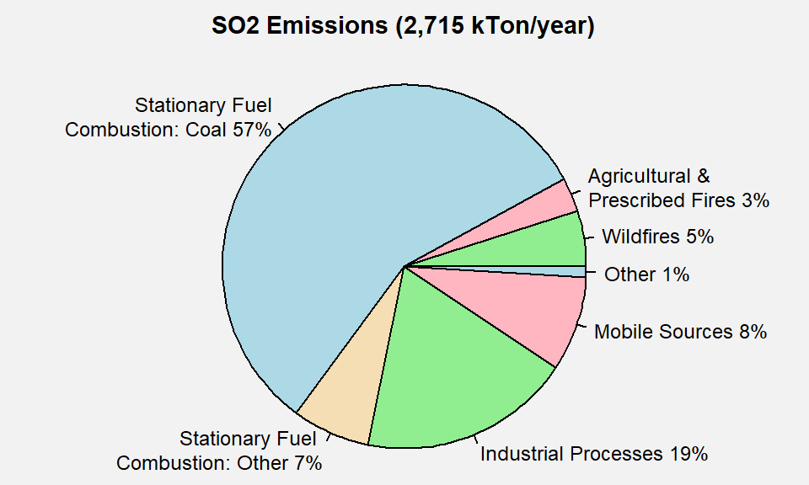

**Figure 1.** U.S. SO2 emissions by sector. **Source:** [2017 NEI](https://www.epa.gov/air-emissions-inventories/2017-national-emissions-inventory-nei-data).

     Figure 2 below illustrates the national SO2 emissions trends from 2002 to 20211. Declines in SO2 emissions are likely related to the implementation of national control programs developed under the Clean Air Act Amendments of 1990, including Phase I and II of the Acid Rain Program, the Clean Air Interstate Rule, the Cross-State Air Pollution Rule, and the adoption of low sulfur diesel fuel standards. An additional factor is changes in market conditions, such as the reduction of the use of coal in energy generation. These changes have resulted in a 87% decrease in SO2 emissions from 2002 to 2021, including reductions of 91% in emissions from EGUs and 96% in emissions from mobile sources.

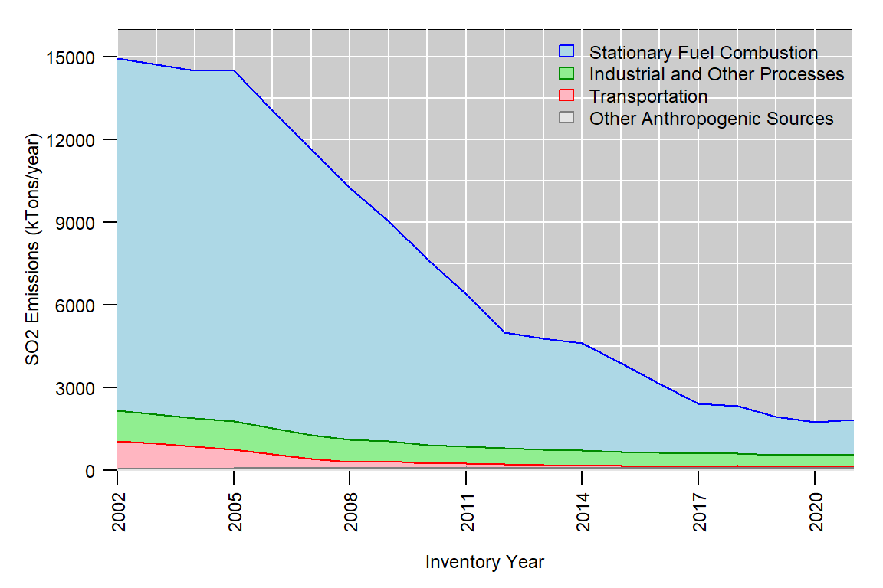

**Figure 2.** U.S. anthropogenic SO2 emissions trend, 2002-2021. **Source:** [EPA’s Air Pollutant Emissions Trends Data](https://www.epa.gov/air-emissions-inventories/air-pollutant-emissions-trends-data)

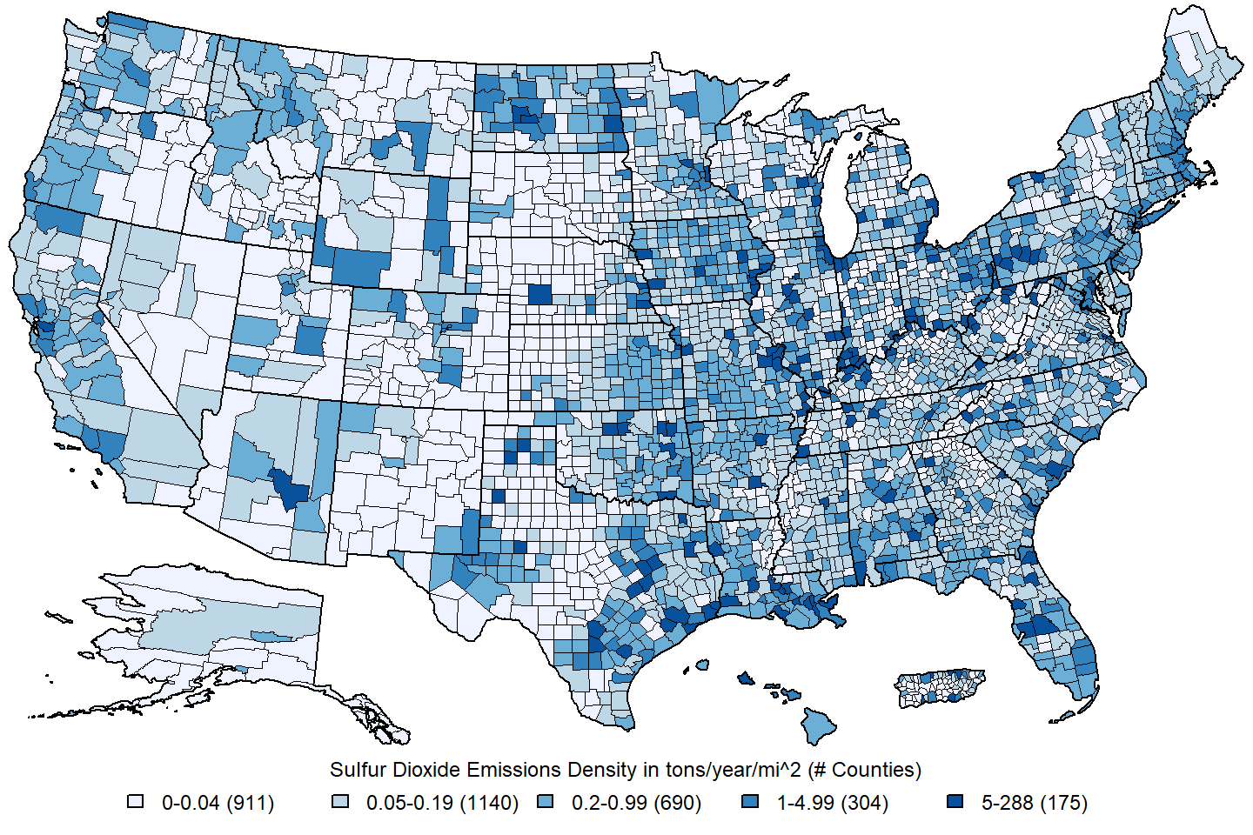 **Figure 3.** U.S. county-level SO2 emissions density estimates in tons/year/mi2. **Source:** [2017 NEI](https://www.epa.gov/air-emissions-inventories/2017-national-emissions-inventory-nei-data)

     Figure 3 shows the SO2 emissions density in tons/mi2/year for each U.S. county based on the 2017 NEI. The majority of SO2 emissions tend to be located near large point sources such as coal-fired EGUs or large industrial facilities. Counties near urban areas also tend to have higher SO2 emissions due to the higher concentration of industrial facilities. Counties in rural areas may also have higher emissions due to oil and gas extraction or fires.

**4. Ambient Air Monitoring Requirements and Monitoring Networks**

     Ambient SO2 concentrations are measured by monitoring networks operated by State, Local, and Tribal air agencies, which are typically funded in part by the EPA. Measurements are made using ultraviolet fluorescence (UVF) instruments, which are designated as Federal Reference Methods (FRMs) or Federal Equivalent Methods (FEMs) and the data are reported to EPA as hourly concentrations and either the maximum 5-minute concentration for each hour or twelve 5-minute average concentrations for each hour. There were 505 monitoring sites reporting hourly SO2 concentration data to the EPA during the 2019-2021 period. The locations of these monitoring sites are shown in Figure 4.

     The main network of monitors providing ambient data for use in implementation activities related to the NAAQS is the State and Local Air Monitoring Stations (SLAMS) network, which comprises over 75% of all SO2 monitoring sites. An important subset of SLAMS sites is the [NCore multipollutant monitoring network](https://www.epa.gov/amtic/ncore-monitoring-network), which was designed to collect consistent measurements of criteria pollutants for trends and NAAQS compliance purposes. The NCore was fully operational as of 2011 and consists of approximately 60 urban monitoring stations and 20 rural monitoring stations. Each State is required to have at least one NCore station.

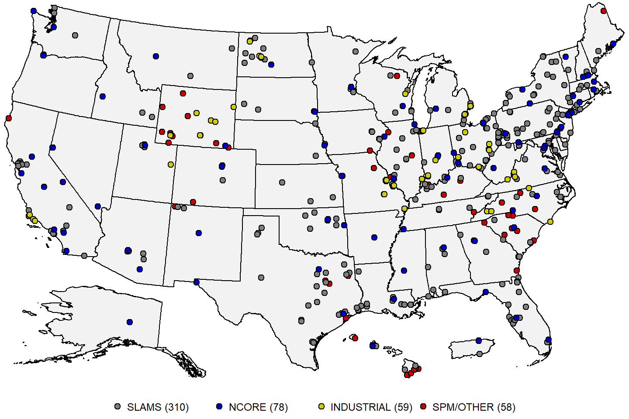 **Figure 4:** Map of U.S. SO2 monitoring sites reporting data to the EPA during the 2019-2021 period. **Source:** [AQS](https://www.epa.gov/aqs).

     In 2015, the EPA finalized the [Data Requirements Rule (DRR)](https://www.epa.gov/so2-pollution/final-data-requirements-rule-2010-1-hour-sulfur-dioxide-so2-primary-national-ambient), which required States to monitor or model ambient SO2 levels in areas with stationary sources of SO2 emissions of over 2,000 tons per year. The EPA identified over 300 sources meeting these criteria, and the States chose to set up ambient monitoring sites to assess compliance with the SO2 NAAQS near 71 of these sources. These monitors were required to begin operating by January 1, 2017 and collect data through the end of 2019 to show compliance with the SO2 NAAQS. Some of these monitors are operated by the States as SLAMS monitors, while others are operated by the industrial sources, which are shown as yellow dots on the map in Figure 4.

     Finally, there are also a number of Special Purpose Monitoring Stations (SPMs), which are not required but are often operated by air agencies for short periods of time (i.e., less than 3 years) to collect data for human health and welfare studies, as well as other types of monitoring sites, including monitors operated by federal agencies and tribal governments. The SPMs are typically not used to assess compliance with the NAAQS.

     To provide an assessment of data quality, monitoring agencies must perform quality assurance (QA) checks at least once every two weeks to derive estimates of precision and bias for SO2 and the other gaseous criteria pollutant measurements using calibration gas. For SO2 monitors, the data quality goal for precision and bias is 10 percent. Ambient air quality data and associated QA data are reported to the EPA via the [Air Quality System (AQS)](https://www.epa.gov/aqs).2 Data are reported quarterly and must be submitted to AQS within 90 days after the end of each calendar quarter (i.e. Jan/Feb/Mar, Apr/May/Jun, Jul/Aug/Sep, Oct/Nov/Dec). Additionally, each monitoring agency is required to certify all FRM/FEM data that is submitted to AQS annually, taking into consideration any QA findings, and a data certification letter must be sent to the EPA Regional Administrator by May 1st of the following year.

**5. Data Handling Conventions and Computations for Determining Whether the Standards are Met**

     To assess whether a monitoring site or geographic area (usually a county or urban area) meets or exceeds a NAAQS, the monitoring data are analyzed consistent with the established regulatory requirements for the handling of monitoring data for the purposes of deriving a design value. A design value summarizes ambient air concentrations for an area in terms of the indicator, averaging time and form for a given standard such that its comparison to the level of the standard indicates whether the area meets or exceeds the standard. The primary SO2 NAAQS has a 1-hour averaging time, which was established in 2010. The procedures for calculating design values for the primary SO2 NAAQS are detailed in [Appendix T to 40 CFR Part 50](https://www.ecfr.gov/current/title-40/part-50/appendix-Appendix%20T%20to%20Part%2050) and are summarized below.

     Hourly SO2 measurement data collected at an ambient air monitoring site using FRMs or FEMs, meeting all applicable requirements in 40 CFR Part 58, and reported to AQS in parts per billion (ppb) with decimal digits after the first decimal place truncated are used in design value calculations. If multiple monitors collect measurements at the same site, one monitor is designated as the primary monitor. Measurement data collected with the primary monitor are used to calculate the design value, and may be supplemented with data from collocated monitors whenever data is not available for the primary monitor.

     First, the maximum hourly concentration is determined for each day (i.e., the “daily maximum value”) in a given 3-year period. For each year, the 99th percentile of the daily maximum values is determined, and the design value is the average of the three annual 99th percentile values, rounded to the nearest integer in ppb. The primary SO2 NAAQS is met when the design value is less than or equal to 75 ppb, the level of the NAAQS.

     In addition, the design value must meet data completeness requirements in order to be considered valid. Specifically, a sample day is considered complete when at least 18 hourly measurements are reported. For each calendar quarter, the quarter is considered complete if at least 75% of the days in the quarter have complete data. The primary SO2 design value is considered complete when all 12 calendar quarters in the 3-year period have complete data. In addition, there are two data substitution tests specified in Appendix T to 40 CFR Part 50 which may be used to yield a valid design value above or below the NAAQS, respectively, in the event that a site falls short of the minimum data completeness requirement.

**6. SO2 Concentrations Measured at Ambient Air Monitoring Sites Across the U.S.**

     Table 1 below presents summary statistics based on two daily SO2 metrics, the daily maximum 1-hour (MDA1) metric, and the daily 24-hour average (DA24) metric. These statistics are presented for year-round and each season (winter=Dec/Jan/Feb, spring=Mar/Apr/May, summer=Jun/Jul/Aug, autumn=Sep/Oct/Nov) based on data reported to AQS for 2019-2021. Table 2 presents the same set of summary statistics for the two daily SO2 metrics based on four types of sites: source-oriented sites, urban non-source sites, rural non-source sites, and sites in Hawaii County, HI which are regularly impacted by natural SO2 emissions from volcanic eruptions. Table 1 shows that SO2 concentrations are generally similar throughout the year, and that the vast majority of concentrations measured in recent years are well below the NAAQS. The distribution of measured SO2 concentrations is very skewed, with a mean concentration that is approximately three times higher than the median concentration. Table 2 shows that while median SO2 concentrations at source-oriented sites are only slightly higher than at non-source sites in urban areas, the peak concentrations measured at source oriented sites are several times higher than those measured at non-source sites in urban areas. Rural non-source sites typically measure slightly lower concentrations than urban non-source sites, while the Hawaii sites affected by volcanic eruptions usually measure higher concentrations than a typical source-oriented site. The very high maximum concentration at an urban non-source site in Illinois appears to be an isolated occurrence whose cause is unknown.

**Table 1.** National distribution of SO2 concentrations in ppb by season for 2019-2021.3 **Source:** [AQS](https://www.epa.gov/aqs).

|  |  |  |  |  |  |  |  |  |  |  |  |  |  |  |  |  |  |  |
| --- | --- | --- | --- | --- | --- | --- | --- | --- | --- | --- | --- | --- | --- | --- | --- | --- | --- | --- |
| metric | season | N.sites | N.obs | mean | SD | min | p1 | p5 | p10 | p25 | p50 | p75 | p90 | p95 | p98 | p99 | max | max.site |
| MDA1 | all | 402 | 429,661 | 3.0 | 13.0 | -3.7 | -0.1 | 0 | 0 | 0.3 | 0.9 | 2.0 | 5.0 | 11.0 | 24.1 | 39.2 | 2,732.4 | 171193007 |
| MDA1 | winter | 401 | 105,937 | 3.0 | 13.7 | -2.0 | -0.1 | 0 | 0 | 0.3 | 1.0 | 2.0 | 4.6 | 10.0 | 23.3 | 40.0 | 1,980.6 | 150012020 |
| MDA1 | spring | 400 | 108,468 | 3.1 | 12.6 | -3.4 | -0.1 | 0 | 0 | 0.3 | 0.9 | 2.0 | 5.2 | 12.0 | 26.2 | 42.0 | 564.5 | 120570112 |
| MDA1 | summer | 397 | 107,212 | 2.9 | 13.2 | -2.7 | -0.1 | 0 | 0 | 0.3 | 0.9 | 2.0 | 5.4 | 11.0 | 22.7 | 36.0 | 2,732.4 | 171193007 |
| MDA1 | autumn | 394 | 105,117 | 3.1 | 12.8 | -3.7 | -0.2 | 0 | 0 | 0.3 | 1.0 | 2.0 | 5.1 | 11.1 | 24.7 | 40.2 | 881.0 | 271630436 |
| DA24 | all | 402 | 429,661 | 0.9 | 3.6 | -3.7 | -0.4 | 0 | 0 | 0.1 | 0.4 | 0.9 | 1.8 | 2.7 | 4.8 | 7.7 | 395.0 | 150012020 |
| DA24 | winter | 401 | 105,937 | 0.9 | 3.9 | -2.4 | -0.4 | 0 | 0 | 0.1 | 0.4 | 1.0 | 1.8 | 2.6 | 5.0 | 8.7 | 395.0 | 150012020 |
| DA24 | spring | 400 | 108,468 | 0.9 | 3.9 | -3.5 | -0.4 | 0 | 0 | 0.1 | 0.4 | 0.9 | 1.8 | 2.6 | 4.9 | 7.8 | 222.3 | 291439002 |
| DA24 | summer | 397 | 107,212 | 0.8 | 3.0 | -2.9 | -0.4 | 0 | 0 | 0.1 | 0.4 | 0.9 | 1.8 | 2.6 | 4.3 | 6.6 | 212.3 | 171193007 |
| DA24 | autumn | 394 | 105,117 | 0.9 | 3.8 | -3.7 | -0.5 | 0 | 0 | 0.1 | 0.4 | 1.0 | 1.8 | 2.9 | 4.9 | 7.9 | 296.1 | 291439001 |

N.sites = number of sites; N.obs = number of observations; SD = standard deviation; min = minimum; p1, p5, p10, p25, p50, p90, p95, p98, p99 = 1st, 5th, 10th, 25th, 50th, 90th, 95th, 98th, 99th percentiles; max = maximum; max.site = AQS ID number for the monitoring site corresponding to the observation in the max column. winter = December/January/February; spring = March/April/May; summer = June/July/August; autumn = September/October/November.

**Table 2.** Distribution of SO2 concentrations in ppb by site type for 2019-2021.3 **Source:** [AQS](https://www.epa.gov/aqs).

|  |  |  |  |  |  |  |  |  |  |  |  |  |  |  |  |  |  |  |
| --- | --- | --- | --- | --- | --- | --- | --- | --- | --- | --- | --- | --- | --- | --- | --- | --- | --- | --- |
| metric | site.type | N.sites | N.obs | mean | SD | min | p1 | p5 | p10 | p25 | p50 | p75 | p90 | p95 | p98 | p99 | max | max.site |
| MDA1 | All | 402 | 429,661 | 3.0 | 13.0 | -3.7 | -0.1 | 0 | 0 | 0.3 | 0.9 | 2.0 | 5.0 | 11.0 | 24.1 | 39.2 | 2,732.4 | 171193007 |
| MDA1 | Source Oriented | 161 | 172,216 | 5.1 | 17.4 | -2.7 | -0.2 | 0 | 0 | 0.4 | 1.1 | 3.0 | 11.0 | 21.9 | 42.5 | 67.4 | 881.0 | 271630436 |
| MDA1 | Urban Non-Source | 202 | 215,820 | 1.6 | 7.0 | -3.7 | -0.1 | 0 | 0 | 0.3 | 0.8 | 1.6 | 3.1 | 5.3 | 10.0 | 14.8 | 2,732.4 | 171193007 |
| MDA1 | Rural Non-Source | 33 | 35,297 | 0.9 | 1.4 | -1.4 | 0.0 | 0 | 0 | 0.2 | 0.4 | 1.0 | 2.1 | 2.9 | 4.0 | 5.9 | 34.9 | 380130004 |
| MDA1 | Hawaii Volcanic | 6 | 6,328 | 6.4 | 36.6 | -2.0 | 0.0 | 0 | 0 | 0.9 | 1.8 | 3.5 | 6.3 | 17.0 | 56.2 | 102.4 | 1,980.6 | 150012020 |
| DA24 | All | 402 | 429,661 | 0.9 | 3.6 | -3.7 | -0.4 | 0 | 0 | 0.1 | 0.4 | 0.9 | 1.8 | 2.7 | 4.8 | 7.7 | 395.0 | 150012020 |
| DA24 | Source Oriented | 161 | 172,216 | 1.3 | 5.4 | -3.5 | -0.6 | 0 | 0 | 0.1 | 0.5 | 1.1 | 2.3 | 3.9 | 7.9 | 13.3 | 315.2 | 291439001 |
| DA24 | Urban Non-Source | 202 | 215,820 | 0.6 | 1.1 | -3.7 | -0.3 | 0 | 0 | 0.1 | 0.3 | 0.8 | 1.4 | 2.0 | 3.0 | 4.0 | 212.3 | 171193007 |
| DA24 | Rural Non-Source | 33 | 35,297 | 0.4 | 0.6 | -1.4 | -0.1 | 0 | 0 | 0.1 | 0.2 | 0.6 | 1.1 | 1.6 | 2.2 | 2.5 | 15.3 | 460710001 |
| DA24 | Hawaii Volcanic | 6 | 6,328 | 2.2 | 7.1 | -2.0 | -0.3 | 0 | 0 | 0.5 | 1.3 | 2.3 | 3.7 | 4.9 | 13.4 | 22.3 | 395.0 | 150012020 |

N.sites = number of sites; N.obs = number of observations; SD = standard deviation; min = minimum; p1, p5, p10, p25, p50, p90, p95, p98, p99 = 1st, 5th, 10th, 25th, 50th, 90th, 95th, 98th, 99th percentiles; max = maximum; max.site = AQS ID number for the monitoring site corresponding to the observation in the max column.

     Figure 5 below shows a map of the 1-hour SO2 design values at U.S. ambient air monitoring sites based on data the 2019-2021 period. There were 15 sites with design values exceeding the NAAQS. The maximum design value was 376 ppb at a monitoring site near an industrial park in Missouri. The sites with design values exceeding the NAAQS in Hawaii are due to natural SO2 emissions from recurring volcanic eruptions.

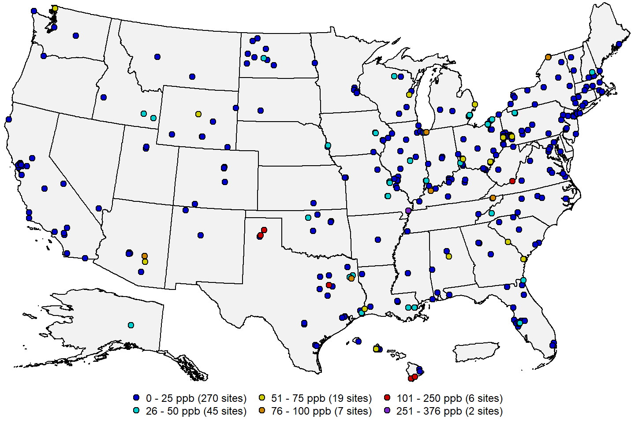 **Figure 5:** SO2 design values in ppb for the 2019-2021 period. **Source:** [AQS](https://www.epa.gov/aqs).

     Figure 6 below shows a map of the site-level trends in the 1-hour SO2 design values at U.S. monitoring sites having valid a design value in at least 15 of the 20 3-year periods from 2000 through 2021. The trends were computed using the Thiel-Sen estimator, and tests for significance (p-value < 0.05) were computed using the Mann-Kendall test. From this figure it is apparent that SO2 concentrations have been decreasing at nearly all sites in the U.S, and there were no sites with significant increasing trends.

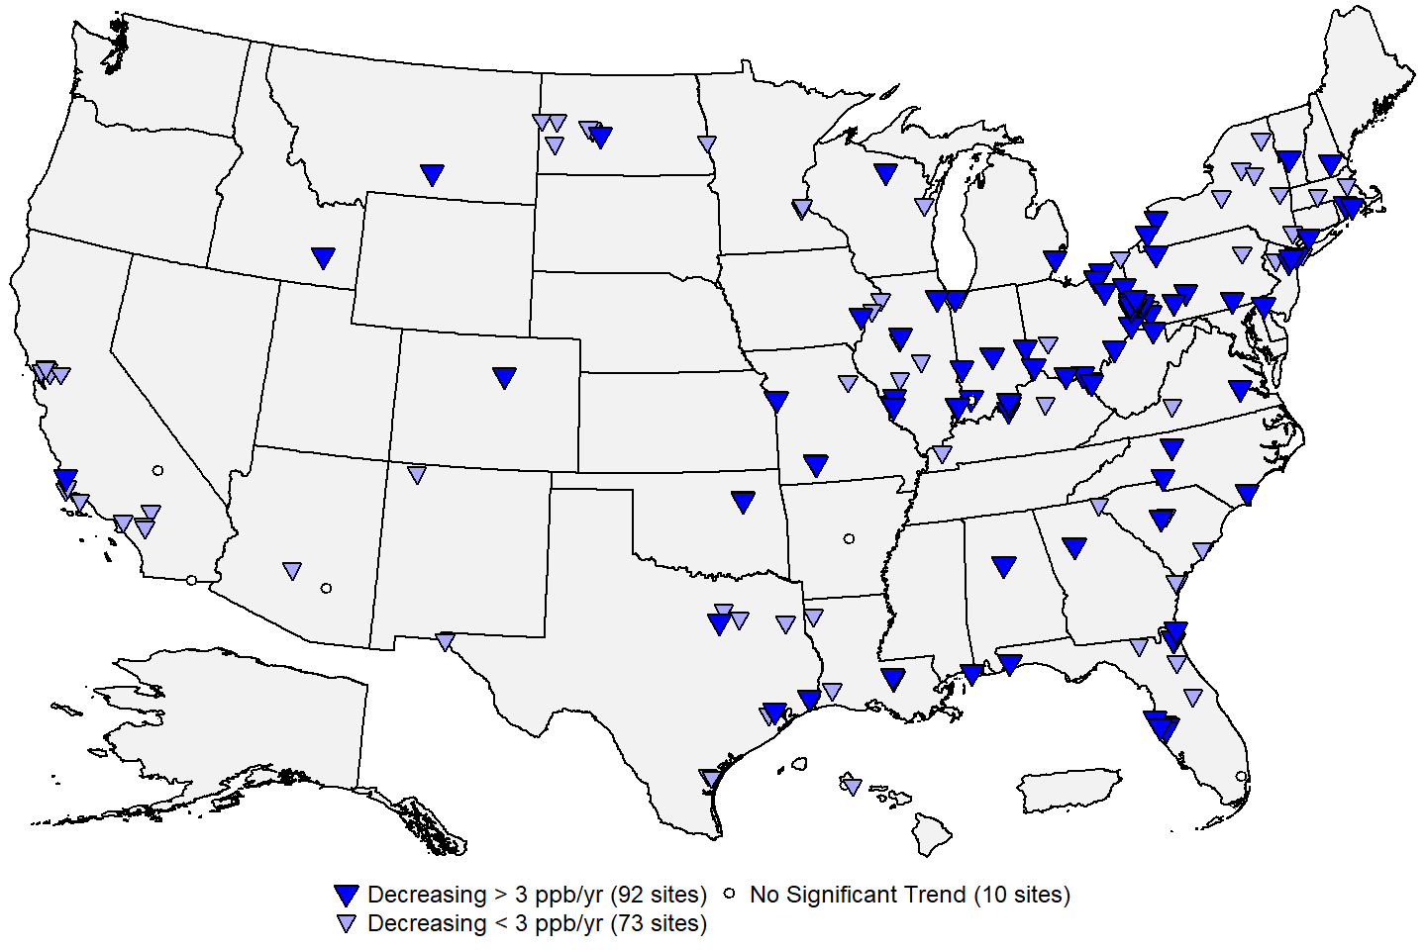 **Figure 6:** Site-level trends in 1-hour SO2 design values based on data from 2000 through 2021. **Source:** [AQS](https://www.epa.gov/aqs), trends computed using R statistical software.

     Figure 7 below shows the national trends in the 1-hour SO2 design values based on the 175 sites shown in Figure 6. The national median of the design values has decreased by about 90% from 69 ppb in 2000 to 7 ppb in 2021.

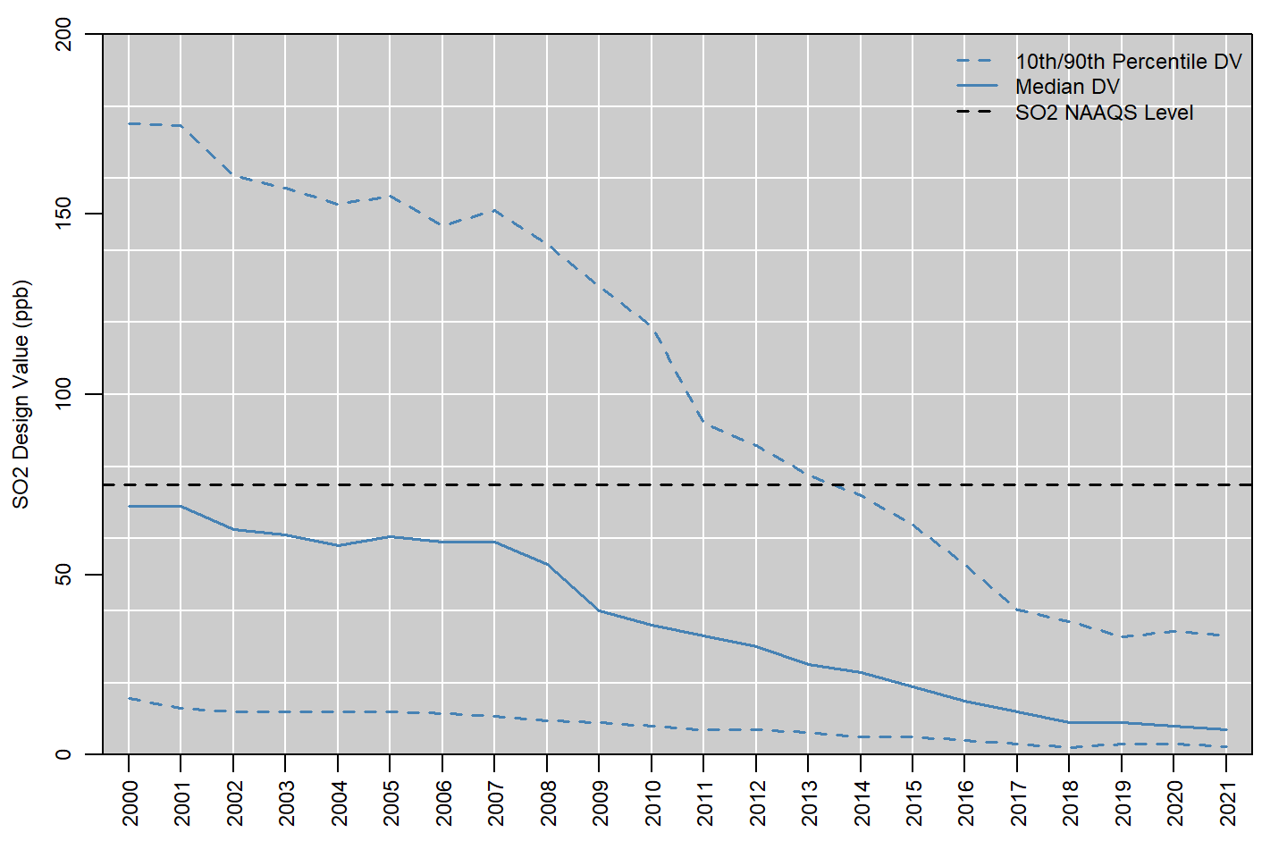

**Figure 7:** National trends in SO2 design values in ppb, 2000 to 2021. **Source:** [AQS](https://www.epa.gov/aqs).

     Figure 8 below shows the national distribution of the annual 99th percentile MDA1 SO2 concentrations reported in each year from 1980 to 2021.4 The red line shows the number of sites included in the boxplot for each year, and the high concentrations originating from the sites in Hawaii influenced by volcanic eruptions are marked with orange dots. The median annual 99th percentile MDA1 SO2 concentration decreased by about 95 percent, from 130 ppb in 1980 to 6.7 ppb in 2021. While annual 99th percentile values as high as 2,000 ppb (2 ppm) were measured near some industrial sources in the 1980s, all of the 99th percentile concentration values above 500 ppb that have been reported since 2010 have come from sites in Hawaii that are influenced by volcanic eruptions. The SO2 monitoring network grew quickly in the early 1980s, reaching a peak size of over 750 sites in 1984. Since then, the monitoring network has slowly decreased in size as many sites measuring low concentrations have been discontinued. There was a brief increase in the number of sites in 2017, as SO2 monitors required through the DRR (see section 4 above for more information) came online. These additional sites were all located near major industrial sources of SO2 and likely caused the slight increase in the median concentration observed in 2017.

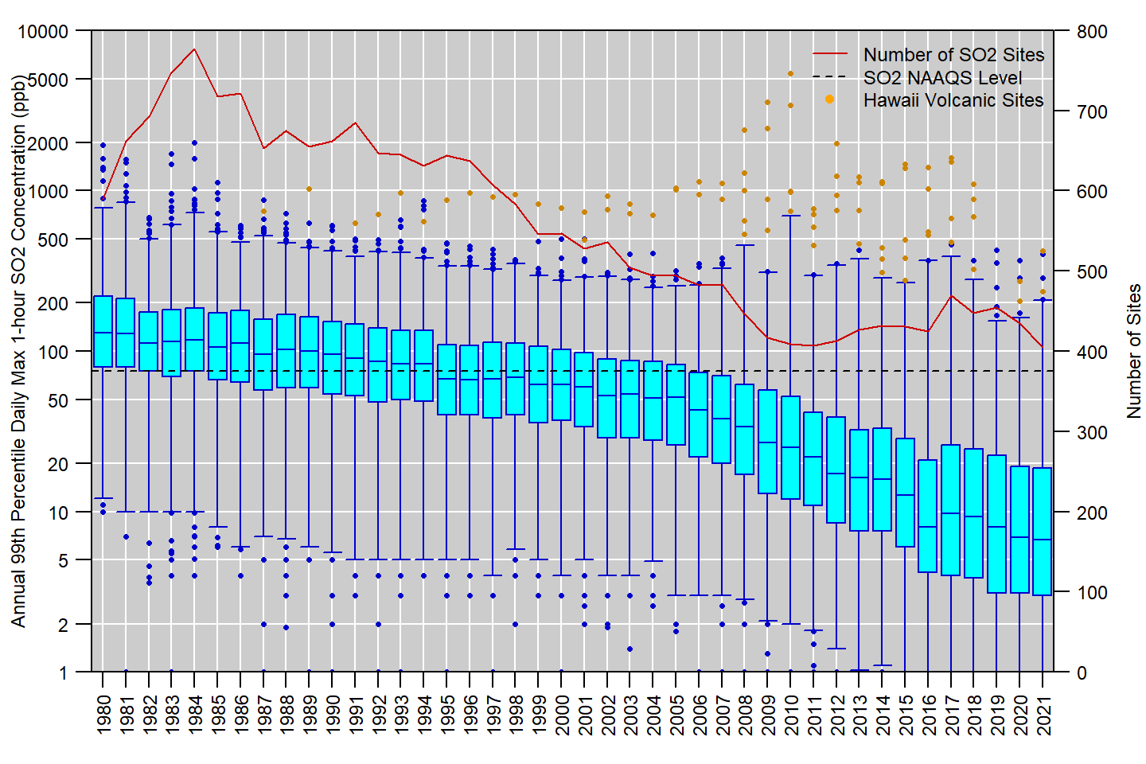 **Figure 8:** Distribution of annual 99th percentile MDA1 SO2 concentrations measured at U.S. monitoring sites, 1980 to 2021. Boxes represent the median and interquartile range, whiskers extend to the 1st and 99th percentiles, and values outside this range are shown as circles.5 The red line shows the number of SO2 monitoring sites reporting data to EPA in each year. **Source:** [AQS](https://www.epa.gov/aqs).

**References**

U.S. EPA. [Integrated Science Assessment for Sulfur Oxides - Health Criteria (Final Report, December 2017)](https://cfpub.epa.gov/ncea/isa/recordisplay.cfm?deid=338596). U.S. Environmental Protection Agency, Washington, DC, EPA/600/R-17/451, 2017.

U.S. EPA. [Policy Assessment for the Review of the Primary NAAQS for Sulfur Oxides (Final Report, May 2018)](https://www.epa.gov/sites/default/files/2018-05/documents/primary_so2_naaqs_-_final_pa_-_may_2018.pdf). U.S. Environmental Protection Agency, Research Triangle Park, NC, EPA-452/R-18-002, 2018.

**Additional Resources**

* [Sulfur Dioxide (SO2) Pollution](https://www.epa.gov/so2-pollution)
* [Sulfur Dioxide (SO2) Primary Air Quality Standards](https://www.epa.gov/naaqs/sulfur-dioxide-so2-primary-air-quality-standards)
* [National Emissions Inventory (NEI)](https://www.epa.gov/air-emissions-inventories/national-emissions-inventory-nei)
* [Ambient Monitoring Technology Information Center (AMTIC)](https://www.epa.gov/amtic)
* [Air Quality Design Values](https://www.epa.gov/air-trends/air-quality-design-values)
* [National Air Quality: Status and Trends of Key Air Pollutants](https://www.epa.gov/air-trends)
* [Air Data: Air Quality Data Collected at Outdoor Monitors Across the U.S.](https://www.epa.gov/outdoor-air-quality-data)

**Footnotes:**

1. Data for Figure 2 come from the EPA’s [Air Pollutant Emissions Trends Data](https://www.epa.gov/air-emissions-inventories/air-pollutant-emissions-trends-data). Note that emissions for some sectors are interpolated between inventory years, and the emissions for some sectors are held constant beyond the most recent inventory year (for details, see the “Development of Data” table in the [national emissions trends data file](https://www.epa.gov/sites/default/files/2021-03/national_tier1_caps.xlsx). For the purposes of this document, wildfires are considered to be natural emissions and thus are not included in Figure 2.↩︎
2. Quality assurance requirements for monitors used in evaluations of the NAAQS are provided in [Appendix A to 40 CFR Part 58](https://www.ecfr.gov/current/title-40/part-58/appendix-Appendix%20A%20to%20Part%2058). Annual summary reports of precision and bias can be obtained for each monitoring site at the EPA’s [Air Data website](https://www.epa.gov/outdoor-air-quality-data/single-point-precision-and-bias-report).↩︎
3. Negative concentration values may appear in AQS datasets down to the negative of the lower detection limit (LDL) to allow for normal instrument variability at very low concentrations. Data that exceed the negative of the LDL is typically indicative of a malfunction or another issue that affects the data defensibility.↩︎
4. For this analysis, the annual 99th percentile MDA1 SO2 concentrations were retrieved from AQS for all U.S. sites for years that had at least 75% annual data completeness.↩︎
5. In Figure 8, orange circles are used to represent measurements from sites on the big island of Hawaii, while blue circles are used to represent measurements from all other sites.↩︎