**1.**

A sky diver is falling at terminal speed when she opens her parachute. What is the direction of her velocity vector and the direction of her acceleration vector before she reaches the new terminal speed?

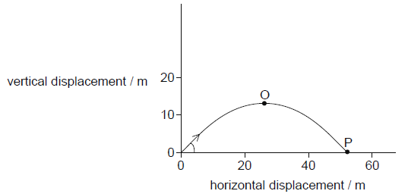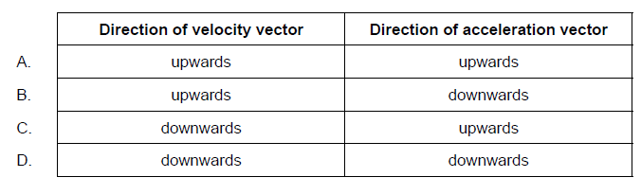

**2.**

A stone is thrown downwards from the edge of a cliff with a speed of 5.0 m s. It hits the ground 2.0 s later. What is the height of the cliff?

A. 20 m

B. 30 m

C. 40 m

D. 50 m

**3.**

A ball is thrown upwards at an angle to the horizontal. Air resistance is negligible. Which statement about the motion of the ball is correct?

A. The acceleration of the ball changes during its flight.

B. The velocity of the ball changes during its flight.

C. The acceleration of the ball is zero at the highest point.

D. The velocity of the ball is zero at the highest point.

**4.**

A truck has an initial speed of 20 m s. It decelerates at 4.0 m s. What is the distance taken by the truck to stop?

A.   2.5 m

B.   5.0 m

C.   50 m

D.   100 m

**5.**

A projectile is fired at an angle to the horizontal. Air resistance is negligible. The path of the projectile is shown.



Which gives the magnitude of the horizontal component and the magnitude of the vertical component of the velocity of the projectile between O and P?

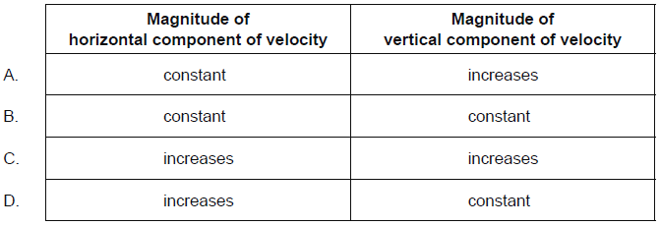

**6.**

An object is projected vertically upwards at time *t* = 0. Air resistance is negligible. The object passes the same point above its starting position at times 2 s and 8 s.

If g = 10 m s, what is the initial speed of the object?

A.     50

B.     30

C.     25

D.     4

**7.**

Two balls of equal mass are dropped from the top of a tall building one after the other. Air resistance is negligible. The distance between the balls

A.     increases with time.

B.     depends on the initial velocity only.

C.     remains constant.

D.     depends on the mass of the balls.