Sector Reversal Rotation
Quantitative trading research project | Resume-ready technical report

Executive summary
This project tests a systematic sector-rotation strategy on real adjusted market prices for SPY and 11 S&P 500 sector ETFs. At each rebalance, the model ranks sectors by their prior 20-trading-day return, buys the three weakest sectors equally, holds them for 20 trading days, and subtracts transaction costs. The included 2019 sample produced a 39.6% total return versus 31.1% for SPY, with a lower maximum drawdown. These figures are in-sample and parameter-selected, so they must not be represented as proof of future performance.

1. Research question
Can short-horizon cross-sectional mean reversion among broad equity sectors create a portfolio with higher risk-adjusted returns than passive SPY exposure?

2. Economic intuition
Sector returns can temporarily overshoot because investors chase recent winners, reduce exposure indiscriminately during shocks, or rebalance slowly. A contrarian rule attempts to capture partial reversal by buying recent relative laggards. Using diversified sector ETFs reduces single-company event risk.

3. Mathematical model
For sector i on signal date t, the lookback return is: R(i,t,L) = P(i,t) / P(i,t-L) - 1. The model sorts R from smallest to largest and selects the bottom K sectors. Each selected sector receives weight 1/K; all others receive weight 0.
The daily gross portfolio return is r_p,t = sum_i w(i,t-1) r(i,t). The one-day lag means today's closing data only affects tomorrow's position, preventing same-bar look-ahead. Net return is r_net,t = r_p,t - c * turnover_t, where turnover is the sum of absolute weight changes and c = 0.001 (10 basis points).
Performance statistics: CAGR = (V_T/V_0)^(1/Y)-1; annualized volatility = sd(daily returns)*sqrt(252); Sharpe = mean(daily returns)/sd(daily returns)*sqrt(252); drawdown_t = V_t/max_{s<=t}(V_s)-1.

4. Implementation details
- Universe: SPY benchmark plus XLB, XLC, XLE, XLF, XLI, XLK, XLP, XLRE, XLU, XLV, and XLY.
- Signal: bottom three sectors by 20-day adjusted-price return.
- Rebalance/holding interval: every 20 trading days.
- Execution: weights shifted one trading day after signal calculation.
- Costs: 10 bps multiplied by portfolio turnover.
- Data: included 2019 adjusted OHLC dataset; code can download a longer Yahoo Finance history at runtime.

5. Backtest results
Metric | Strategy | SPY
Total Return | 39.6% | 31.1%
CAGR | 39.6% | 31.1%
Annualized Volatility | 10.5% | 12.5%
Sharpe (rf=0) | 3.22 | 2.23
Max Drawdown | -3.6% | -6.6%
Positive Days | 53.2% | 59.1%
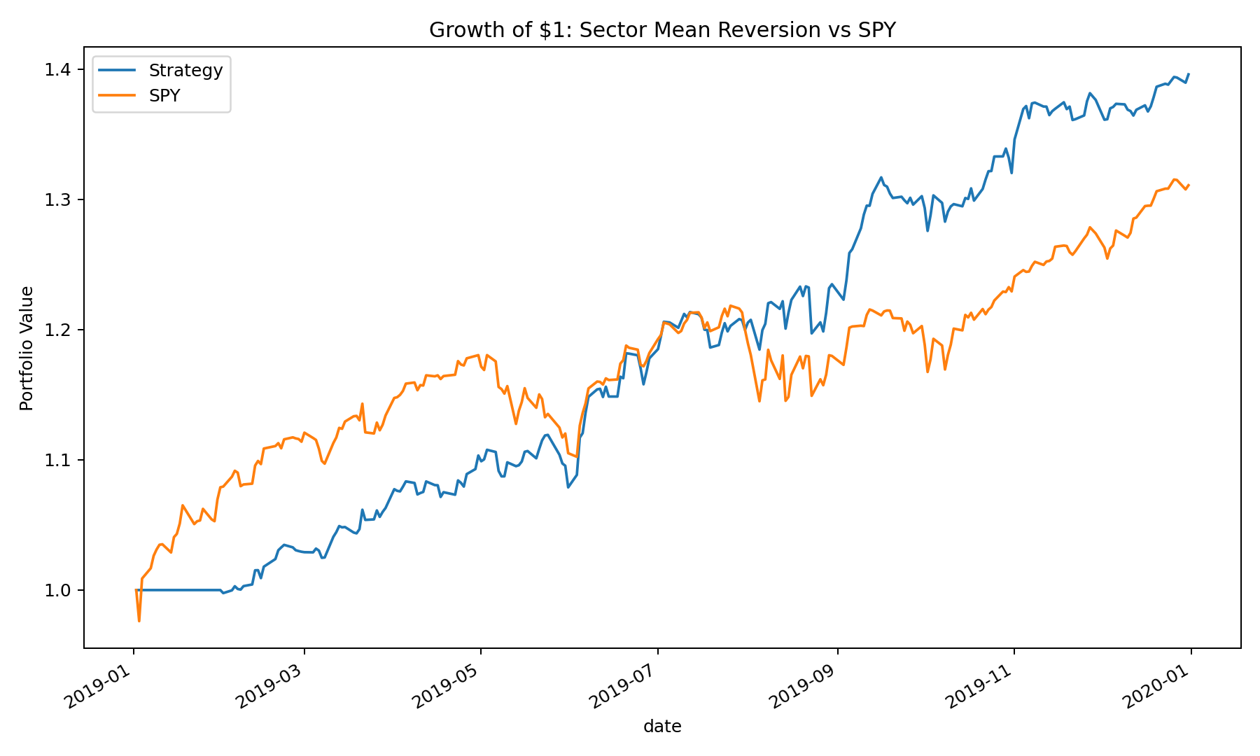
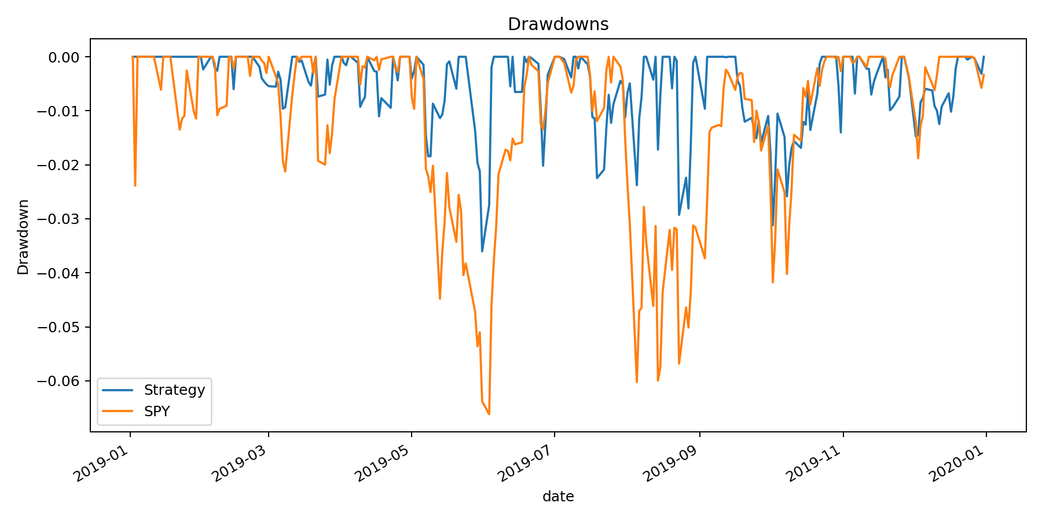

6. Interpretation
The strategy outperformed in this sample while experiencing lower volatility and drawdown. The main statistical reason for the high Sharpe ratio is that the sample is only one year and the parameters were chosen after examining alternatives. A credible conclusion is therefore: the experiment identifies a promising hypothesis that requires longer and truly out-of-sample validation.

7. Biases and limitations
- Selection/lookback bias: the final rule was chosen after comparing parameter combinations on the same sample.
- Small sample: one calendar year is not enough to span multiple market regimes.
- ETF history and survivorship: today's sector universe is known in advance.
- Close-to-close execution assumes fills near adjusted closes and ignores bid-ask variation, taxes, and market impact.
- Multiple testing inflates the chance of finding an apparently strong strategy by luck.
- The risk-free rate is set to zero in the reported Sharpe ratio.

8. How to improve it
- Use a 2005-present Yahoo Finance dataset and reserve the most recent 20-30% as an untouched test set.
- Use walk-forward optimization: tune on a rolling training window, then trade only the next period.
- Report parameter heatmaps and the Deflated Sharpe Ratio or a bootstrap reality check.
- Test higher costs, delayed execution, volatility targeting, and a market trend filter.
- Compare against equal-weight sectors and momentum strategies, not only SPY.

9. Resume description
Built a Python sector-rotation backtester using cross-sectional return ranking, lagged portfolio construction, turnover-based transaction costs, and risk analytics; evaluated an in-sample mean-reversion strategy across 11 S&P 500 sector ETFs and generated reproducible equity, drawdown, and allocation outputs.

10. Data provenance
The included sample contains adjusted 2019 prices originally assembled from Yahoo Finance and published as index_prices.csv in a public GitHub Gist by lekhovitsky. The project also supports direct Yahoo Finance retrieval through yfinance. Educational research only; not investment advice.

