Fara-Wayland Collection Site Plan

Ben Wayland

WDD 130

Overview

Purpose
The purpose of this website is to provide a human-curated catalog of things that I find interesting. It’ll spotlight things that other might not have heard about, maybe they’ll find something new that they’ll love.

Audience
This is for a general audience. People who might use this site are people who want to find something new they might not have known about before.

Branding

Website Logo


Style Guide

Color Palette
Primary | Secondary | Accent 1 | Accent 2
#02111B | #FCFCFC | #30292F | #5D737E

Typography

Heading Font: Bagel Fat One

Paragraph Font: Bpmf Huninn

Navigation
Home Comedy Animation Educational Fun

Content

Website Description:
This is Fara-Wayland Collection, a little website that just showcases several YouTube channels I find interesting. These are all human-curated channels that I think more people should know about. Some of them are small, some of them are big, but I think they all give value to this world, and I just want to share that with others.

Comedy Page Description:
These channels are the funny ones. These are channels that have genuine humor to them. One making fun of the hype around the modern software industry, and one making fun of strange cultural differences in living in another country.

Alberta Tech
https://www.youtube.com/@albertatech
Alberta makes videos making fun of a lot of the hype around the software industry. And with AI she has had a lot to talk about and make fun of. I would recommend watching this video making fun of vibe coders.

Richard Lindesay
https://www.youtube.com/@richardlindesay
This is THE Richard playing his recorder in the corner. He also makes tons of other short-form videos that have a little funny song to them. I would recommend this short of his about consecutive numbers.

Justan Oval
https://www.youtube.com/@justanoval
Justan oval makes funny and almost surreal songs with absurd topics including, but not limited to, sharks with lasers, krill Miku, Mr. Shy Frog, Pip the Shrimp, and holy burger. All of this is accompanied by crunchy, low-poly animations. A good video of his is it's a seal!

Raxdflipnote
https://www.youtube.com/@raxdflipnote/videos
Raxdflipnote is known for making mostly short-form comedic animations entirely using the animation program Flipnote Studio on the Nintendo DS with it’s low pixels and crunchy audio. A lot of it feels like brainrot, but, at least in my opinion, is the good kind of brainrot. He also has a few long-form story-time animations. He is well known for his “gamblecore” series with the iconic phrase, “Let’s go gambling! Ahh Dang it! Ahh Dang it! …”. This long-form video is a good one explaining how gamblecore affected him.

Uyen Ninh
https://www.youtube.com/@uyenninh
Uyen grew up in Vietnam and later in life went to live in Germany to get an education and to be with her boyfriend (now husband) she met on the internet. She found success in making funny short-form videos that make fun of the massive cultural differences between living in Vietnam and in Germany. This is a good recent short of hers.

Animation Page Description:
This is where there are really talented artists. They’re just putting what they do up online for free. These include story-time animators, including some really small channels. There’s also some telling a story and making a world in their art.

Ice Cream Sandwich
https://www.youtube.com/@IceCreamSandwich/videos
Ice Cream Sandwich is a story-time animator, but he also will sometimes ask silly questions of his audience such as “Which video game item would you chose to: 1) survive a zombie apocalypse 2) use for every day things 3) annex Toronto” and animated his thoughts on people’s responses. You can find that video here.

Vritziestar
https://www.youtube.com/@vritziestar
Vritziestar is a very small story-time animation channel that only really started not too long ago. She is an amazing artist who loves cute things and drawing cute things. A good one of hers is this video on her thoughts on bugs.

Coopymations
https://www.youtube.com/@Coopymations
Coopymations is another recent story-time animator that only started 5 months ago! He is a bit more chill of an animator. I would recommend this video where he discusses a bad experience on his first job.

Luke Humphris
https://www.youtube.com/@lukehumphris
In Luke Humphris’s animations he shows these fascinating worlds of his own creation. Many of the worlds and themes he explores are on the darker side with there being videos of life “after society collapsed”, liminal spaces, and cosmic horror, but they always have a hopeful edge to them. There’s always someone being hopeful even in inevitable death and always people rebuilding after society collapsed. This video is a compilation of his Inter-C-Zone series. It’s an amazing trek through several fascinating liminal spaces.

Its ok koy
https://www.youtube.com/@itsokkoy
Its ok koy animates over songs. A lot of the songs he covers are more serious songs. He also manages to tell a unique story from in between the lines. For example, in this video, a cover of Aimee Carty’s 2 days into college, early in the song it mentions how the protagonist didn’t want to get into a relationship with a boy named Colin because he didn’t play guitar. Throughout the song we see Colin learning to play the guitar. There’s several cute things like this sprinkled throughout Its ok koy’s videos.

Jim EdLee
https://www.youtube.com/@Jim_EdLee
Jim EdLee animates shorts (not quite short-form content because they’re horizontal). He is most well known for his “You Cant Run Forever” series that stars a silent protagonist traveling with this insane blue guy as they try to find a hospital. The series is very comedic and has them traveling through this haunted forest that is full of cryptids, but it’s often that the blue guy just owes the money. A good video from this series is Road Trip.

Educational Page Description:
You might notice that this is the largest page on here, that’s because I really like learning things. These have videos on AI and why they’re so complex and potentially dangerous. There’s also some talking about silly though experiments like “What if we drained the ocean?”, or “Can you draw every flag in Powerpoint?”.

Rational Animations
https://www.youtube.com/@RationalAnimations
Rational Animations is a channel that talks about the potential dangers of Artificial Intelligence and also how we can prevent it. All of this is wonderfully animated and has cute dogs as people. They also talk about aligning AI and how difficult it is. I would recommend this video about a 100-year-old horse and measuring AI intelligence.

Siliconversations
https://www.youtube.com/@Siliconversations
Siliconversations talks about AI safety and the steps we are trying to take to put that safety into place. All of it is animated in stick figures and is often done in a silly way. This video is a good summary of what he stands for and talks about an open letter on AI safety.

Vlogbrothers
https://www.youtube.com/@vlogbrothers
Vlogbrothers is a very, very long running YouTube channel that existed since before YouTube had an algorithm. It is in the format of two brothers Hank and John Green telling each other about things they find interesting or talking about things they find important. John Green is a well-known author and the leader in preventing the world’s most infections, curable disease that you have may have never heard of, Tuberculosis. Hank Green is well known for his own YouTube channel, “Hank Green” that is formatted similarly to Vlogbrothers. He is also known for having started several companies and projects including starting Complexly, a company that produces several shows that Hank Green often hosts including Crash Course. On Vlogbrothers they often talk about the current situation in the world and about projects they have been working on. It’s difficult to recommend a specific video so here is the most recent as of writing.

Veritasium
https://www.youtube.com/@veritasium
Veritasium is a long-running YouTube channel that makes videos on disparate topics in the world of STEM. The videos are all in a documentary-like style and go into detail of how the technologies work and how they evolved. One of my favorite videos of theirs is this video on game theory and how it is mathematically proven that being nice makes things better.

Kurzgesagt – In a Nutshell
https://www.youtube.com/@kurzgesagt
Kurzgesagt is a science and biology focused channel that explains various topics in these fields using beautiful animation. They talk about everything from psychology, to the fermi paradox, to the immune system, and to what would happen if we detonated all nuclear bombs at once. I would recommend this video on the bacteriophage.

Minutephysics
https://www.youtube.com/@MinutePhysics/videos
Minutephysics is a physics focused channel that talks about various topics from classifications of planets to thinking seriously about small questions like, what happens when an immovable object meets an unstoppable force. All of these are done in videos that are just a few minutes long and are all animated in pencil and paper stick figures. I would recommend this video on how different media depict time travel and how they differ from each other.

Dr. Zye
https://www.youtube.com/@DrZye
Dr. Zye makes videos on several math topics in a more comedic fashion. He is most famous for this video on how you can draw every flag in Powerpoint.

3Blue1Brown
https://www.youtube.com/@3blue1brown
3Blue1Brown explains extremely complex math topics in a way that is (relatively) easy to understand. All of the concepts are beautifully visualized in a way that makes it easier to understand them. They are extremely deep and can be difficult to understand, but they are so fascinating once you begin to understand them. He often explains things in a way that makes it seem like something that you could have come up with. I would recommend this video on exactly how bitcoin works behind the scenes.

Ryan Kelly Comedy
https://www.youtube.com/@Ryan-Kelly-Comedy
Ryan Kelly makes comedic videos usually depicting himself asking a company (depicted as him with a hat) what they do and their history. This has him comedically responding with what that company does and all of the atrocities they have committed which usually have something to do with the “tiny mustache man” or they made guns at some point. I would recommend this recent video of his on Ford.

Juniper Dev
https://www.youtube.com/@JuniperDev
Juniper Dev makes video essay-like videos on how games are made. One of the things she shares her knowledge about is pixel art. She talks on how different games achieve what they are doing and she even talks about her own experience making games sometimes. I would recommend this video on “Number Go Up” games.

Auranym
https://www.youtube.com/@auranym
Auranym is a recent YouTuber who makes video essays on video games. She mostly talks about how she sees video games as an art form. I’d recommend this video on the subtleties of Celeste’s pixel art.

Fun Page Description:
These are the more fun channels. Some are wholesome, one is about meteor hammers, and another doing covers of video game music.

Becorns | David M Bird
https://www.youtube.com/@davidmbird
On this channel, David poses these little figures made of nuts, pine cones, and twigs that he calls Becorns. They’re little woodland creatures that explore the world and have their own names and personalities. They’re often posed beside woodland creatures such as birds or mice. He does a really great job telling a story with these pictures and telling of his experience taking them. I’d recommend this video where he tells of his experience making a figure out of flowers.

We Love You
https://www.youtube.com/@_WeLoveYou_
We Love You is a wholesome channel that is mostly short-form hopecore videos. The videos are them talking to each other about various things such as the nature of life and how we can see hope in it. All of these videos have them exploring in a beautiful landscape in the outdoors. They also have recently started a podcast with the same general vibes that I quite enjoy. I’d recommend this video on how things of any size are not ordinary.

InstrumentManiac
https://www.youtube.com/@InstrumentManiac
InstrumentManiac does covers of various video game soundtracks. He does it all with real instruments which gives the song a unique vibe. I would recommend this cover of Choral Chambers from Hollow Knight: Silksong.

Instructor Bensei
https://www.youtube.com/@instructor_bensei
Instructor Bensei makes short-form content about meteor hammer martial arts (metal ball on the end of a rope). He also runs a meteor hammer dojo. He also tries to do silly things with meteor hammers sometimes and often tries out weird meteor hammers people have sent him. He also likes to give bits of genuinely wholesome wisdom. I would recommend this video of him playing with a chain chomp meteor hammer that was sent to him.

Daily Deltarune News
https://www.youtube.com/@DailyDeltaNews
If you like Deltarune you should watch this. This is a slightly jokey channel that gives daily updates on Deltarune news (which hardly ever happens) It’s mostly hosted by one guy, but they often have guest hosts telling the sad fact that there is no news. There’s also crazy people who comment on these videos every day. Sometimes they have special events when there is news or on a chapter release day.

Wireframes

Home
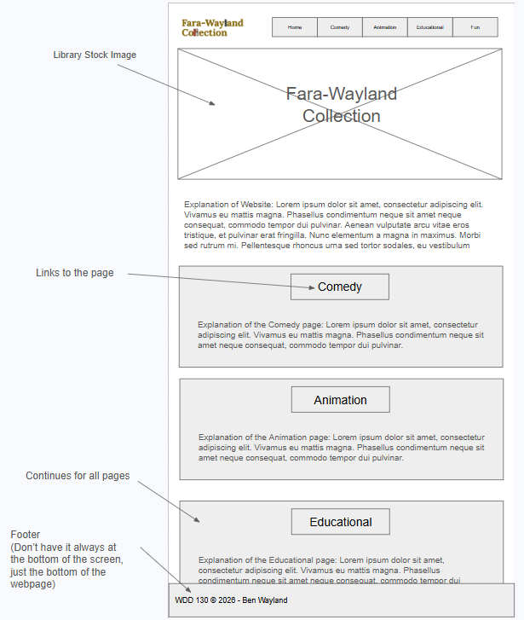

Other


