**PL/SQL**简介

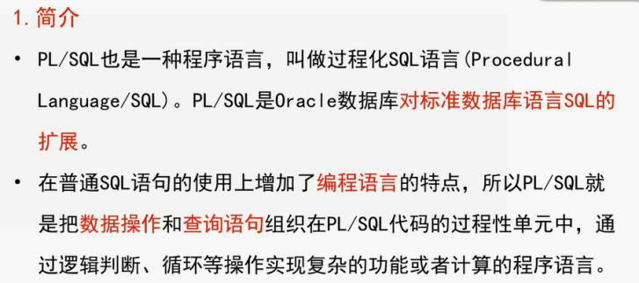

声明部分、执行部分、异常处理部分

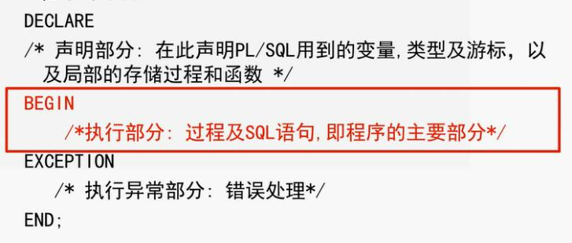

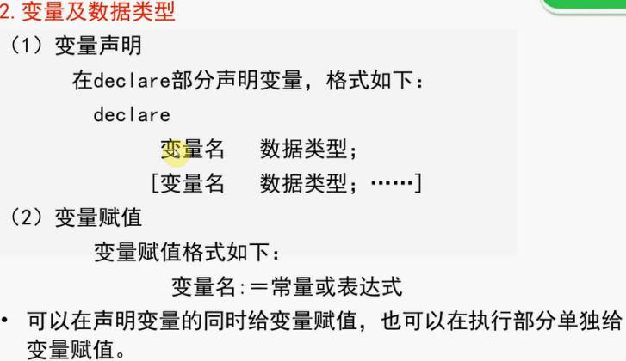

DECLARE

v_sno VARCHAR2(10) := '04001 ';

v_cno VARCHAR2(10) := '001 ';

v_grade NUMBER :=90;

BEGIN

INSERT INTO SC VALUES (v_sno,v_cno,v_grade);

CONNIT;

END;

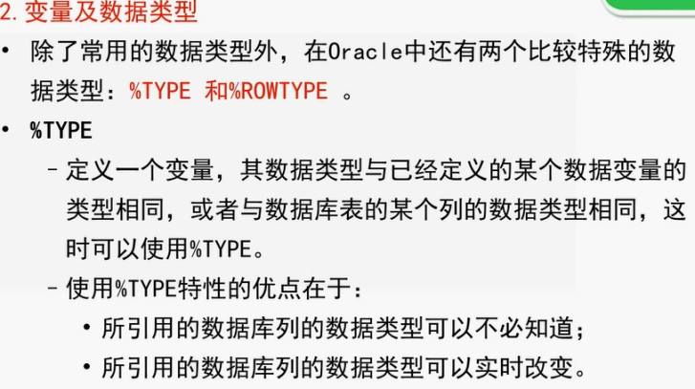

练习实例

DECLARE

m sc.sno%type;

n sc.cno%type;

t sc.grade%type;//没有必要提前知道数据列的数据类型

BEGIN

m= '04001 ';

n= '001 ';

t= '90';

INSERT

INTO SC

VALUES (m,n,t);

CONNIT;

END;

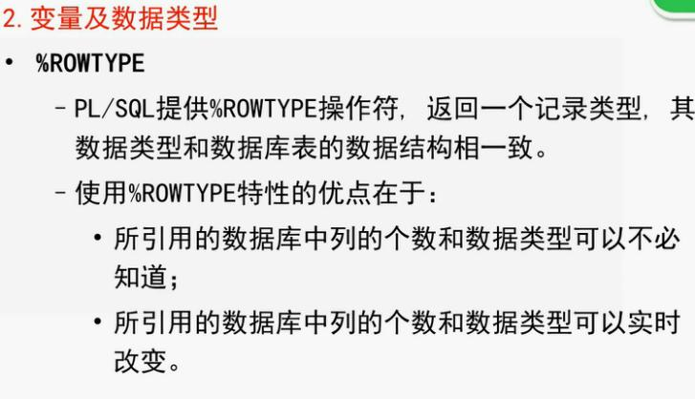

DECLARE

m sc.sno%rowtype;

BEGIN

m.sno= '04002 ';

m.cno= '001 ';

m.grade= '91 ';

INSERT

INTO SC

VALUES (m.sno,m.cno,m.grade);

CONNIT;

END;

运算符与表达式

一般运算符

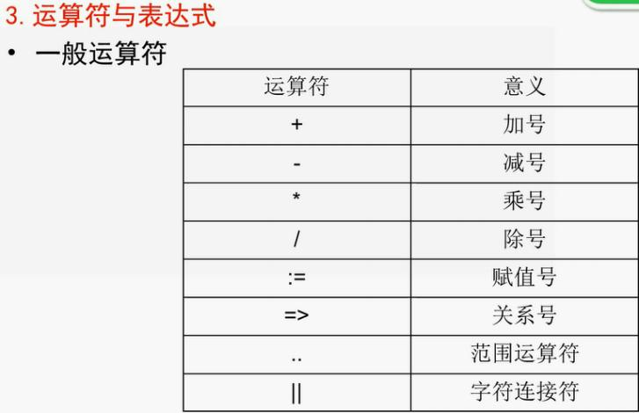

关系符号作用：调用存储过程中为形参赋值

关系运算符

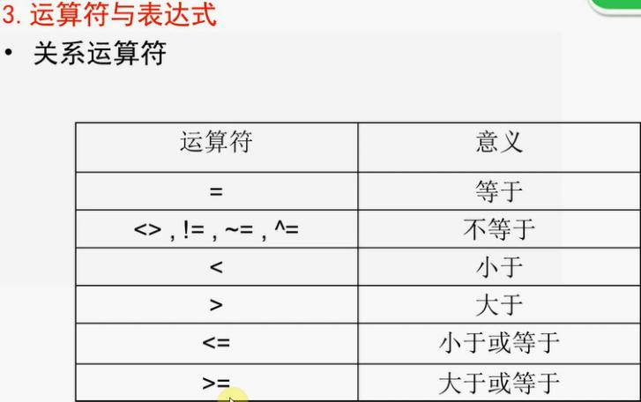

逻辑运算符

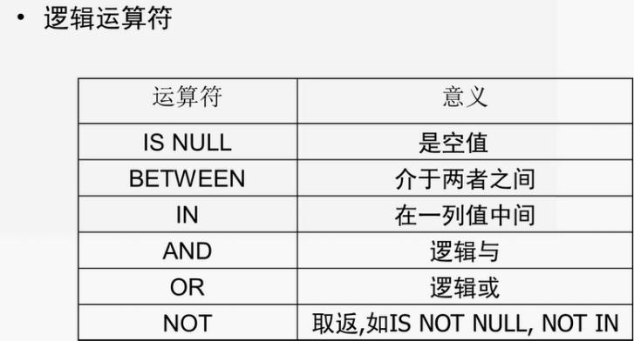

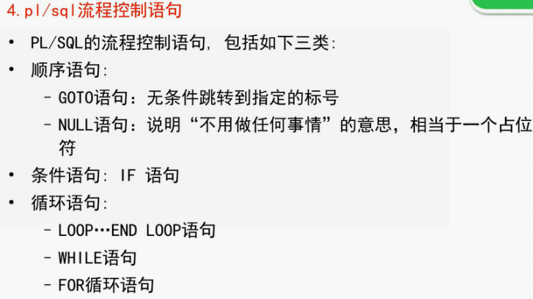

条件语句

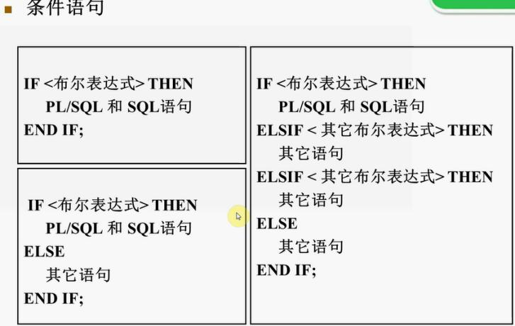

DECLARE

m sc.grade%type;

BEGIN

select grade into m

from sc

where sno = '04001 ' and cno = '005 ';

if m<60 then

dbms_output.put_line(‘不及格’);

elsif m>=60 and m<80 then

dbms_output.put_line(‘及格’);

elsif m>=80 and m<90 then

dbms_output.put_line(‘良好’);

else

dbms_output.put_line(‘优秀’);

end if;

END;

循环语句

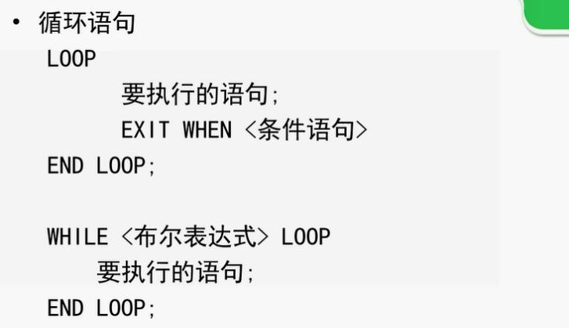

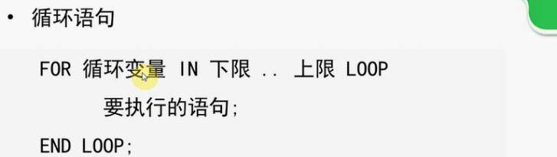

游标

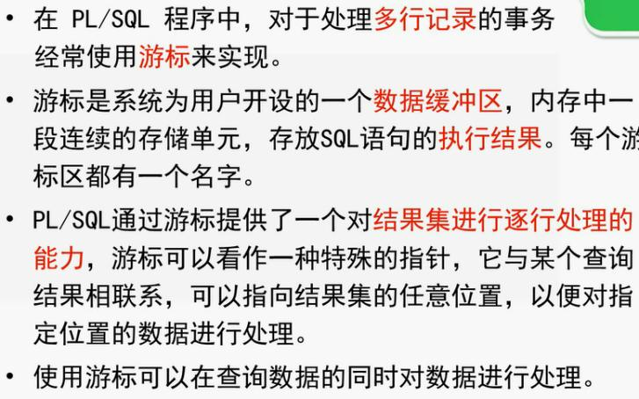

声明游标

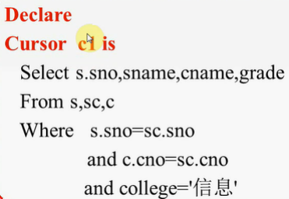

打开游标

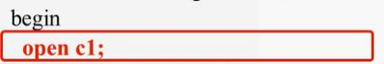

提取游标数据

移动游标指针



DECLARE

a varchar2(10);

b varchar2(20);

c varchar2(40);

d number;

m number;

cursor c is select s.sno,sname,cname,grade;

from s,sc,c

where s.sno=sc.sno and c.cno=sc.cno and college= '信息';

BEGIN

open c1;

loop

fetch c1 into a,b,c,d;

exit when c1%notfound;

if(d>60)then

m:=m+d;

dbms_output.put_line(a| |b| |c| |d| |m);

end if;

end loop;

close c1;

END;

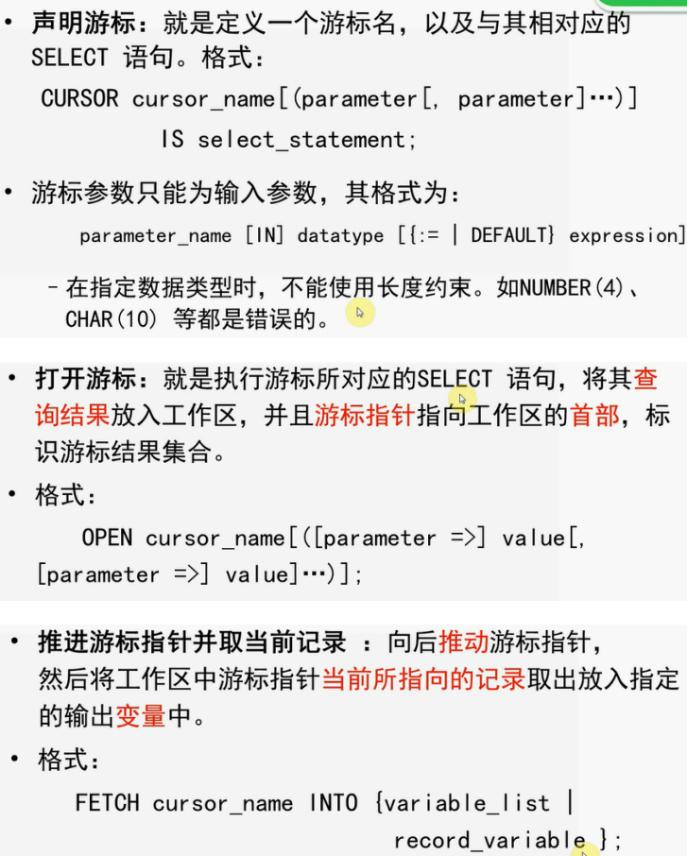

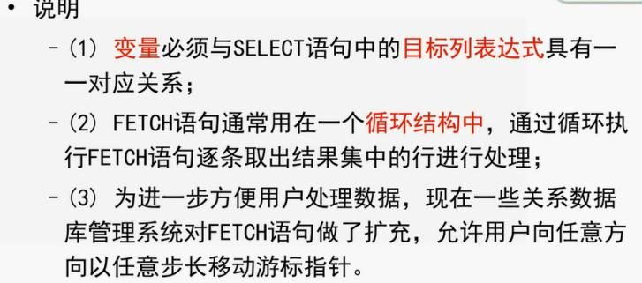

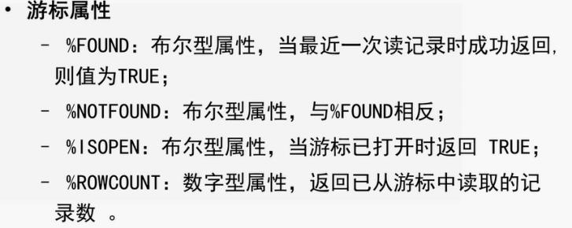

存储过程

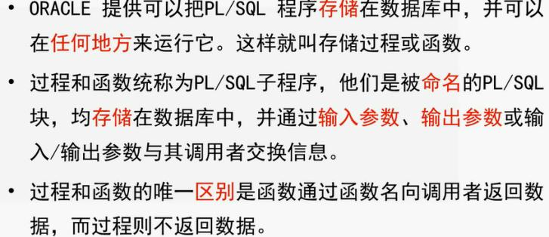

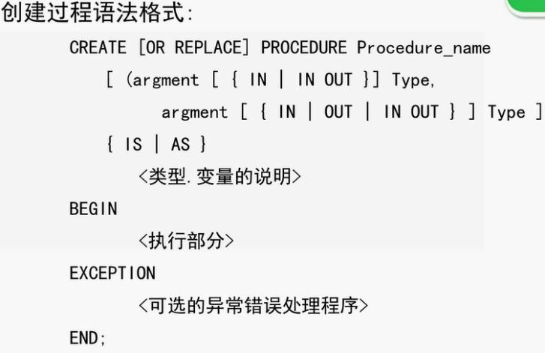

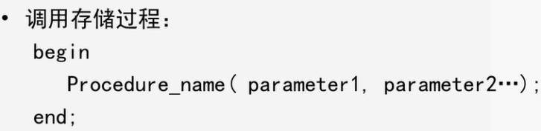

DECLARE

a varchar2(10);

b varchar2(20);

c varchar2(40);

d number;

m number;

cursor c is select s.sno,sname,cname,grade;

from s,sc,c

where s.sno=sc.sno and c.cno=sc.cno and college= '信息';

BEGIN

open c1;

loop

fetch c1 into a,b,c,d;

exit when c1%notfound;

if(d>60)then

m:=m+d;

dbms_output.put_line(a| |b| |c| |d| |m);

end if;

end loop;

close c1;

END;