How to Slicing Images from Video Process

Here is one of the many ways

- Download VLC


Fig – 1(https://videolan.org/vlc/)

  - Lunch VLC
- -Instructions : From Toobars –Go to (Tools → Prefrences → Click (All) go to Video and click Filters(video filters are used to process the video stream) from video filter module click Scene video filter and save it after.

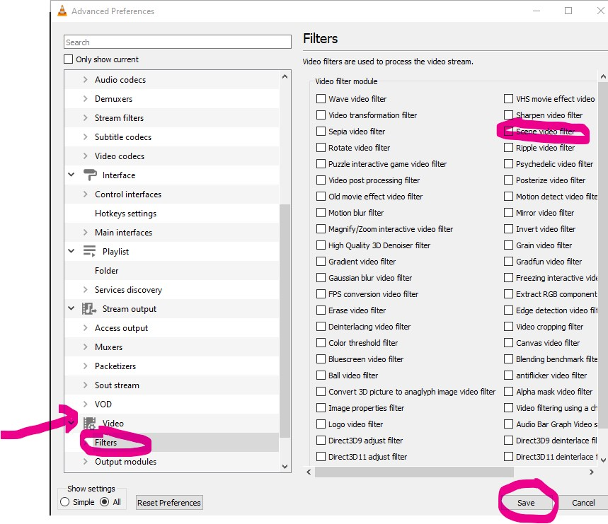

Fig – 2

  - Expand Filters and go to Scene filter and click it again , you will see this screen as follows:

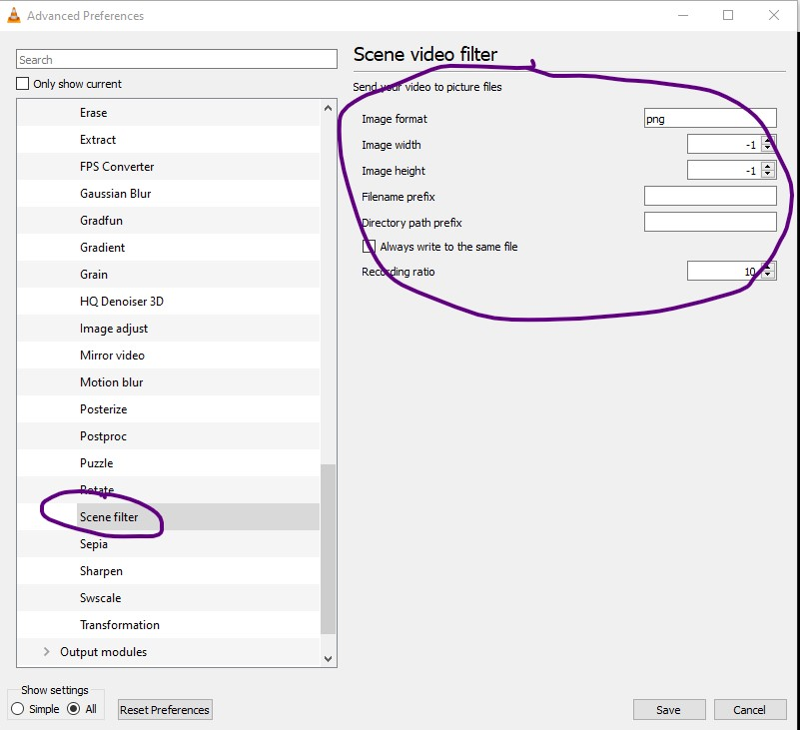
Fig – 3

And fill in the Scene video filters boxes as follows

- Gey your video ready
- Create Folder where you will store video
- Do the following to the boxes
- Copy the path of your directory where you want to store the video into and save
- Please close the VLC and restart again and the you can upload your video and within few seconds it will give you image slicing.
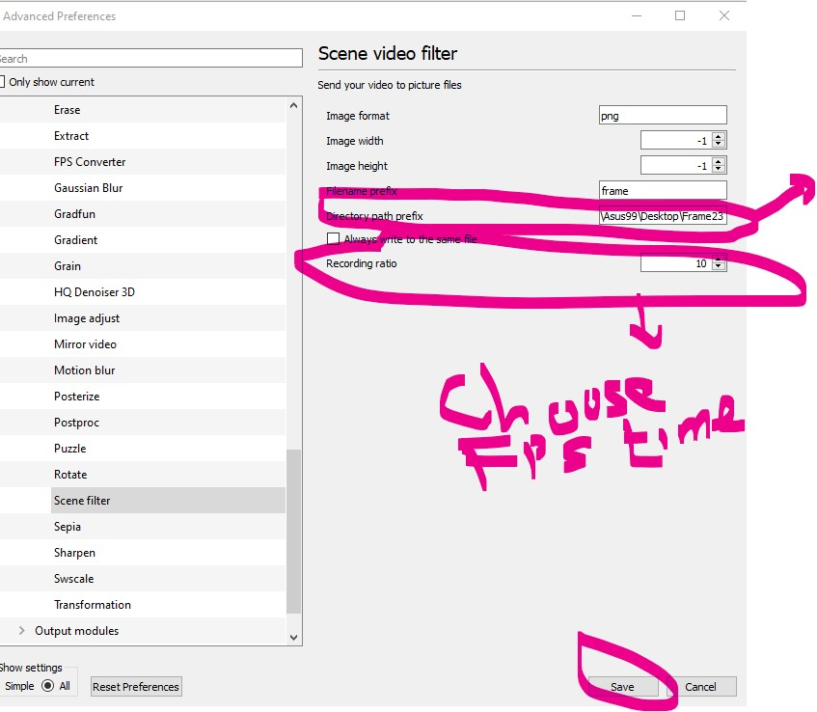

Fig – 4

- Important note ,
- Make sure you go back to Prefrences to unclick the (Scene Vidoe Filter) and save
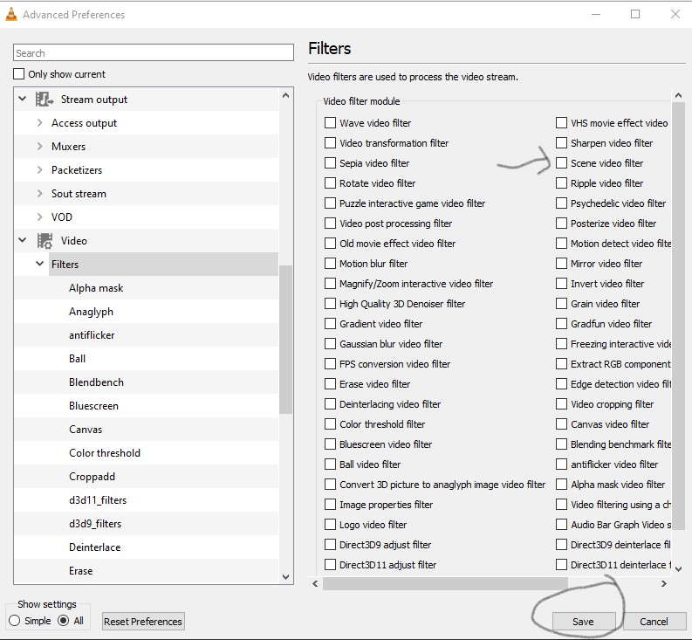
Fig - 5
- it and after go to
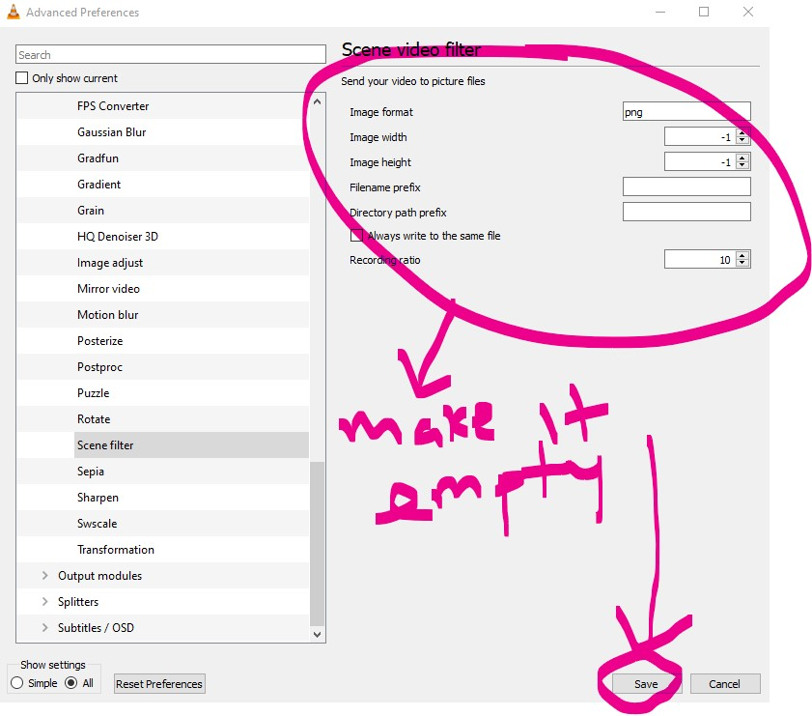
Fig – 6

Happy VLC using for image slicing

