Uncertainty Quantification of Machine Learning Models in Medical Imaging: An Open, Hands-On Tutorial with an LLM-Based Content Evaluation
Benyamin Gheiji, Danial Elyassirad, Mahsa Vatanparast, Shahriar Faghani
Course materials: https://github.com/benyamin-gheiji/Uncertainty-Quantification-Medical-Imaging

Abstract
Machine learning models deployed in clinical imaging are usually evaluated on how often they are correct, and rarely on whether they can indicate when they are likely to be wrong. A model that fails silently on the minority of cases it cannot handle is more dangerous in a hospital than one that flags those cases for human review. Uncertainty quantification addresses this directly, but the material is dispersed across primary methodological papers and surveys, and comparatively little of it is executable, clinically framed, or organised for someone learning the subject for the first time.
We present an open, hands-on tutorial on uncertainty quantification for medical imaging, comprising nineteen sessions arranged in four parts, from the clinical motivation through Bayesian and non-Bayesian methods to the evaluation of the uncertainty estimates themselves. Every method is implemented in PyTorch on a public chest radiograph dataset, and every session runs end to end on freely available hardware. The materials are released as Jupyter notebooks, as executable Kaggle notebooks, and as a static website.
We further introduce a protocol for evaluating an educational resource of this kind by treating it as a knowledge source for a language model. One hundred four-option multiple-choice items were generated from the primary methodological literature rather than from the tutorial itself, and twenty instruction-tuned models spanning six families answered every item twice: once unaided, and once with passages retrieved from the tutorial. Supplying the tutorial improved mean accuracy from 0.680 to 0.742 and mean AUROC for failure prediction from 0.725 to 0.788, with eighteen of twenty models improving on each metric (Wilcoxon signed-rank, Holm-corrected p = 0.00032 for both). The evaluation therefore assesses the tutorial using the same selective-prediction ideas the tutorial teaches.

1. Introduction
Clinical machine learning is generally reported in terms of accuracy, area under the receiver operating characteristic curve, or sensitivity and specificity at a chosen operating point. These summarise how often a model is right across a population. They say nothing about the individual case in front of a clinician, and in particular they say nothing about whether the model has encountered anything resembling that case before.
The distinction matters because the failure modes are not symmetric. A model that is uncertain and says so invites a second read, an additional view, or a confirmatory test; the cost is the clinician's time. A model that is confidently wrong invites none of these, and the error propagates into the decision. The softmax layer of a standard classifier compounds the problem: it produces a normalised distribution over the training classes for any input whatsoever, including inputs drawn from a distribution the model has never seen, so the output continues to look like a confident probability long after it has stopped being a meaningful one.
Uncertainty quantification is the body of work that addresses this. It is an active area with a substantial literature, but that literature is organised for researchers who already know the field. The Bayesian treatments assume comfort with variational objectives; the conformal prediction literature is written in the language of exchangeability and quantiles; the calibration work sits in yet another idiom. For a practitioner who trains medical imaging models and wants their predictions to carry an honest measure of confidence, there is no single path through this material that starts from the clinical problem and ends with working code.
This paper describes such a path, and then asks whether it works. Our contributions are:
- An open tutorial of nineteen sessions covering the main families of uncertainty quantification for medical image classification, in which every method is implemented in PyTorch on a public chest radiograph dataset and every notebook runs on freely available hardware.
- A deliberate pedagogical structure in which conceptual sessions are paired with implementation sessions, and in which the final part is devoted not to producing uncertainty estimates but to establishing whether they can be trusted.
- A protocol for evaluating an educational resource by treating it as a knowledge source for a language model, measuring both answer accuracy and the model's ability to predict its own failures, with the item bank generated from the primary literature rather than from the tutorial.
- An empirical result across twenty models and six families showing that supplying the tutorial improves both quantities.

2. Related work
Uncertainty quantification in deep learning has developed along several partly independent lines. Bayesian neural networks place distributions over weights and approximate the resulting posterior, using variational inference or the reinterpretation of dropout at test time as approximate Bayesian inference. Deep Ensembles set the Bayesian machinery aside entirely and take the disagreement among independently initialized models as the uncertainty signal, which remains a strong baseline. Evidential approaches predict the parameters of a Dirichlet distribution in a single forward pass. Conformal prediction takes a different route again, producing prediction sets with finite-sample coverage guarantees under exchangeability alone, without assumptions about the model.
A parallel line of work concerns whether uncertainty estimates are trustworthy once produced. Calibration studies established that modern networks are systematically overconfident and introduced both measurement and correction. Selective prediction and risk–coverage analysis formalise the decision to abstain. Out-of-distribution detection asks whether an input belongs to the training distribution at all.
Several reviews survey these methods for medical imaging. Reviews serve a different purpose from the present work: they map a field for readers who intend to enter it, and they do not generally provide executable implementations or a graded path for a newcomer. Educational resources that do provide code tend to cover a single method rather than the range, and are seldom framed around clinical decision-making.
Evaluation of educational materials is the second area this paper touches. Tutorials and courses are conventionally assessed by expert review or by studies with human learners, both of which are expensive and slow. Retrieval-augmented generation offers a cheaper proxy: if a document is a good knowledge source, supplying it to a language model should improve that model's answers to questions about its subject matter. We use this as a content-coverage probe rather than as a claim about human learning.

3. Tutorial design

3.1 Audience and prerequisites
The tutorial is aimed at researchers and practitioners who already build models for medical imaging and want their predictions to carry a defensible measure of confidence. It does not assume prior exposure to Bayesian deep learning or conformal prediction, but it does assume the following.
Prerequisite | What is assumed
Python | Functions, classes, NumPy arrays, and working in Jupyter notebooks.
Machine learning fundamentals | Training and evaluation, over- and underfitting, data splits, and metrics beyond raw accuracy.
Deep learning and PyTorch | How neural networks are trained, plus enough PyTorch to define a model, write a training loop, and run inference.
Medical imaging data | Some experience handling image datasets, and an appreciation of the clinical stakes when a model is wrong.
Table 1. Assumed background.

3.2 Structure
The material is arranged in four parts of nineteen sessions. The ordering is deliberate: the clinical argument comes first and no method is introduced until the problem it solves has been made concrete; the methods follow; and the final part is concerned entirely with whether the resulting estimates deserve to be believed.
Part | Sessions | Focus
Part 1 — Foundations | 1–3 | Why accuracy alone is insufficient in clinical AI; aleatoric versus epistemic uncertainty; how clinicians already reason probabilistically.
Part 2 — Core UQ Methods | 4–15 | The Bayesian perspective; variational inference; MC Dropout; Deep Ensembles; Evidential Deep Learning; Conformal Prediction. Each concept session is paired with a PyTorch implementation, and the part closes with a side-by-side comparison.
Part 3 — Evaluation & Reliability | 16–18 | Calibration and reliability diagrams; risk–coverage analysis and selective prediction; out-of-distribution detection. All three combine concept and implementation in one notebook.
Part 4 — Future Directions | 19 | Choosing a method for a clinical problem; open challenges; where the field is going.
Table 2. Structure of the tutorial.
Within Part 2, each conceptual session is followed by an implementation session that builds the method from scratch on the same dataset and the same backbone, so that differences between methods are attributable to the methods rather than to differences in setup. Part 3 combines concept and implementation within single notebooks, because the evaluation techniques are shorter and are best understood against outputs from the methods already built.

3.3 Implementation and delivery
All implementation sessions use the same publicly available paediatric chest radiograph dataset and a DenseNet-121 backbone, with the classification head trained and the backbone frozen where the computational budget requires it. This choice is constrained by a design decision: every notebook must run to completion on the free GPU tier of a hosted notebook service, so that no part of the tutorial is inaccessible to a reader without institutional compute.
The material is released in three forms. The Jupyter notebooks and their figures are in a public repository. Each session is also published as a Kaggle notebook, which can be executed in the browser with the dataset already attached. A static website renders every session with navigation between parts and sessions for readers who want to read rather than run.

4. What the tutorial covers

4.1 Part 1 — Foundations
The first part builds the clinical argument before introducing any mathematics. It separates the two ways a clinical model fails — confident error and indiscriminate caution — and argues that the first is the more dangerous because it is invisible. It then draws the distinction that organises everything afterwards: aleatoric uncertainty, which arises from noise and ambiguity in the data and cannot be reduced by collecting more of it, and epistemic uncertainty, which reflects what the model has not learned and can. The distinction is not academic, because the clinical responses differ: irreducible ambiguity in an image calls for a different test, whereas model ignorance calls for a human read. The part closes by observing that clinicians already reason this way, reporting a likelihood, a confidence, a differential, and a recommended action rather than a bare label.

4.2 Part 2 — Core UQ methods
The second part is the longest. It opens with the Bayesian view of a neural network, treating weights as distributions rather than fixed values, and works through the two approximations that make this tractable in practice: variational inference, which fits a factorised Gaussian posterior by optimising the evidence lower bound, and MC Dropout, which reinterprets dropout at inference time as sampling from an approximate posterior.
Deep Ensembles arrive by a different route. They make no Bayesian claims and require no special layers or loss functions: the same architecture is trained several times from different random initializations, and the disagreement among members is the uncertainty signal. It is the simplest idea in the part and, on most benchmarks, among the strongest.
Two further methods take their own paths. Evidential Deep Learning predicts the parameters of a Dirichlet distribution over the class probabilities in a single forward pass, separating aleatoric and epistemic components analytically rather than by sampling. Conformal Prediction steps outside all of these frames, using a held-out calibration set and a nonconformity score to produce prediction sets that contain the true label with a specified marginal probability, guaranteed in finite samples under exchangeability and without any assumption about the underlying model.
Every method is instrumented the same way, so that the resulting quantities can be compared directly. Figure 1 shows the decomposition produced by the Deep Ensembles session across the test set.
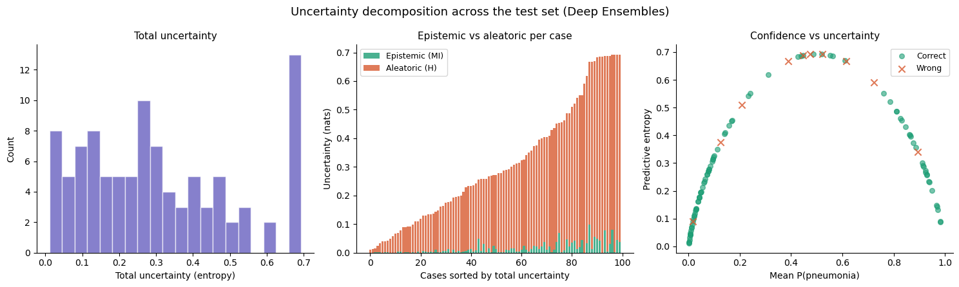
Figure 1. Uncertainty decomposition produced by the Deep Ensembles implementation session. Left: distribution of total predictive entropy across the test set. Centre: epistemic (mutual information) and aleatoric components per case, sorted by total uncertainty. Right: predictive entropy against mean predicted probability, with incorrect predictions marked; errors concentrate in the high-entropy region.

4.3 Part 3 — Evaluation and reliability
A method that emits an uncertainty score is not thereby useful. The score has to mean something, and the third part is devoted to establishing whether it does.
Calibration asks whether stated confidence matches observed frequency: among cases assigned 80% confidence, roughly 80% should be correct. The session measures this with reliability diagrams and expected calibration error, and applies temperature scaling as a post-hoc correction (Figure 2).
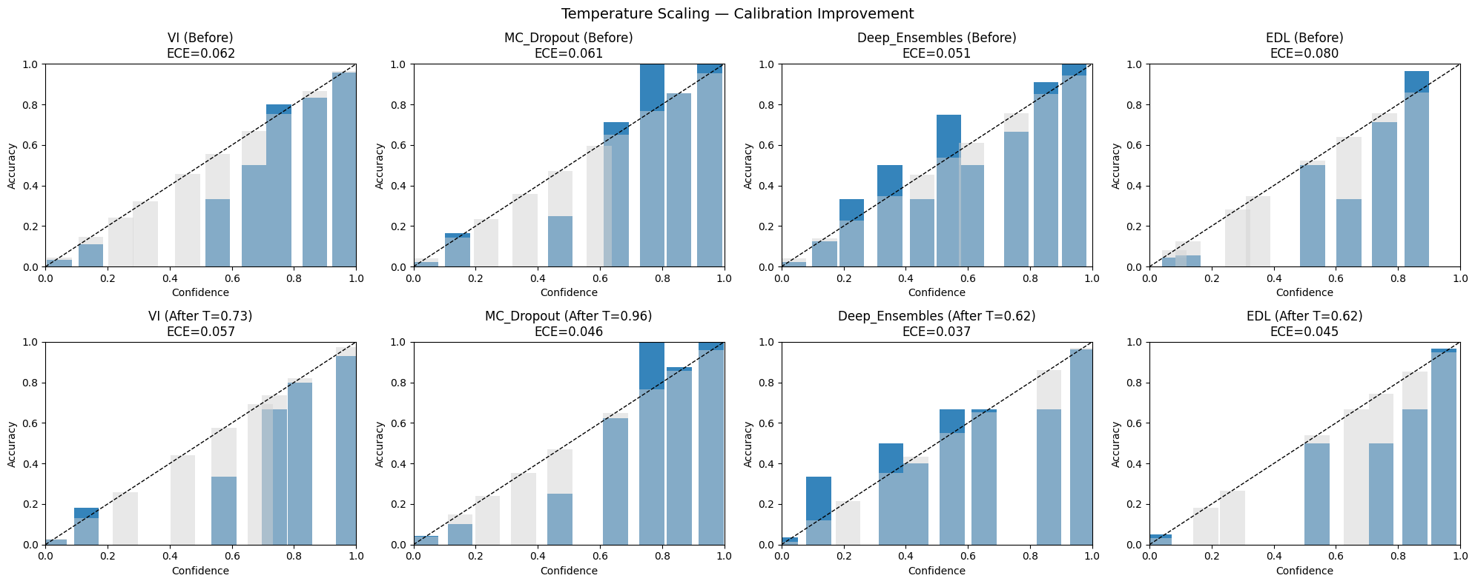
Figure 2. Reliability diagrams for four methods before (top) and after (bottom) temperature scaling, from the calibration session. Expected calibration error falls for every method; the fitted temperatures below one indicate that the uncorrected models were overconfident.
Risk–coverage analysis addresses the operational question of when a model should decline to predict. Ordering cases by uncertainty and progressively abstaining on the least certain traces out a curve of error rate against the fraction of cases retained; the area under it summarises the quality of the uncertainty ranking independently of any particular threshold (Figure 3). This connects the abstract quantity to a deployment decision: what accuracy is achievable if a given share of cases is referred for human review.
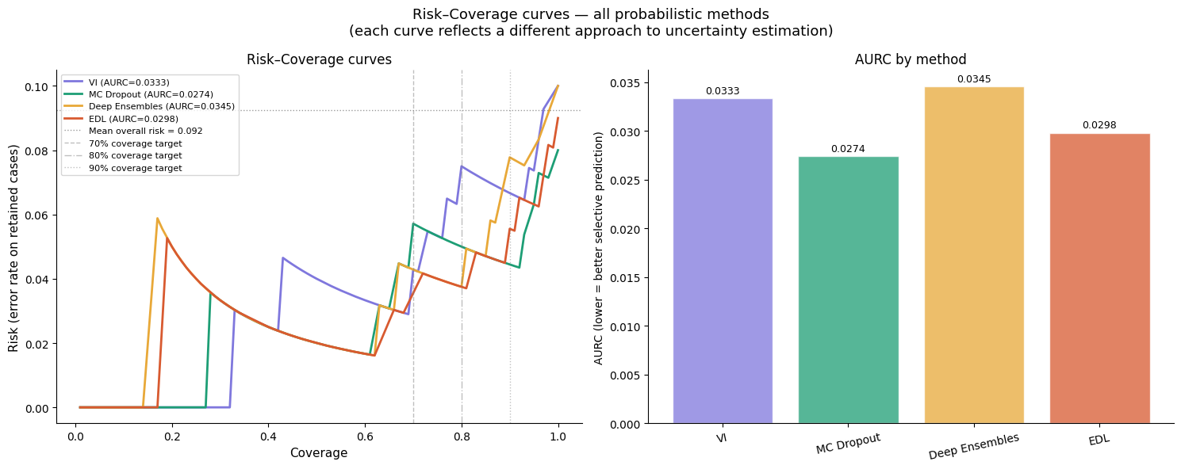
Figure 3. Risk–coverage curves for the four probabilistic methods, from the selective-prediction session, with clinically motivated coverage targets marked. The right panel summarises each curve by its area (lower is better).
Out-of-distribution detection asks the prior question of whether an input belongs to the training distribution at all. The session constructs corrupted and transformed radiographs as a controlled out-of-distribution set and evaluates how well each method's uncertainty score separates them from held-out in-distribution cases (Figure 4). The results are instructive precisely because they are uneven: methods that perform comparably on calibration or selective prediction do not necessarily separate distribution shift equally well.
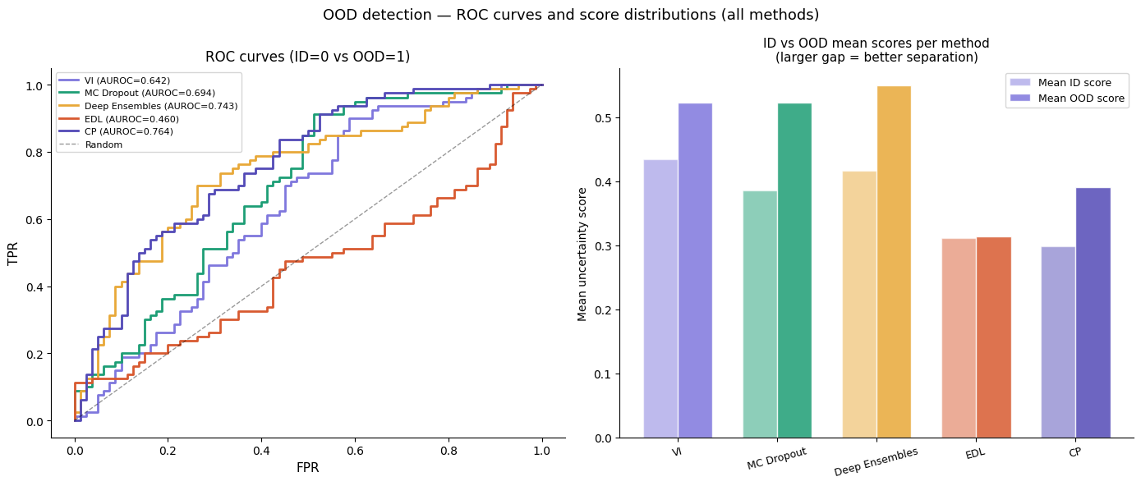
Figure 4. Out-of-distribution detection across all five methods. Left: receiver operating characteristic curves for separating in-distribution from out-of-distribution inputs using each method's uncertainty score. Right: mean uncertainty assigned to each group, where a larger gap indicates better separation.
Figure 5 shows the qualitative counterpart, which is the form in which such behaviour would be encountered in practice.
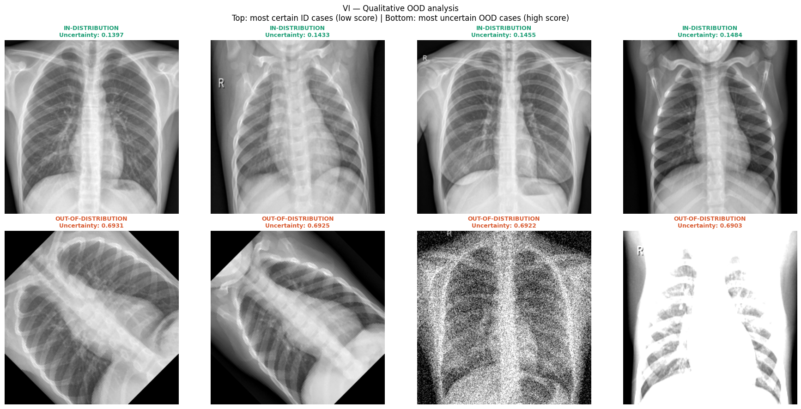
Figure 5. Qualitative out-of-distribution analysis from the same session. Top row: in-distribution radiographs receiving the lowest uncertainty. Bottom row: out-of-distribution inputs, produced by rotation, noise, and intensity corruption, receiving the highest.

4.4 Part 4 — Future directions
The closing part compares the methods across the dimensions that determine which to use in practice — computational cost at training and inference, intrusiveness to an existing pipeline, quality of the resulting estimates, and the strength of any guarantee — and sets out the open problems, including distribution shift between institutions, scaling to foundation models, and the unresolved question of how uncertainty should be communicated to the clinician who must act on it.

5. Evaluation

5.1 Rationale
The evaluation treats the tutorial as a knowledge source and asks whether making it available to a language model improves that model's answers to questions about uncertainty quantification. It is a content-coverage probe: it tests whether the tutorial contains the relevant information in a form that can be located and used. It is not a measure of human learning outcomes.
Two outcomes were measured. Accuracy is whether the model selected the correct option. AUROC is whether the probability the model assigned to the option it chose separates its correct from its incorrect answers; this measures failure prediction, which accuracy does not imply. A model can become more accurate while its confidence becomes less informative about which of its answers to trust. Measuring both is a deliberate echo of the tutorial's own argument.

5.2 Question bank
One hundred four-option multiple-choice items were generated with Claude Opus 5, in four categories of twenty-five items each: recall items covering definitions, mechanisms, and the operation of specific methods; conceptual items requiring the integration of two or more ideas; counterintuitive items where common intuition yields the wrong answer, with that intuition present among the distractors; and applied items concerning clinical deployment, including threshold selection, abstention policies, external validation, acquisition shift, inference-time compute, and the communication of uncertainty to clinicians.
Items were generated from the primary methodological literature rather than from the tutorial, to avoid the circularity of testing a text against questions derived from itself. The generation prompt named the source works explicitly: Gal and Ghahramani (2016); Lakshminarayanan et al. (2017); Blundell et al. (2015); Kendall and Gal (2017); Sensoy et al. (2018); Guo et al. (2017); Angelopoulos and Bates; Vovk et al.; Hendrycks and Gimpel (2017); Ovadia et al. (2019); and Geifman and El-Yaniv.
The prompt also imposed construction constraints intended to prevent the answer being inferable from surface features: exactly one unambiguously correct option; distractors defensible as incorrect for an identifiable reason, being a documented misconception, a conflated adjacent concept, or a true statement that does not answer the question; option lengths within approximately fifteen per cent of one another within each item, achieved by expanding distractors rather than abbreviating the correct option; no hedging qualifiers or absolute quantifiers confined to incorrect options; self-contained stems posing a specific question; no two items assessing the same fact; and, where the subject matter permitted, a concrete imaging context. The full prompt is reproduced in the appendix.

5.3 Retrieval
The tutorial condition supplied context by retrieval rather than as full text, since nineteen notebooks exceed the context window of the smaller models.
The notebooks were flattened to text, with markdown as written and code fenced, then split on markdown headings and packed into chunks of approximately four hundred tokens, splitting oversized units on sentence boundaries so that no chunk begins or ends mid-sentence. One structural unit of overlap was carried between consecutive chunks.
Chunks were embedded with BAAI/bge-large-en-v1.5 and indexed with FAISS using inner-product search over L2-normalised vectors. BGE is trained asymmetrically, so its query instruction prefix was applied to queries only and never to passages. Each query consisted of the item stem concatenated with all four options, and the top five chunks were retrieved. Retrieval was computed once and cached, so identical context was supplied to every model; retrieval variation therefore cannot contribute to any difference between conditions.

5.4 Models
Twenty instruction-tuned models across six families were evaluated, loaded in 4-bit NF4 quantisation with double quantisation.
Family | Models
Qwen2.5 | 0.5B, 1.5B, 3B, 7B, 14B
Falcon3 | 1B, 3B, 7B, 10B
Phi | Phi-3-mini (3.8B), Phi-3.5-mini (3.8B), Phi-4-mini (3.8B), Phi-3-medium (14B)
Mistral | Mistral-7B-v0.3, Ministral-8B, Mistral-Nemo (12B)
Granite 3.1 | 2B, 8B
Gemma 3 | 1B, 4B
Table 3. Models evaluated.

5.5 Scoring
Each model answered all one hundred items twice: once with the question alone, and once with the retrieved passages prepended. Option order was shuffled once per item with a fixed seed and held identical across models and conditions.
The answer was read from the model's logits at the first position after the generation prompt, taking the maximum logit across the plausible token forms of each letter — 'A' and ' A', and so on, since tokenizers differ in whether a leading space is emitted — and applying a softmax across the four letters. Scoring is therefore deterministic: there is no sampling, no text parsing, and no model acting as judge.
The confidence score used for AUROC is the probability on the predicted letter. The probability on the correct letter would be circular, since it is high precisely when the model is right.

5.6 Statistical analysis
The model is the unit of analysis. Each model contributes one paired observation per metric, so the tests make no assumption that questions are independent: a question answered by twenty models yields twenty correlated observations, not twenty independent ones. Paired differences were tested with the two-sided Wilcoxon signed-rank test, with Holm correction across the two metrics.

6. Results
Accuracy improved in eighteen of twenty models, and AUROC in eighteen of twenty.
Metric | n | No context | Tutorial | Mean diff. | Median diff. | p | p (Holm)
Accuracy | 20 | 0.680 | 0.742 | +0.062 | +0.070 | 0.00016 | 0.00032
AUROC | 20 | 0.725 | 0.788 | +0.063 | +0.069 | 0.00026 | 0.00032
Table 4. Paired comparison across twenty models. Chance accuracy is 0.25; an AUROC of 0.5 indicates confidence carrying no information about correctness.
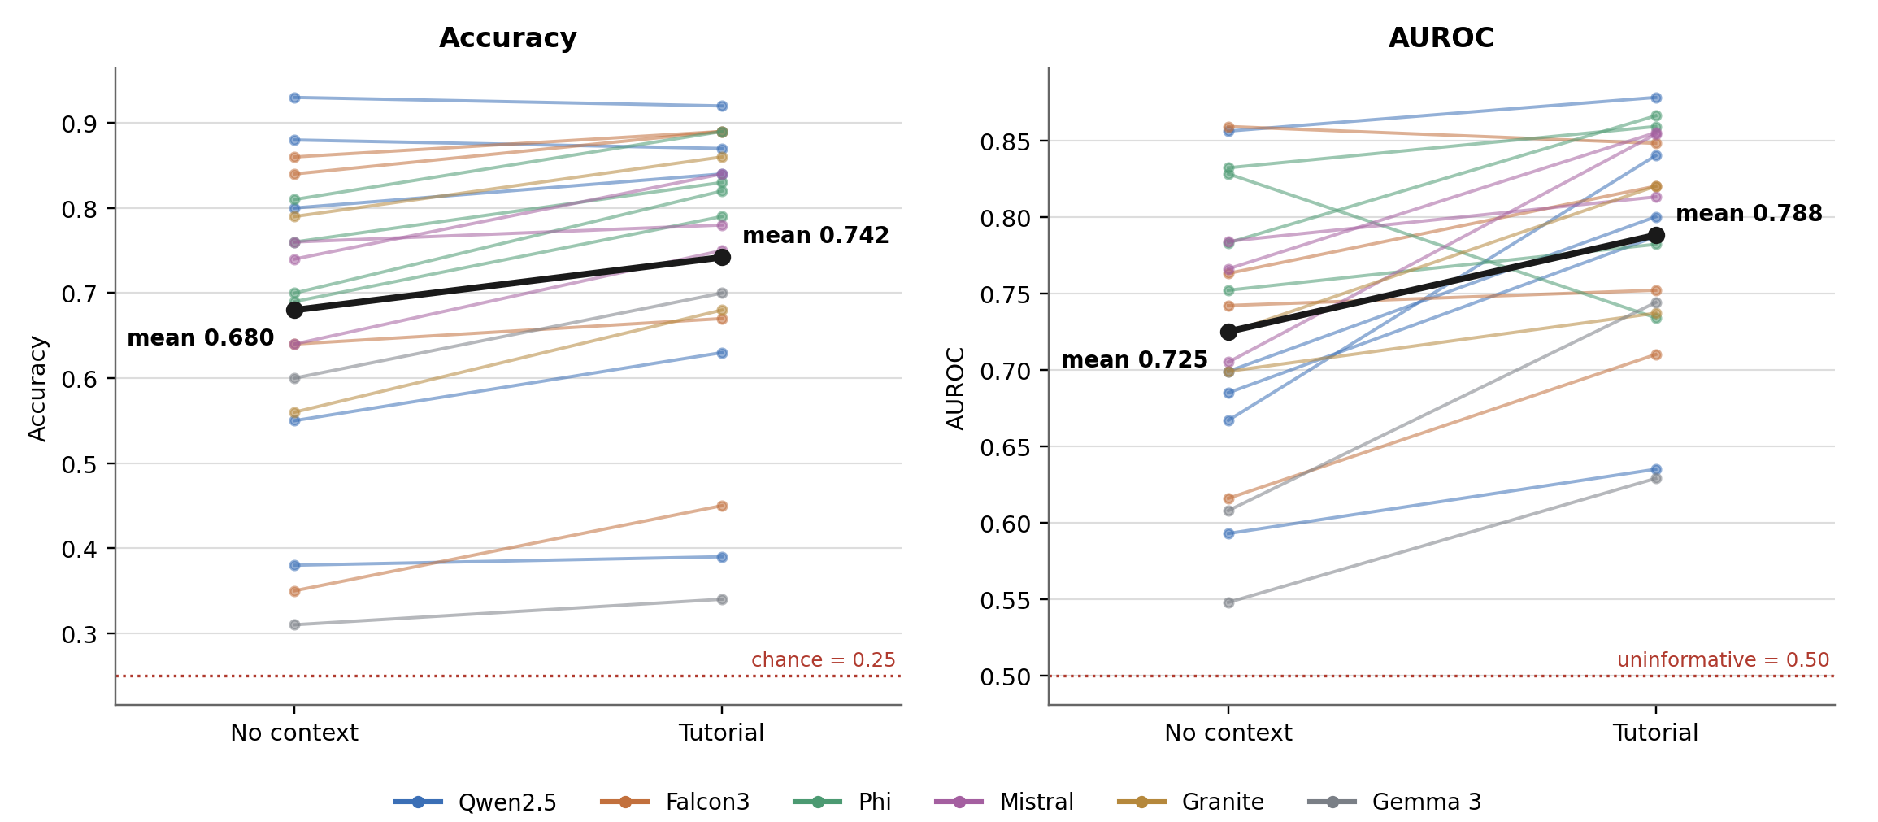
Figure 6. Per-model paired differences between the no-context and tutorial conditions, coloured by model family. Each thin line is one model; the heavy black line is the mean. Left: accuracy. Right: AUROC for failure prediction.
The two exceptions on accuracy are Qwen2.5-7B and Qwen2.5-14B, which scored 0.88 and 0.93 without context and each lost a single item with it, a pattern consistent with a ceiling rather than with interference. Both nonetheless gained on AUROC, by 0.022 and 0.172 respectively. Across the set, accuracy gains are largest in the mid-range models and compress at both ends: the weakest models remain near the floor in both conditions, while the strongest have little headroom.
The dissociation between the two metrics is worth noting. Qwen2.5-14B is the clearest case: its accuracy did not improve, yet its AUROC rose by 0.172, meaning that the tutorial changed how informative its confidence was about its own errors without changing how many it made. Since a model's ability to flag its own failures is precisely what the tutorial argues matters clinically, this is not a secondary observation.
Model | Family | Acc. no ctx | Acc. tutorial | Δ Acc. | AUROC no ctx | AUROC tut. | Δ AUROC
Qwen2.5-0.5B | Qwen2.5 | 0.38 | 0.39 | +0.01 | 0.593 | 0.635 | +0.042
Qwen2.5-1.5B | Qwen2.5 | 0.55 | 0.63 | +0.08 | 0.685 | 0.787 | +0.102
Qwen2.5-3B | Qwen2.5 | 0.80 | 0.84 | +0.04 | 0.699 | 0.800 | +0.101
Qwen2.5-7B | Qwen2.5 | 0.88 | 0.87 | −0.01 | 0.856 | 0.878 | +0.022
Qwen2.5-14B | Qwen2.5 | 0.93 | 0.92 | −0.01 | 0.667 | 0.840 | +0.172
Falcon3-1B | Falcon3 | 0.35 | 0.45 | +0.10 | 0.616 | 0.710 | +0.094
Falcon3-3B | Falcon3 | 0.64 | 0.67 | +0.03 | 0.742 | 0.752 | +0.010
Falcon3-7B | Falcon3 | 0.84 | 0.89 | +0.05 | 0.763 | 0.820 | +0.057
Falcon3-10B | Falcon3 | 0.86 | 0.89 | +0.03 | 0.859 | 0.848 | −0.011
Phi-3-mini | Phi | 0.69 | 0.79 | +0.10 | 0.783 | 0.866 | +0.083
Phi-3.5-mini | Phi | 0.70 | 0.82 | +0.12 | 0.752 | 0.782 | +0.030
Phi-4-mini | Phi | 0.76 | 0.83 | +0.07 | 0.828 | 0.734 | −0.094
Phi-3-medium | Phi | 0.81 | 0.89 | +0.08 | 0.832 | 0.859 | +0.027
Mistral-7B-v0.3 | Mistral | 0.64 | 0.75 | +0.11 | 0.784 | 0.813 | +0.030
Ministral-8B | Mistral | 0.74 | 0.84 | +0.10 | 0.766 | 0.855 | +0.089
Mistral-Nemo | Mistral | 0.76 | 0.78 | +0.02 | 0.705 | 0.854 | +0.150
Granite-3.1-2B | Granite | 0.56 | 0.68 | +0.12 | 0.724 | 0.820 | +0.096
Granite-3.1-8B | Granite | 0.79 | 0.86 | +0.07 | 0.699 | 0.737 | +0.038
gemma-3-1b | Gemma 3 | 0.31 | 0.34 | +0.03 | 0.548 | 0.629 | +0.081
gemma-3-4b | Gemma 3 | 0.60 | 0.70 | +0.10 | 0.608 | 0.744 | +0.137
Table 5. Per-model results.

7. Discussion
The result supports a narrow claim: the tutorial contains information relevant to questions drawn from the primary literature, in a form that a retrieval system can locate and a language model can use. Because the items were written from the source papers rather than from the tutorial, this is not a test of whether the tutorial can reproduce its own contents.
The pattern of gains is informative about where such a resource helps. The models that improve most are those with enough capacity to use the retrieved text but insufficient parametric knowledge of the field to answer without it. Models at the ceiling gain little on accuracy because there is little to gain; models near the floor gain little because they cannot exploit the context. That the strongest models nonetheless improved on failure prediction suggests that supplying relevant material affects the confidence attached to an answer separately from the answer itself.
The evaluation is deliberately reflexive. A tutorial arguing that a model should be judged not only on whether it is right but on whether it knows when it is wrong should be assessed on both counts, and the choice of AUROC over accuracy alone follows directly from the argument in Part 1.

8. Limitations
The tutorial is preliminary. It is designed to bring a reader from no background in uncertainty quantification to working implementations of the main methods, and that objective trades depth for coverage. Each method is presented with enough theory to justify the implementation and enough implementation to make the theory concrete, but none is treated to the depth of its primary literature; readers intending to work on these methods rather than with them should treat the tutorial as an entry point and the cited sources as the substance.
The scope is restricted to classification. Every implementation session addresses a binary classification task on chest radiographs, and while the concepts transfer, the implementations do not directly. Segmentation raises the question of what an uncertainty map means at the pixel and structure level; regression requires distributional rather than categorical treatment; registration and image reconstruction raise their own formulations. We intend to extend the tutorial to these settings.
The evaluation measures recognition rather than generation. A multiple-choice format establishes whether a model can identify a correct statement, not whether it can produce the underlying reasoning or apply it to a case.
Language model performance is a proxy for content quality. An improvement in model answers indicates that the tutorial contains locatable, usable information; it is not evidence about human learning, for which a study with human participants would be required.
Retrieval is confounded with content. An item for which the relevant session is never retrieved cannot benefit from the tutorial however well that session is written, so the measured gains reflect the combination of content quality and retrievability rather than content quality alone.
The item bank was generated by a language model. Items were produced by Claude Opus 5 from the primary literature and are released with the evaluation code so that they can be independently inspected.

9. Availability
The notebooks, figures, generated website, evaluation code, and the full item bank are available at https://github.com/benyamin-gheiji/Uncertainty-Quantification-Medical-Imaging. Each session is additionally published as an executable Kaggle notebook. The chest radiograph dataset used throughout is publicly available under its own licence.

10. Conclusion
We have presented an open tutorial on uncertainty quantification for medical imaging that moves from the clinical case for uncertainty through the main methodological families to the evaluation of the resulting estimates, with every method implemented on public data and every notebook runnable on free hardware. We have also proposed and applied a protocol for evaluating such a resource by treating it as a knowledge source for a language model and measuring both answer accuracy and the model's ability to anticipate its own errors. Across twenty models spanning six families, supplying the tutorial improved both. The protocol is not specific to this subject matter and may be useful for evaluating technical educational resources more generally.

Appendix A. Item generation prompt
The prompt used with Claude Opus 5 to generate the hundred-item bank is reproduced here in full. [Insert the verbatim prompt text.]

