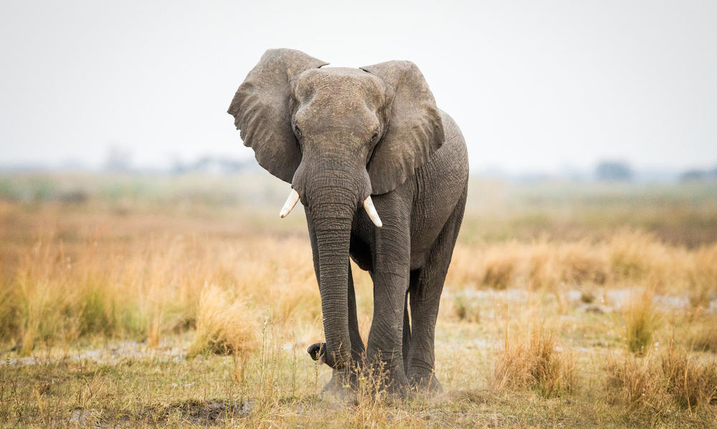
Are you ready to save the world! Well hold on tight.
Are you ready to save the world?

