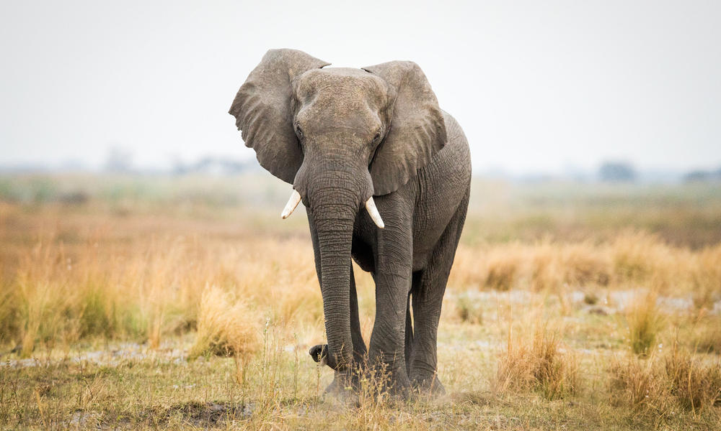

**Are you ready to save the world! Well hold on tight.**

**Are you ready to save the world?**