Quarto To Docs Example

## Quarto

Quarto enables you to weave together content and executable code into a finished document. To learn more about Quarto see <https://quarto.org>.

## Running Code

When you click the **Render** button a document will be generated that includes both content and the output of embedded code. You can embed code like this:

1 + 1

[1] 2

You can add options to executable code like this

[1] 4

The echo: false option disables the printing of code (only output is displayed).

# This is a Plot

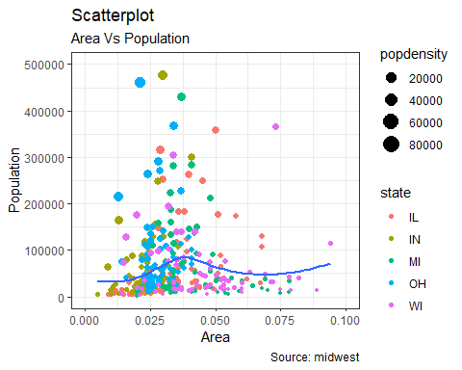

# This is some code

set.seed(123)   
x <- rnorm(10)   
cat("Here are 10 random numbers:", x)

Here are 10 random numbers: -0.5604756 -0.2301775 1.558708 0.07050839 0.1292877 1.715065 0.4609162 -1.265061 -0.6868529 -0.445662

# Thanks for Reading!